Topic Name: Smart Learning

Screen Layouts:

Module 1

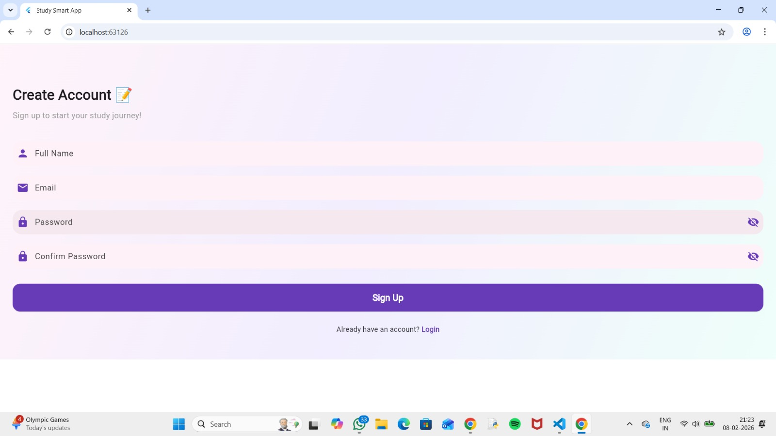

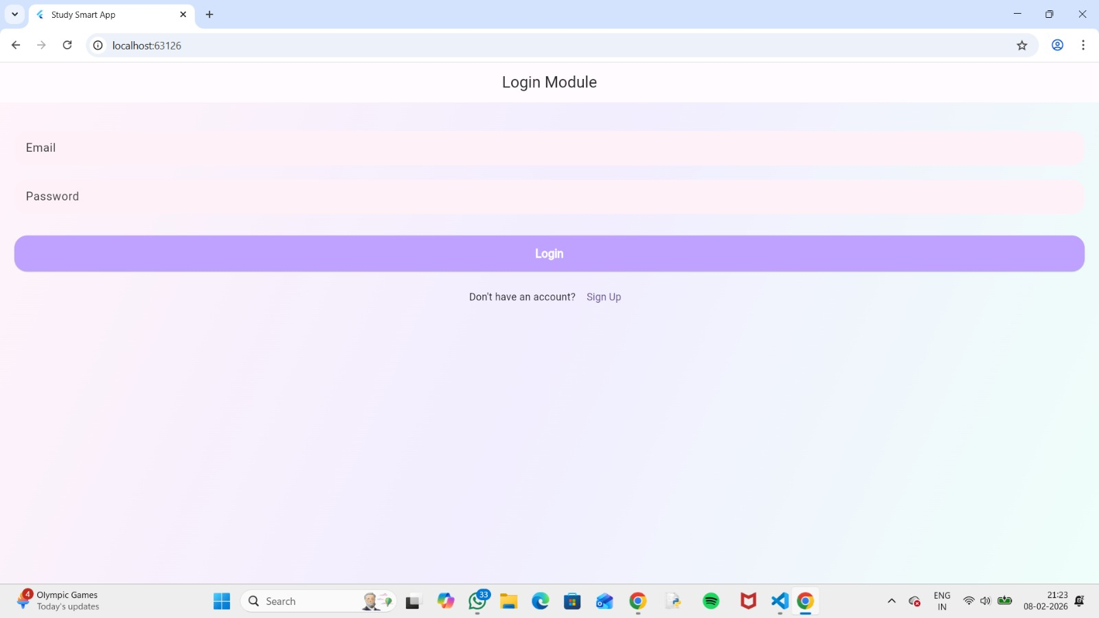

Module 2

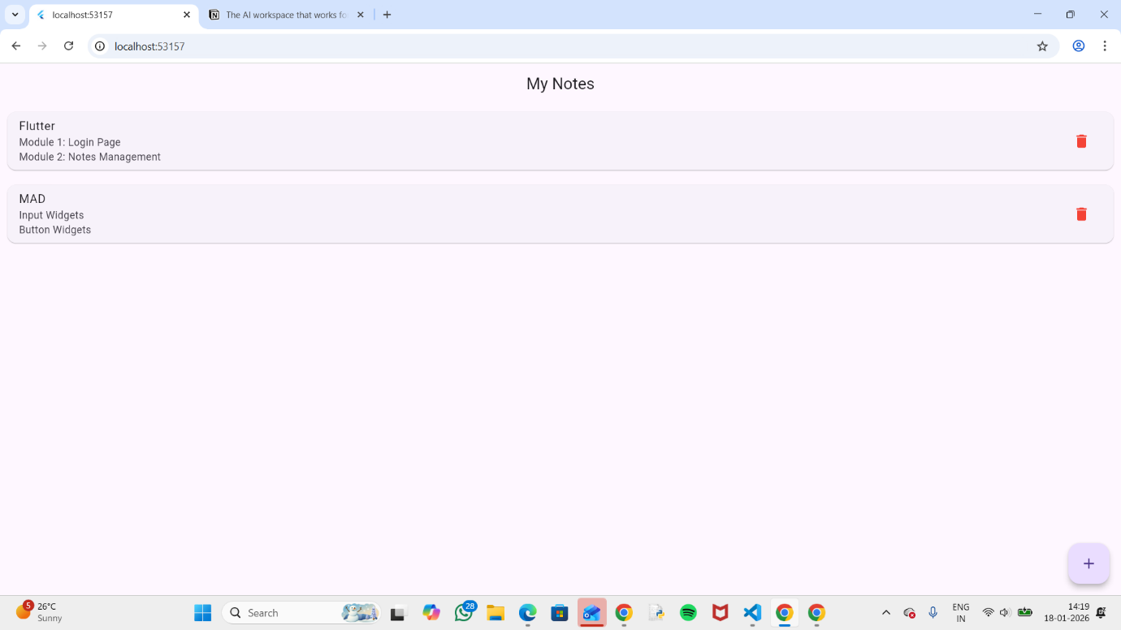

Module 3

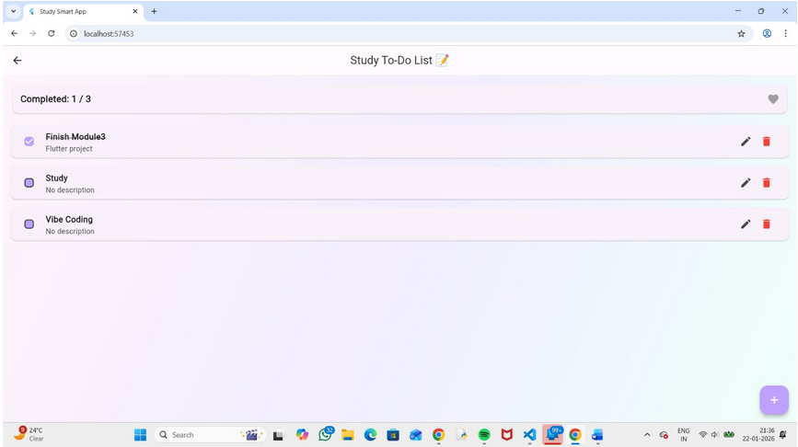

Module 4

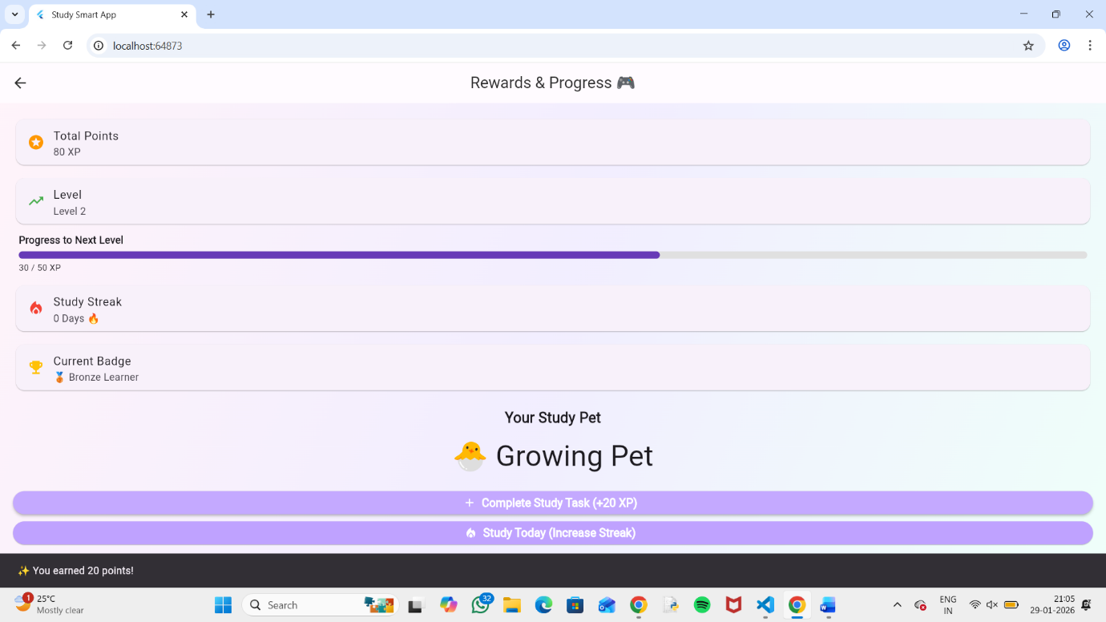

Module 5



Module 6

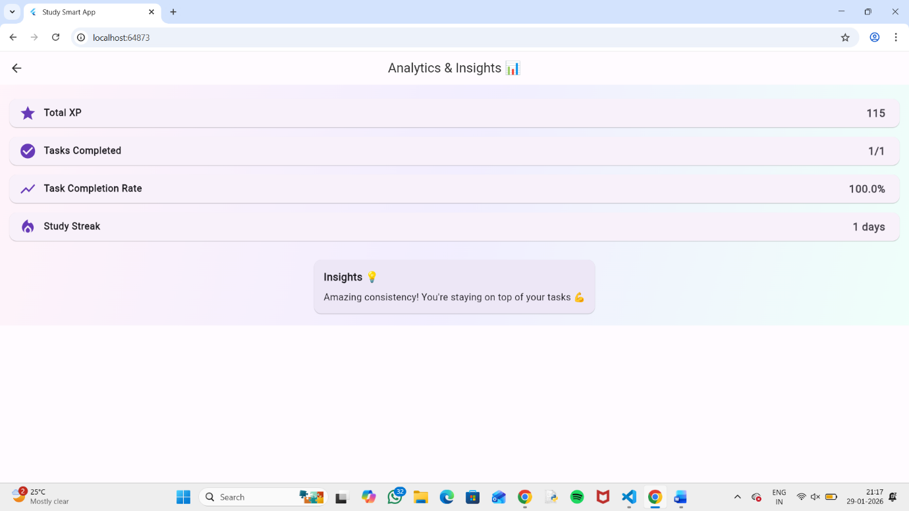

Conclusion:

The smart learning mobile application will enable students to learn effectively by integrating features of study management and productivity into one mobile application. It helps the users in organizing study notes, planning studies, setting reminders, progress tracking, and analysis of academic performance. Overall, the project provides a smart, organized, efficient learning system.

