
WORKSHEET

WORKSHEET 3 SQL

Refer the following ERD and answer all the questions in this worksheet. You have to write the queries using mysql for the required Operation.
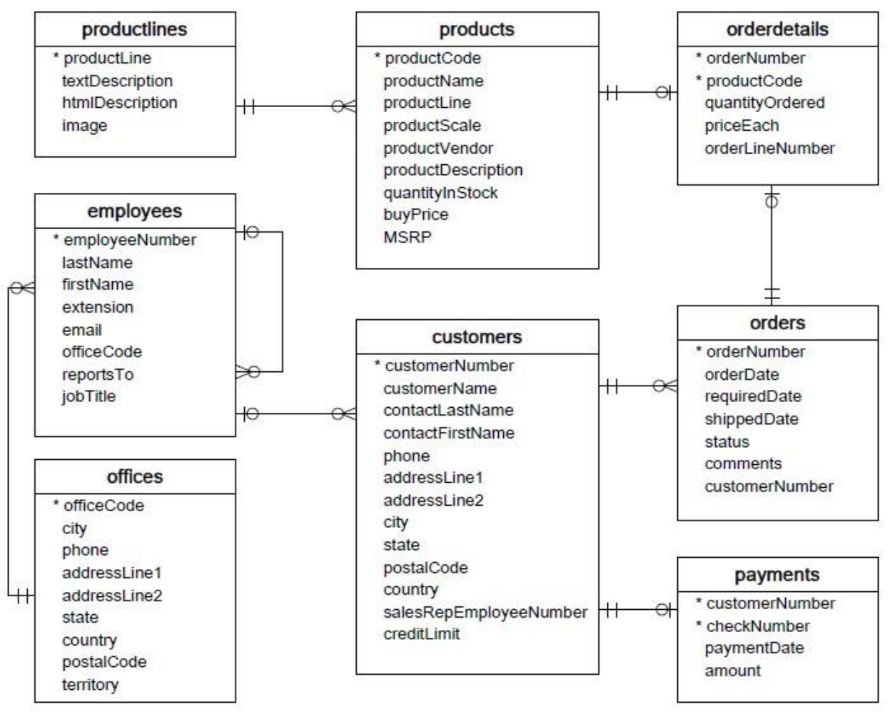

- Customers: stores customer’s data.

- Products: stores a list of scale model cars.

- ProductLines: stores a list of product line categories.

- Orders: stores sales orders placed by customers.
- OrderDetails: stores sales order line items for each sales order.

- Payments: stores payments made by customers based on their accounts.

- Employees: stores all employee information as well as the organization structure such as who reports to whom.
- Offices: stores sales office data.

  - Write SQL query to create table Customers.

  - Write SQL query to create table Orders.

  - Write SQL query to show all the columns data from the Orders Table.

  - Write SQL query to show all the comments from the Orders Table.

  - Write a SQL query to show orderDate and Total number of orders placed on that date, from Orders table.

  - Write a SQL query to show employeNumber, lastName, firstName of all the employees from employees table.

  - Write a SQL query to show all orderNumber, customerName of the person who placed the respective order.

  - Write a SQL query to show name of all the customers in one column and salerepemployee name in another column.

WORKSHEET

- Write a SQL query to show Date in one column and total payment amount of the payments made on that date from the payments table.

- Write a SQL query to show all the products productName, MSRP, productDescription from the products table.

- Write a SQL query to print the productName, productDescription of the most ordered product.

- Write a SQL query to print the city name where maximum number of orders were placed.

- Write a SQL query to get the name of the state having maximum number of customers.

- Write a SQL query to print the employee number in one column and Full name of the employee in the second column for all the employees.

- Write a SQL query to print the orderNumber, customer Name and total amount paid by the customer for that order (quantityOrdered × priceEach)

Answers:

- select avg(ordershippedperday) from ( select count(orderNumber) as ordershippedperday from orders group by shippedDate) as count_table;

- select avg(ordersperday) from ( select count(orderNumber) as ordersperdayfrom orders group by orderDate) as count_table;

- select productName from products where MSRP=(select min(MSRP) from products);

- select productName from products where quantityInStock=(select max(quantityInStock) from products);

- select productName from orderdetails join products on orderdetails.productCode=products.productCode group by orderdetails.productCode order by sum(quantityOrdered) desc limit 1;

- select customerName from payments join customers on payments.customerNumber=customers.customerNumber order by amount desc limit 1;

- select customerName,customerNumber from customers where city like 'Melbourne%';

- select customerName from customers where customerName like 'N%';

- select customerName,phone,city from customers where phone like '7%' and city like 'las%as';

- select customerName from customers where creditLimit < 1000 and city in ('Las Vegas','Nantes','Stavern');

- select orderNumber from orderdetails where quantityOrdered < 10 ;

- select orderNumber from customers join orders on customers.customerNumber=orders.customerNumber where customerName like 'N%';

- select customerName from customers join orders on customers.customerNumber=orders.customerNumber where status='disputed';

- select customerName from payments join customers on payments.customerNumber=customers.customerNumber where checkNumber like 'H%' and paymentDate='2004-10-19';

- select checkNumber from payments where amount > 1000;

