AIAC-13.4
RUPALI
R0LLNUM-2303A52308
Batch-43

TASK-1
Refactor the following legacy Python code to make it more Pythonic. Replace the explicit loop with a list comprehension or a helper function while keeping the same output.
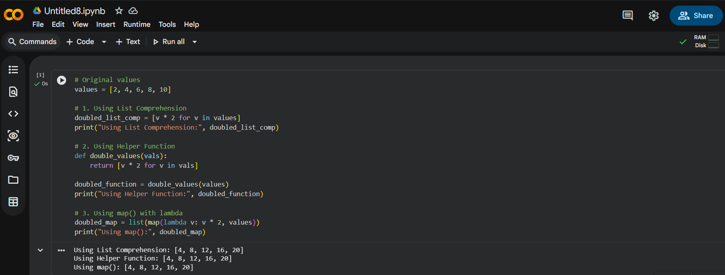
OBSERVATION:
The AI suggested replacing the explicit for loop with a list comprehension, which makes the code shorter, cleaner, and more readable. The refactored code performs the same transformation while reducing the number of lines and improving Pythonic style.

TASK-2
Analyze the following Python code that builds a sentence using string concatenation in a loop. Suggest a more efficient and readable approach while keeping the same output, and provide the improved code with a short explanation.

words = ["Refactoring", "with", "AI", "improves", "quality"]
message = ""
for w in words:
message += w + " "
print(message.strip())

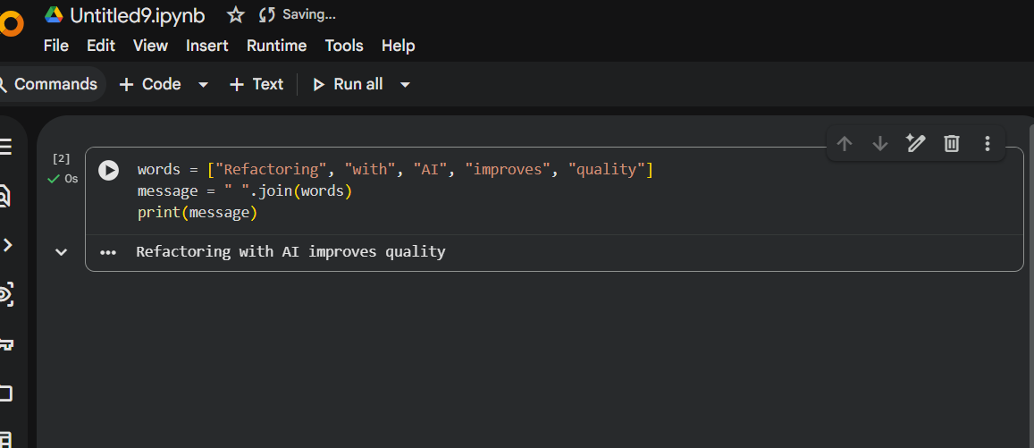
OBSERVATIONS:
The legacy code uses repeated string concatenation inside a loop, which is less efficient because strings are immutable in Python.
Using " ".join(words) is more readable and directly expresses the intention of combining words into a sentence.
The refactored code is shorter, cleaner, and easier to maintain.
The final output remains unchanged when the same word sequence is preserved.
If punctuation must appear with a preceding space exactly as shown, it should be included as a separate list element.

TASK-3
Ask the AI to review the Python code that checks for a dictionary key before accessing it and suggest a safer, more readable way to access the value while keeping the same behavior when the key is missing.
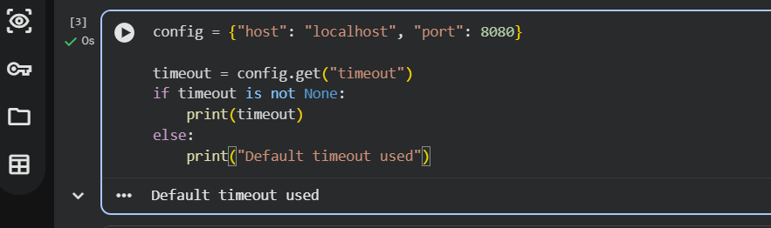

OBSERVATIONS:
dict.get() safely accesses dictionary values.
It avoids manual key checking using if key in dictionary.
Code becomes shorter, cleaner, and easier to maintain.
Behavior remains the same when the key is missing.

TASK-4
Ask the AI to review the Python code that uses multiple if–elif conditions to perform operations and suggest a cleaner, more scalable approach using a mapping technique while keeping the same functional.
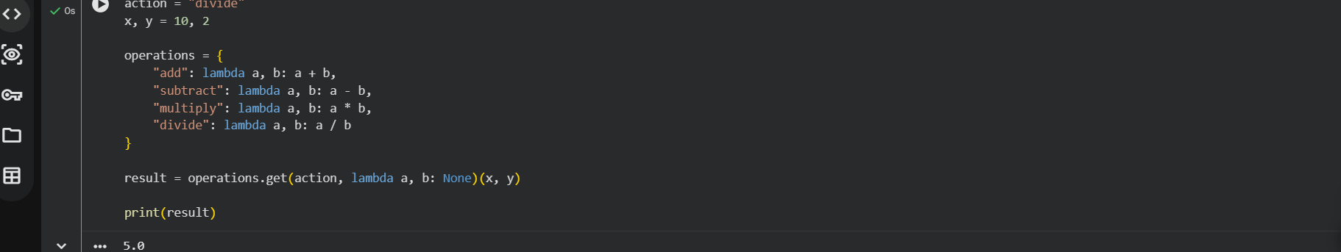
OBSERVATIONS:
Replaces long if–elif chains with a dictionary mapping.
Code becomes cleaner and easier to scale.
Adding a new operation only requires adding one entry to the dictionary.
Improves readability and maintainability.

TASK-5
Ask the AI to review the Python code that uses a manual loop to search for an item in a list and suggest a more concise and readable method while keeping the same output behavior.
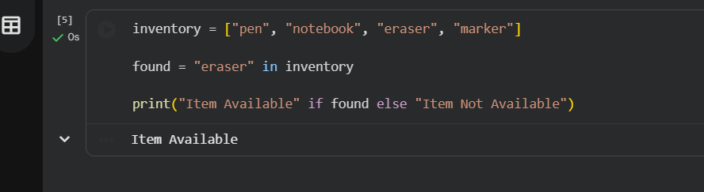
OBSERVATIONS:
Uses the in operator instead of a manual loop.
Code becomes shorter and easier to read.
Improves efficiency and clarity while keeping the same behavior.

