2303A52308
RUPALI-43
AI-CODING
ASS-5.4
TASK-1: Prompt GitHub Copilot to generate a Python script that collects
user data (e.g., name, age, email). Then, ask Copilot to add
comments on how to anonymize or protect this data.
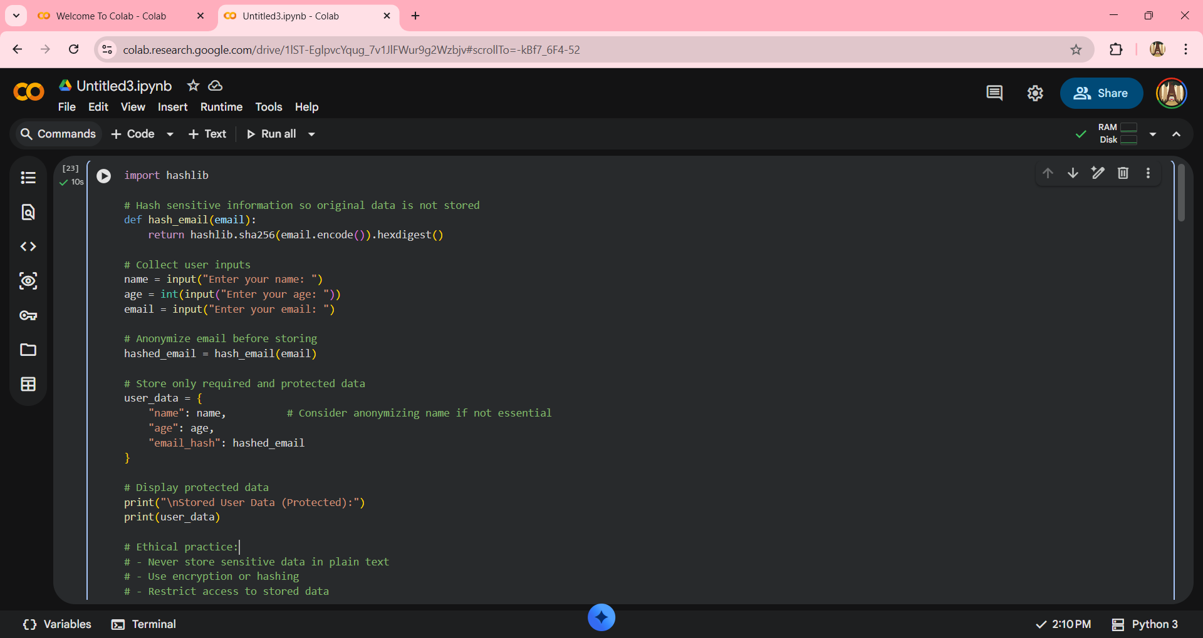
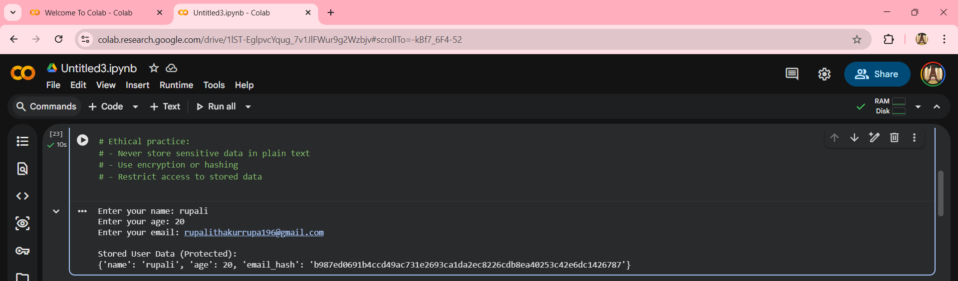

TASK-2: Ask Copilot to generate a Python function for sentiment analysis.
Then prompt Copilot to identify and handle potential biases in the
data.
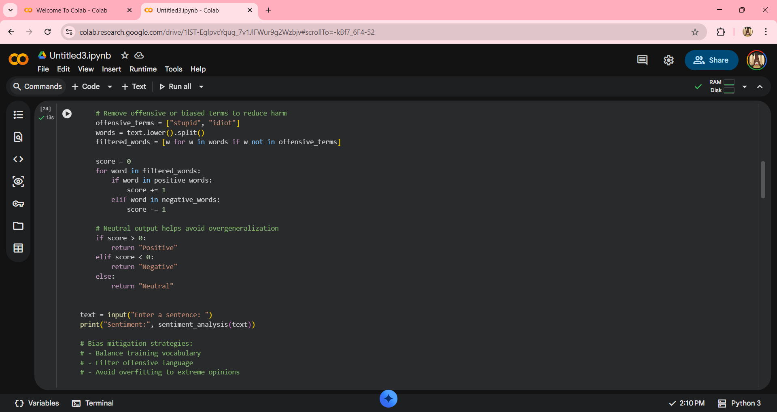
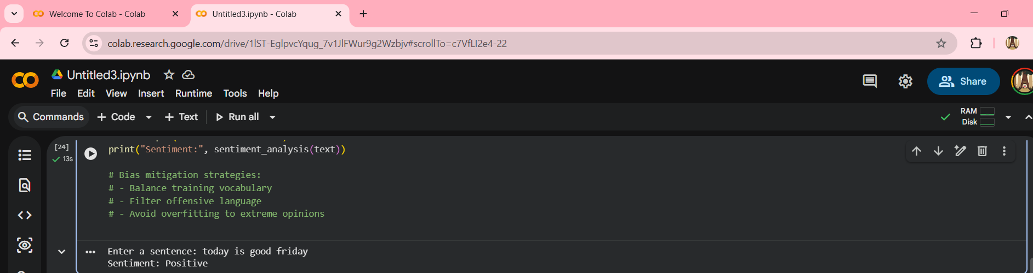

TASK-3: Use Copilot to write a Python program that recommends
products based on user history. Ask it to follow ethical guidelines
like transparency and fairness.
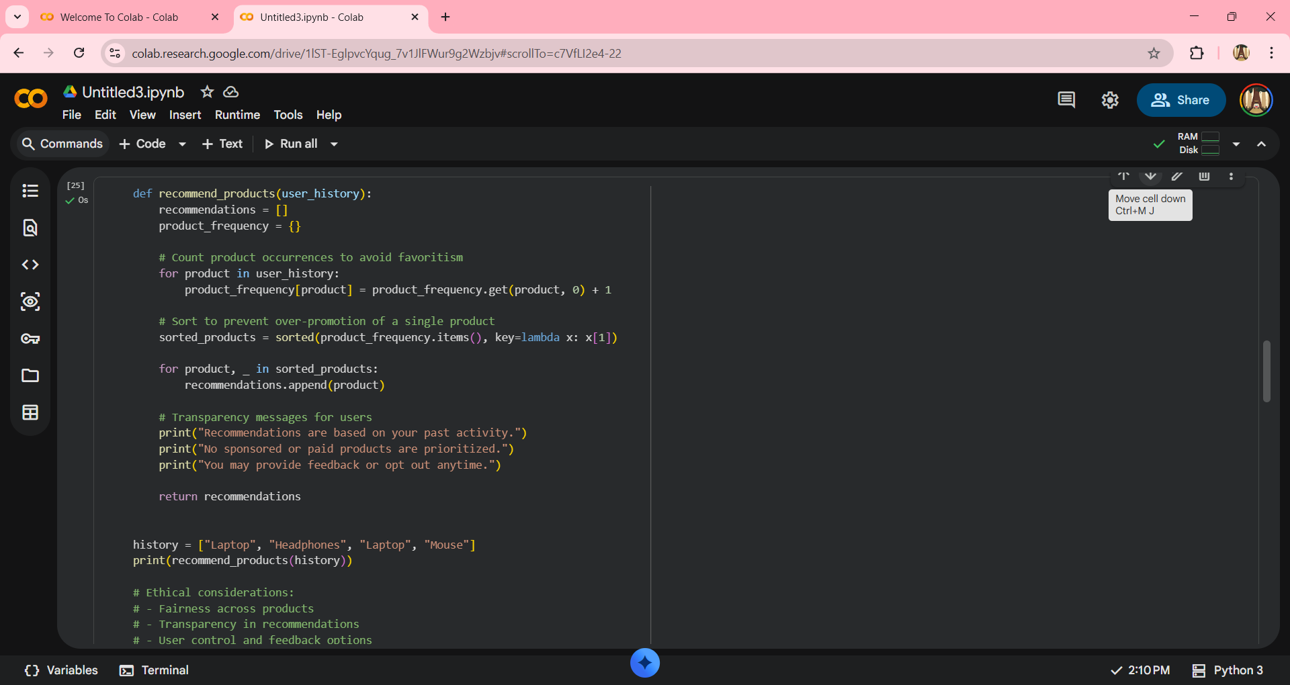
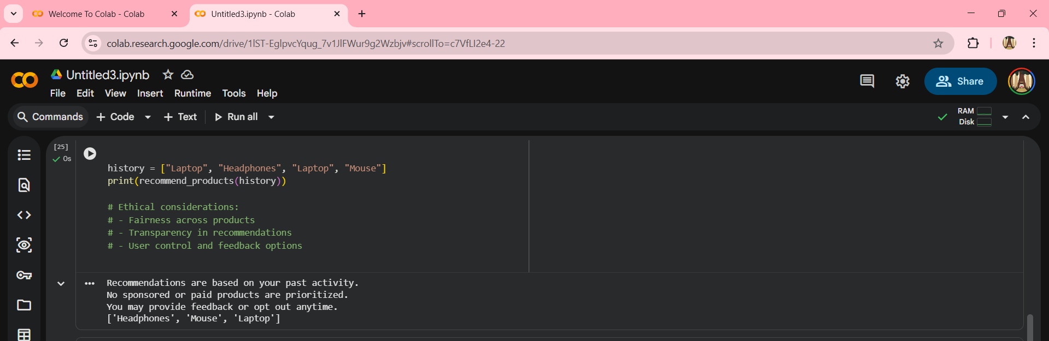

TASK-4: Prompt Copilot to generate logging functionality in a Python web
application. Then, ask it to ensure the logs do not record sensitive
information.
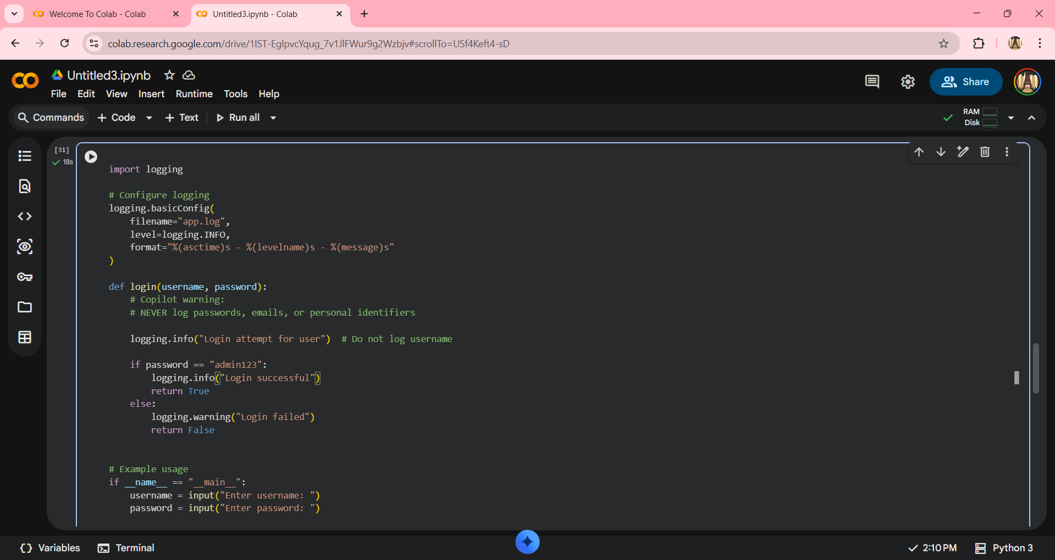
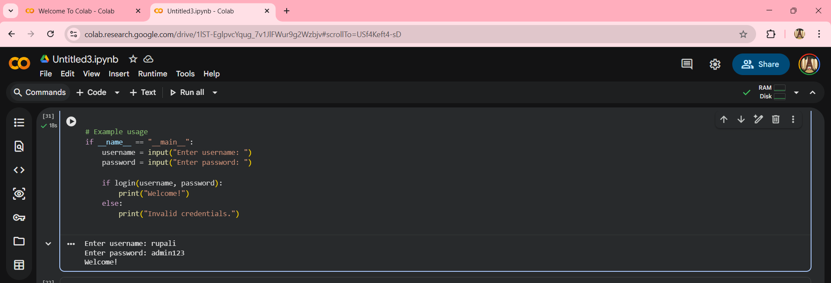

TASK:5Ask Copilot to generate a machine learning model. Then, prompt
it to add documentation on how to use the model responsibly
(e.g., explainability, accuracy limits
