AI-ASSINGMENT-12.4
RUPALI
BATCH-43
2303A52308

- Task 1: Bubble Sort for Ranking Exam Scores
🔹 Prompt Used
“Generate a Python program to implement Bubble Sort for sorting student scores. Add inline comments explaining comparisons, swaps, iteration passes, and include early termination optimization. Also provide time complexity analysis and sample input/output.”
🔹 Observations
- AI generated Bubble Sort with proper comments and early termination (swapped flag).
- Early termination reduces unnecessary passes when the list is already sorted.
- Suitable for small datasets like exam scores.
Time Complexity:
- Best Case: O(n)
- Average Case: O(n²)
- Worst Case: O(n²)
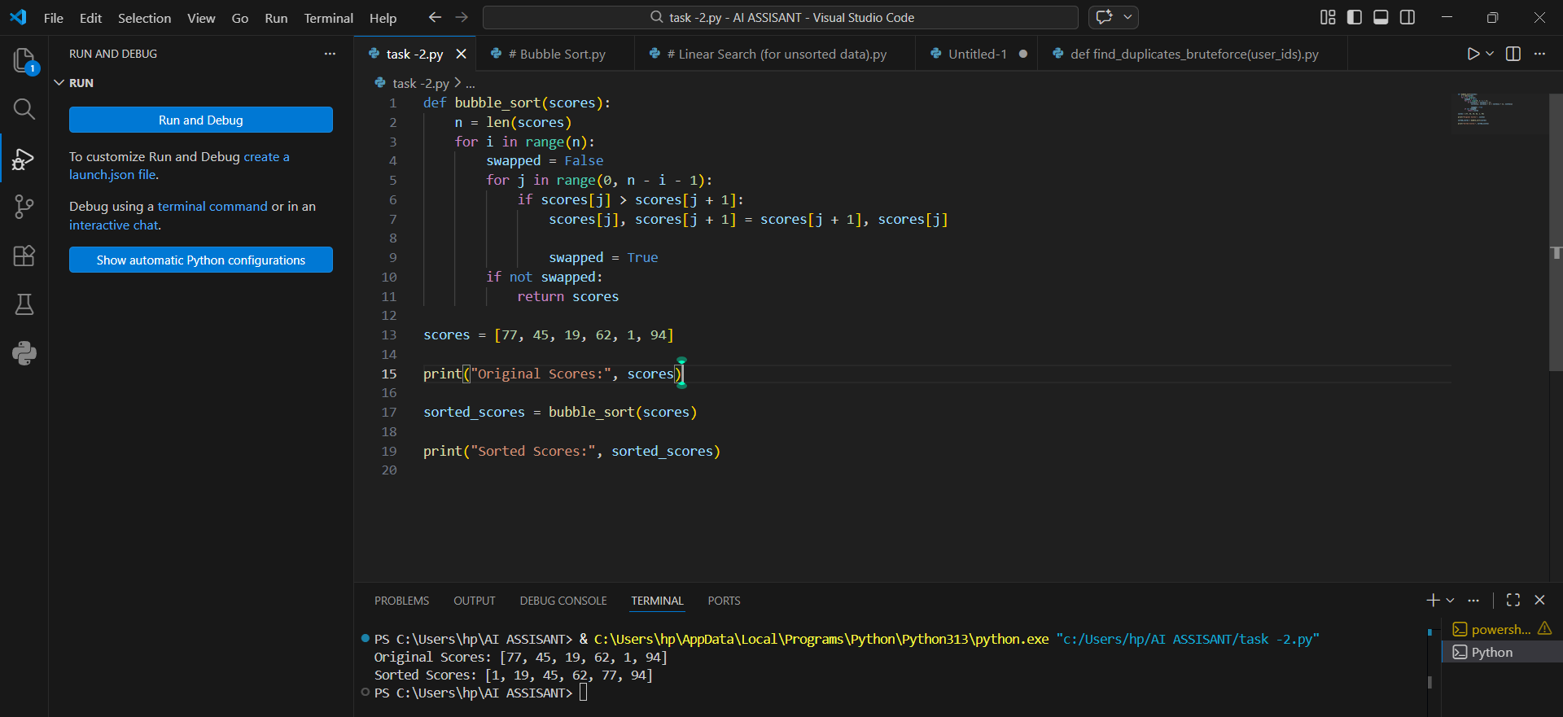

- ✅ Task 2: Improving Sorting for Nearly Sorted Attendance Records
🔹 Prompt Used
“Review Bubble Sort for nearly sorted attendance records and suggest a more efficient algorithm. Generate Insertion Sort implementation and explain why it performs better for partially sorted datasets.”
🔹 Observations
- AI suggested Insertion Sort as a better alternative.
- Insertion Sort performs fewer shifts when data is nearly sorted.
- It adapts to existing order, making it efficient for attendance records.
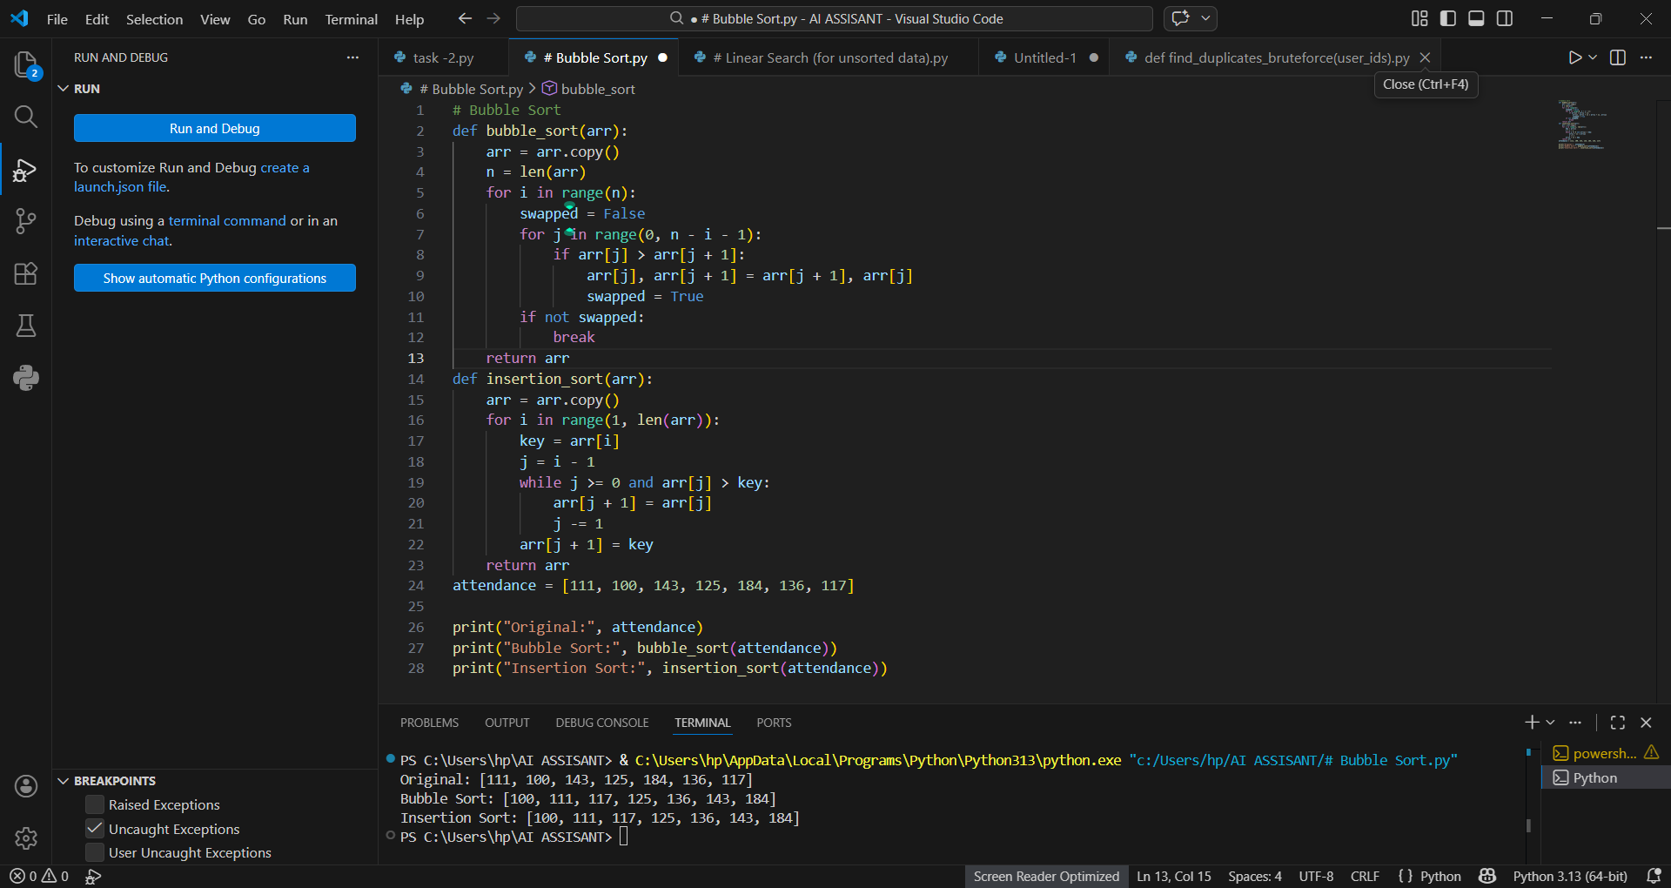

- ✅ Task 3: Searching Student Records in Database
🔹 Prompt Used
“Write Python functions for Linear Search and Binary Search with proper docstrings. Explain when Binary Search is applicable and compare their performance.”
🔹 Observations
- Linear Search works on unsorted data but checks each element.
- Binary Search requires sorted data and divides search space in half.
- Binary Search is much faster for large sorted datasets.
Time Complexity:
- Linear Search: O(n)
- Binary Search: O(log n)
Student Observation:
Binary Search is preferred for large sorted databases, while Linear Search is useful for small or unsorted lists.


- ✅ Task 4: Quick Sort vs Merge Sort
🔹 Prompt Used
“Complete recursive Quick Sort and Merge Sort implementations with meaningful docstrings. Explain recursion and compare best, average, and worst-case complexities.”
🔹 Observations
- Both algorithms use divide-and-conquer strategy.
- Quick Sort is faster on average but may degrade to O(n²).
- Merge Sort guarantees O(n log n) in all cases.
- Merge Sort requires extra memory, while Quick Sort is more space-efficient.
Conclusion:
Quick Sort is good for average performance, while Merge Sort is better when worst-case guarantee and stability are required.
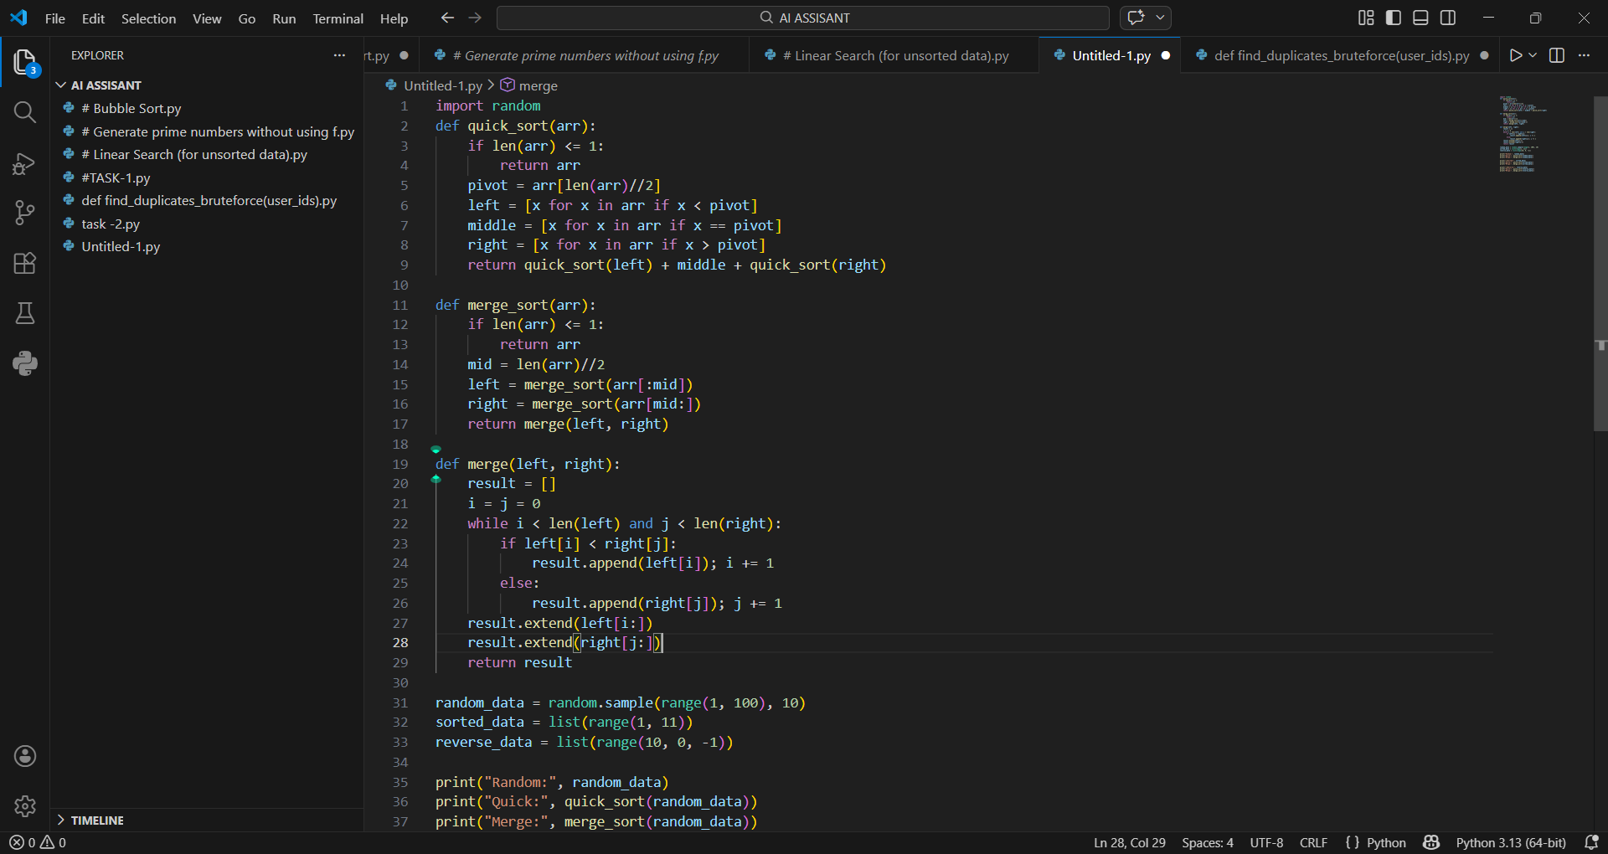
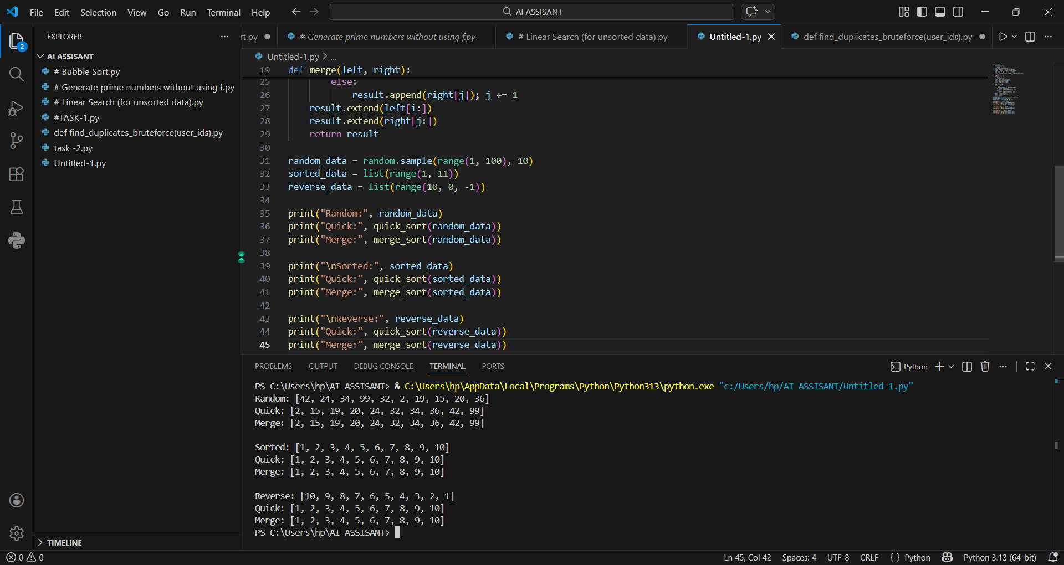

- ✅ Task 5: Optimizing Duplicate Detection Algorithm
🔹 Prompt Used
“Write a naive duplicate detection algorithm using nested loops. Analyze its time complexity and optimize it using sets or dictionaries. Compare performance for large inputs.”
🔹 Observations
- Brute-force method used nested loops (O(n²)).
- AI suggested using a set for faster lookup.
- Optimized version reduced time complexity to O(n).
- Performance improvement is significant for large datasets.
Conclusion:
Using hashing (set/dictionary) greatly improves efficiency and scalability.
