Global Vaccination Data Analysis Dashboard using Power BI
Project Documentation
Submitted By: Rupali Rathore
Step 1 – Project Setup
1.1 Project Objective
The objective of this project is to analyze global vaccination data using Python, SQL, and Microsoft Power BI and transform raw datasets into meaningful visual insights. The project focuses on understanding vaccination coverage, reported disease cases, incidence rates, vaccine introduction trends, and vaccination schedules through interactive dashboards.
The project follows a complete data analytics workflow, including data cleaning, exploratory data analysis (EDA), SQL-based analysis, and dashboard development. The final Power BI dashboard enables users to explore vaccination data interactively using filters and visualizations, making the analysis easier to understand and interpret.
1.2 Problem Statement
Global vaccination datasets contain a large amount of information collected across different countries, vaccines, and years. Analyzing this raw data directly is difficult because it contains multiple datasets, inconsistent values, and requires preprocessing before meaningful insights can be generated.
The purpose of this project is to clean, analyze, and visualize the vaccination data using modern data analytics tools. An interactive Power BI dashboard was developed to simplify the analysis and provide meaningful insights into global vaccination trends.
1.3 Tools and Technologies Used
Tool / Technology | Purpose
Python | Data cleaning and preprocessing
Pandas | Data manipulation and transformation
Jupyter Notebook | Exploratory Data Analysis (EDA)
SQL | Data analysis using queries
Microsoft Power BI | Interactive dashboard development
Microsoft Excel | Original data source
Git & GitHub | Project version control and repository management
  - Project Workflow
The project was completed by following a structured workflow from raw data collection to dashboard development.
WHO Vaccination Datasets
↓
Data Cleaning & Preprocessing (Python)
↓
Exploratory Data Analysis (Jupyter Notebook)
↓
SQL Analysis
↓
Power BI Dashboard Development
↓
Insights & Findings

Step 2 – Data Collection & Understanding
2.1 Data Source
The datasets used in this project were obtained from the World Health Organization (WHO) vaccination database. The data contains information related to vaccination coverage, reported disease cases, incidence rates, vaccine introduction, and vaccination schedules across multiple countries and years.
All datasets were initially available in Microsoft Excel format and were imported into Jupyter Notebook for preprocessing before being used in Power BI..
2.2 Datasets Used
The project uses five different datasets, where each dataset represents a specific aspect of global vaccination analysis.
Dataset Name | Purpose
Vaccination Coverage | Analyze vaccination coverage across countries and years.
Reported Cases | Analyze disease cases reported by different countries.
Incidence Rate | Study disease incidence trends.
Vaccine Introduction | Analyze vaccine introduction over different years.
Vaccine Schedule | Study vaccination schedules and target population information.
2.3 Initial Data Inspection
Before starting data preprocessing, each dataset was examined in Jupyter Notebook to understand its structure and quality. Basic inspection techniques were performed to verify column names, dataset dimensions, data types, missing values, duplicate records, and summary statistics.
This initial inspection helped identify the preprocessing steps required before analysis and dashboard development.
Step 3 – Data Cleaning & Preprocessing
3.1 Import Required Libraries
Python libraries such as Pandas, NumPy, and Matplotlib were imported to perform data preprocessing and analysis.
3.2 Loading Datasets
The five WHO vaccination datasets were imported into Jupyter Notebook using the Pandas library.
The datasets include:
- Vaccination Coverage
- Reported Cases
- Incidence Rate
- Vaccine Introduction
- Vaccine Schedule
3.3 Data Inspection
Each dataset was inspected to understand its structure before analysis.
The following checks were performed:
- Dataset dimensions
- Column names
- Data types
- Missing values
- Duplicate records
- Summary statistics
3.4 Dataset-wise Preprocessing
Different preprocessing steps were applied depending on the characteristics of each dataset.
Vaccination Coverage Dataset
- Checked missing values.
- Verified data types.
- Used a filtered dataset for visualization because some vaccination coverage values were greater than 100%, which affected graphical representation.
The filtered dataset was created only for visualization purposes.
coverage_plot = coverage_df[
coverage_df["COVERAGE"] <= 100
]
Reported Cases Dataset
- Inspected missing values.
- Verified column names and data types.
- Prepared the dataset for exploratory data analysis.
Incidence Rate Dataset
- Checked data quality.
- Verified numerical fields.
- Prepared the dataset for visualization.
Vaccine Introduction Dataset
- Inspected the dataset structure.
- Verified year-related information.
- Prepared the dataset for trend analysis.
Vaccine Schedule Dataset
- Examined schedule-related information.
- Identified missing records for specific years.
- Prepared the dataset for dashboard development.
3.5 Export Clean Data
After preprocessing, the datasets were used for Exploratory Data Analysis (EDA), SQL analysis, and Power BI dashboard development.

Step 4 – Exploratory Data Analysis (EDA)
4.1 Overview
After completing data preprocessing, Exploratory Data Analysis (EDA) was performed to understand the characteristics, distribution, and trends present in the datasets. EDA helped identify patterns, detect inconsistencies, and generate meaningful insights before developing the Power BI dashboard.
The analysis was performed separately for each dataset using Python libraries such as Pandas and Matplotlib.
4.2 Vaccination Coverage Analysis
The Vaccination Coverage dataset was analyzed to understand the distribution of vaccination coverage across different countries and years.
During visualization, it was observed that some coverage values were greater than 100%, which affected the graphical representation. Therefore, a filtered dataset was created specifically for visualization while preserving the original dataset.
The analysis included:
- Distribution of vaccination coverage.
- Coverage trends across different years.
- Identification of unusual coverage values.
- Summary statistics of vaccination coverage.
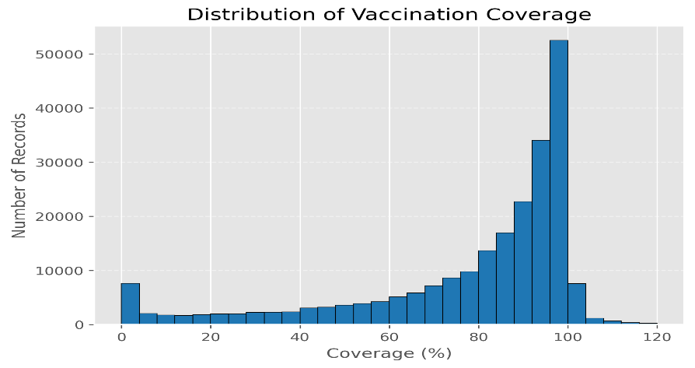

4.3 Reported Cases Analysis
The Reported Cases dataset was explored to understand disease occurrence across different countries and years.
The analysis focused on identifying countries with a higher number of reported cases and understanding overall reporting trends.
The following analyses were performed:
- Country-wise reported cases.
- Distribution of reported cases.
- Summary statistics.
4.4 Incidence Rate Analysis
The Incidence Rate dataset was analyzed to examine disease incidence trends across multiple countries.
The exploratory analysis helped understand the variation in disease incidence and identify countries with comparatively higher incidence rates.
The analysis included:
- Incidence rate distribution.
- Country-wise comparison.
- Trend observation.
4.5 Vaccine Introduction Analysis
The Vaccine Introduction dataset was analyzed to understand the timeline of vaccine introduction across different countries.
The analysis helped identify vaccine introduction patterns and year-wise trends.
The analysis included:
- Year-wise vaccine introduction.
- Country-wise vaccine introduction.
- Trend analysis.
4.6 Vaccination Schedule Analysis
The Vaccination Schedule dataset was explored to understand the recommended vaccination schedules.
During analysis, it was observed that data for certain years was unavailable, which was considered during dashboard development.
The analysis included:
- Vaccination schedule information.
- Year availability.
- Data completeness check.
4.7 Summary of EDA
The exploratory data analysis helped identify important observations before developing the Power BI dashboard.
The key findings are summarized below:
- Vaccination coverage contained values greater than 100%. Therefore, a filtered dataset was created specifically for visualization purposes.
- The Vaccination Schedule dataset did not contain records for the year 2020.
- Exploratory analysis helped understand vaccination coverage, reported cases, incidence rates, vaccine introduction trends, and vaccination schedules across different datasets.
- These observations were considered while selecting appropriate visualizations and designing the interactive dashboard.

Step 5 – SQL Analysis
5.1 Purpose of SQL Analysis
After completing data preprocessing and exploratory data analysis, SQL was used to perform structured data analysis on the cleaned datasets. SQL queries helped retrieve meaningful information, summarize records, and validate the datasets before dashboard development.
The analysis was performed using SQLite and focused on answering important business questions related to vaccination data.
5.2 SQL Operations Performed
The following SQL operations were performed during the project:
- Viewing dataset records.
- Counting total records.
- Filtering data based on specific conditions.
- Grouping records using GROUP BY.
- Sorting data using ORDER BY.
- Performing aggregate calculations using COUNT(), SUM(), and AVG().
- Identifying country-wise and year-wise trends.
5.3 SQL Analysis Outcomes
The SQL queries helped in:
- Understanding the distribution of vaccination data.
- Summarizing records across different datasets.
- Supporting exploratory data analysis.
- Verifying data before importing it into Power BI.
- Providing meaningful insights for dashboard visualizations.

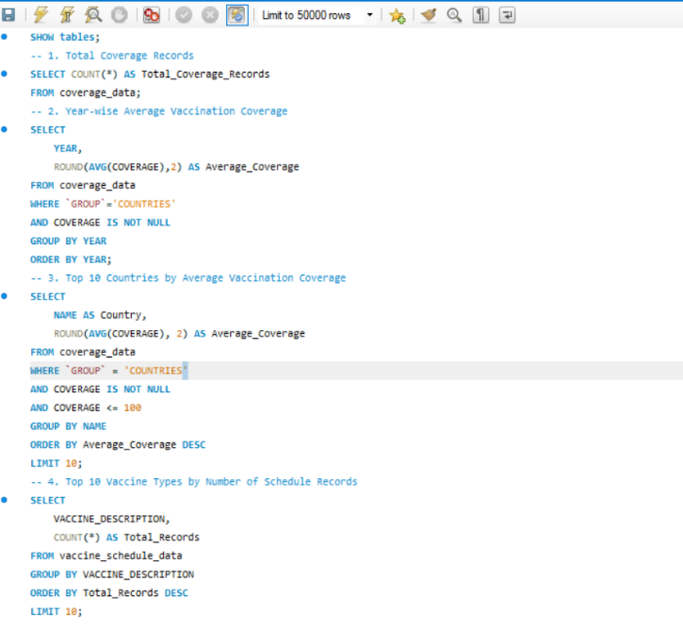

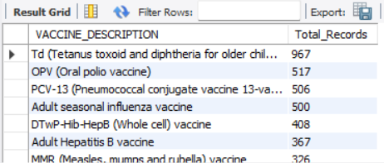
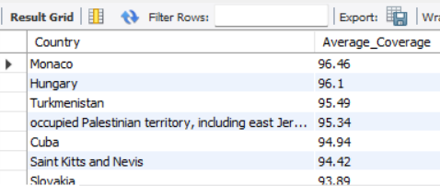
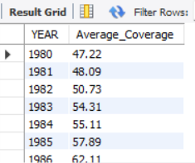
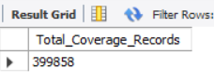

Step 6 – Power BI Dashboard Development
6.1 Dashboard Overview
After completing data preprocessing, exploratory data analysis, and SQL analysis, an interactive Power BI dashboard was developed to visualize vaccination-related insights.
The dashboard was designed to provide a clear understanding of vaccination coverage, disease incidence, reported cases, vaccine introduction, and vaccination schedules through interactive visualizations and slicers.
The dashboard consists of three report pages, each focusing on a different aspect of the analysis.
6.2 Executive Dashboard
The Executive Dashboard provides an overall summary of the vaccination datasets.
The page includes:
- KPI Cards
- Interactive slicers
- Vaccination coverage trend
- Disease incidence trend
- Reported cases trend
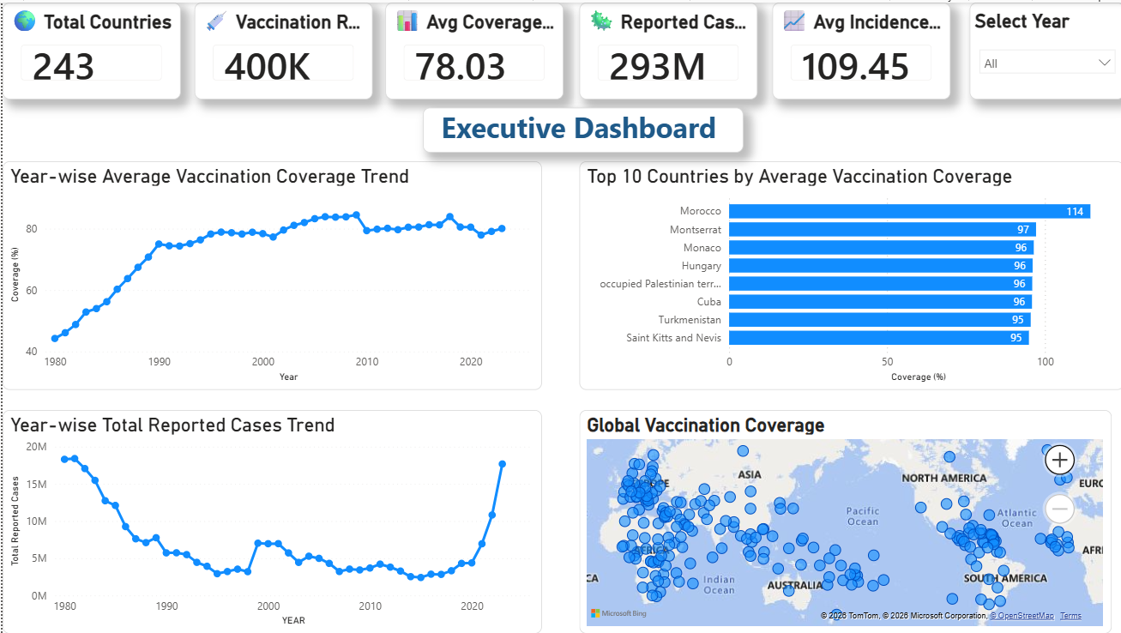
The dashboard allows users to filter the data using Year and Country, making the analysis interactive and user-friendly.

6.3 Disease & Incidence Analysis
This dashboard focuses on disease-related information.
The visualizations include:
- Disease-wise reported cases
- Disease incidence trends
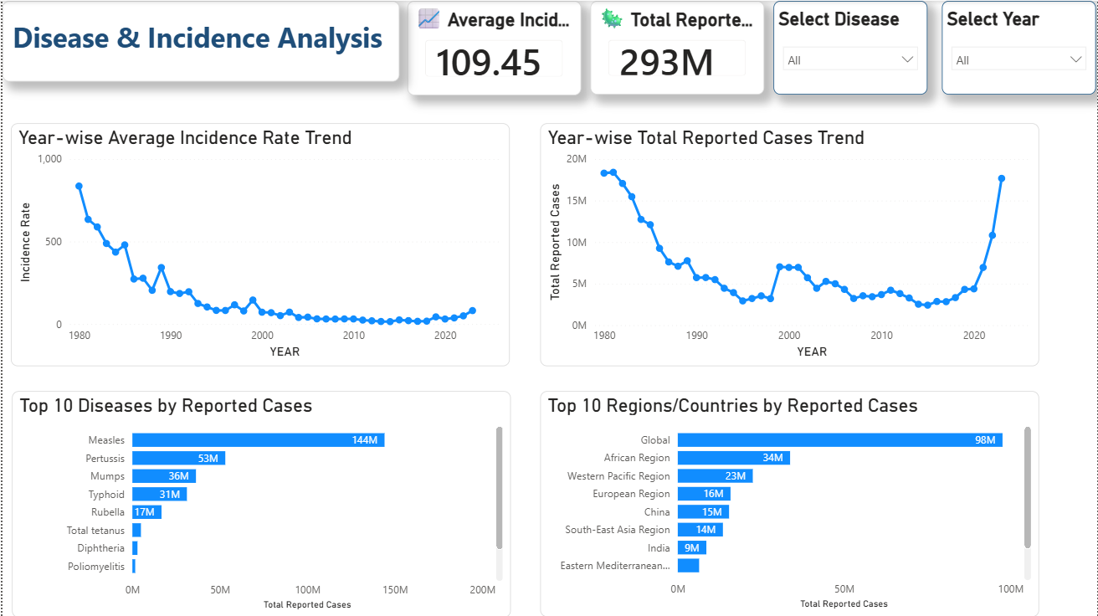
- Country-wise comparison
- Year-wise analysis
Interactive filters enable users to explore disease patterns across different years and countries.
6.4 Vaccine Coverage & Insights Analysis
This dashboard presents insights related to vaccination coverage and vaccine information.
The page includes:
- Vaccination coverage distribution
- Vaccine-wise analysis
- Vaccination trends
- Coverage comparison across different years
Interactive slicers allow users to analyze vaccination performance based on vaccine type and year.
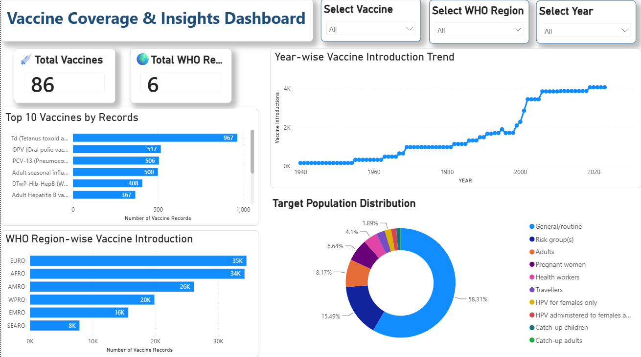

6.5 Dashboard Features
The dashboard includes the following interactive features:
- Interactive slicers for Year, Country, Vaccine, and WHO Region.
- Dynamic KPI cards.
- Interactive charts and graphs.
- Clean and user-friendly layout.
- Cross-filtering between visualizations.
- Consistent color theme across all report pages.

Step 7 – Challenges Faced and Solutions Implemented
During the development of this project, several challenges were encountered while preprocessing the datasets and developing the Power BI dashboard. These challenges were carefully analyzed and resolved to ensure accurate analysis and meaningful visualizations.
Challenge 1: Invalid Vaccination Coverage Values
Issue
While analyzing the Vaccination Coverage dataset, some records contained coverage values greater than 100% (up to approximately 3200%). These values distorted the histogram and other visualizations, making it difficult to interpret the actual distribution of vaccination coverage.
Solution
Instead of modifying the original dataset, a filtered dataset (coverage_plot) was created specifically for visualization by considering only coverage values less than or equal to 100%. This preserved the original data while producing meaningful visualizations.
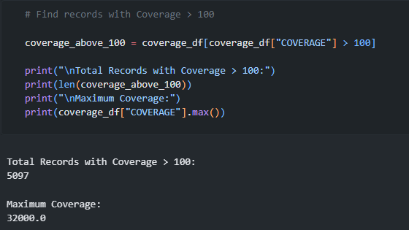
Challenge 2: Missing Year in Vaccination Schedule Dataset
Issue
During the analysis of the Vaccination Schedule dataset, it was observed that records for the year 2020 were not available. This resulted in gaps during year-wise analysis.
Solution
The missing year was documented and considered while designing the dashboard. The visualizations were created using the available data without introducing any artificial values.
Challenge 3: Limited Variation in Reported Cases Visualization
Issue
The Year slicer produced clear changes in the Average Vaccination Coverage Trend, but very little visible change in the Reported Cases visualization. This occurred because the reported case values were comparatively large and the year-to-year variation was relatively small.
Solution
The slicer functionality was verified and confirmed to be working correctly. The visualization was retained because it accurately represented the available data, even though the visual difference across years was minimal.
Challenge 4: Dashboard Layout and Visual Selection
Issue
While developing the Vaccine Insights & Coverage Dashboard, the visualization "Top 10 Countries by Vaccine Records" was initially created. However, it was observed that almost every country had nearly the same number of vaccine records, making the chart less informative and difficult to interpret.
Solution
To improve the dashboard, the chart was replaced with the Year-wise Vaccine Introduction Trend line chart. This visualization provided a clear view of how vaccine introduction changed over time and offered more meaningful insights to users.
Step 8 – Key Insights
8.1 Key Insights
The analysis of the WHO vaccination datasets provided several important insights regarding global vaccination trends and disease statistics.
The major findings of the project are summarized below:
- Vaccination coverage has generally improved over the years, indicating continuous efforts toward increasing immunization worldwide.
- A significant number of vaccination coverage records contained values greater than 100%, highlighting the importance of data validation before visualization.
- The Reported Cases and Incidence Rate datasets showed noticeable variations across different diseases and countries.
- Vaccine introduction trends varied across different years, reflecting the gradual adoption of new vaccines.
- The Vaccination Schedule dataset did not contain records for the year 2020, which was considered during analysis.
- Interactive Power BI dashboards made it easier to compare vaccination coverage, disease incidence, reported cases, and vaccine introduction using dynamic filters and visualizations.
8.2 Project Outcomes
The developed dashboard successfully provides:
- Interactive analysis of vaccination-related datasets.
- Easy comparison of vaccination trends across multiple years.
- Disease and incidence monitoring through interactive charts.
- Vaccine introduction analysis using year-wise visualizations.
- User-friendly filtering through slicers for better decision-making.

Step 9 – Conclusion
9.1 Conclusion
This project successfully analyzed multiple WHO vaccination datasets using Python, SQL, and Power BI to gain meaningful insights into global vaccination trends, disease incidence, reported cases, vaccine introduction, and vaccination schedules.
The datasets were preprocessed, analyzed through exploratory data analysis (EDA), and further examined using SQL queries. Finally, interactive Power BI dashboards were developed to present the findings in a clear and user-friendly manner.
The project achieved its primary objectives by:
- Cleaning and preprocessing vaccination datasets.
- Performing exploratory data analysis to identify important trends and patterns.
- Using SQL to retrieve meaningful insights from multiple datasets.
- Developing interactive Power BI dashboards for effective data visualization.
- Identifying and resolving data-related challenges during analysis.
Overall, the project demonstrates how data analytics and business intelligence tools can be combined to transform raw healthcare data into meaningful visual insights that support better understanding and decision-making.
9.2 Future Scope
The project can be further enhanced by incorporating additional datasets and advanced analytical techniques.
Possible future improvements include:
- Integration of real-time WHO vaccination data.
- Predictive analysis using Machine Learning models.
- Development of advanced forecasting dashboards.
- Addition of more interactive filters and drill-through reports in Power BI.
- Deployment of the dashboard as an online reporting solution for wider accessibility.

