Name: Mrs. Rupali N Hosmani.

Course: Executive Post Graduate Certification in Cloud Computing

Contact No. 7720003531

**Assignment 1: GIT Case study**

**Task To Be performed:**

1. Suggest a Git workflow architecture .

2. Simulate this workflow by creating pseudo code files and branches and upload the same to your GitHub account.

3. As a part of the solution, share the link to your GitHub repository.

Steps:

1.Create EC2 ubuntu instance,connect & update the system.

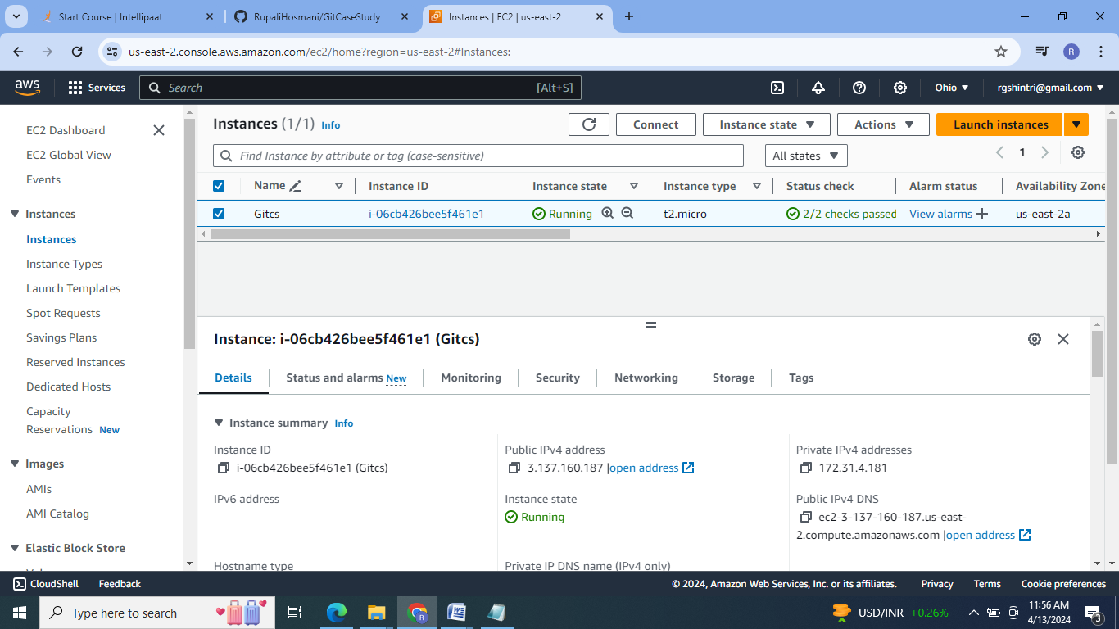

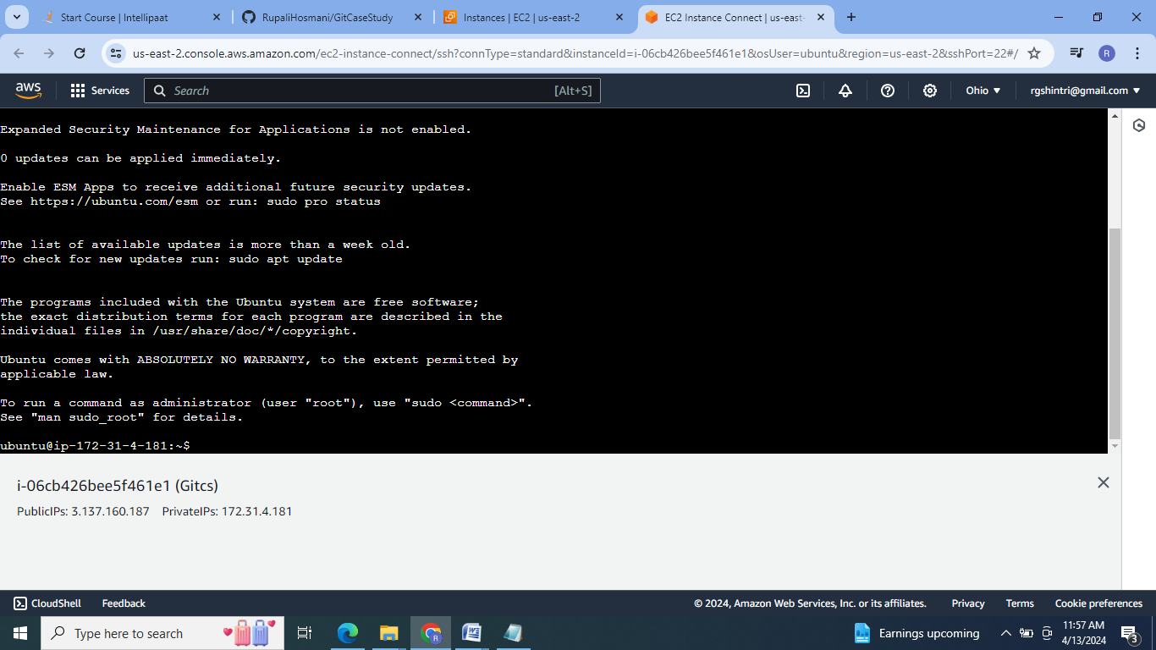

2.Make a new directory , Initialize git, create a new file one.txt ,addd & cimmit it which will be in the master branch.

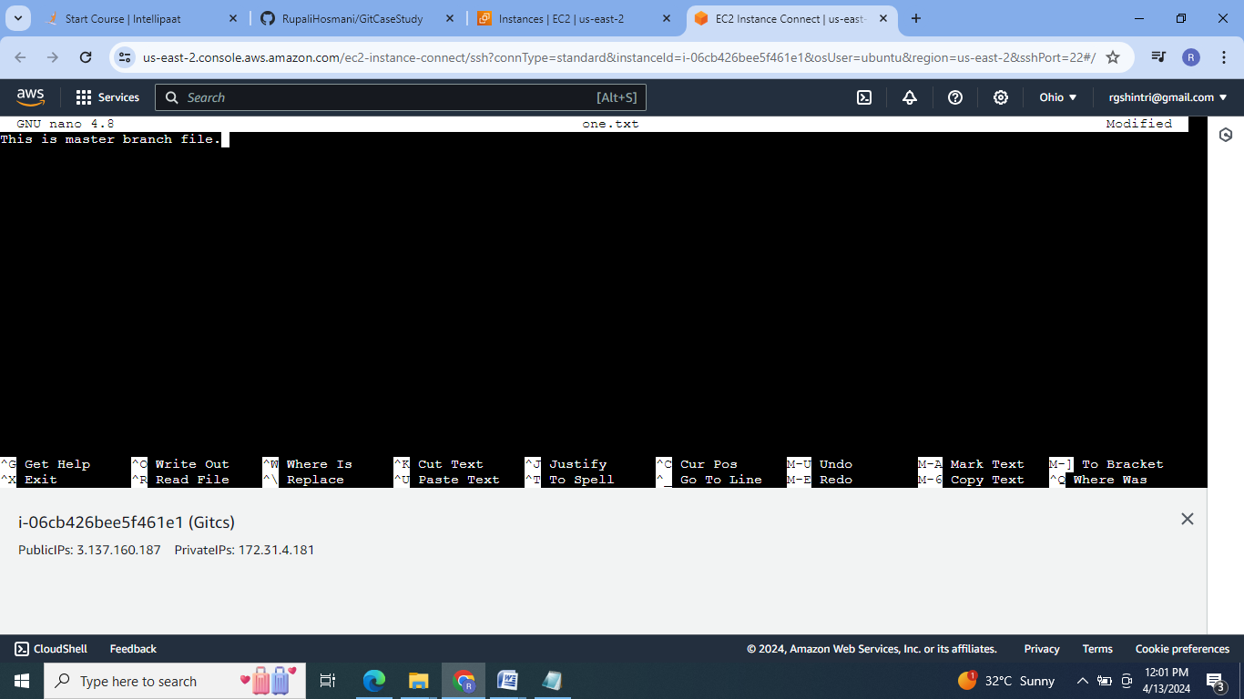

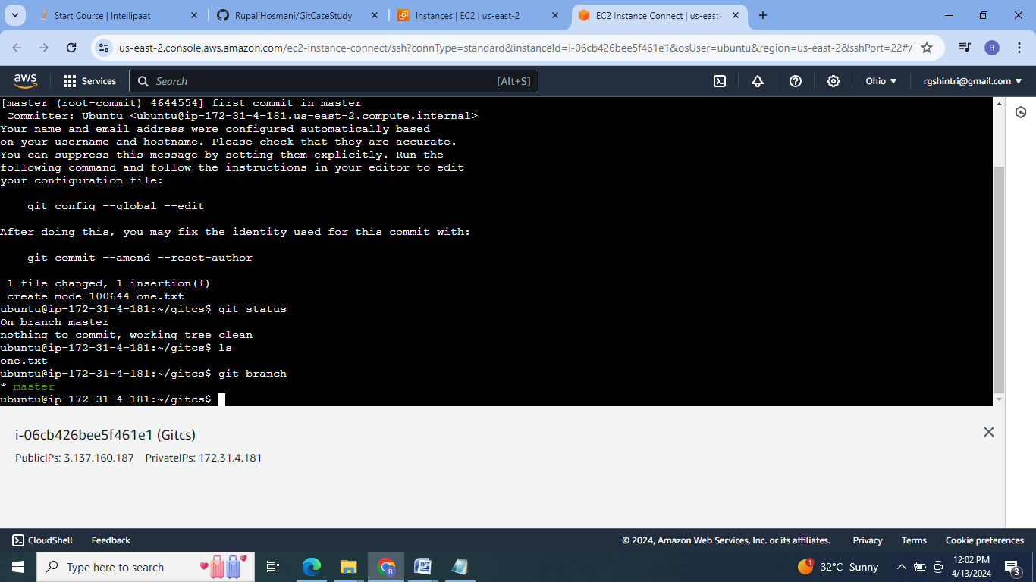

3.Create two more branches as develop & feature:

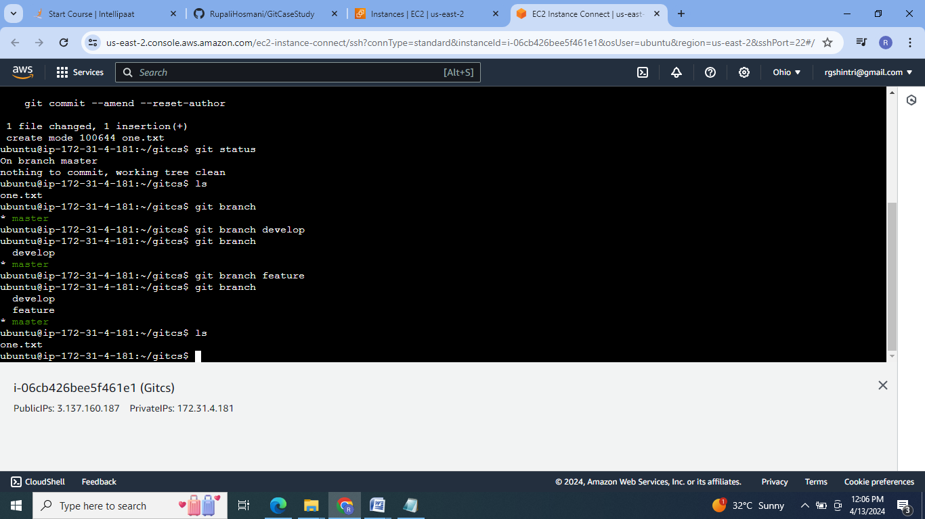

4.Create two.txt in feature branch & merge it with develop.

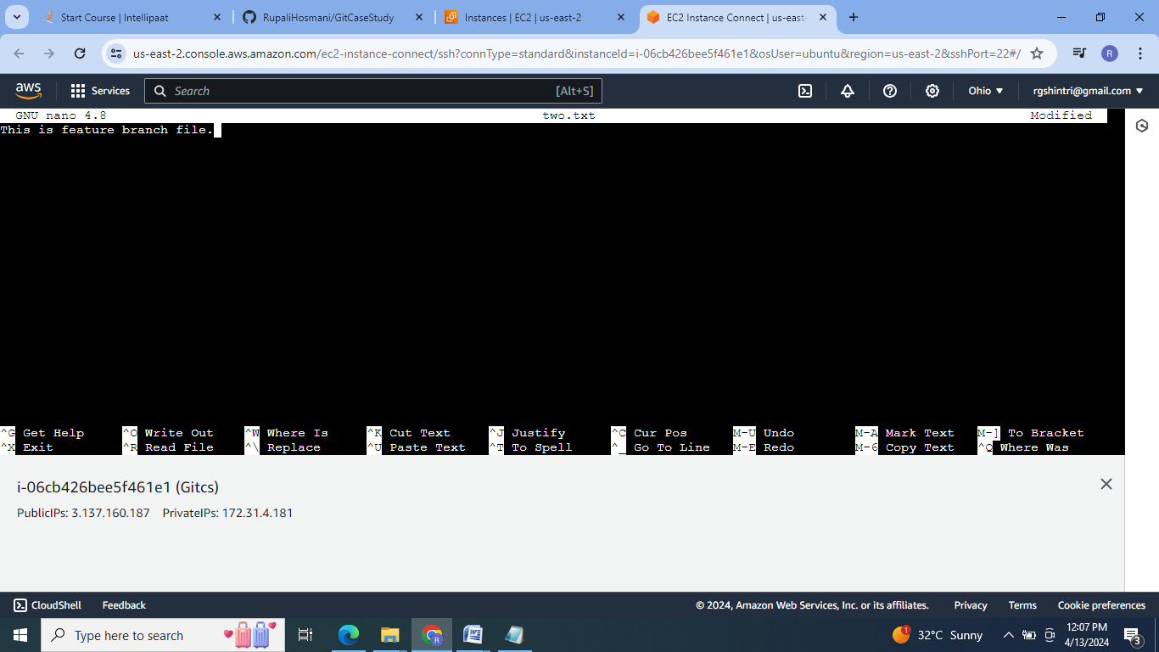

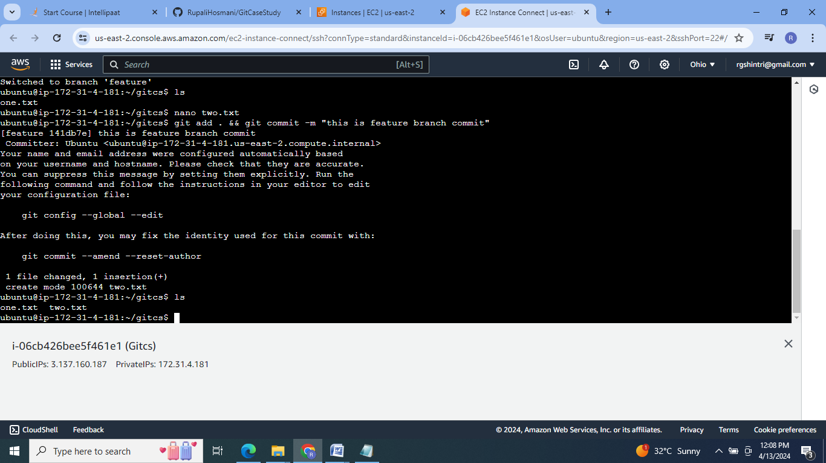

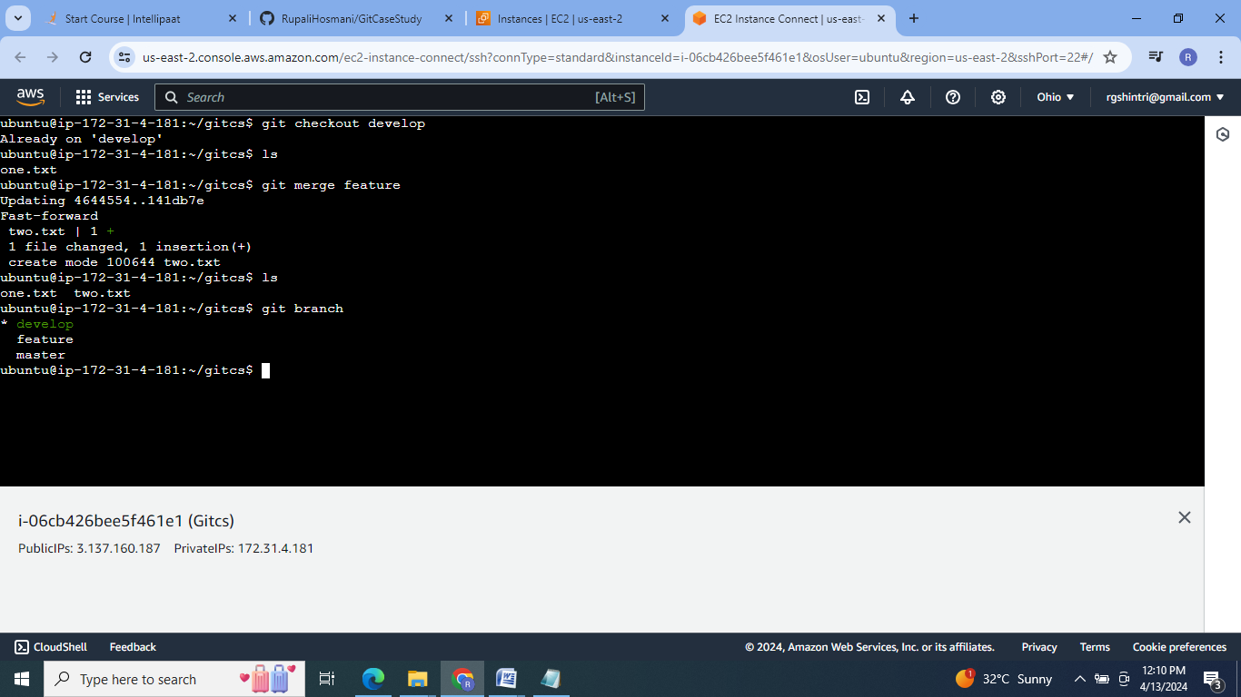

5. Create three.txt on develop branch & merge it with master branch.

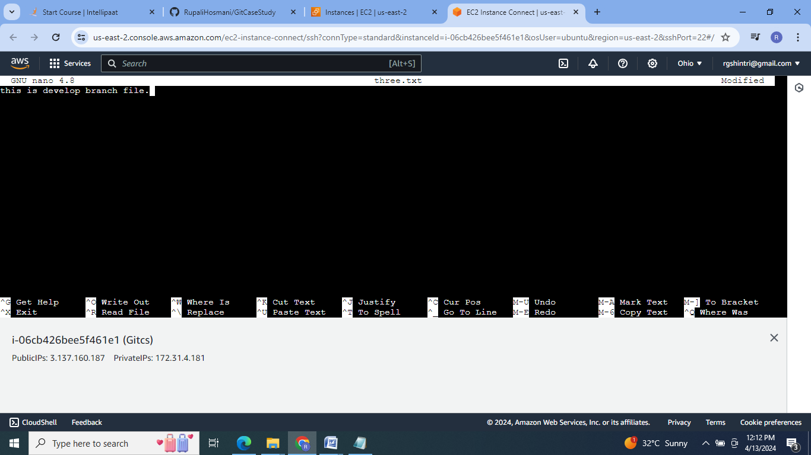

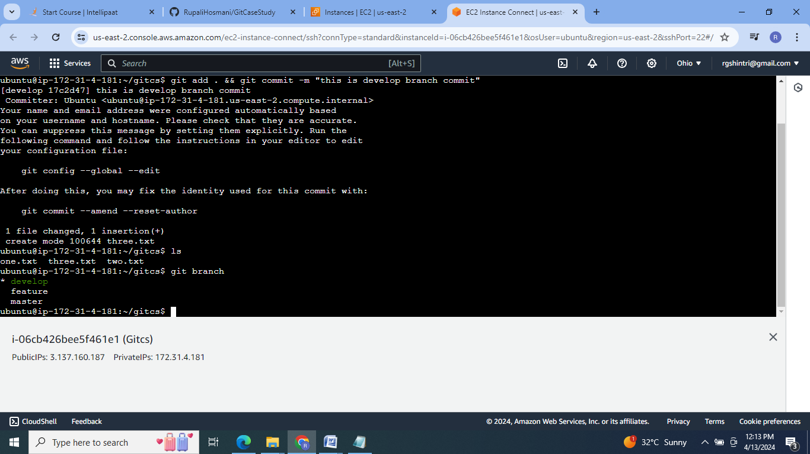

6.Merge develop branch to master branch:

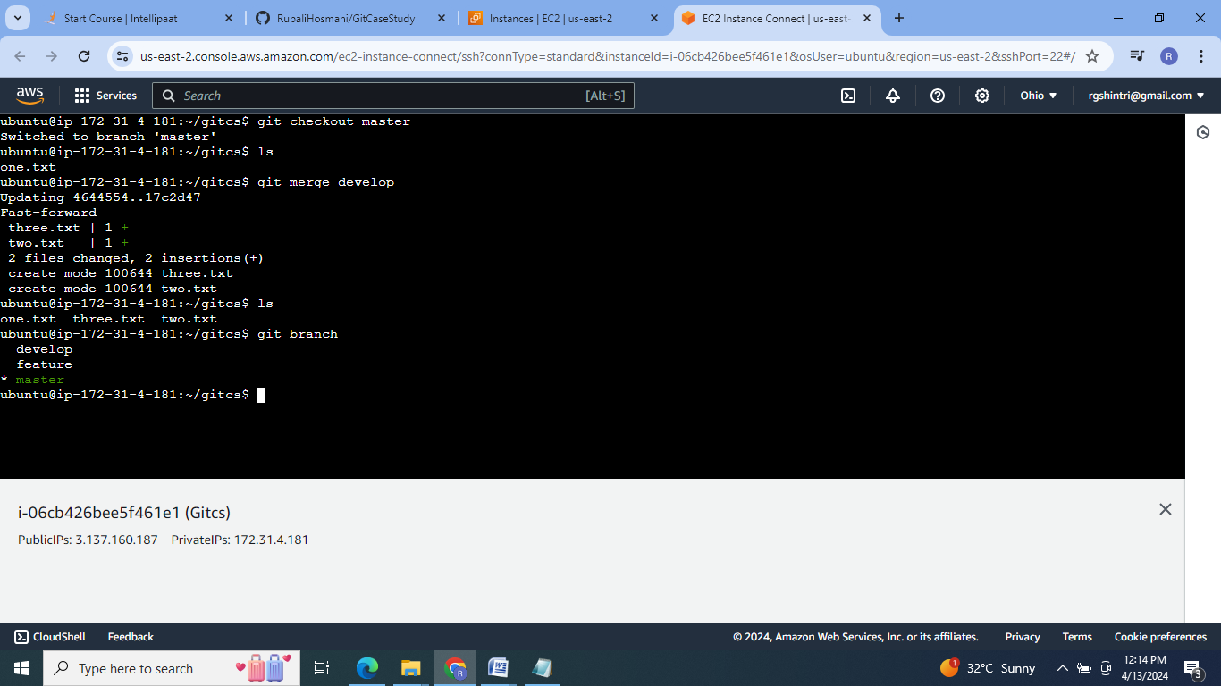

7. Push these changes to git hub repository:

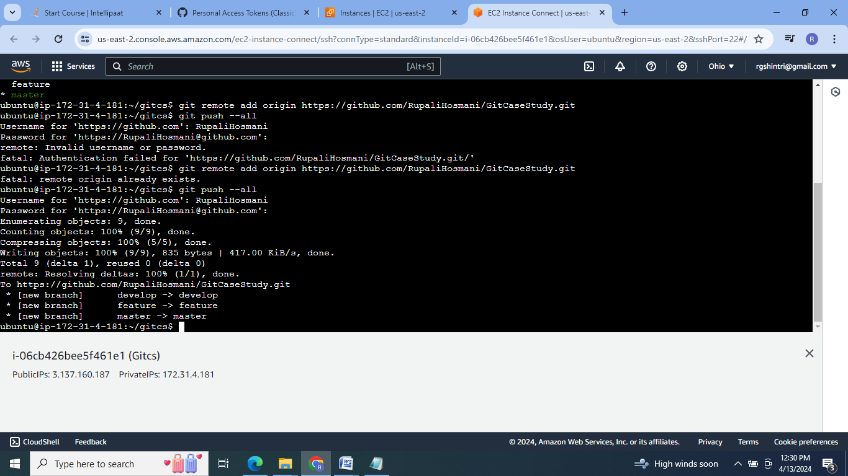

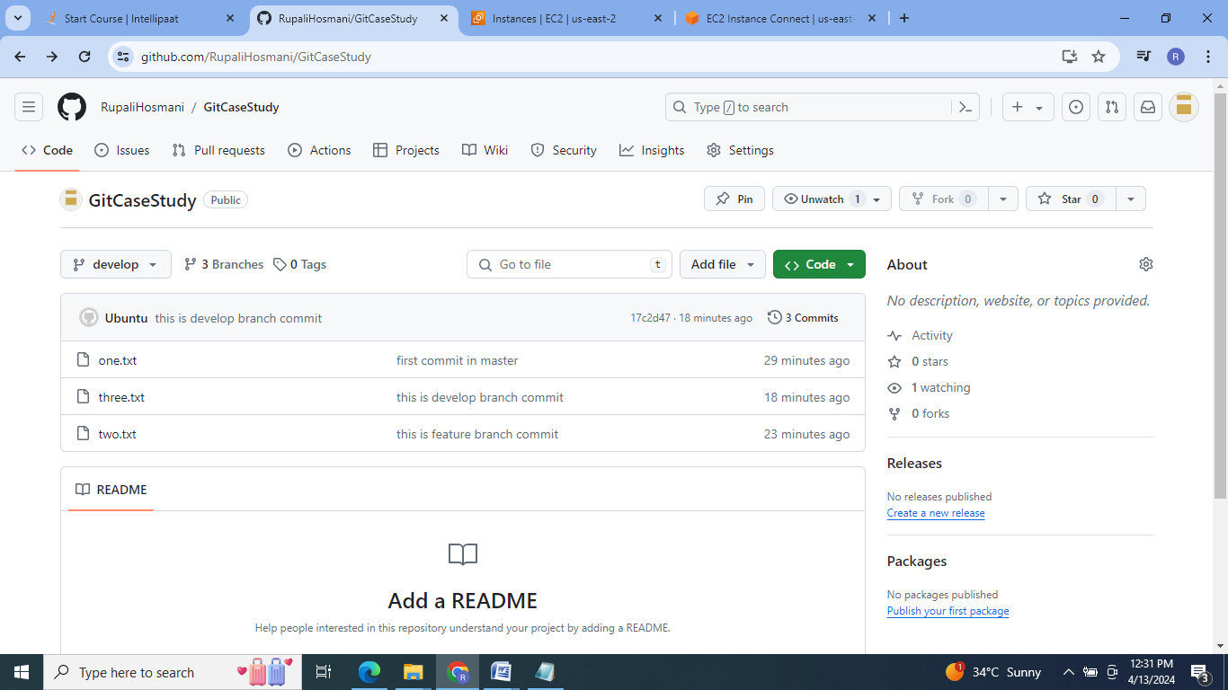

Github link: <https://github.com/RupaliHosmani/GitCaseStudy.git>

Git Commands :

1 sudo apt update

2 clear

3 mkdir gitcs

4 cd gitcs

5 git init

6 nano one.txt

7 git add . && git commit -m "first commit in master"

8 git status

9 ls

10 git branch

11 git branch develop

12 git branch

13 git branch feature

14 git branch

15 ls

16 git checkout feature

17 ls

18 nano two.txt

19 git add . && git commit -m "this is feature branch commit"

20 ls

21 git ckeckout develop

22 git checkout develop

23 clear

24 git checkout develop

25 ls

26 git merge feature

27 ls

28 git branch

29 clear

30 git branch

31 nano three.txt

32 git add . && git commit -m "this is develop branch commit"

33 ls

34 git branch

35 clear

36 git checkout master

37 ls

38 git merge develop

39 ls

40 git branch

41 git remote add origin https://github.com/RupaliHosmani/GitCaseStudy.git

42 git push --all

43 git remote add origin https://github.com/RupaliHosmani/GitCaseStudy.git

44 git push --all

45 history

**Conclusion:**  Git workflow is the recommendation of using the Git to accomplish work in consistent & productive manner.

