Name: Mrs. Rupali N Hosmani.

Course: Executive Post Graduate Certification in Cloud Computing

Contact No. 7720003531

**Assignment 5: Case Study-Ansible**

**Task To Be performed:**

1. Create two Server Groups. One for Apache and another for Nginx.

2. Push two html files with their server information. Start the services once the installation is done.

3. Also send post installation messages for both the server groups. Using Ansible Roles accomplish the above the tasks.

4. Also, once the Apache server configuration is done you need to install Java on that server group using ansible role in a playbook.

Steps:

1.Create the 3 EC2 instances.

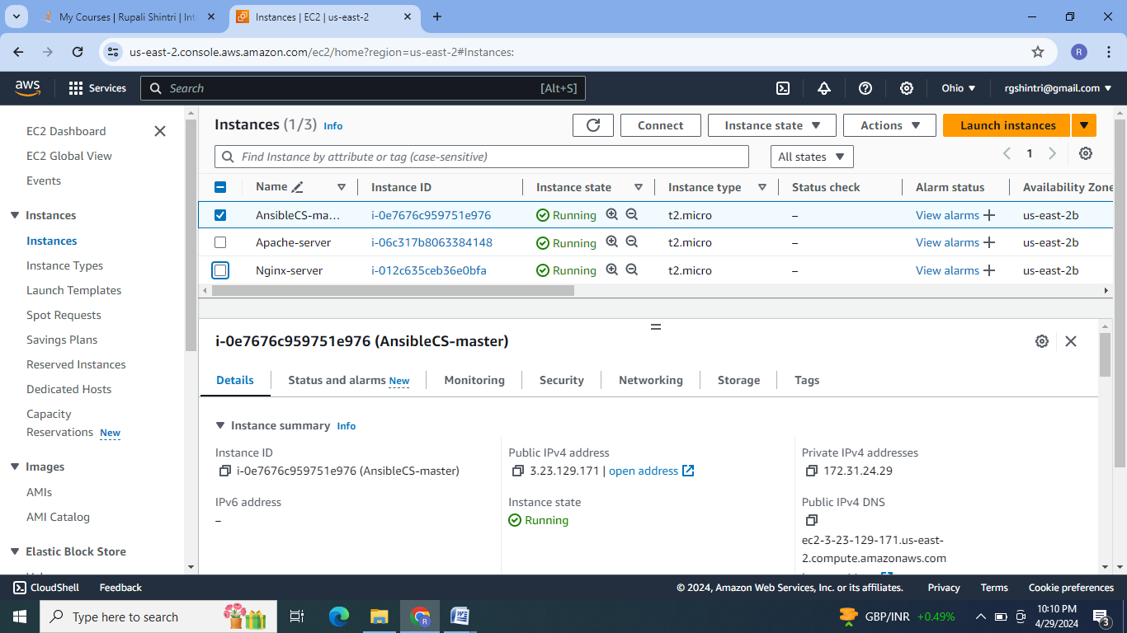

2.Make one EC2 instance as a Ansible master by installing Ansible. Other two instances will work as Apache-Server &Nginx- Server. Establish the connection between master & servers by ssh-keygen to form the cluster.

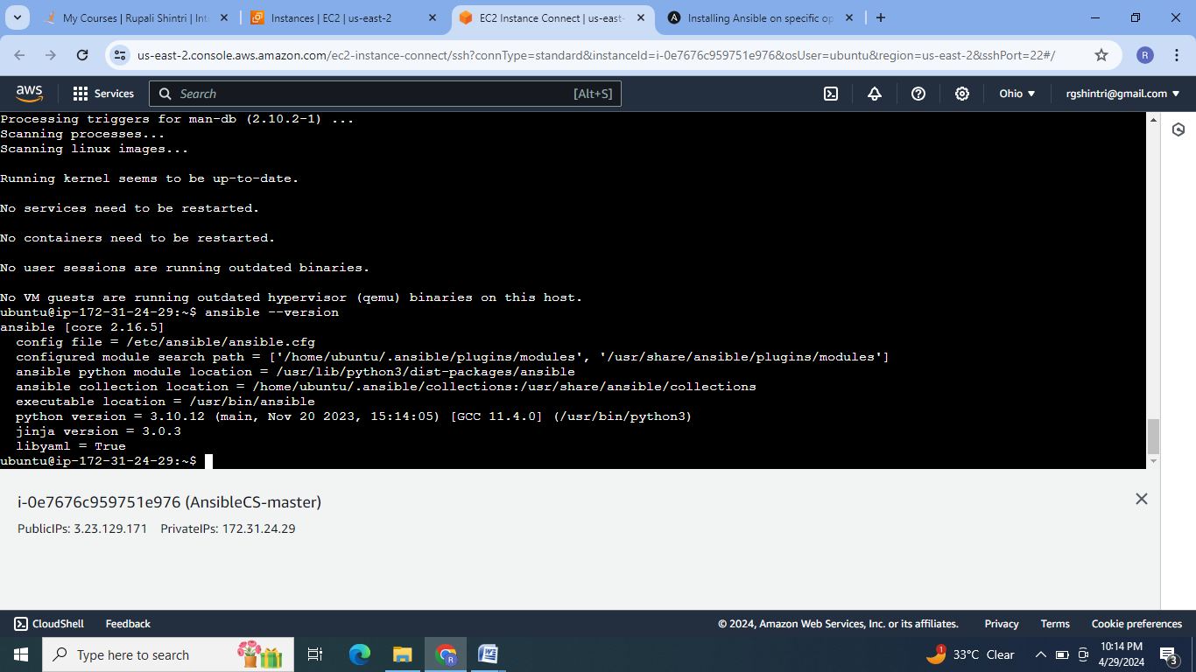

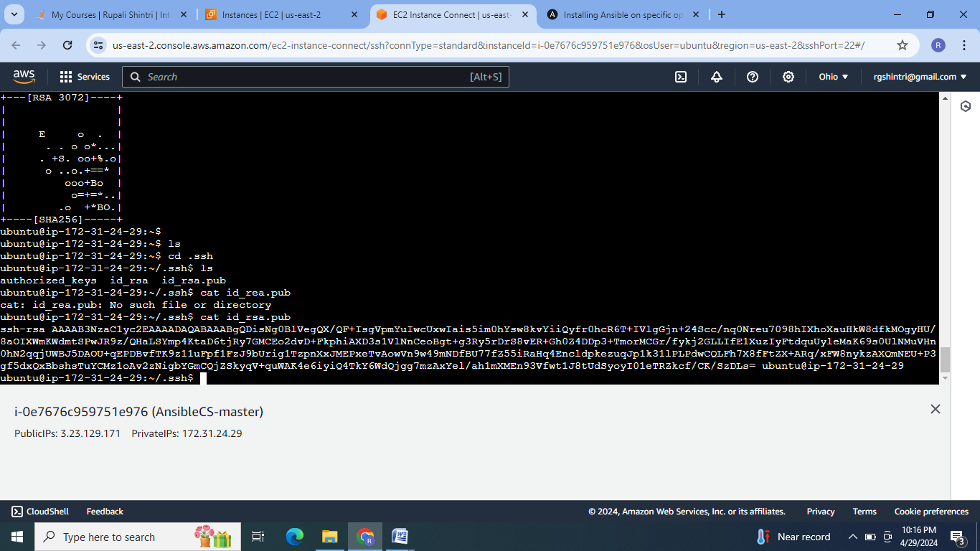

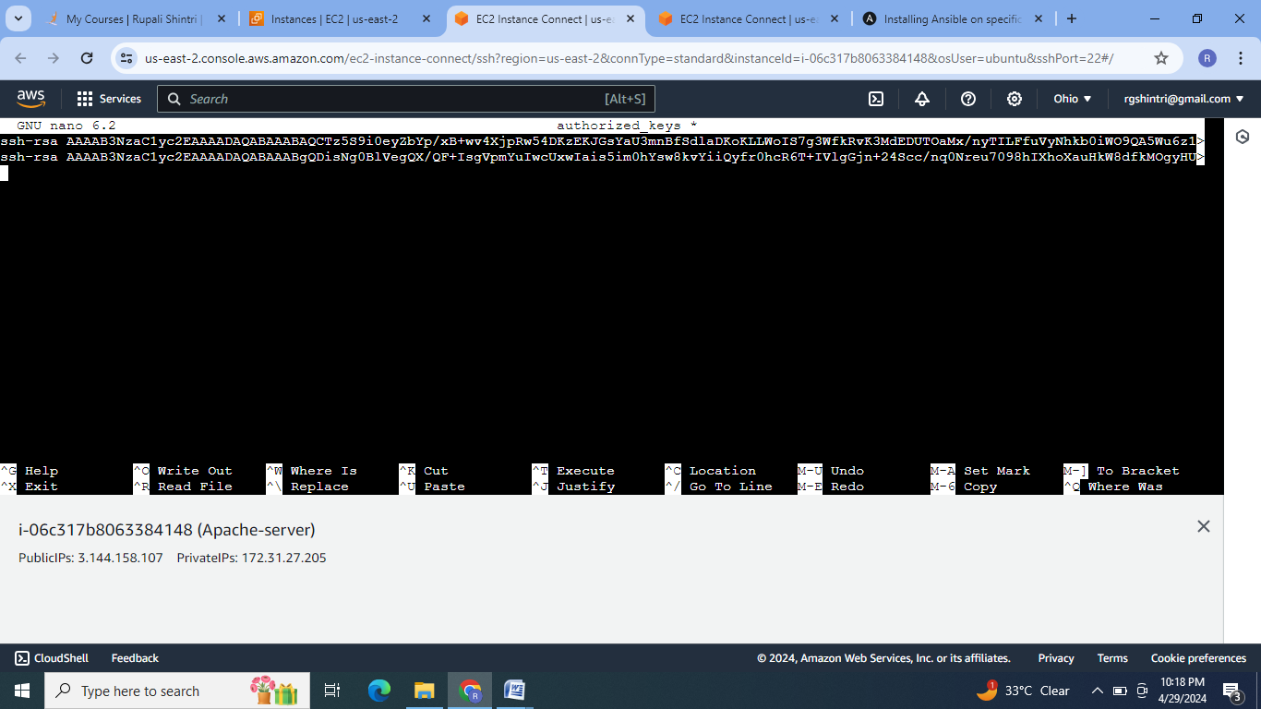

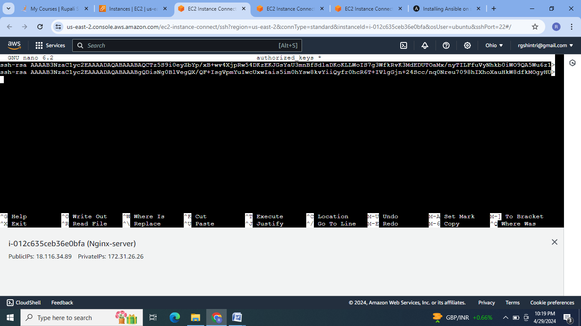

3. Enroll the servers in the host file. Check for cluster formation.

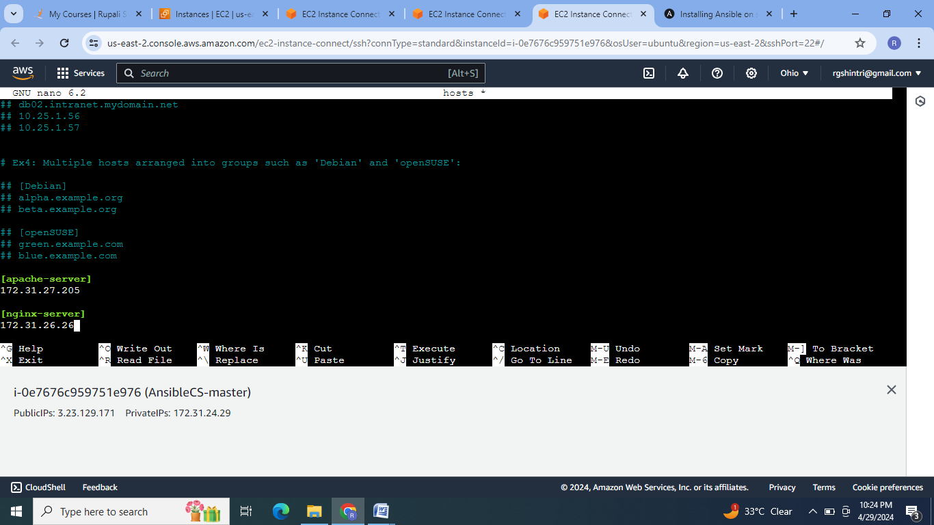

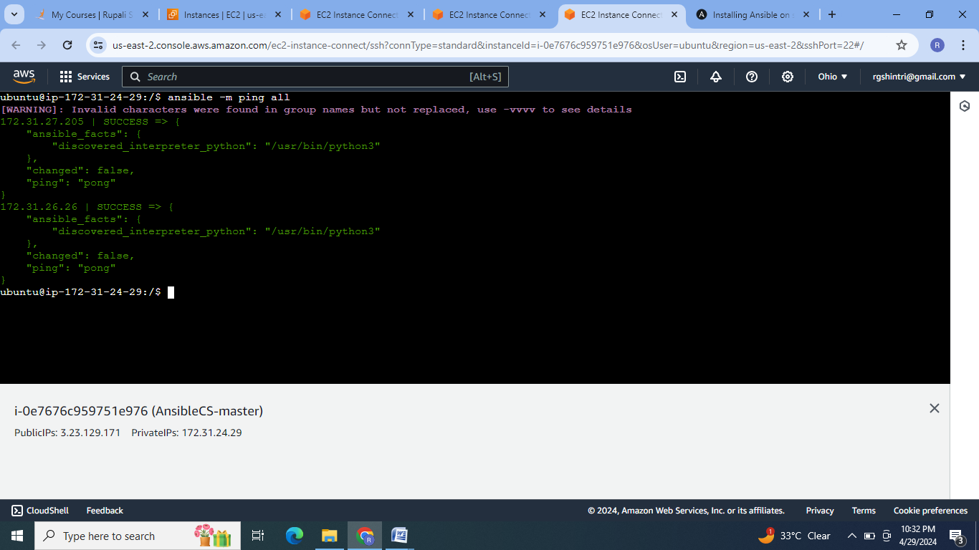

4.Create the 2 roles for apache installation & nginx installation. Create the html file configuration task files & apache & nginx installation task file. Add the task files in main.yaml file of each role.

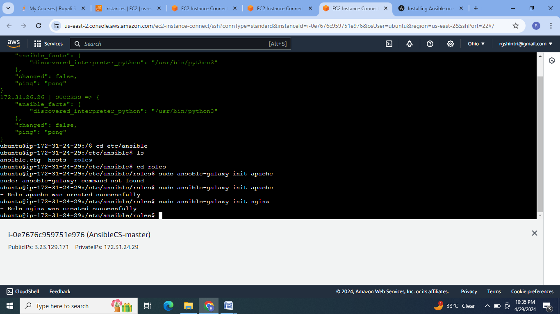

For apache role:

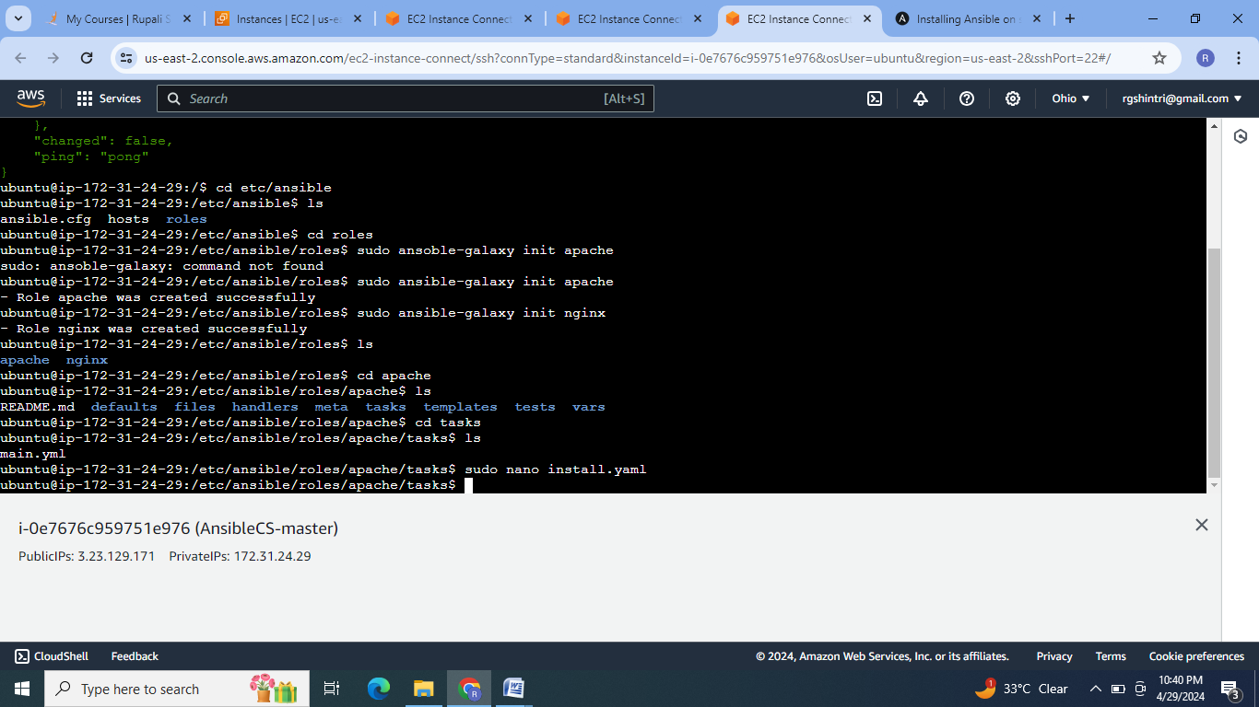

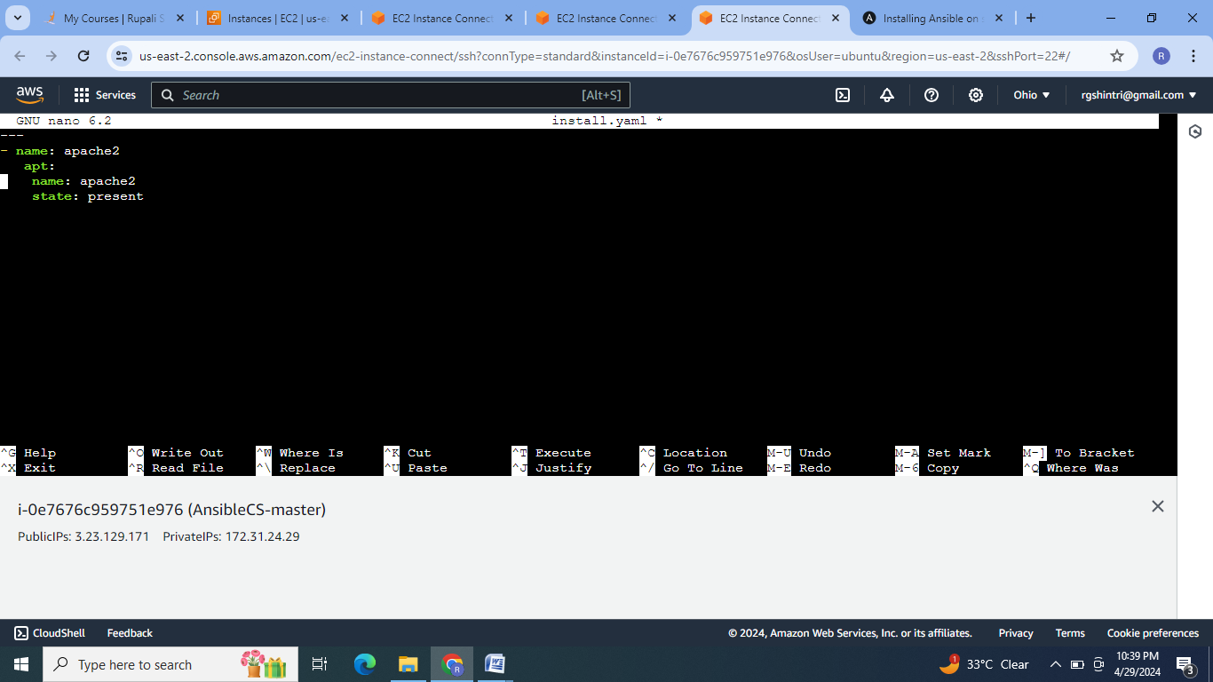

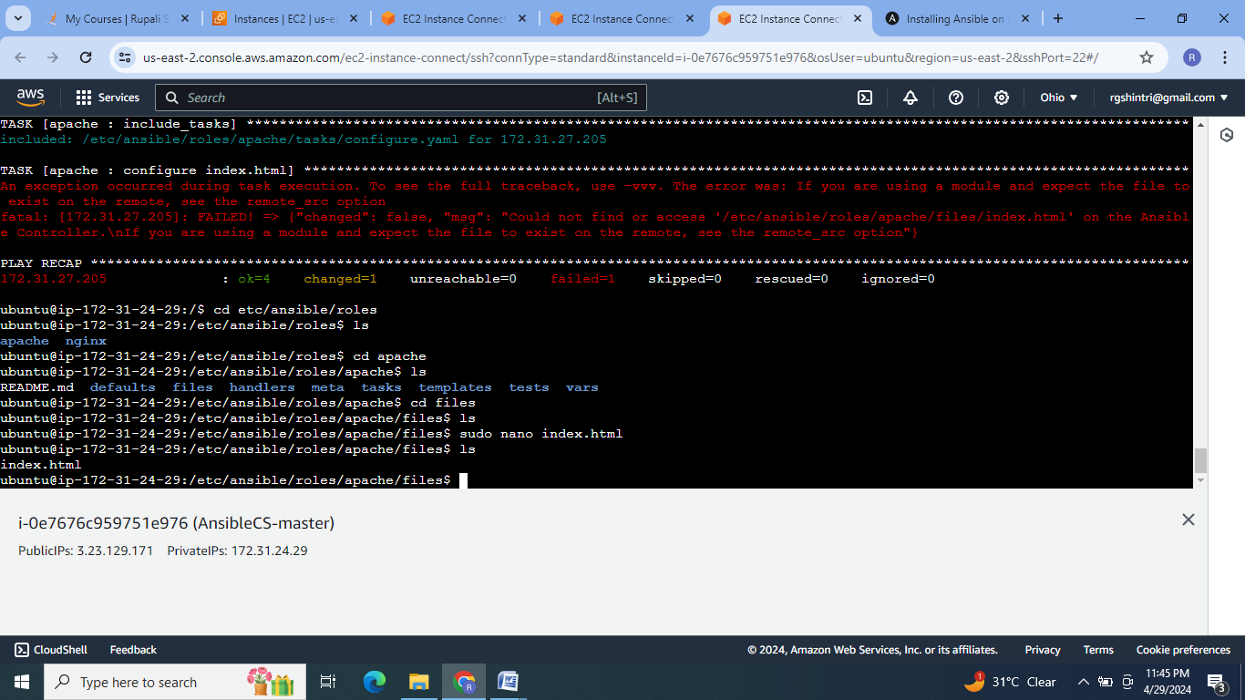

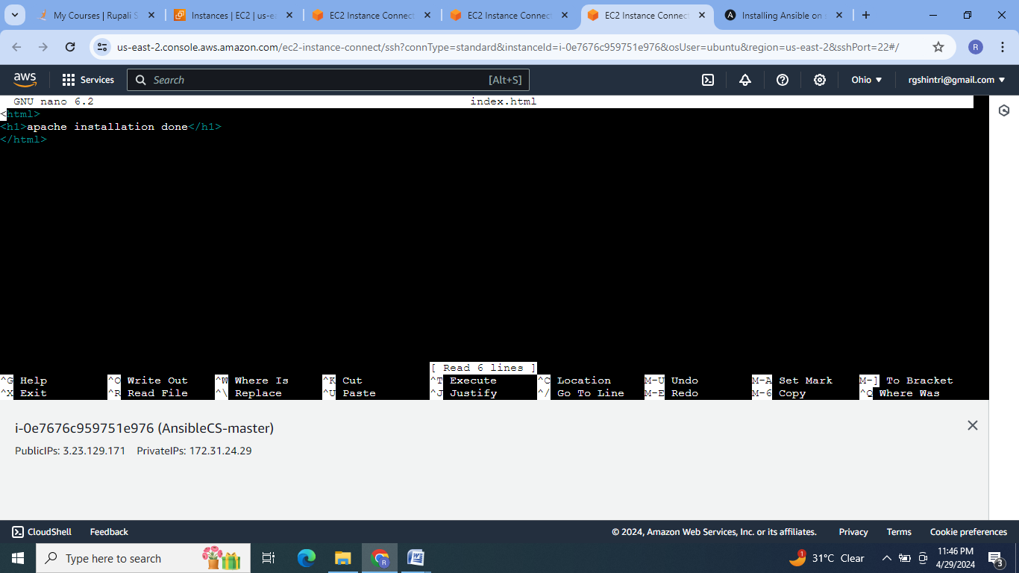

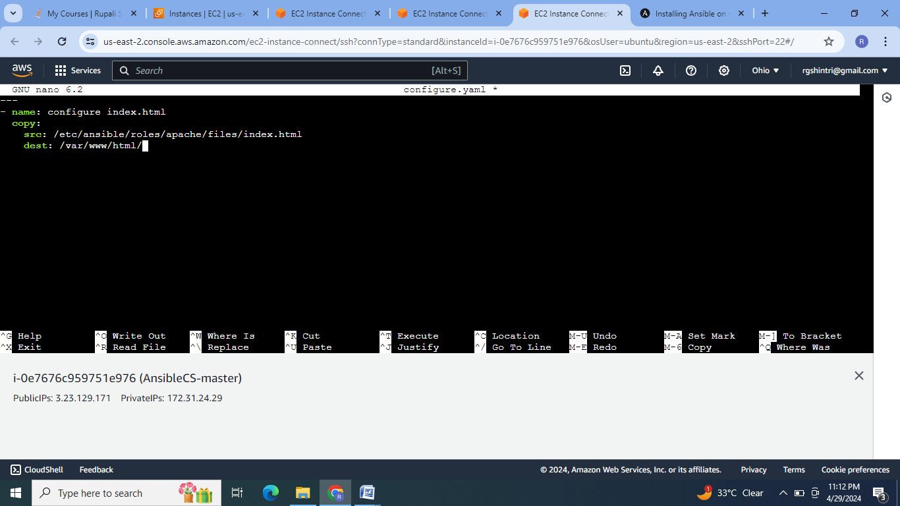

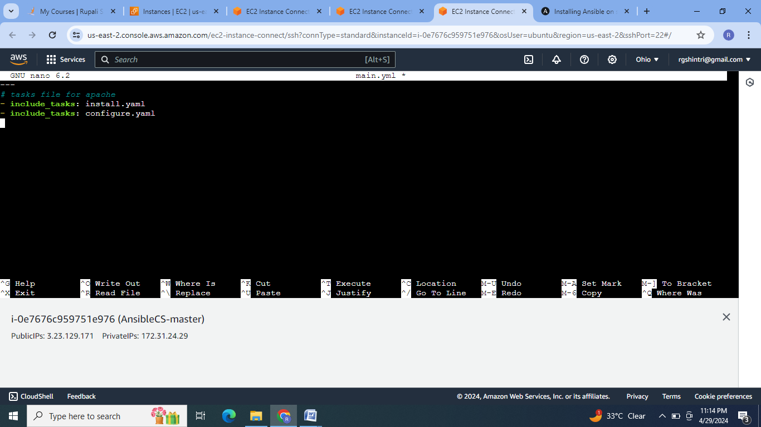

For Nginx:

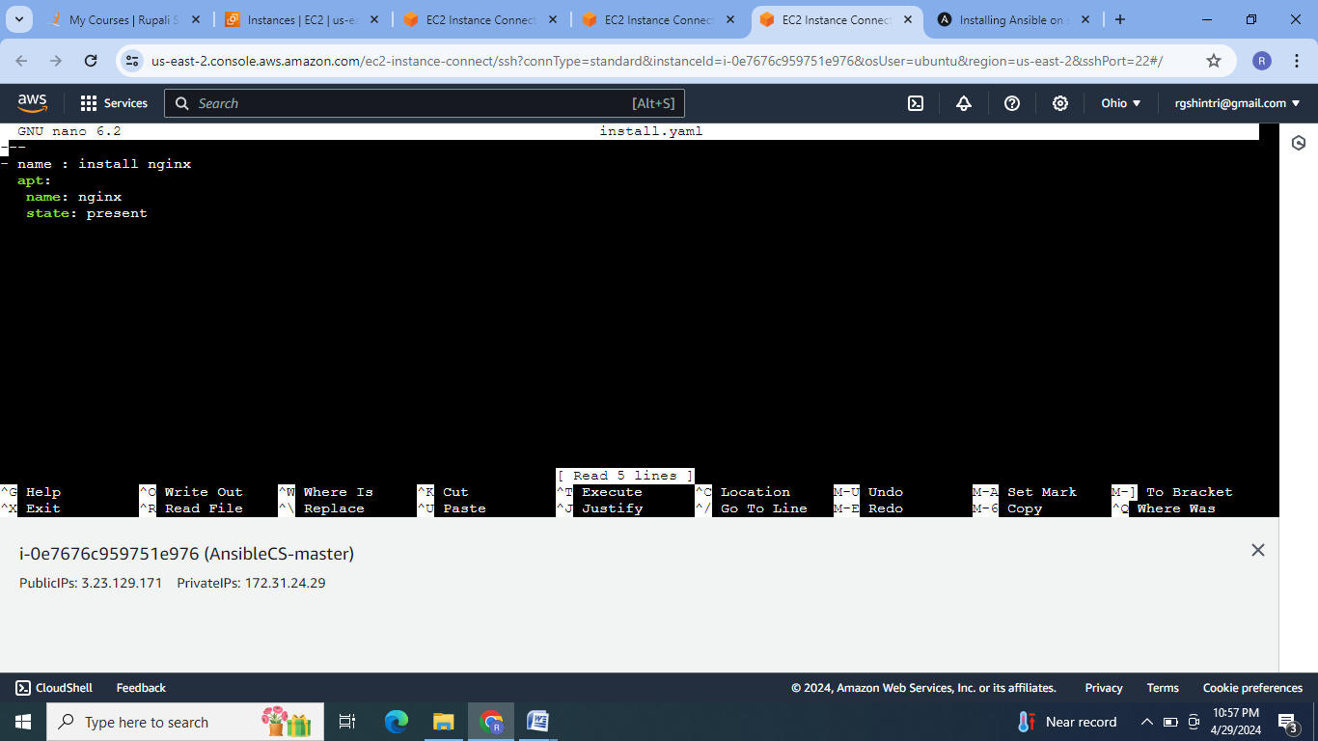

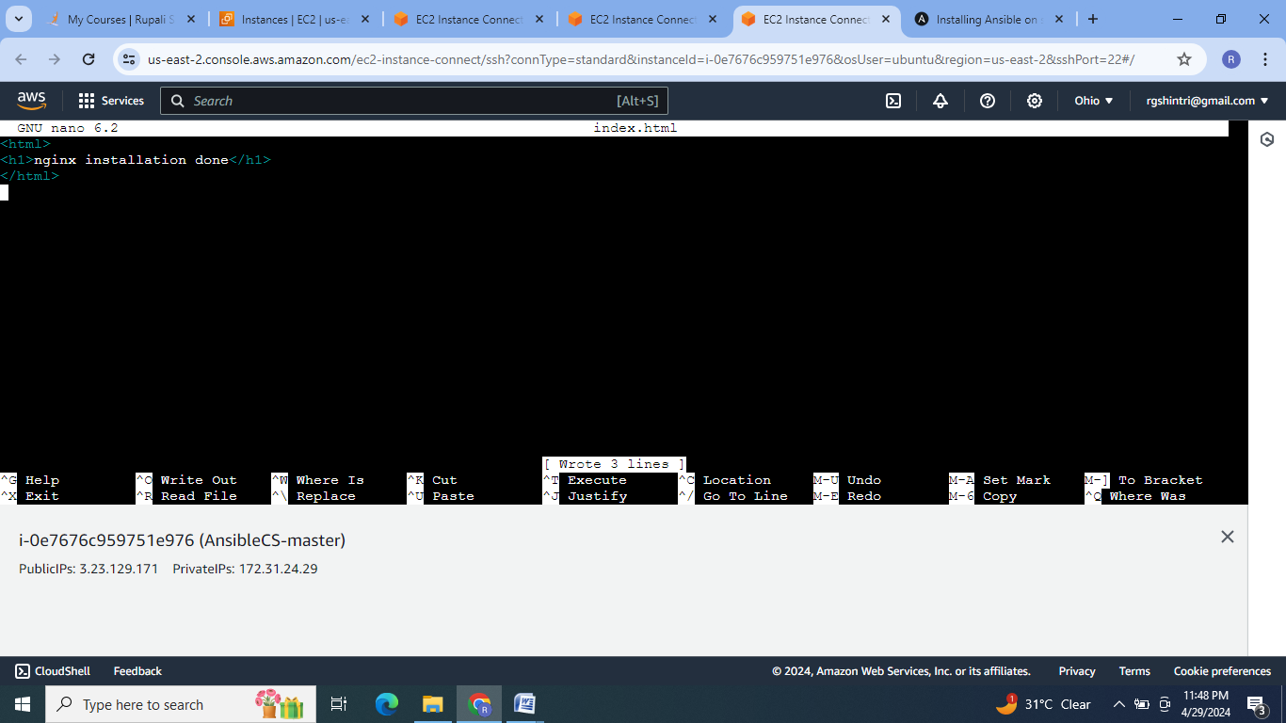

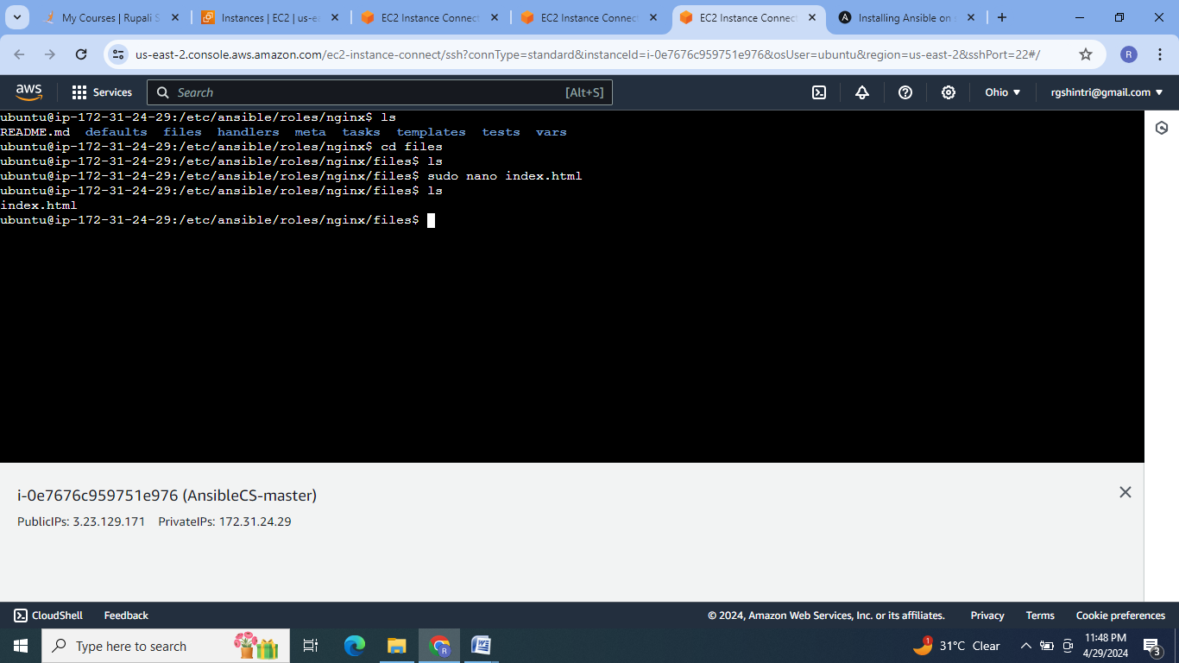

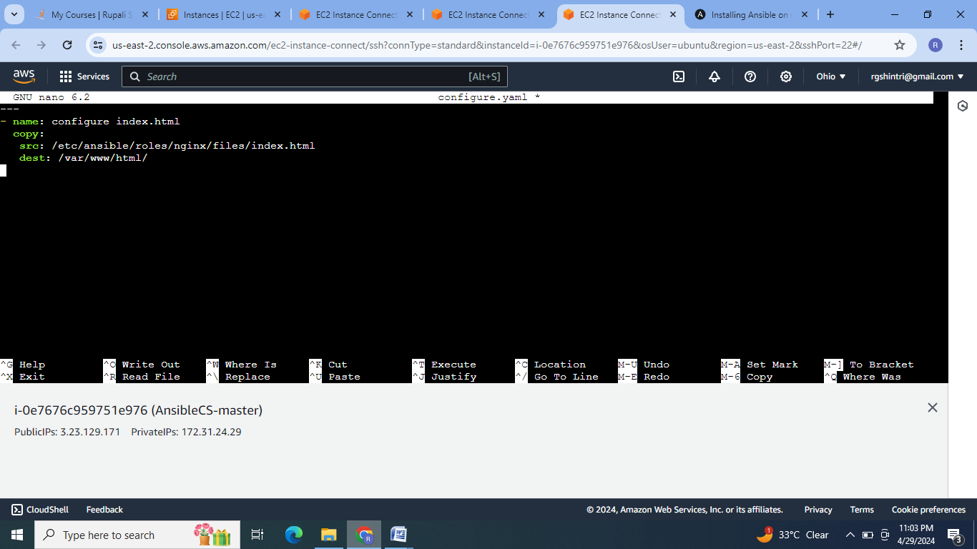

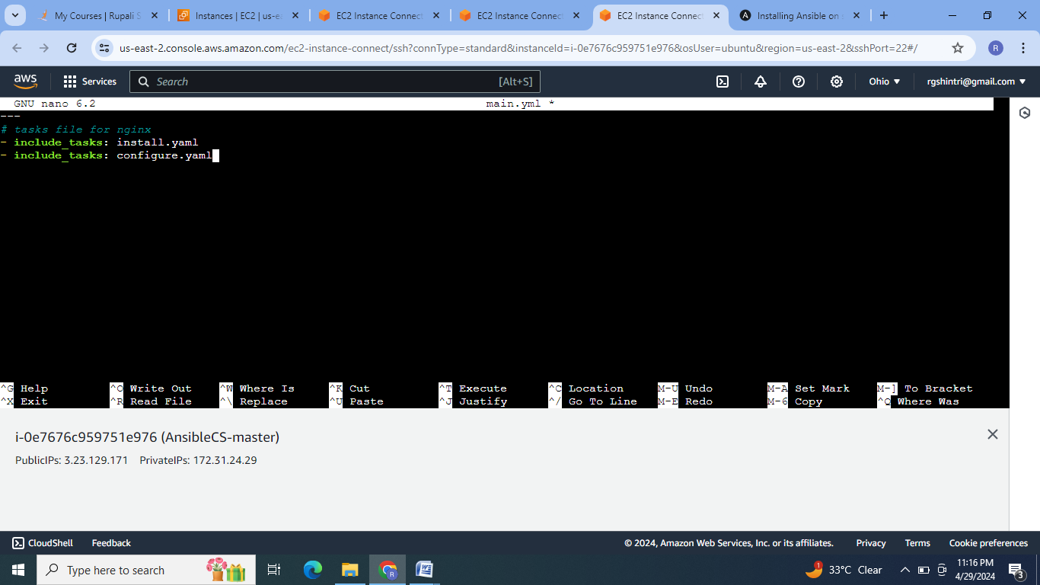

5. Create the ansible playbook file with roles to execute the installation.

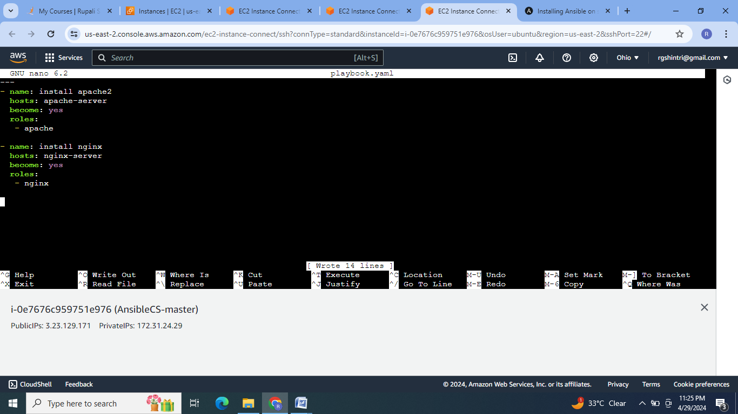

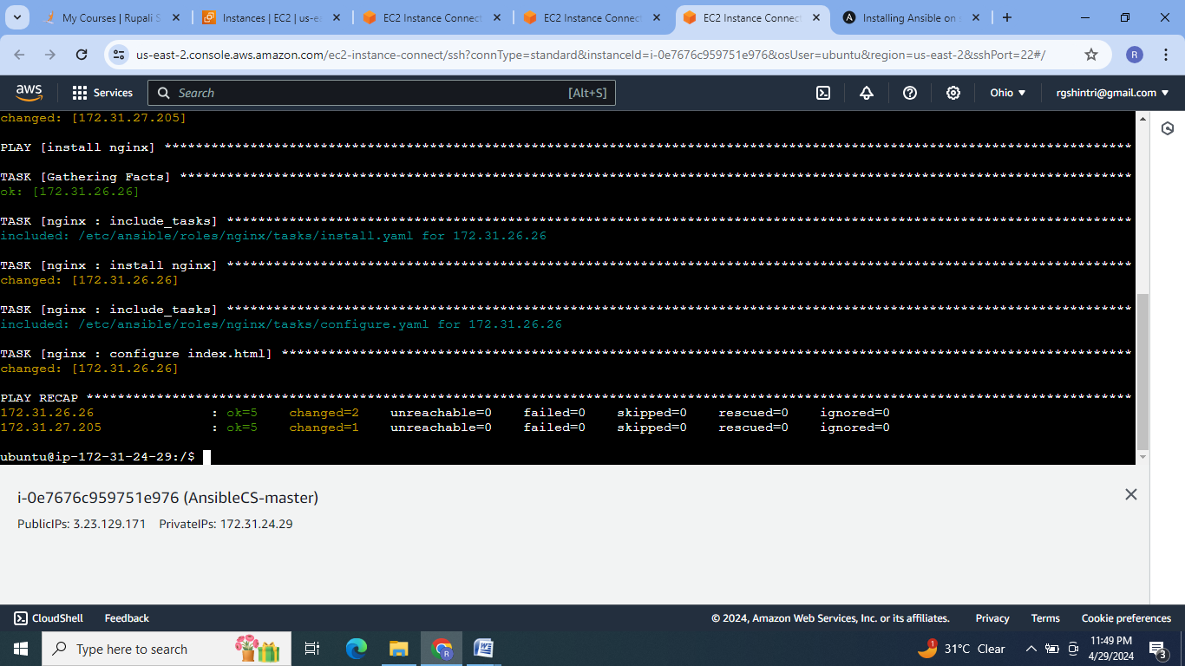

6. Check on respective server ip:

For apache-server:

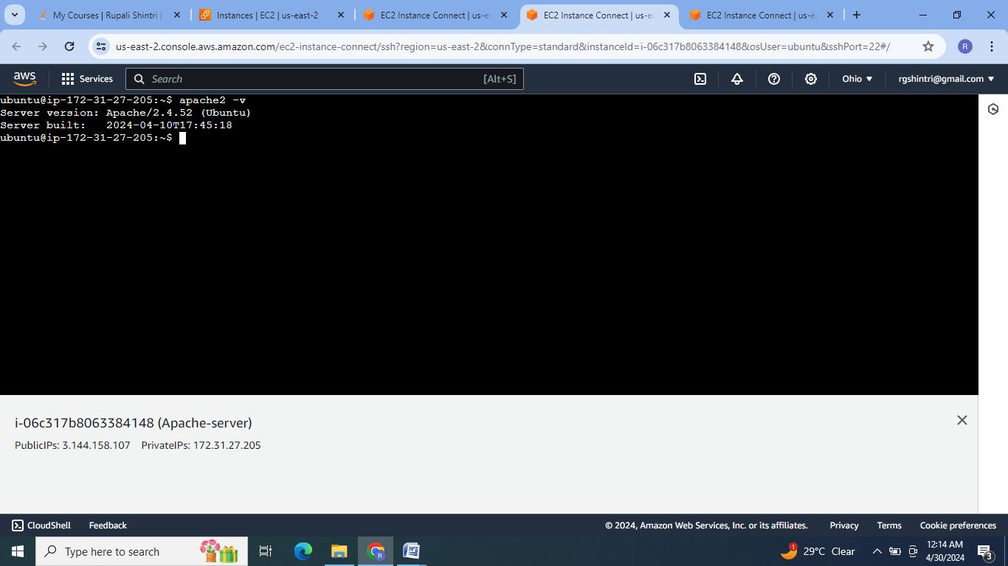



For nginx-server:

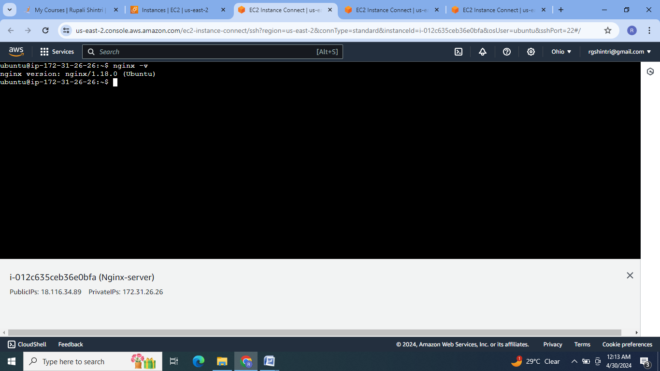



7.For installing java on apache-server create java role:

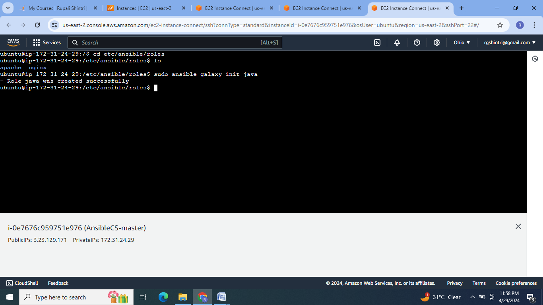

8.Create tasks file & include it in main.yml file .

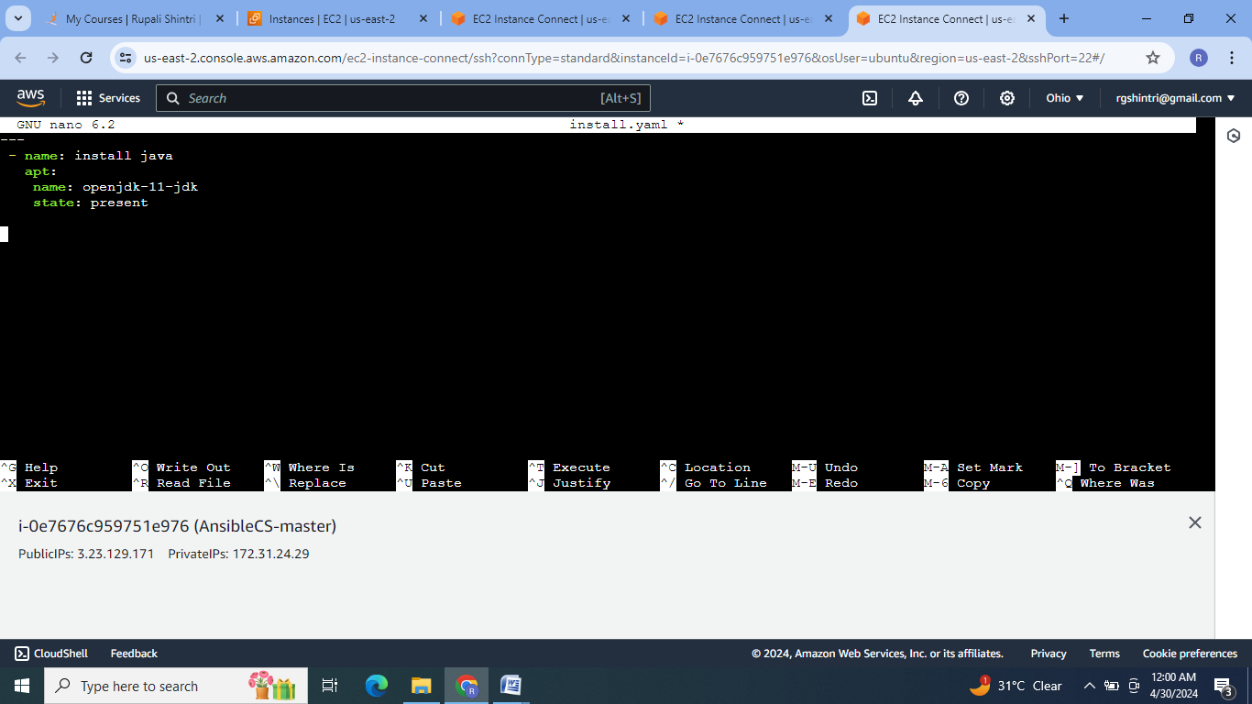

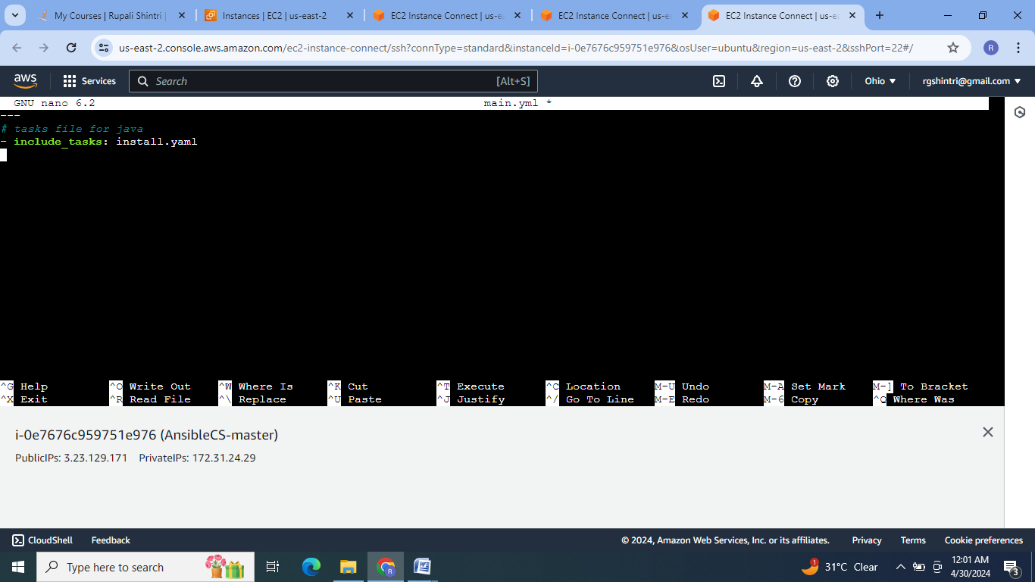

9.Write the playbook file :

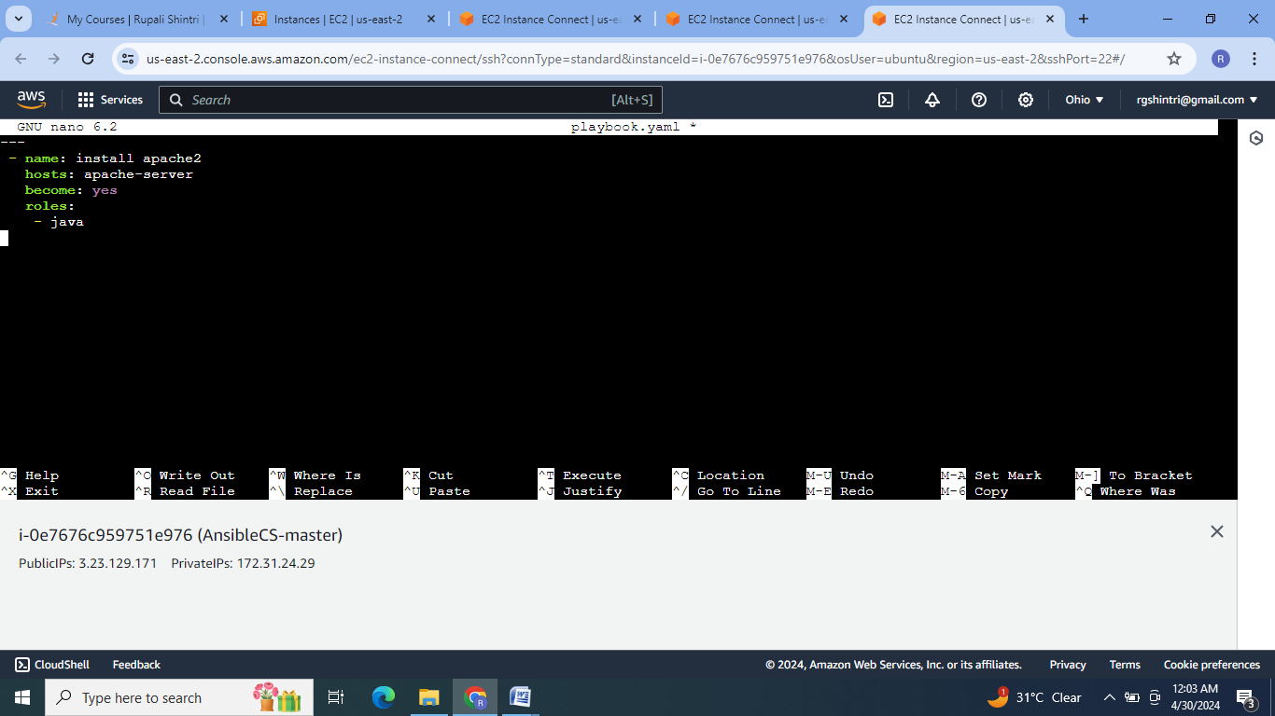

10.Execute the playbook file & check for the java installation on apache-server.

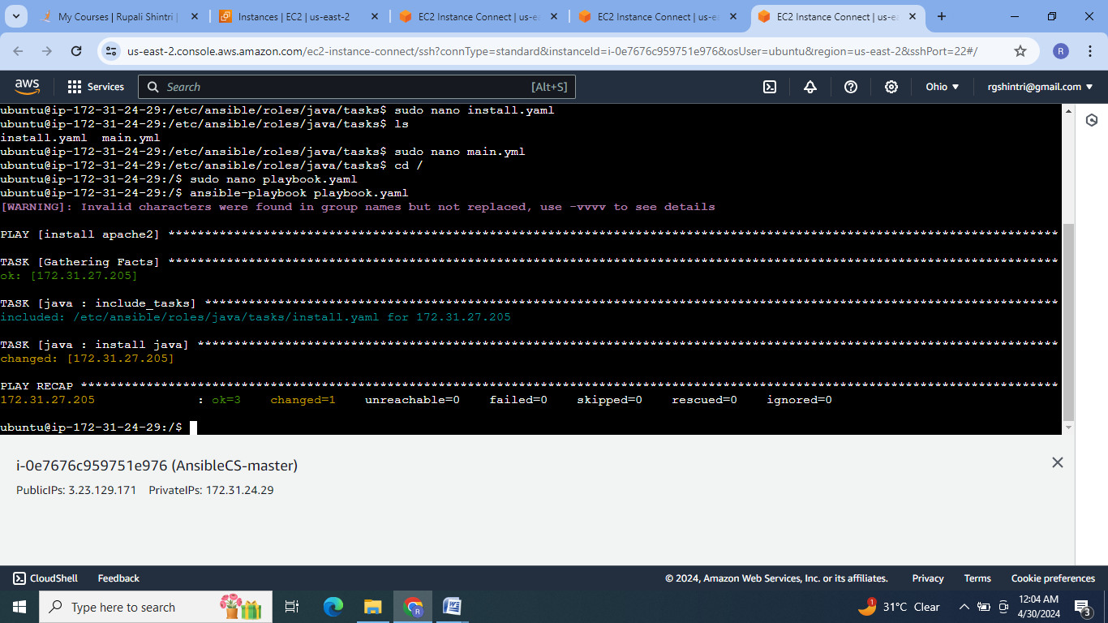

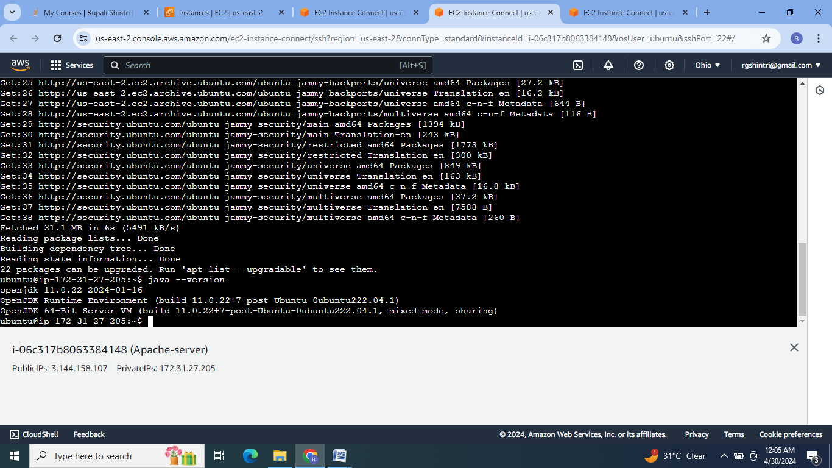

**Conclusion :** So an Ansible can be used for application deployment, updates on servers, configuration management ,addition or deletion of users . It does not depend on agent so its easy to deploy.

