What is cryptography?

Cryptography is a method of protecting information and communications through the use of codes so that only those for whom the information is intended can read and process it.

The pre-fix "crypt" means "hidden" or "vault" and the suffix "graphy" stands for "writing."

cryptography refers to secure information and communication techniques derived from mathematical concepts and a set of rule-based calculations called algorithms to transform messages in ways that are hard to decipher.

These deterministic algorithms are used for cryptographic key generation and digital signing and verification to protect data privacy, web browsing on the internet and confidential communications such as credit card transactions and email.

Cryptography is a part of , but not equal to, security

predated modern computing

in modern computing ,crypto is used to remediate deficiencies in the cyber space.
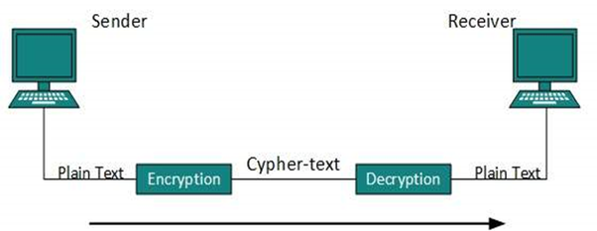

Classification of cryptography

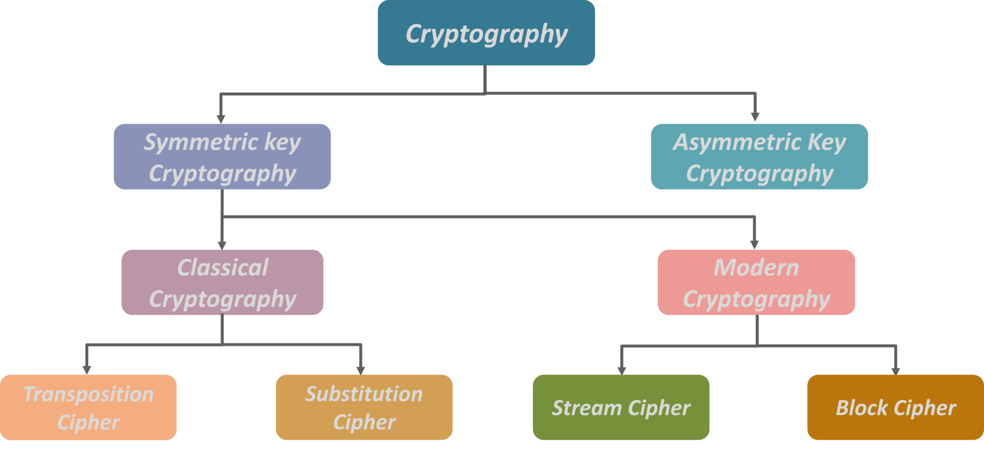
Symmetric cryptography

With symmetric cryptography, the same key is used for both encryption and decryption. A sender and a recipient must already have a shared key that is known to both.
Key distribution is a tricky problem and was the impetus for developing asymmetric cryptography.
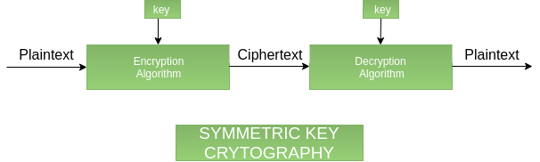
Asymmetric cryptography
With asymmetric crypto, two different keys are used for encryption and decryption. Every user in an asymmetric cryptosystem has both a public key and a private key.
The private key is kept secret at all times, but the public key may be freely distributed.
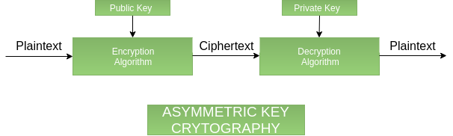

- Public key cryptography

Asymmetric cryptography, also known as public key cryptography, uses public and private keys to encrypt and decrypt data.
The keys are simply large numbers that have been paired together but are not identical (asymmetric).
One key in the pair can be shared with everyone; it is called the public key.
The other key in the pair is kept secret; it is called the private key. Either of the keys can be used to encrypt a message; the opposite key from the one used to encrypt the message is used for decryption.

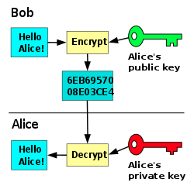

Example:

Public keys of every user are present in the Public key Register.
If B wants to send a confidential message to C, then B encrypt the message using C Public key. When C receives the message from B then C can decrypt it using its own Private key.
No other recipient other than C can decrypt the message because only C know C’s private key.
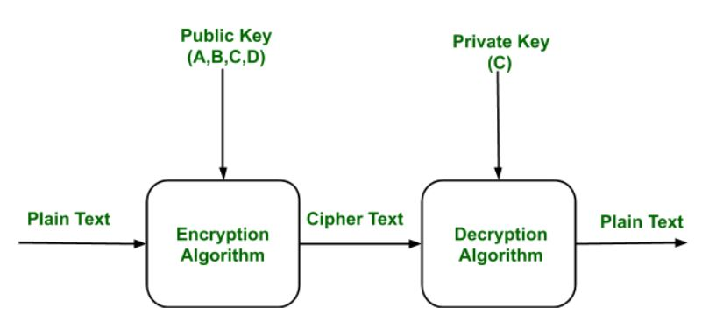
Applications:
- Confidentiality can be achieved using Public Key Encryption. In this the Plain text is encrypted using receiver public key. This will ensures that no one other than receiver private key can decrypt the cipher text.
- Digital signature is for senders authentication purpose. In this sender encrypt the plain text using his own private key. This step will make sure the authentication of the sender because receiver can decrypt the cipher text using senders pubic key only.
- This algorithm can use in both Key-management and securely transmission of data.

- Private key cryptography

A private key, also known as a secret key, is a variable in cryptography that is used with an algorithm to encrypt and decrypt code.
Secret keys are only shared with the key’s generator, making it highly secure. Private keys play an important role in symmetric cryptography, asymmetric cryptography and cryptocurrencies.

- How does a private key work?

Private key encryption is referred to as symmetric encryption, where the same private key is used for both encryption and decryption purposes.
A private key is typically a long, randomly generated number that cannot easily be guessed. Since only one key is involved, the process is fast and simple.
Secret key ciphers generally fall into one of two categories: stream ciphers or block ciphers.
block cipher applies a private key and algorithm to a block of data simultaneously, whereas a stream cipher applies the key and algorithm one bit at a time.
Symmetric-key encryption is much faster computationally than asymmetric encryption

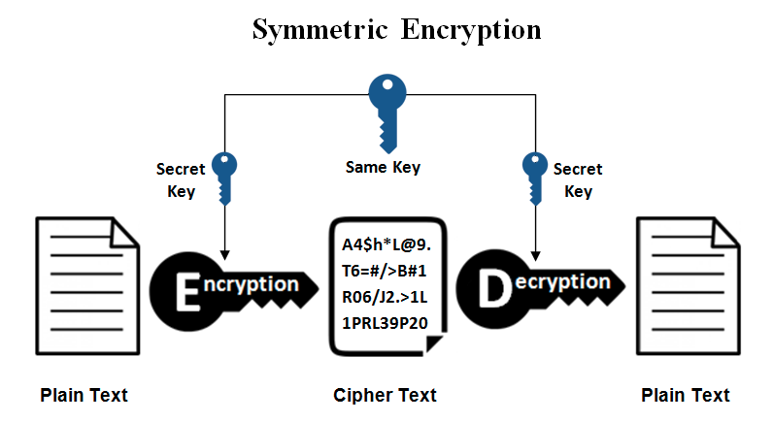

Reference:
https://searchsecurity.techtarget.com/definition/cryptography
https://www.quora.com/What-is-cryptography-1
https://www.geeksforgeeks.org/public-key-encryption/

