# Custom Template Action

An action is the building block of a process automation. Zappy Task Editor comes with various built-in Template Actions. You can read The Zappy Activities Guide for more details and examples, additionally you can create custom activities to better automate processes based on your requirements.

There are two major steps required to create a custom action:

1. Write your own code for custom action.
2. Add an external assembly **(.dll or. nupkg)** in Zappy Task Editor.

**Note:** Please note that the following component is required to create a custom action:

* [Microsoft Visual Studio](https://www.visualstudio.com/) with **.NET** desktop development.

# How to write Custom Action Code:

To better understand how to write code for custom action, we are going to create one action for displaying Message Box using Zappy.

1. Launch Microsoft Visual Studio.
2. Click **File- > New -> Project.**
3. Click on **Visual C#**. The list of all dependencies of C# will display. Select **Class Library (.NET Framework)** and then click **OK**.

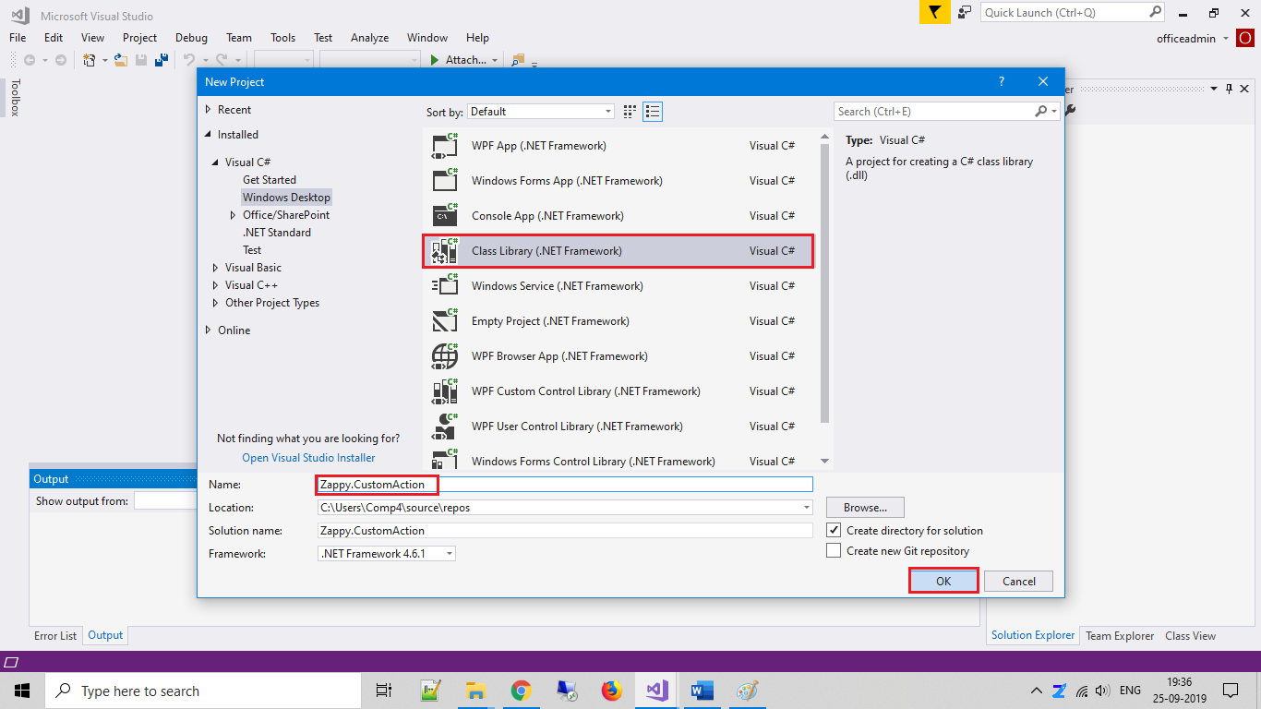

1. Give name for your newly created project. You Must add “**Zappy.**” before Project Name. In our case, Project name is “**CustomAction**” so we used “**Zappy.CustomAction**” as name of this **Project**.

After you click on **OK,** you will get the code as shown below.

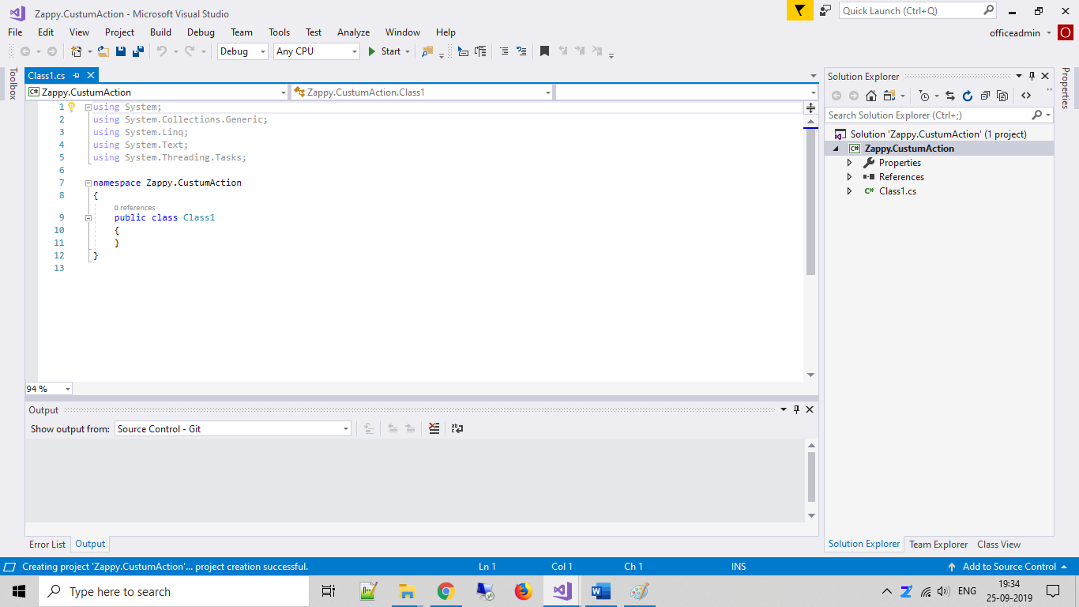

1. In Solution Explore Click **Project -> Add Reference -> Manage NuGet Packages**

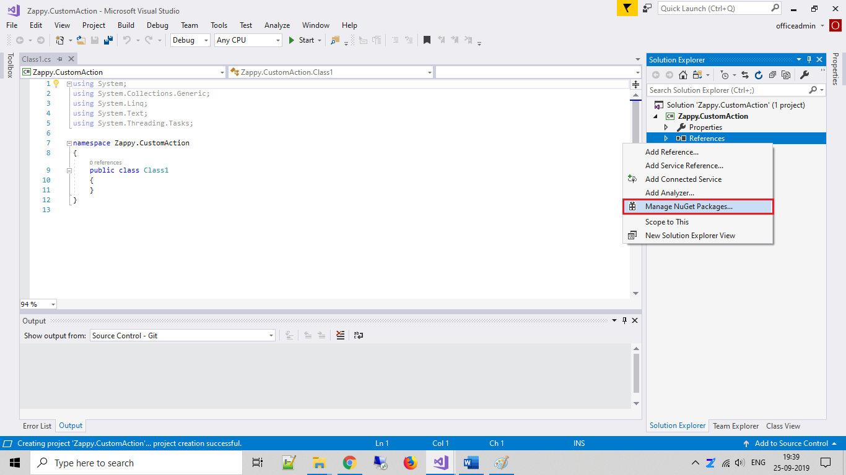

1. Search for the **Zappy.SharedInterface**, Install this Interface.

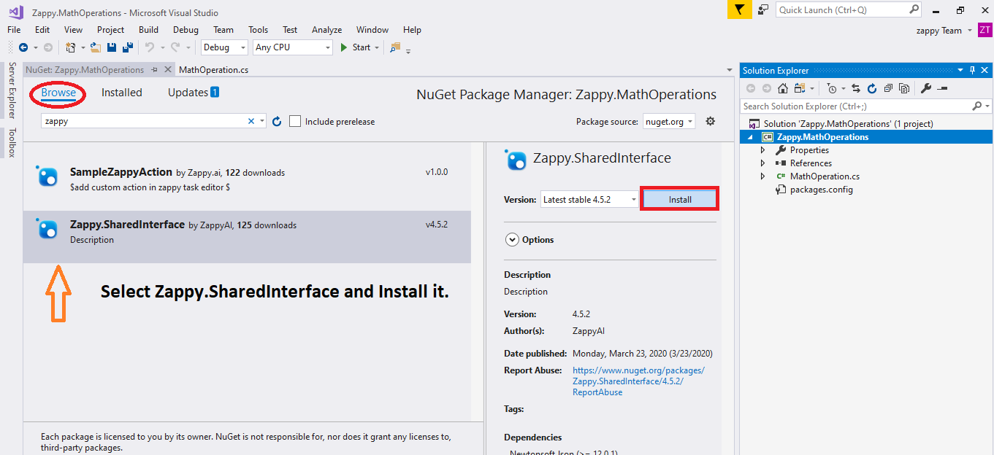

1. Rename “Class.cs” according to your action behavior or keep it as it is, then inherit the “TemplateAction” as shown below.

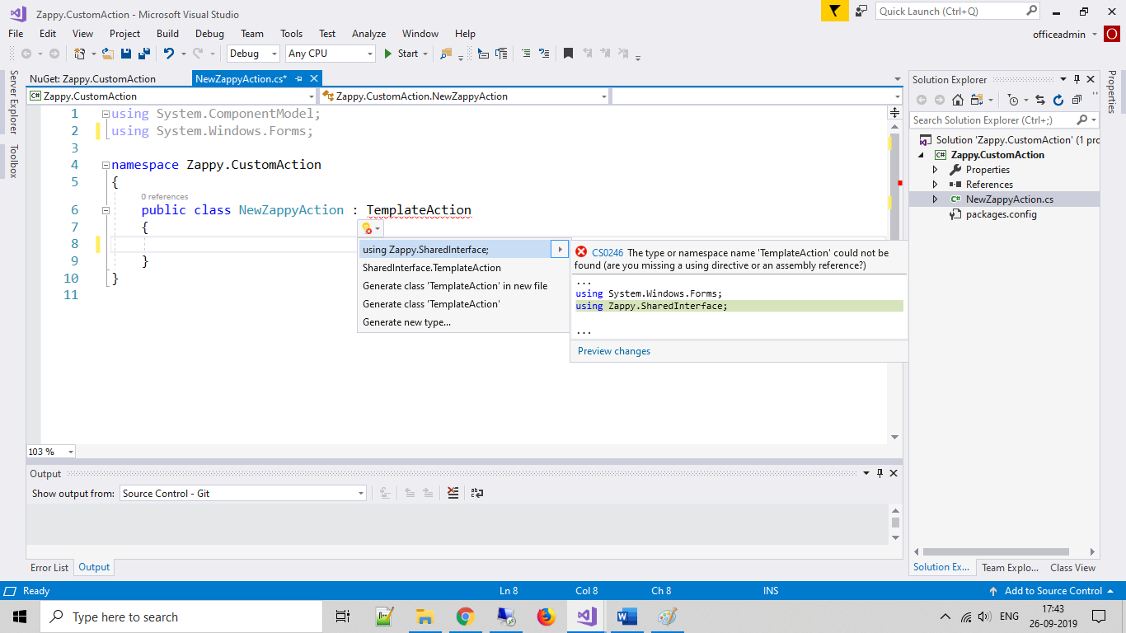

Write the code for your custom activity and Rebuid your project.

1. Please consider the sample code in the below code snippet.

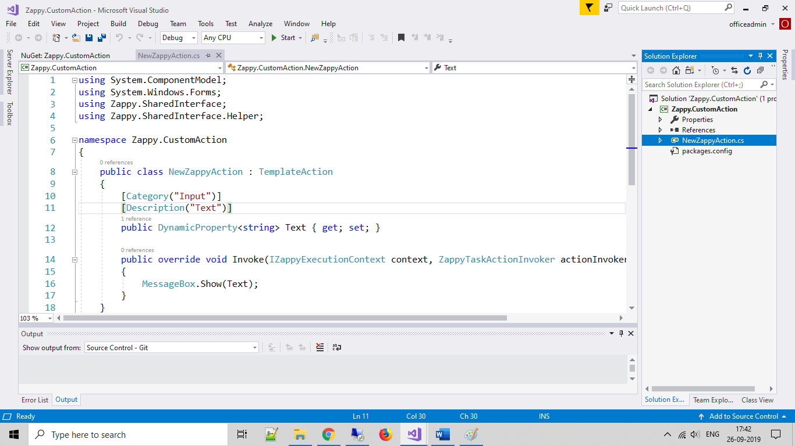

1. Add external assembly in **“Zappy task editor”.** You can do this in two ways.
2. **To create Nuget package:** <https://docs.microsoft.com/en-us/nuget/create-packages/creating-a-package>

**A] Add Nuget package in zappy task editor**

1.Right click on **Zappy Icon > Option > Nuget Manager**

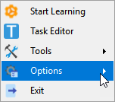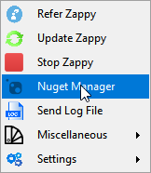

1. Click on **Install Nuget Package** button

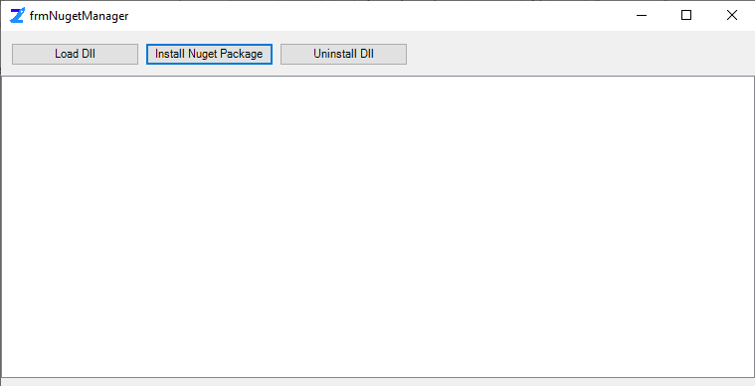

3. Select the **\*. nupkg** package which is recently created.

4. Launch Zappy task editor. Custom activity is added in activity panel.

**B] Add *.dll file in zappy task editor**

1.Right click on **Zappy Icon -> Option -> Nuget Manager**



2.Click on **Load Dll** button

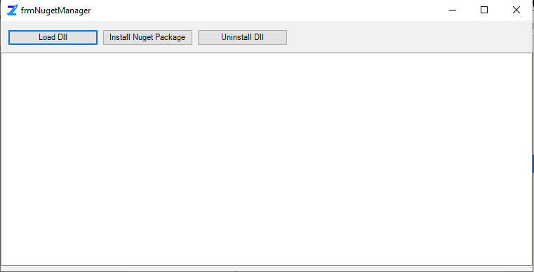

3. Select the **\*.dll** file to load.

4. Launch zappy task editor. Custom activity will add in activity panel.

Then open Zap Task Editor by right click on Zap Icon (or Double click on Zap Icon) .

We will see the Custom activity is added in Zap Activity panel.