**Functionality suggestions:**

1)For dummy email id also it displays msg as "thank you,your sign up request was succesfull,you will recive the email ”

2)For valid email id I got msg as above but didn’t recived the email on my email id

3)In top right corner there is icon for facebook,instagram and linkdin there are not working after cliking on it

4)After click on all “learn more” loader is moving and redirected to same page

5) After click on all “images in circle” loader is moving and redirected to same page

6)For Sign up there is no details askede such as name,password ,comfirm password ,captcha,terms and conditions etc..

7)Sign in button is missing

**UI Suggestions**

1)Top right corner icons should have colour as per their logo so that people will easily understand

2) In place of “search for..” there should be only “search” word

3)after we enter keywords and then click on go then it navigate to another page and we are able to see two search options again this is confusing as shown in below screenshot

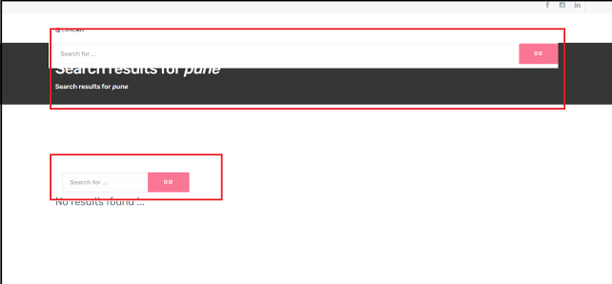

4)The Top left corner log “Landkit” should be large enough to see

5)”The world is a bookstore and we are your clerks” this heading should not be a statement .It should be one or two impactfull words