**Sharksjob Content Rewrite:**

**Homepage:**

**Yellow: Old content**

**Green: New content**

**Get your dream job**

**on SHARKS JOB**

**Secure Your Dream Career**

**with SHARKS JOB**

**\*\*\*\*\*\*\*\*\*\*\*\*\*\*\*\*\*\*\*\*\*\*\*\*\*\*\*\*\*\*\*\*\*\*\*\*\*\*\*\*\*\*\*\*\*\*\*\*\*\*\***

**Connect with opportunities that matter.**

**SHARKS JOB is the cutting-edge hiring platform**

**that reinvents the way you search for jobs.**

Discover meaningful opportunities. SHARKS JOB, the innovative hiring platform, transforms your job search experience."

Why choose SHARKS JOB

What makes SHARKS JOB unique?

What makes SHARKS JOB stand out?

**************************************************************

**Explore**

**Video job descriptions**

**Scroll through jobs as easily as you browse your social media.**

**EXPLORE**

**Interactive job previews**

**Browse job opportunities effortlessly, just like scrolling through your social media feed."**

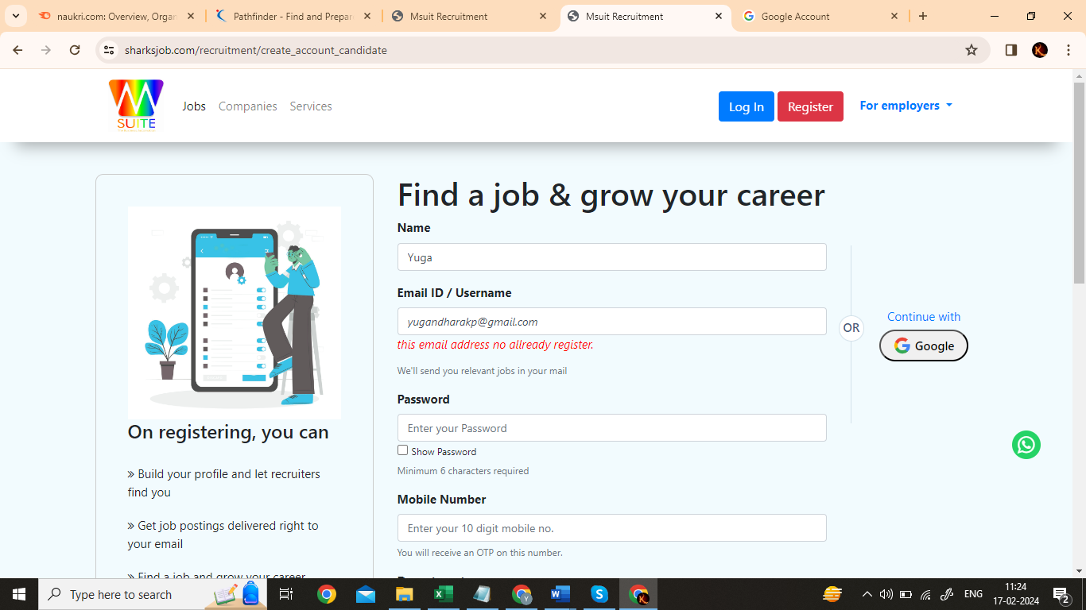

**Every new entered email show:**

this email address no allready register

**Show Password not working**

**Design suggestion :**

**Naukri.com reg process:**

**Hindi language add**

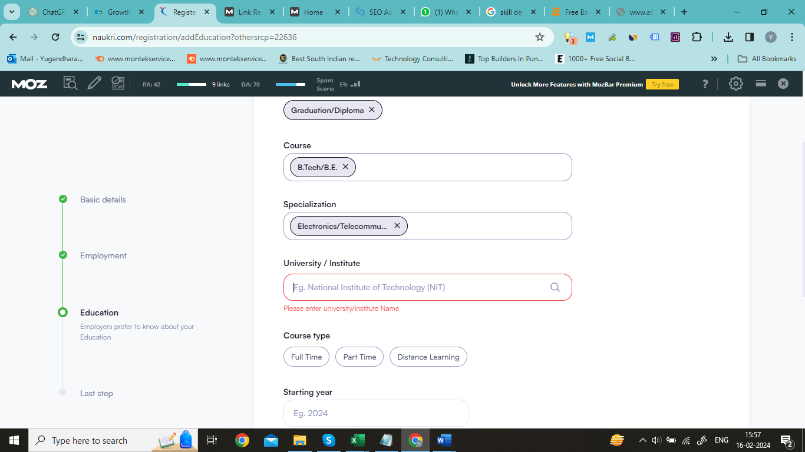

**Add Section**

* **Languages Known**
* **Certifications**
* **Award or Honor**
* **Competitive Exam Results**

**Optimize Website Structure and Navigation:** Ensure that Naukri.com's website has a clear and intuitive site structure with organized categories, subcategories, and navigation menus. Optimize URLs, page titles, and meta descriptions to include relevant keywords and provide accurate descriptions of the content on each page.

**Create High-Quality Content:** Develop informative, engaging, and valuable content related to job search tips, career advice, industry insights, resume writing, interview preparation, and workplace trends. Publish blog posts, articles, guides, infographics, and videos that address the needs and interests of Naukri.com's target audience. Optimize content for targeted keywords while maintaining readability and relevance.

**Mobile Optimization**: With the increasing use of mobile devices for job searching, ensure that Naukri.com's website is optimized for mobile responsiveness and user experience. Implement responsive web design, fast page load times, and mobile-friendly navigation to provide a seamless browsing experience on smartphones and tablets. Google's Mobile-Friendly Test tool can help identify and fix any mobile usability issues.

**Local SEO:** Target local search queries by optimizing Naukri.com's website for location-based keywords, such as city names, neighborhoods, and zip codes. Create localized landing pages, job listings, and business profiles for specific geographical areas to improve visibility in local search results. Additionally, ensure consistent NAP (Name, Address, Phone number) information across all online directories and platforms.

**Brand Building:**

**Value-added Services**: Offering additional services such as resume writing, career counseling, and skill development courses to provide added value to both job seekers and employers

**Continuous Innovation:**

**Mobile Optimization:** Investing in mobile optimization to cater to the growing number of users accessing the platform via mobile devices. This may include developing a responsive website and a mobile app.

[**Send me important updates onWhatsApp**](javascript:void(0))

**Naukri.com reg process:**



**Add Section**

**Languages Known**

**Certifications**

**Award or Honor**

**Competitive Exam Results**