Certificate not edit

Certification date after edit not show

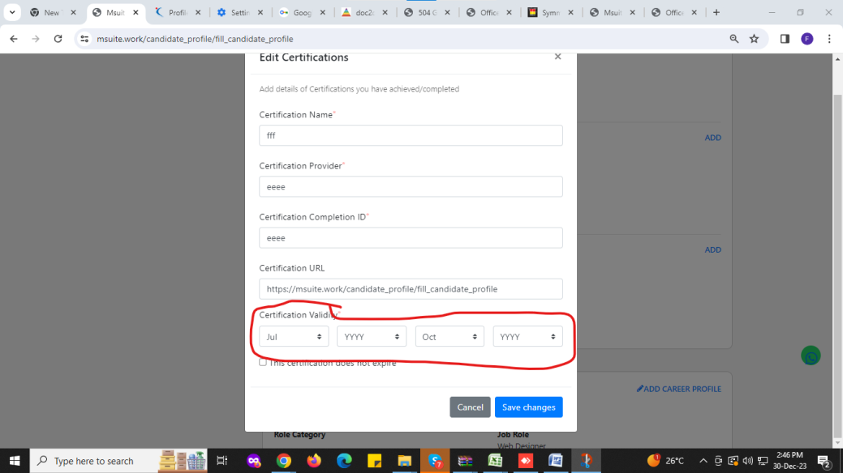

2)personal details---if save personal details got error

<https://msuite.work/recruitment/update_personal_details_candidate>

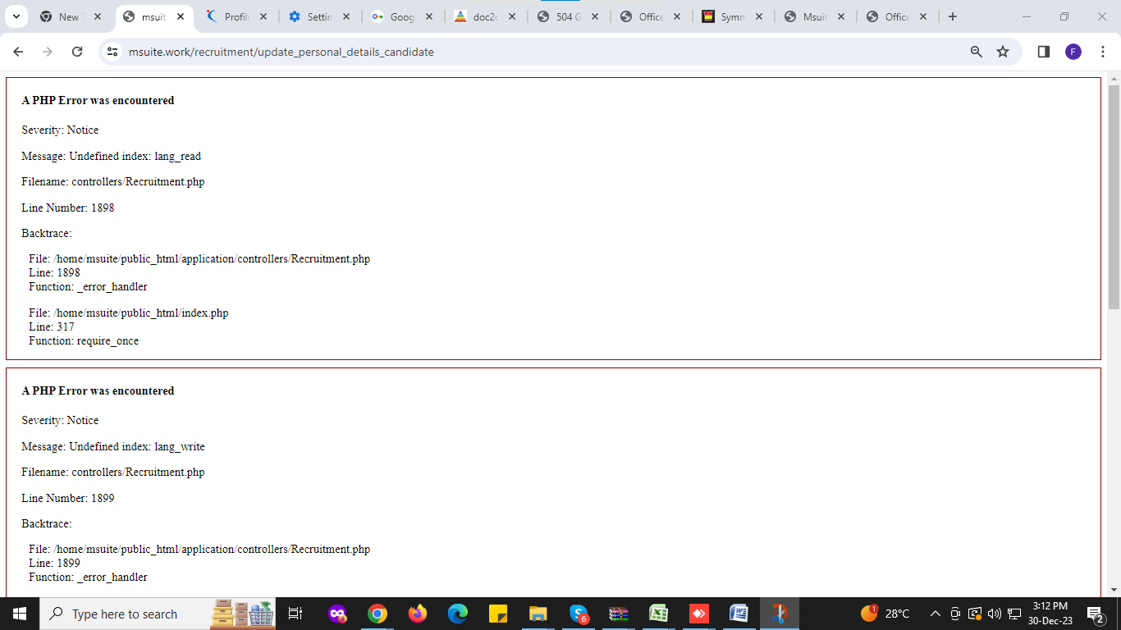

3)ADD languages not proper (plz refer nukari)

4)

Complete profile show percentage (as like nukari)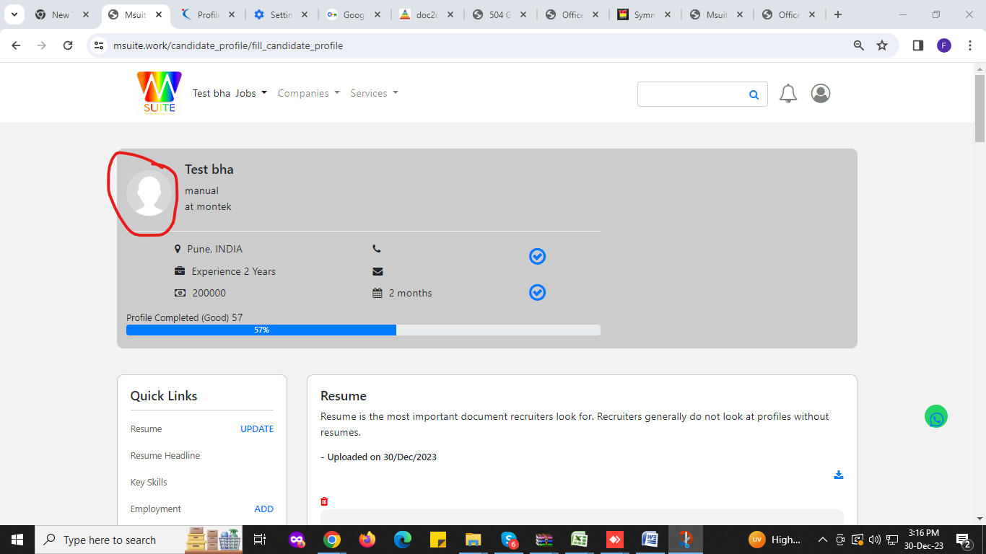

5)Search not wprk proper—

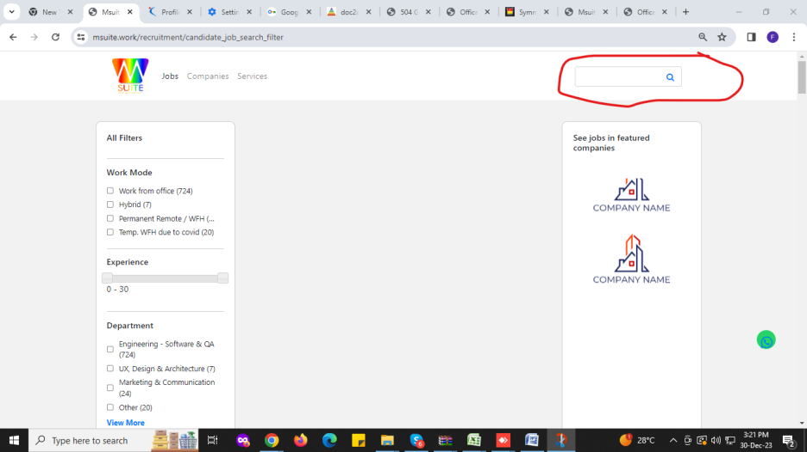

6) This form not option edit

