**### SQL-task 4**

-- Aggregate queries

-- **1. Total stock by category**

SELECT category, SUM(stock) AS total_stock

FROM Products

GROUP BY category;

**Output:**

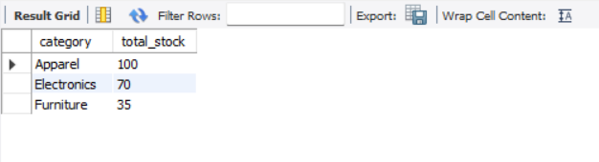

**-- 2. Average price by category**

SELECT category, ROUND(AVG(price), 2) AS average_price

FROM Products

GROUP BY category;

**Output:**

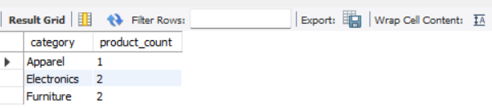

-- **3. Count of products per category**

SELECT category, COUNT(*) AS product_count

FROM Products

GROUP BY category;

**Output:**

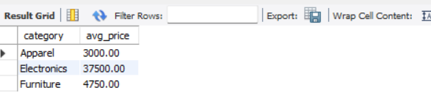

**-- 4. Categories with more than 1 product**

SELECT category, COUNT(*) AS product_count

FROM Products

GROUP BY category

HAVING COUNT(*) > 1;

**Output:**

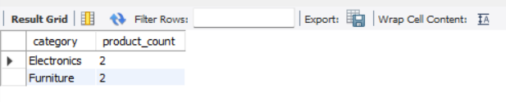

-- **5. Categories where total stock > 40**

SELECT category, SUM(stock) AS total_stock

FROM Products

GROUP BY category

HAVING total_stock > 40;

**Output:**

