**Scalar Subquery in SELECT**

SELECT

CustomerName,

(SELECT AVG(Amount) FROM Orders WHERE Amount IS NOT NULL) AS AvgOrderAmount

FROM Customers;

**Output:**

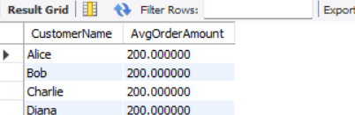

**Correlated Subquery**

SELECT CustomerName

FROM Customers c

WHERE EXISTS (

SELECT 1

FROM Orders o

WHERE o.CustomerID = c.CustomerID

AND o.Amount > (SELECT AVG(Amount) FROM Orders WHERE Amount IS NOT NULL)

);

**Output:**

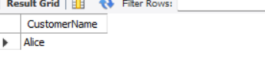

**Subquery using IN**

SELECT CustomerName

FROM Customers

WHERE CustomerID IN (SELECT CustomerID FROM Orders WHERE CustomerID IS NOT NULL);

**Output:**

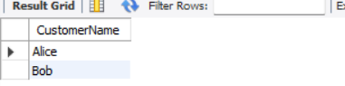

**Subquery using EXISTS**

SELECT CustomerName

FROM Customers c

WHERE EXISTS (

SELECT 1 FROM Orders o

WHERE o.CustomerID = c.CustomerID

);

**Output:**

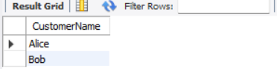

**Subquery in FROM Clause**

SELECT CustomerName, TotalAmount

FROM (

SELECT CustomerID, SUM(Amount) AS TotalAmount

FROM Orders

GROUP BY CustomerID

) AS OrderSummary

JOIN Customers ON Customers.CustomerID = OrderSummary.CustomerID;

**Output:**

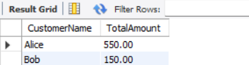

**Subquery with =**

SELECT CustomerName

FROM Customers

WHERE CustomerID = (

SELECT CustomerID

FROM Orders

WHERE Amount = (SELECT MAX(Amount) FROM Orders)

);

**Output:**

