**-- 1. View: Customer Orders with JOIN**

CREATE VIEW CustomerOrders AS

SELECT

o.OrderID,

o.OrderDate,

o.Amount,

c.CustomerName,

c.City

FROM Orders o

LEFT JOIN Customers c ON o.CustomerID = c.CustomerID;

SELECT * FROM CustomerOrders;

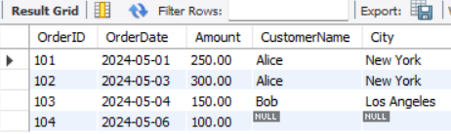

**-- 2. View: High Value Orders**

CREATE VIEW HighValueOrders AS

SELECT

OrderID,

OrderDate,

CustomerID,

Amount

FROM Orders

WHERE Amount > 200;

SELECT * FROM HighValueOrders;

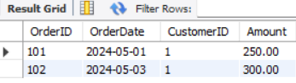

**-- 3. View: Orders with Non-NULL Customers (with CHECK OPTION**)

CREATE VIEW ValidCustomerOrders AS

SELECT * FROM Orders

WHERE CustomerID IS NOT NULL

WITH CHECK OPTION;

SELECT * FROM ValidCustomerOrders;

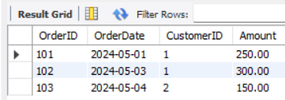

**-- 4. View: Total Orders & Amount per Customer**

CREATE VIEW TotalOrdersPerCustomer AS

SELECT

c.CustomerID,

c.CustomerName,

COUNT(o.OrderID) AS TotalOrders,

SUM(o.Amount) AS TotalAmount

FROM Customers c

LEFT JOIN Orders o ON c.CustomerID = o.CustomerID

GROUP BY c.CustomerID, c.CustomerName;

SELECT * FROM TotalOrdersPerCustomer;

