DELIMITER //

**-- Stored Procedure: Get orders by customer ID**

CREATE PROCEDURE GetOrdersByCustomer(IN cust_id INT)

BEGIN

SELECT o.OrderID, o.OrderDate, o.Amount

FROM Orders o

WHERE o.CustomerID = cust_id;

END //

-**- Function: Calculate 10% bonus on order amount**

CREATE FUNCTION CalculateBonus(amount DECIMAL(10,2))

RETURNS DECIMAL(10,2)

DETERMINISTIC

BEGIN

RETURN amount * 0.10;

END //

DELIMITER ;

**Example usage of procedure**

CALL GetOrdersByCustomer(1);

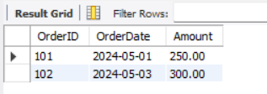

**Example usage of function**

SELECT OrderID, Amount, CalculateBonus(Amount) AS Bonus FROM Orders;

