1.Create a new database: intern_training_db
2. Create your first table: students
3. Insert at least 5 realistic records
4.Retrieve all records using SELECT *
5. Select specific columns
6.filtering data
Queries:
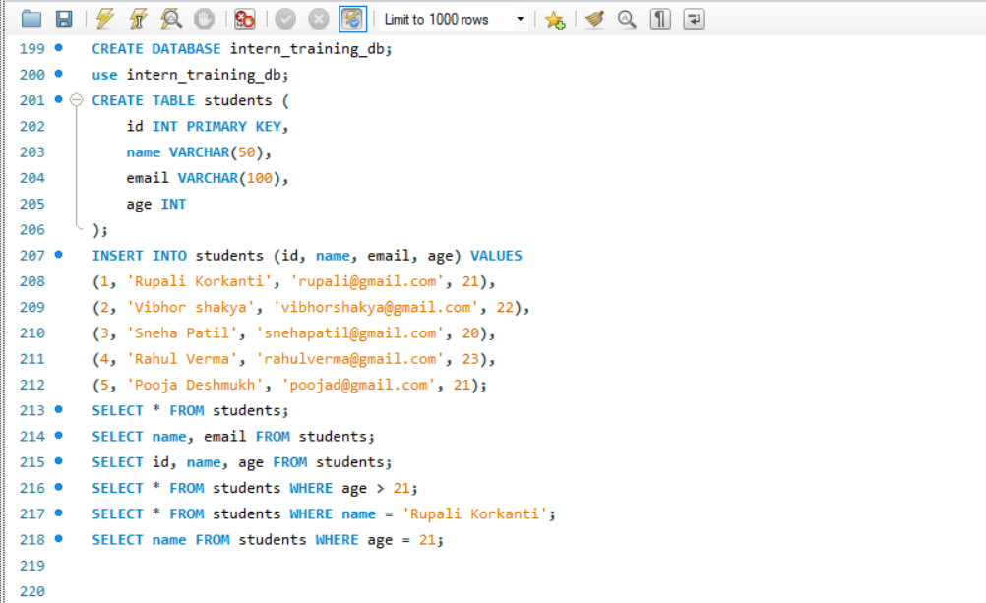

OUTPUT:
