**What's the Weather Like?**

**Background:**

This project is to visualize the weather of randomly selected 500+ cities across the world of varying distance from the equator. It utilizes, the [OpenWeatherMap API](https://openweathermap.org/api) and citipy python library to create a representative model of weather across world cities.

API calls are used to gather information about current weather around the globe.

The information goes into some of the relations a cities latitude and longitude has on things like humidity, cloudiness, wind speed, and max temperatures. Series of scatter plots are used to showcase the following relationships:

* Temperature (F) vs. Latitude

* Humidity (%) vs. Latitude

* Cloudiness (%) vs. Latitude

* Wind Speed (mph) vs. Latitude

A linear regression has been run on each relationship, separating them into Northern Hemisphere.

**Summary statistics of the ~500 randomly selected cities:**

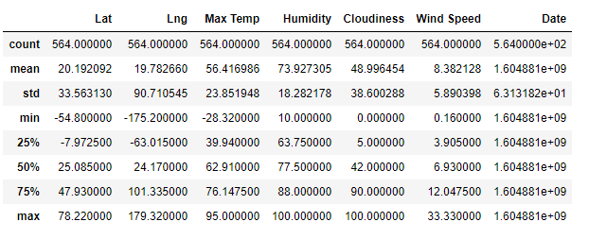

**Scatter plots:**

|  |  |
| --- | --- |
| **Latitude vs. Temperature Plot** | **Latitude vs. Humidity Plot** |
| **Latitude vs. Cloudiness Plot** | **Latitude vs. Wind Speed Plot** |

**Linear Regression:**

|  |  |
| --- | --- |
| **Northern Hemisphere - Max Temp vs. Latitude** | **Southern Hemisphere - Max Temp vs. Latitude** |
| **Northern Hemisphere - Humidity (%) vs. Latitude** | **Southern Hemisphere - Humidity (%) vs. Latitude** |
| **Northern Hemisphere - Cloudiness (%) vs. Latitude** | **Southern Hemisphere - Cloudiness (%) vs. Latitude** |
| **Northern Hemisphere - Wind Speed (mph) vs. Latitude** | **Southern Hemisphere - Wind Speed (mph) vs. Latitude** |

#### **Analysis:**

### Temperature rises going closer to the equator. As we move away from the equator on either directions, northern or the southern hemisphere, the temperature drops from high to low.[¶](http://localhost:8818/notebooks/code/WeatherPy.ipynb#Above-scatter-plot-demonstrates-how-the-temperature-changes-based-on-the-latitude.-Temperature-rises-going-closer-to-the-equator.-As-we-move-away-from-the-equator-on-either-directions,northern-or-the-southern-hemisphere,-the-temperature-drops-from-high-to-low.)

### The highest temperatures are around 23.5 N latitude which is known as the Tropic of Cancer,  latitude on Earth at which the Sun can be directly overhead and may be due to the tilt in the Earth`s Axis.

### Humidity tends to be high closer to the north pole.

### Cloudiness tends to be either 0 or 100% for majority locations.[¶](http://localhost:8818/notebooks/code/WeatherPy.ipynb#Above-scatter-plot-demonstrates-the-cloudiness-changes-based-on-the-latitude.-Cloudiness-tends-to-be-either-0-or-100%-for-majority-locations.)

### Wind speed is on an average around 8 mph (pretty calm) compared to the highest windspeed of about 33 mph. As we move away from the equator the wind speed remains closely tied to the 0 to 10 mph.

### There is a strong negative correlation between latitude and maximum temperature in northern hemisphere.

### There is a moderate positive correlation between latitude and max temperature in southern hemisphere.

### There is a weak positive correlation between latitude and humidity in northern hemisphere.

### There is very weak correlation between latitude and humidity in southern hemisphere. The difference between hemispheres is not significant enough to point out.

### There is a weak positive correlation between latitude and cloudiness in northern hemisphere.

### There is a weak positive correlation between latitude and humidity in southern hemisphere. The difference between hemispheres is not significant enough to point out.

### There is a very weak positive correlation between latitude and wind speed in northern hemisphere. It indicates that there is no relationship between wind speed and latitude.

### There is a weak positive correlation between latitude and wind speed in southern hemisphere. It indicates that there is no relationship between wind speed and latitude. The difference between hemispheres is not significant enough to point out.

### Latitude does not seem to affect humidity percentages, cloudiness, or wind speed.