**The VBA of Wall Street by Rupali Surve**

**Objective:** Use VBA scripting to analyze real stock market data.

* Create a script that will loop through all the stocks for one year and output the following information.

* The ticker symbol.

* Yearly change from opening price at the beginning of a given year to the closing price at the end of that year.

* The percent change from opening price at the beginning of a given year to the closing price at the end of that year.

* The total stock volume of the stock.

* You should also have conditional formatting that will highlight positive change in green and negative change in red.

**Challenges**

1. Solution will also be able to return the stock with the "Greatest % increase", "Greatest % decrease" and "Greatest total volume".

2. Make the appropriate adjustments to your VBA script that will allow it to run on every worksheet, i.e., every year, just by running the VBA script once.

**Screenshots:**

From the alphabetical_testing.xlsm,

I saved the original alphabetical_testing.xlsx file as macro enabled with .xlsm extension to include VBA script.

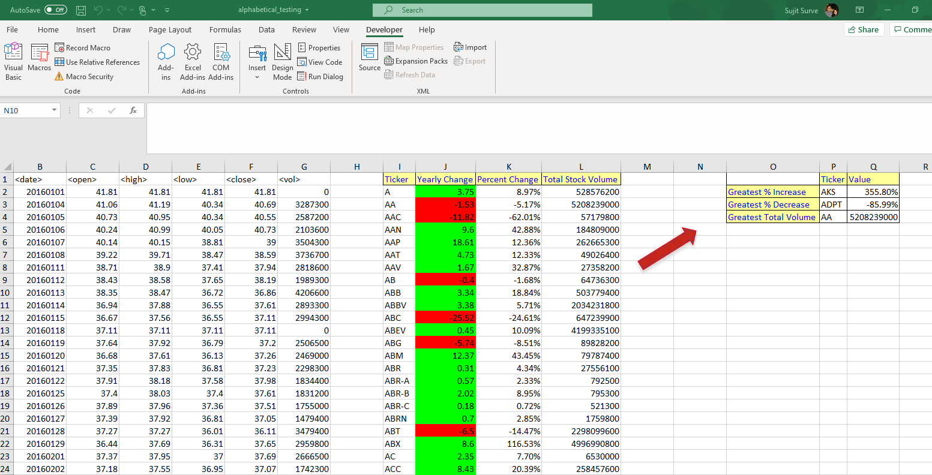

From the Multiple_year_stock_data.xlsm,

I saved the original Multiple_year_stock_data.xlsx file as macro enabled with .xlsm extension to include VBA script.

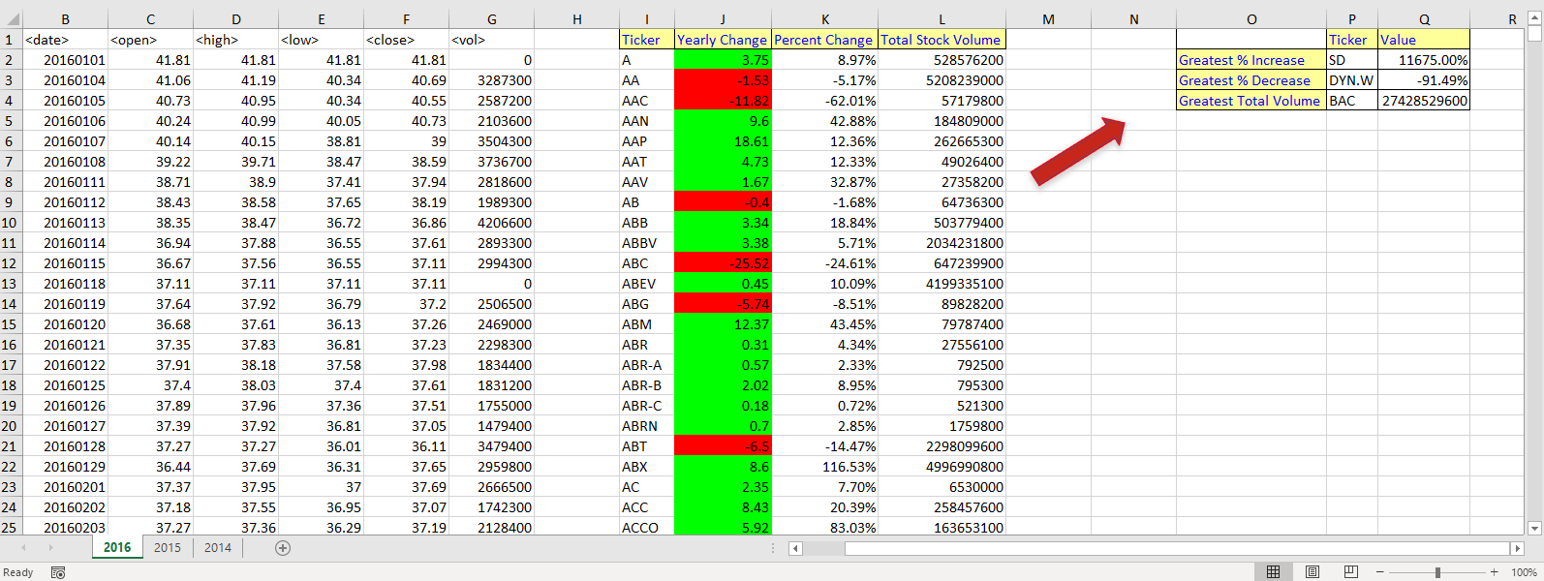

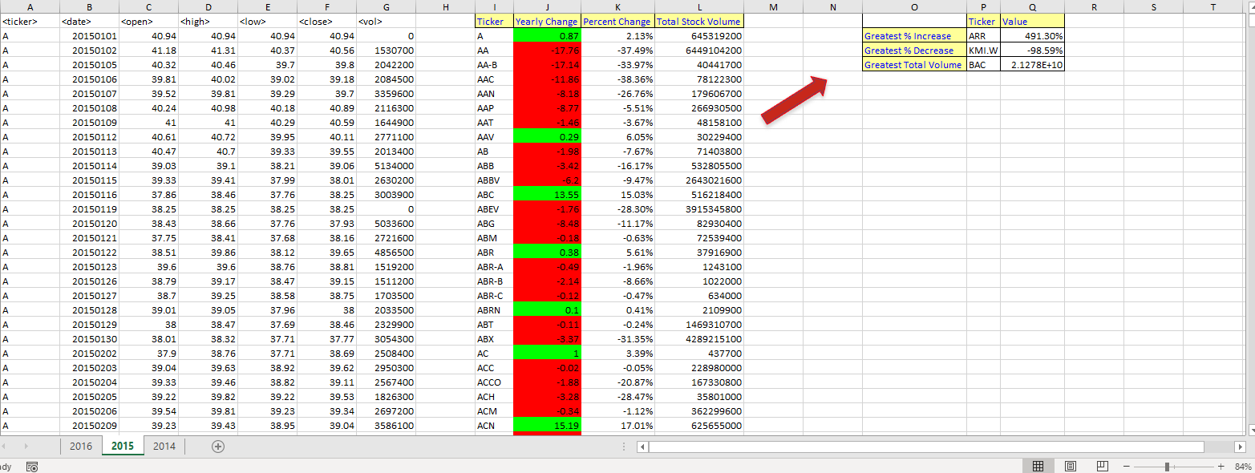

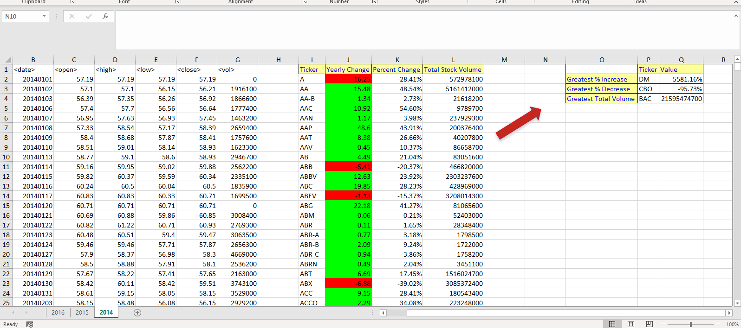

VBA Script

**P.S. :**

Before starting with the script, I analyzed stock data thoroughly.

There are several records within spreadsheet with zero as the opening stock price. Those records also have corresponding high, low, close and volume zero as well. This potentially indicates lack of trade for that day.

However to calculate percent change, zero opening stock price will lead to a mathematical problem. To address this issue I have included below logic,

if opening price = 0 then percent change =0

**Note:** Below VBA script is comprised of the homework assignment including challenge activity.

Below are all the sub routines included with the script,

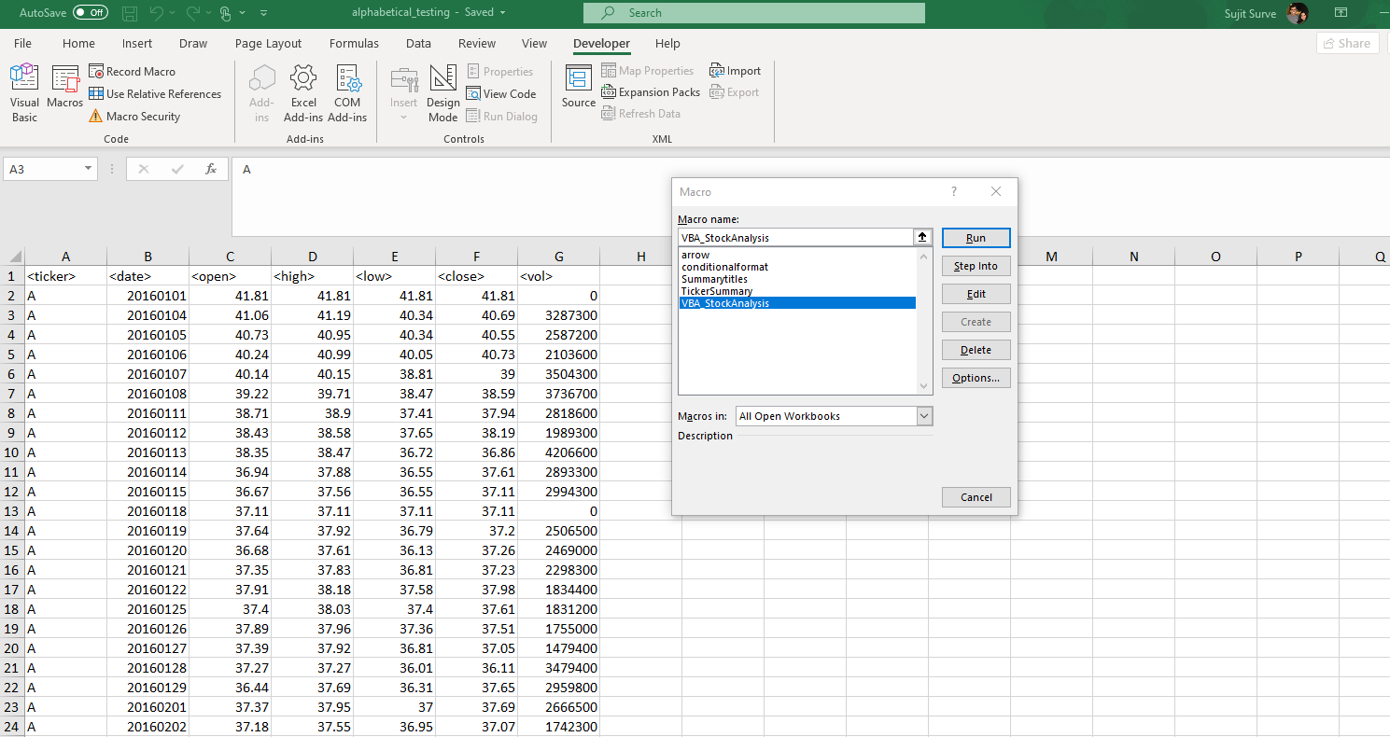

VBA_StockAnalysis is the main sub routine to populate summary of stock data. It will call multiple sub routines used to perform calculations and formatting. Script will run through all the worksheets within the spreadsheet.

If you need to rerun the script within same spreadsheet then please remove all summary to clear of formatting and run the script. That way it will not overlap the formatting of the shape object used.

Code begins below,

'Below VBA script is comprised of the homework assignment including challenge activity.

Sub VBA_StockAnalysis()

'this code works - satisfies homework requirement and challege 2

'to repeat the ticker summary calculation for each sheet in the workbook

'This is part of challenge 2

For Each ws In Worksheets

ws.Activate

'calling the sub routine which calculates ticker summary

Call TickerSummary

'Call StockSummaryChallengeSolution

Next ws

End Sub

Sub TickerSummary()

'Trying with one sheet

'Declaring variables to hold current ticker name, next ticker name, ticker summary count and total volume per ticker

Dim Thisticker As String

Dim NextTicker As String

Dim Summaryticker As LongLong

'setting up start of ticker at row 2 as 1st row is a header.

Summaryticker = 2

Dim Tickerstockvolume As LongLong

'Tickerstockvolume = 0

'Counting total number of rows. This will help to stop counting after the last row.

Dim Totalrows As LongLong

Totalrows = Cells(Rows.Count, 1).End(xlUp).Row

'defining variables to hold current ticker open and close values for yearly and percent change

Dim Thistickeropen As Double

Dim Thistickerclose As Double

Dim Yearlychange As Double

Dim Percentchange As Double

'setting initial value for ticker open value

Thistickeropen = Cells(2, 3).Value

'-----end of declare

' defining a loop so we can go through ticker in the current row, check the next row ticker value

'if both values match then raise current ticker count by 1 and add current ticket volume to the Tickerstockvolume

'if values don`t match then restart the loop at new value for the ticker and calculate summary per same logic

For i = 2 To Totalrows

'check the details of the ticker from the curernt row

Thisticker = Cells(i, 1).Value

'check the details for the ticker from the next row

NextTicker = Cells(i + 1, 1).Value

Tickerstockvolume = Tickerstockvolume + Cells(i, 7).Value

'check if the value of the current cell and next cell are different so can write to summary

If Thisticker <> NextTicker Then

'when ticker value changes, calculate summery and write to the summary table/columns

'Cells(Summaryticker, 9).Value = Thisticker

'Cells(Summaryticker, 12).Value = Tickerstockvolume

Range("I" & Summaryticker).Value = Thisticker

Range("L" & Summaryticker).Value = Tickerstockvolume

'----------------This is the start for yearly change and percent change calculations---------------------------------------

Thistickerclose = Cells(i, 6).Value

'calculate yearly change which is (close price at the end of the year - open price at the beginning of the year)

Yearlychange = Thistickerclose - Thistickeropen

'write yearlychange to the summary table/column

Range("J" & Summaryticker).Value = Yearlychange

'calculate % change ...set % change = 0 if open price = 0 to address mathematical problem with % calculation

'% change here will be (yearlychange)/Open)*100 ---since using number format to covert using yearlychange/Open

If Thistickeropen = 0 Then

Percentchange = 0

Else

Percentchange = Yearlychange / Thistickeropen

End If

'Debug.Print Percentchange

'Write the % change for each ticker in the summary table

Range("K" & Summaryticker).Value = Percentchange

Range("K" & Summaryticker).NumberFormat = "0.00%"

'----------------This is the end for yearly change and percent change calculations---------------------------------

'since now we have summary for the current ticker, write it to the summary table and advance to the next row for the ticker

Summaryticker = Summaryticker + 1

'since now we have new ticker, resetting the total

Tickerstockvolume = 0

'reset open value for next ticker

Thistickeropen = Cells(i + 1, 3).Value

' Percentchange = 0

' Tickerstockvolume = 0

End If

Next i

'Challenge 1 - To calculate Greatest % increase, Greatest % decrease and Greatest total volume of all tickers,

'if Percentchange is -ve then price decreased, if +ve means price increased

'to accommodate this logic using maximum and minimum values from the percentchange

Dim TotRowsSummary As LongLong

TotRowsSummary = Cells(Rows.Count, 9).End(xlUp).Row

For i = 2 To TotRowsSummary

If Cells(i, 11).Value = Application.WorksheetFunction.Max(Range("K2:K" & TotRowsSummary)) Then

Cells(2, 16).Value = Cells(i, 9).Value

Cells(2, 17).Value = Cells(i, 11).Value

Cells(2, 17).NumberFormat = "0.00%"

ElseIf Cells(i, 11).Value = Application.WorksheetFunction.Min(Range("K2:K" & TotRowsSummary)) Then

Cells(3, 16).Value = Cells(i, 9).Value

Cells(3, 17).Value = Cells(i, 11).Value

Cells(3, 17).NumberFormat = "0.00%"

ElseIf Cells(i, 12).Value = Application.WorksheetFunction.Max(Range("L2:L" & TotRowsSummary)) Then

Cells(4, 16).Value = Cells(i, 9).Value

Cells(4, 17).Value = Cells(i, 12).Value

End If

Next i

'calling the subroutines which formats summary data

Call Summarytitles

Call conditionalformat

Call arrow

End Sub

Sub Summarytitles()

'Defining new column headers for the ticker summary.

'clearing cell values and formatting

' Range("I:Q").Value = ""

' Range("I:Q").Interior.ColorIndex = 0

'for the ticker summary

Range("i1").Value = "Ticker"

Range("j1").Value = "Yearly Change"

Range("k1").Value = "Percent Change"

Range("l1").Value = "Total Stock Volume"

Range("i1").Font.ColorIndex = 5

Range("i1").Interior.ColorIndex = 36

Range("j1").Font.ColorIndex = 5

Range("j1").Interior.ColorIndex = 36

Range("k1").Font.ColorIndex = 5

Range("k1").Interior.ColorIndex = 36

Range("l1").Font.ColorIndex = 5

Range("l1").Interior.ColorIndex = 36

Range("i1:l1").BorderAround (1)

Range("i1:l1").Borders.LineStyle = xlContinuous

Range("i1:l1").Borders.ColorIndex = 0

Range("i1:l1").Borders.TintAndShade = 0

Range("i1:l1").Borders.Weight = xlThin

'for the challenge 1

Range("p1").Value = "Ticker"

Range("q1").Value = "Value"

Range("o2").Value = "Greatest % Increase"

Range("o3").Value = "Greatest % Decrease"

Range("o4").Value = "Greatest Total Volume"

Range("p1").Font.ColorIndex = 5

Range("p1").Interior.ColorIndex = 36

Range("q1").Font.ColorIndex = 5

Range("q1").Interior.ColorIndex = 36

Range("o2").Font.ColorIndex = 5

Range("o2").Interior.ColorIndex = 36

Range("o3").Font.ColorIndex = 5

Range("o3").Interior.ColorIndex = 36

Range("o4").Font.ColorIndex = 5

Range("o4").Interior.ColorIndex = 36

Range("o1:q4").BorderAround (1)

Range("o1:q4").Borders.LineStyle = xlContinuous

Range("o1:q4").Borders.ColorIndex = 0

Range("o1:q4").Borders.TintAndShade = 0

Range("o1:q4").Borders.Weight = xlThin

Range("I:Q").Columns.AutoFit

'Range("i1").Font.ColorIndex = 5

'Range("i1").Interior.ColorIndex = 6

'Range("i1").Font.Size = 15

'Range("i1").Font.Name = "Calibri"

'Range("i1").ColumnWidth = 20

'Range("i1").Font.Bold = True

End Sub

'Conditional formatting to highlight positive change in green and negative change in red.

Sub conditionalformat()

Dim summaryrows As LongLong

'find the last row of the summary table

summaryrows = Cells(Rows.Count, 9).End(xlUp).Row

'set color depending on yearly change

For i = 2 To summaryrows

If Cells(i, 10).Value > 0 Then

Cells(i, 10).Interior.ColorIndex = 4

Else

Cells(i, 10).Interior.ColorIndex = 3

End If

Next i

End Sub

'formating for object arrow

Sub arrow()

ActiveSheet.Shapes.AddShape(msoShapeRightArrow, 850, 91.5, 80, 22.5).Select

Selection.ShapeRange.IncrementRotation 327.8691666667

Selection.ShapeRange.IncrementLeft -5.2500787402

Selection.ShapeRange.IncrementTop -7.5000787402

With Selection.ShapeRange.Fill

.Visible = msoTrue

.ForeColor.RGB = RGB(187, 33, 21)

.Transparency = 0

.Solid

End With

With Selection.ShapeRange.Shadow

.Type = msoShadow25

.Visible = msoTrue

.Style = msoShadowStyleOuterShadow

.Blur = 4

.OffsetX = 2.4492935983E-16

.OffsetY = 4

.RotateWithShape = msoFalse

.ForeColor.ObjectThemeColor = msoThemeColorBackground1

.ForeColor.TintAndShade = 0

.ForeColor.Brightness = -0.150000006

.Transparency = 0

End With

With Selection.ShapeRange.Shadow

.Type = msoShadow25

.Visible = msoTrue

.Style = msoShadowStyleOuterShadow

.Blur = 4

.OffsetX = 2.4492935983E-16

.OffsetY = 4

.RotateWithShape = msoFalse

.ForeColor.RGB = RGB(255, 0, 0)

.Transparency = 0

.Size = 100

End With

With Selection.ShapeRange.Shadow

.Type = msoShadow25

.Visible = msoTrue

.Style = msoShadowStyleOuterShadow

.Blur = 4

.OffsetX = 2.4492935983E-16

.OffsetY = 4

.RotateWithShape = msoFalse

.ForeColor.ObjectThemeColor = msoThemeColorBackground1

.ForeColor.TintAndShade = 0

.ForeColor.Brightness = -0.150000006

.Transparency = 0

.Size = 100

End With

Selection.ShapeRange.Reflection.Type = msoReflectionType1

Selection.ShapeRange.Reflection.Type = msoReflectionTypeNone

With Selection.ShapeRange.Glow

.Color.RGB = RGB(255, 0, 0)

.Transparency = 0

.Radius = 10

End With

With Selection.ShapeRange.Glow

.Color.ObjectThemeColor = msoThemeColorAccent4

.Color.TintAndShade = 0

.Color.Brightness = 0.8000000119

.Transparency = 0

.Radius = 10

End With

With Selection.ShapeRange.Glow

.Color.ObjectThemeColor = msoThemeColorAccent2

.Color.TintAndShade = 0

.Color.Brightness = 0

.Transparency = 0.6000000238

.Radius = 5

End With

With Selection.ShapeRange.Glow

.Color.ObjectThemeColor = msoThemeColorBackground1

.Color.TintAndShade = 0

.Color.Brightness = -0.150000006

.Transparency = 0.6000000238

.Radius = 5

End With

Application.CommandBars("Format Object").Visible = False

Selection.ShapeRange.ThreeD.ContourColor.RGB = RGB(255, 0, 0)

Range("N10").Select

End Sub