|  |  |
| --- | --- |
| Drinks Website  Report  Web Design and Development  Coursework 1 – Report  Matriculation Number - 40596677 |  |
|  |  |

**Contents**

Initial Research 3

Mission Statement: - 4

Evaluation Criteria: - 4

Measures of Success 5

Requirements 6

Horizontal Prototype and its requirements 7

# Initial Research

**URL:** [**www.gotoliquorstore.com**](http://www.gotoliquorstore.com)

When we open this website, a pop-up window will appear first. In this age question box, if a person is under 21 years of age, then that person is not eligible to view this website. This one feature is very good, but another section has been created for under 21s. When we select the 'yes' button, the web page will display the entire content. The website content, images and design are beautiful and attractive. On this website, we can log in, create an account and add a product to a wish list or cart. We can easily buy drinks according to functions and types of drinks.

**URL:** [**www.winewell.in**](http://www.winewell.in)

We can easily get all the drinks through this website. They charge no mark-ups and have low delivery fees. There is also a pop-up massage for upcoming drinks. we can also buy different kinds of blenders through this website. The control panel of this website is easy to use and understand. But one thing that is not according to the rules is certain age criteria for consuming drinks, but on this site. There are no age restrictions for users.

**URL:** [**www.drinkspune.com**](http://www.drinkspune.com)

We can easily order different liqueurs. Same day delivery is also available on this website. The dashboard with the color combination of yellow and black is also an easy to understand dashboard of this site. There are no age criteria for alcohol consumption.

# Mission Statement: -

Our mission is to offer all sorts of drinks, appetizers, spirites, mocktails, cocktails, soft drinks, etc. to quench your thirst and reach a bigger audience day by day and lure them with our promised services.

# Evaluation Criteria: -

**We need to follow these things while evaluating any website: -**

|  |  |
| --- | --- |
| Criteria | Description |
| Website Availability | Customers should be able to easily find your website and all pages should be easily linked to each other. Otherwise, users will get confused when finding the page they need. |
| Compatibility | Your website should be compatible with all current technologies, platforms and modern web browsers. |
| Speed | The website should load instantly and not keep the user waiting for a long time |
| Integrity | Your website should be well structured and have good navigation. Users should also be able to get different options when logging in. |
| Typography | Website text layout should be well formatted and legible. Content should follow a similar format |
| User Friendly | The internet site should display to the person if there may be any errors came about. The website must provide right mistakes messages so the user is aware of what desires to be accomplished |
| Styling | There should be only one css file controlling every style of the website. |
| Uniformity | Websites should have a similar pattern, the header and footer should be the same on every page of the website. |
| Meta Data | The website should be properly filled with metadata, keywords, description and images should also contain appropriate alternative description. |
| Responsiveness | A website should be responsive for every type of device like computer, laptop, mobile etc. User can use any kind of device so it is better to be responsive. |
| Color Combination | The color combination of the website should satisfy the user's eyes. |

# Measures of Success

**Marketing** - Since it is an era of digital marketing, by shifting to online mode the marketing has become easier and we are able to reach more customers now. Marketing efforts has been reduced by 50% and awareness has been increased by 60% of our website.

**Reduced Load on inventory** - Since orders can also be placed to vendors directly if there are no items available in inventory, this feature has reduced the load on our inventory team by 50%.

**Low cost of staff** - Staffing cost has been reduced by 20% because of less maintenance of inventory required and less accounting needed, as it is handled by the website itself.

**Delivery Overhead** - Though website has more advantages but this is one disadvantage that we have now few members in delivery team who deliver the drinks from door to door, this has increased expenses by 15%.

**Customer Retention** - Due to ease of using the website, more and more customers do return to us and place more and more orders. Customer retention has increased by 30%.

# Requirements

**For developing any kind of website these are the following requirements: -**

* The website should have the right color combination so that the user feels very satisfied while browsing the website
* Websites should be accessible from any type of device, not just one specific type of device
* The website should be responsive, which means that any type of screen will be suitable for the website to load properly.
* Images should have the correct width and height and should not take up a lot of space on the site.
* There should be no horizontal scrolling.
* The website should have proper navigation so that the user can go through each individual page of the website.
* A website should have proper headers and footers and the like throughout the website
* There should be sufficient padding and space between elements.
* Websites should have a similar font and should have the correct font size and color.
* The product display should be in the correct card format where the image should be at the top and the add to cart button at the bottom.
* There should be proper login and registration buttons to redirect users to appropriate pages.
* The navigation bar should be static or sticky at the top of the web page.
* A logged-in user should get different permissions than a non-logged-in user.
* The navigation bar should contain at least 4 links to the menu, logo and login and registration buttons.
* The background color should match the color of the text and images.
* The text should be as legible as possible.
* Correct labels to put in input labels for best user understanding.

# Horizontal Prototype and its requirements

1. There is fix navigation bar which has website name Sippers and 4 links to redirect Home, Alcoholic, Non Alcoholic, Contact us and login.

Then comes to footer which has all links mentioned like quick links, extra link also contact information.

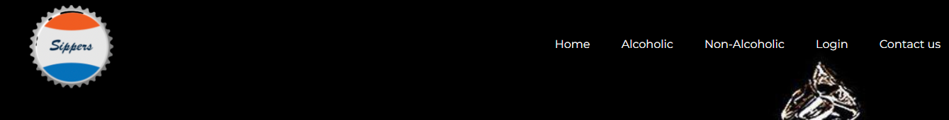

1. **Home**

There is big image which explains the motive of website by categorizing alcoholic and Non alcoholic buttons.

Below we have three blocks which shows easiness features which we will be giving to customers.

Products with discounts are also displayed on Home page with the brands.

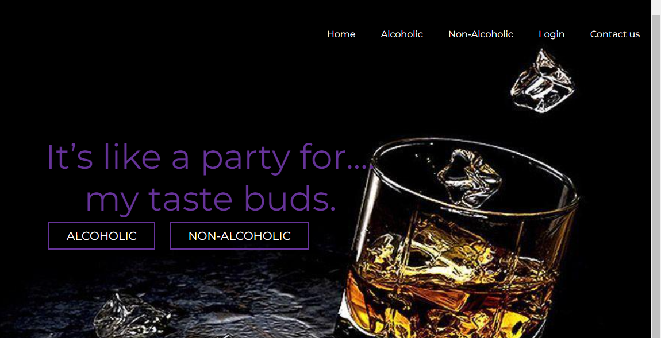

1. Alcoholic

This page has all products with there images and price below it.



1. Non Alcoholic

This page has all information with the features of website with the image.

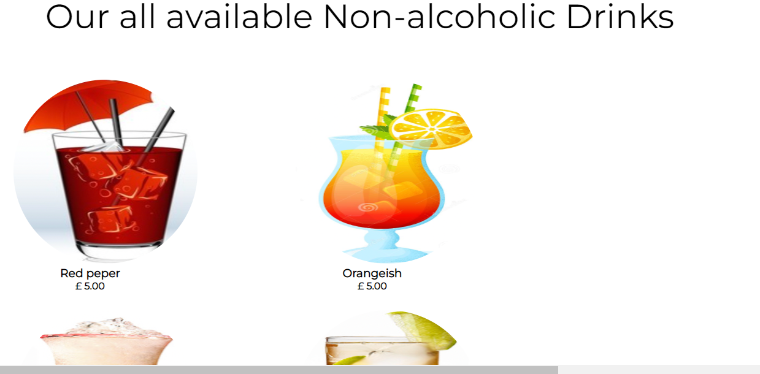

1. Contact Us

This page contains the form which customer has to fill to reach out with the queries to us with their contact information.

1. Login

This is the page which has form for the users who want to register and make their profile on out website.

