B.Tech. CSE(AIML & IOT) (III YEAR – V SEM) (2025-2026)

DEPARTMENT OF COMPUTER ENGINEERING & APPLICATIONS


GLA University
17km Stone, NH-19, Mathura-Delhi Road P.O. Chaumuhan, Mathura –
281406(Uttar Pradesh) India

Project Title: AI Agent Website Builder

Team Member 1: Rupam Ganguly
UR: 2315510177
Team Member 2: Mishi Johri
UR: 2315510124

Mentor Name: Mr. Preshit Mangesh Desai
Signature:

INDEX

S.NO | Content
1 | Project Introduction
2 | Project Index
3 | Week Wise Project TimeLine
4-6 | Individual Contributions
7 | Technical Documentataion
8-9 | Project Snapshots

AI Agent Website Builder

Cover:
Project title: AI Agent Website Builder
Team name & ID: Team 12
Institute / Course: GLA UNIVERSITY, Mini Project
Date: 14 Feb 2026

- Week Wise TimeLine:

Week/Duration | Task & Activities | Assigned To | Outcome | Completion Status
Week 1 (3rd Feb –  9th Feb 2026 ) | - Studied the concept of AI-powered website builders and agentic code generation frameworks.  Explored existing tools and identified scope for a natural-language-driven website builder.  Set up the development environment (Python, Node.js, React.js, Vite, and Git).  Created project structure and initialized backend using Python/Flask and Node.js.  - Explored existing SEO automation projects and identified scope for enhancement.  - Set up the development environment (Python, Node.js, React, and Git).  - Created project structure and initialized backend using  FastAPI / Flask. | TEAM | Project plan and scope finalized | Completed
Week 2 ( 10th Feb  – 16th Feb 2026 ) | - Integrated the AI agent framework for multi-agent orchestration.  Implemented core agents for prompt interpretation and website code generation.  Connected OpenAI / LLM APIs for natural language processing and code output.  Defined REST API routes for communication between frontend, backend, and AI agents.  - Implemented basic SEO task agents (keyword research, SERP analysis, content optimization).  - Connected SerpAPI / SerperAPI for real-time keyword and search data.  - Defined API routes for communication between backend and agents. | Rupam, Mishi | Backend Setup & AI Agent Framework Integration | Completed
Week 3 ( 17th Feb –  23rd Feb 2026 ) | - Implemented data flow between AI agents and the backend API.  Designed MongoDB schemas for project metadata, messages, and file storage.  Tested inter-agent communication and task coordination through the agent orchestration layer.  - Designed schemas for keyword analysis results and SEO reports.  - Tested inter-agent communication and task coordination through AI Agent Website Builder workflows. | Rupam, Mishi | Data Flow & Agent Coordination | Completed

Week 4 ( 24th Feb  – 2nd Mar 2026 ) | - Set up React.js frontend using Vite.  Designed the Home page, Login, Signup pages, and initial Dashboard layout.  Integrated frontend with backend REST APIs for project listing and creation.  Worked on responsive layouts and theming using Tailwind CSS and custom CSS.  - Designed the dashboard UI for displaying keyword insights, analytics, and reports.  - Integrated frontend with backend APIs for real-time updates.  - Worked on responsive layouts and basic styling using Tailwind CSS / Material UI. | Rupam, Mishi | Frontend Development Begins | Completed
Week 5 ( 3rd Mar  – 9th Mar 2026 ) | - Enhanced AI agents with autonomous code generation and iterative refinement based on user feedback.  Added functionality for project-specific Git version control (commit, history, revert).  Improved the AI prompt-to-code pipeline for accuracy and speed.  Optimized backend efficiency and reduced API response latency.  - Added functionality for automated SEO strategy generation.  - Integrated OpenAI / LLM API for natural language content optimization.  - Improved backend efficiency and reduced API latency. | Rupam, Mishi | Advanced AI Code Generation Features | Completed
Week 6 ( 10th Mar  – 16th Mar 2026 ) | - Completed the cinematic Dashboard UI overhaul with glass card effects, light/dark mode, and project management features.  Implemented protected routing - Dashboard accessible only after login/signup.  Conducted testing for both frontend and backend modules.  Debugged inter-agent communication and API responses.  - Implemented login/authentication system (if applicable).  - Conducted testing for both frontend and backend modules.  - Debugged inter-agent communication and API responses. | TEAM | UI  Enhancem ent & Testing | In Progress
Week 7 (17th Mar –  6th Apr 2026) | - Finalized the Workspace UI with live preview, AI chat, and file explorer.  Integrated all modules - frontend, backend, AI agents, and Git - into a unified platform.  Performed end-to-end testing of the complete system.  Prepared documentation and project presentation materials.  - Integrated all modules into a unified dashboard.  - Performed end-to-end testing  of the system.  - Prepared documentation and final project presentation. | TEAM | Report Generation & Final Integration | Pending

Week 8 (7th Apr –  15th May 2026) | - Optimized frontend for performance, visual polish, and user experience.  Conducted final checks, minor bug fixes, and deployment preparation.  Compiled report materials, screenshots, and documentation for final submission.  - Conducted final checks, minor bug fixes, and deployment preparation.  - Compiled report materials and screenshots for documentation. | TEAM | Final Review & Optimization | Pending

- Individual Contribution:
Team Member 1: Rupam Ganguly
Role: Frontend Developer & Team Lead
  - Responsibilities as Lead

- Acted as the team lead, coordinating workflow and task distribution across the frontend and AI integration teams.
- Supervised the integration between AI agents, REST APIs, and the React frontend, ensuring seamless communication.
- Conducted code reviews, maintained repository structure, and guided best practices in frontend architecture and component design. Managed project timeline and weekly progress tracking, ensuring milestone completion.
- Supported team members in debugging, testing, and understanding the AI agent framework and Node.js backend. Led project demonstrations and documentation for evaluation and presentation.

Technical Contribution:

    - Designed and developed the core frontend UI using React.js and Vite, including the Home page, cinematic Dashboard, and project workspace.
    - Built reusable React components for the landing page hero section, feature showcase, testimonials, and infinite-scroll carousel.
    - Integrated the React frontend with backend REST APIs (Node.js/Flask) for real-time project listing, creation, and workspace management.
    - Implemented the navigation routing system using React Router, including conditional rendering of Navbar/Footer for the dashboard route.
    - Developed the project workspace UI for displaying the live preview pane, file explorer, and AI chat interface.
    - Implemented frontend performance optimizations including code splitting, lazy loading, and responsive layouts.
    - Conducted end-to-end testing of all frontend flows, validating API integration and navigation behaviour.
    - Collaborated with Mishi on integrating AI-generated responses and dynamic content updates into the frontend.

Frontend Development Work:

    - Built React.js page components: Home, Login, Signup, Dashboard, and Workspace, each with dedicated CSS styling.
    - Designed and implemented the overall application layout including global Navbar, Footer, and route-based conditional rendering.
    - Integrated Axios-based API calls for fetching projects, creating new workspaces, and loading file content from the backend.
    - Developed the project card grid on the Dashboard with search filtering, framework badges, and creation modals.
    - Ensured frontend security by implementing authenticated route guards — unauthenticated users are redirected to Login.
    - Applied light/dark mode theming using Tailwind CSS class toggling and scoped CSS overrides for each page.
    - Continuously refined the frontend for visual polish, responsiveness, and consistency across all screen sizes.

GitHub Branch:
- https://github.com/RupamGanguly46/UdgatiSEO/tree/Rupam

Name: Mishi Johri Role: AI Integration & Frontend Development
  - Responsibilities:

    - Collaborated with Rupam on frontend development and led the AI agent integration within the project.
    - Focused on integrating the AI backend (Python/Flask) with the frontend, managing API endpoints and ensuring stable communication.
    - Built and refined the AI prompt interface allowing users to describe their website in natural language and receive live code generation.
    - Took initiative in implementing the light/dark theme system, sidebar navigation, and dashboard UI improvements.
    - Coordinated documentation of both AI workflows and frontend processes, and assisted in final integration testing.

Technical Contribution:

    - Integrated the AI agent backend with the React frontend, enabling natural language prompts to trigger real-time website generation.
    - Developed the AI chat interface in the Workspace page where users interact with the AI to modify and build their projects.
    - Designed and implemented the cinematic-style Dashboard UI — including the project card grid, search bar, and new project modal.
    - Built the Login and Signup authentication pages with password visibility toggles and post-auth routing to the Dashboard.
    - Implemented the full light/dark mode theming system using scoped CSS in Dashboard.css with Tailwind class toggling.
    - Configured auth-protected routing — Dashboard is accessible only after login/signup via a localStorage session flag.

Frontend & AI Development Work:

    - Created and styled the modular Dashboard page with glassmorphism card effects, cinematic shadows, and responsive layout.
    - Performed testing and validation of the AI prompt-to-code pipeline and frontend API response handling.
    - Optimized the light mode appearance — sidebar, header, and card components — to precisely match the design specification.
    - Improved the sidebar icon contrast, active state highlighting, and search bar text legibility in light mode.
    - Supported the frontend-backend integration by ensuring consistent API response handling and error state management.

GitHub Branch:
- https://github.com/RupamGanguly46/UdgatiSEO/tree/Mishi

- https://github.com/RupamGanguly46/UdgatiSEO/tree/Poorvi

Technical Documentation & Research Work

  - Overview:

The AI Agent Website Builder is an innovative AI-powered platform that enables users to create, modify, and deploy fully functional websites through natural language prompts. It leverages a multi-agent AI architecture where intelligent agents interpret user descriptions and autonomously generate production-ready code — eliminating the need for manual coding. Built with a modern full-stack architecture, the platform provides a collaborative, real-time development environment accessible through a cinematic web dashboard.

Core Technologies Used:

. AI & Agent Frameworks

    - Custom AI Agent Framework: Powers intelligent agent communication, task decomposition, and code generation using LLMs (Large Language Models).
    - OpenAI / LLM APIs: Integrated for generating website code, interpreting natural language prompts, and producing structured HTML/CSS/JS outputs.
    - Agentic Orchestration Layer: Developed for coordinating multiple intelligent agents that collaborate autonomously — one for prompt interpretation, one for code generation, and one for Git version control.

Backend Technologies:

- Python / Flask: Core backend language and framework used to implement REST APIs, AI agent communication modules, and project management logic.
- Node.js + Express: Used alongside Python for serving project files, managing the dev server lifecycle, and handling real-time workspace operations.
- MongoDB: NoSQL database used for storing project metadata, user sessions, conversation history, and file references.
- Postman: Utilized for API testing, validation, and debugging of all backend REST endpoints.

Frontend Technologies:

- React.js + Vite: Used to build a fast, responsive, and dynamic user interface including the Dashboard, Workspace, Login, Signup, and Home pages.
- Tailwind CSS + Custom CSS: For professional, cinematic, and consistent interface styling with full light/dark mode support.

Tools & Version Control:

- Git & GitHub: Used for version control, collaboration, and continuous tracking of development progress.
- VS Code: Primary development environment for writing, testing, and debugging both backend and frontend code.
- NPM: For managing both frontend (React/Vite) and backend (Node.js) dependencies and build scripts.
- Git Branching Strategy: Each team member works on their named branch (mishi, rupam) with pull requests for integration.

. AI & Code Generation Components

- Prompt-to-Code Generation: AI agents translate natural language descriptions into structured, production-ready HTML/CSS/JavaScript and React component code.
- Git-Based Version Control: Every AI-generated change is committed to a project-specific Git repository, enabling full versioning, history browsing, and rollback.

- NLP-Based Prompt Interpretation: Implemented text understanding pipelines for parsing user intent from natural language into structured code modification instructions.

Research & Conceptual Study:

Website development has traditionally required deep expertise in programming languages, frameworks, and design systems. However, this creates a significant barrier for individuals and small businesses who wish to establish a web presence without technical know-how. The AI Agent Website Builder addresses this gap by enabling users to describe their desired website in plain English and receive a fully functional, deployable website in return.
With the rapid advancement in Large Language Models (LLMs) and agentic AI architectures, the scope for automating software development has expanded significantly. The AI Agent Website Builder leverages these advancements to create an end-to-end platform where AI agents handle code generation, modification, and version control — making professional web development accessible to everyone.

Research Motivation:

Conventional website builders like Wix, Squarespace, and Webflow offer drag-and-drop tools but rely heavily on user interaction with predefined templates. They lack the ability to:
    - Understand and interpret free-form natural language instructions,
    - Generate custom code beyond predefined blocks and templates, and
    - Maintain a versioned, collaborative development workflow for non-technical users.
This motivated the creation of an AI-driven website builder that could simulate a professional developer — where the AI agent interprets the user's vision and autonomously generates, modifies, and version-controls the website codebase through natural conversation.

Literature Review & Related Work

Recent advancements in multi-agent systems and agentic AI architectures (2023–2025) have introduced frameworks that enable distributed, goal-oriented collaboration among AI components, including code generation, debugging, and deployment automation.
Research in LLM-based code generation (GitHub Copilot, Devin, GPT-4o) highlights that autonomous agents can produce functional software components with minimal human supervision when given structured prompts and context.
Several studies emphasize the growing potential of conversational AI for software development tasks. This project builds upon these findings by creating a multi-agent system specifically optimized for website generation from natural language.

Conceptual Framework:

The conceptual foundation of the AI Agent Website Builder is based on multi-agent AI intelligence, LLM-powered code generation, and Git-based version control. The system is designed with the following conceptual components:
    - AI Agent Layer:
A set of intelligent agents that specialize in prompt interpretation, code generation, and file management. Each agent operates semi-independently but communicates within a shared orchestration layer to deliver coherent, contextually accurate website code.
    - Backend Intelligence Layer:
Built using Python/Flask and Node.js, this layer manages project creation, AI prompt routing, Git operations, and file serving for the live preview environment.

    - Code Generation & Version Control Layer:
Implements AI-driven file creation, structured code modification, and automatic Git commits — enabling users to browse history and revert to any previous version of their website.
    - Frontend Visualization Layer:
A React.js-based cinematic dashboard that enables project management, real-time AI interaction, live website preview, and file browsing in an immersive development environment.

Research Objectives:

The conceptual study led to the formulation of the following research objectives:
- To design an AI-driven multi-agent framework for automating website creation from natural language prompts.
- To develop a backend capable of coordinating autonomous AI agents for code generation, file management, and Git versioning.
- To implement an intuitive, real-time frontend workspace where users interact with AI agents conversationally.
- To provide a cinematic dashboard for project management with support for multiple frameworks (React, Node.js, Python).
- To establish a scalable and modular architecture that supports future integration with cloud deployment and CI/CD pipelines.

Research Gap and Innovation:

While traditional website builders provide template-based creation, they lack autonomous code generation and natural language understanding.
The AI Agent Website Builder fills this gap by introducing:
    - Conversational AI agents that understand free-form user intent and translate it into production-ready code.
    - End-to-end automation of the website creation, editing, and versioning workflow.
    - AI-driven code generation that dynamically adapts to user feedback and iterative prompt refinement.
    - A developer-friendly architecture integrating AI intelligence with a live, real-time frontend preview.

Conceptual Outcome:

The outcome of this conceptual study is a robust, intelligent, and modular system capable of:
    - Understanding user website requirements contextually through natural language processing,
    - Generating complete, functional website code autonomously through coordinated AI agents,
    - And providing real-time visual feedback to users via a live preview pane within the web workspace.
This fusion of AI, multi-agent orchestration, and modern web technologies demonstrates how automation can transform website creation from a technical endeavour into an accessible, conversational, and intelligent experience.

- Project Snapshots and Outputs:

  - Code:
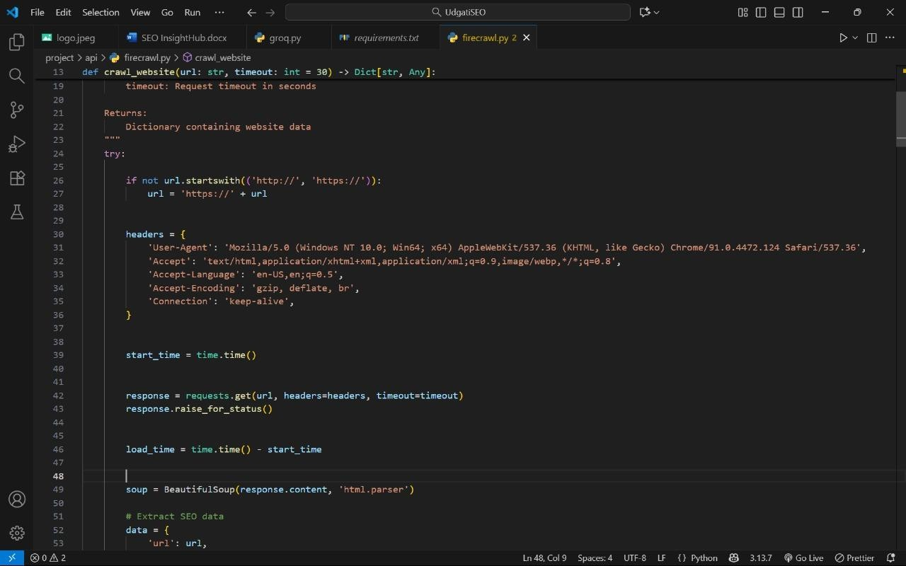

  - AI Agent Website Builder Key Features:
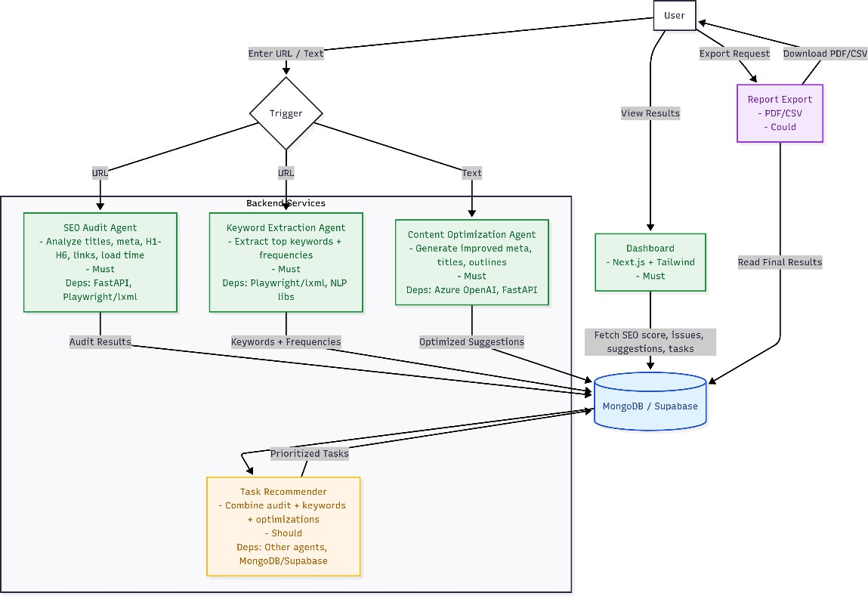
  - Team Workflow:

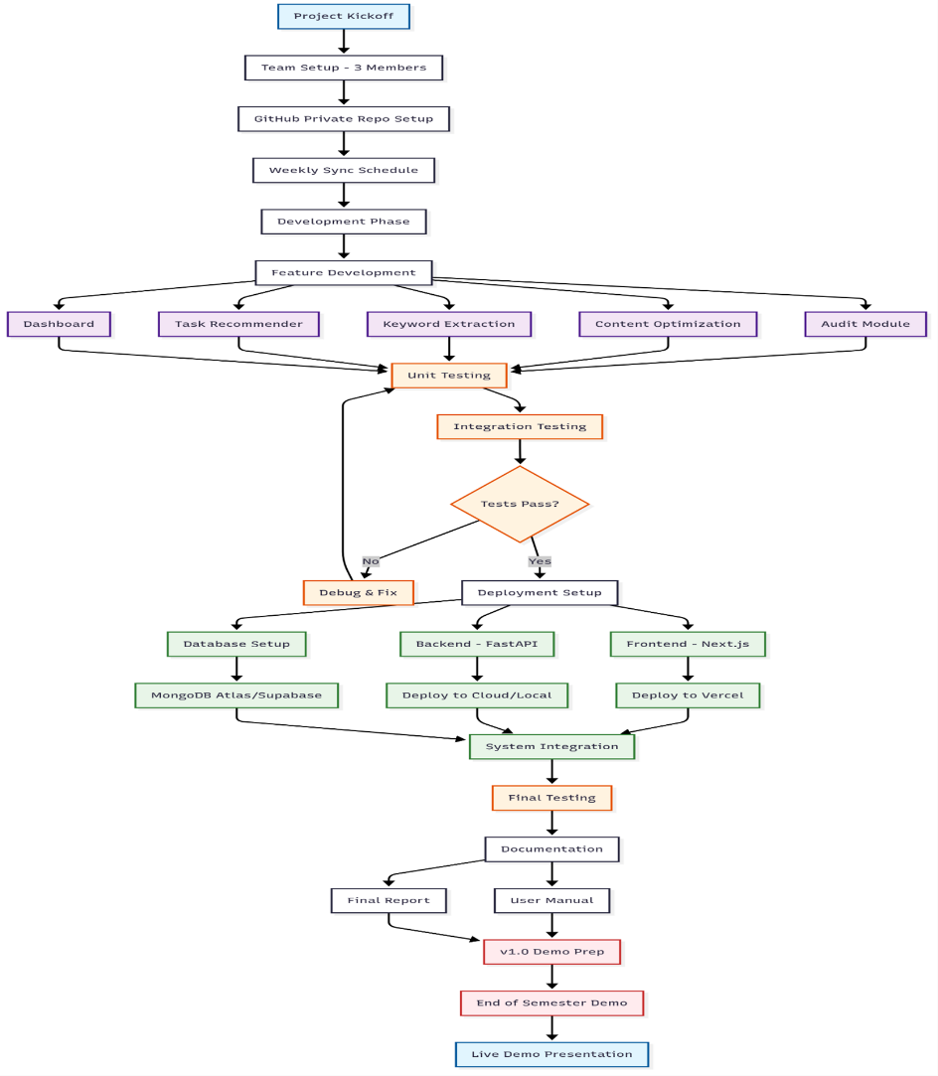

  - Front-end Dashboard:
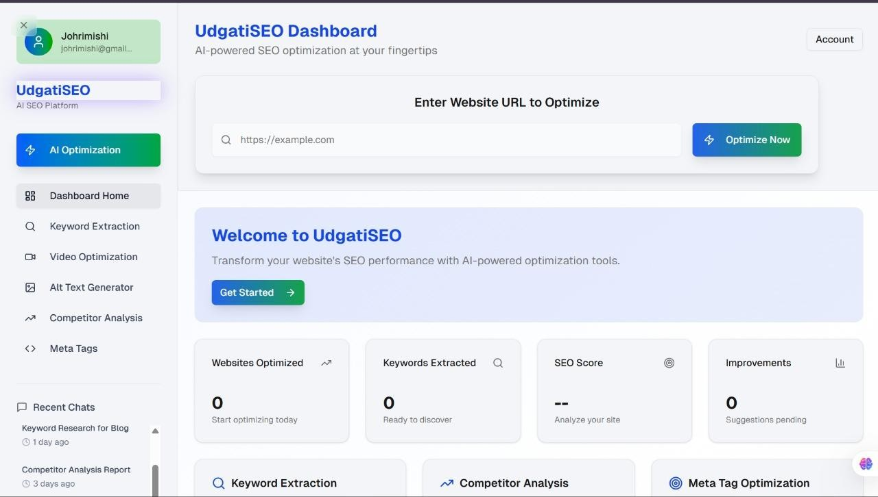

  - Github repository and branches :

