Experiment 1 — Installation of Hypervisors and initiation of VMs with an image file.
Install and configure an open-source hypervisor and create/instantiate a Virtual Machine (VM) using an existing image file. Demonstrate the successful installation and execution of the VM.
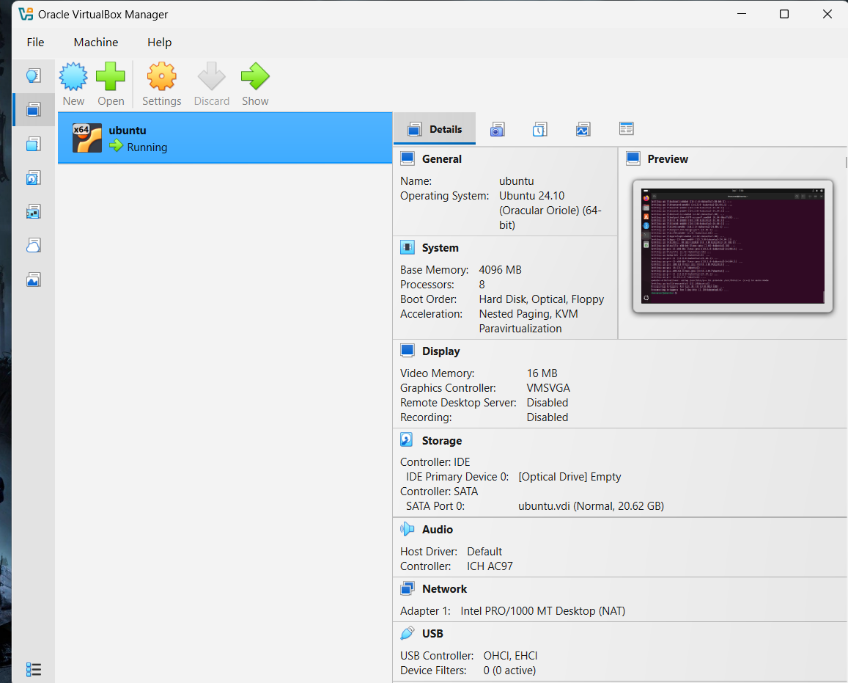

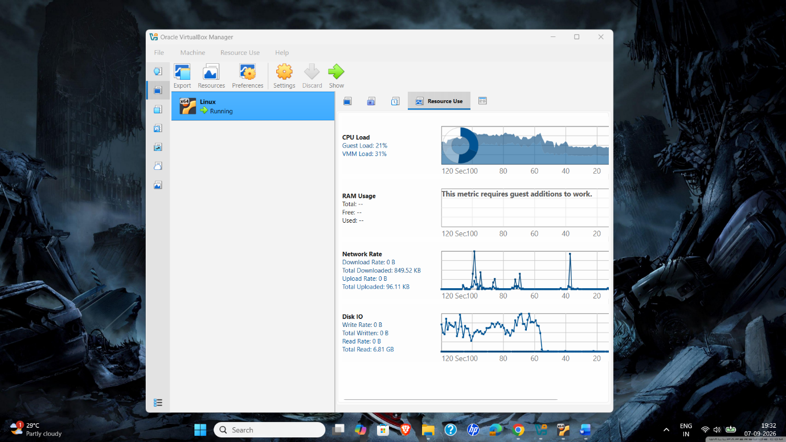
• Configure the VM's CPU, RAM, storage, and network.
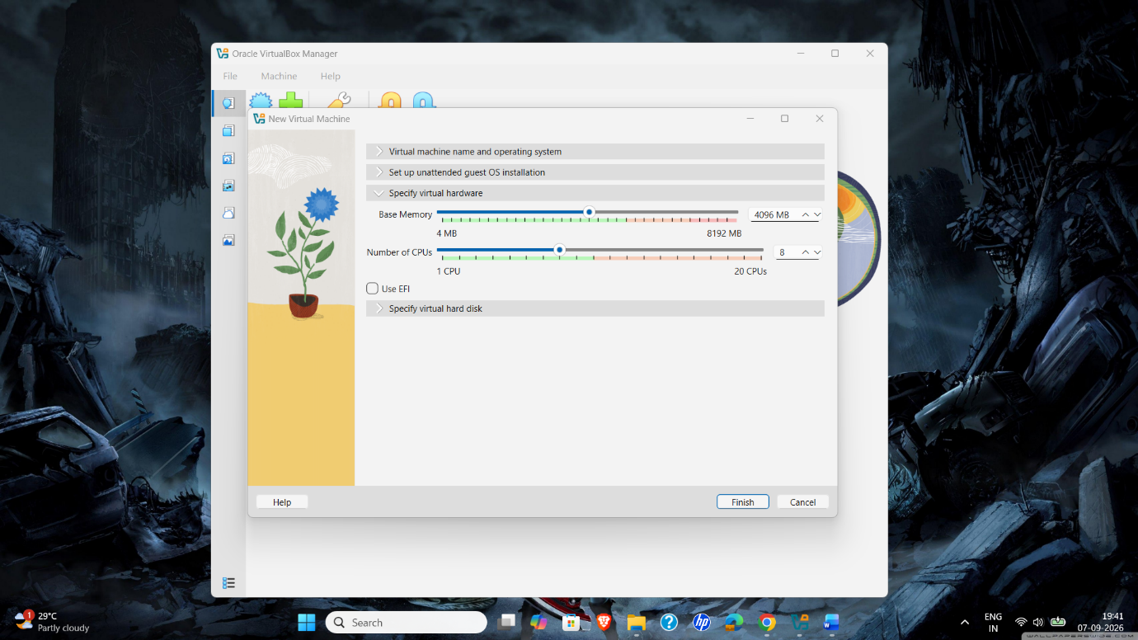
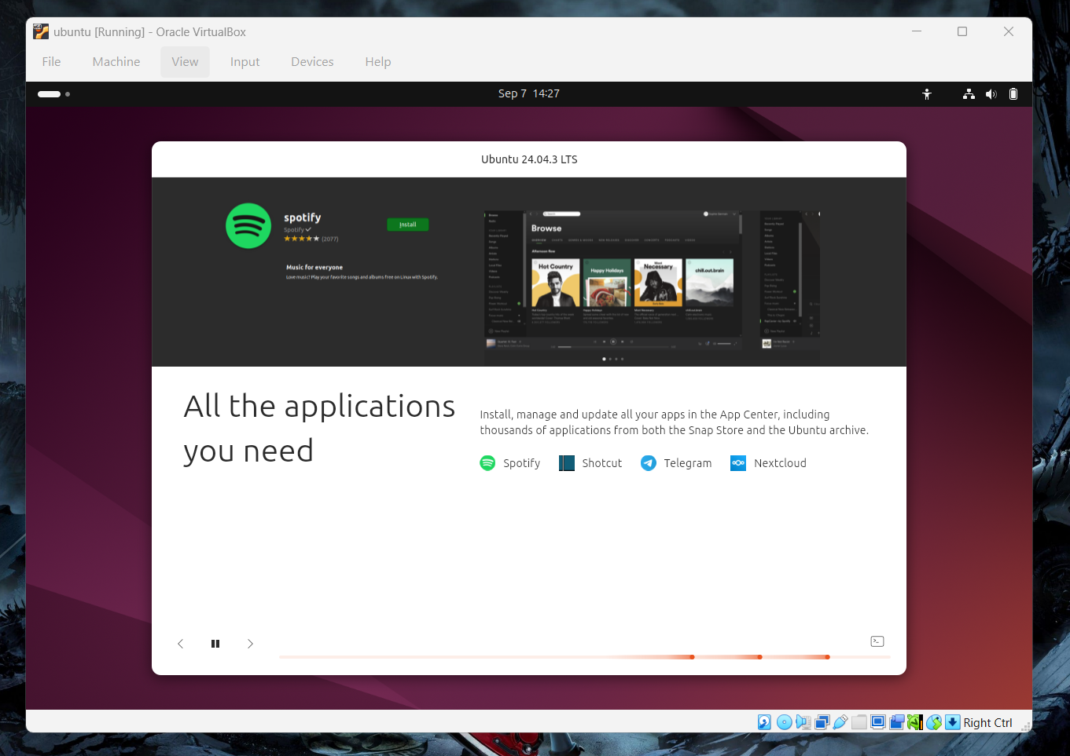
Verify that the VM is running successfully.
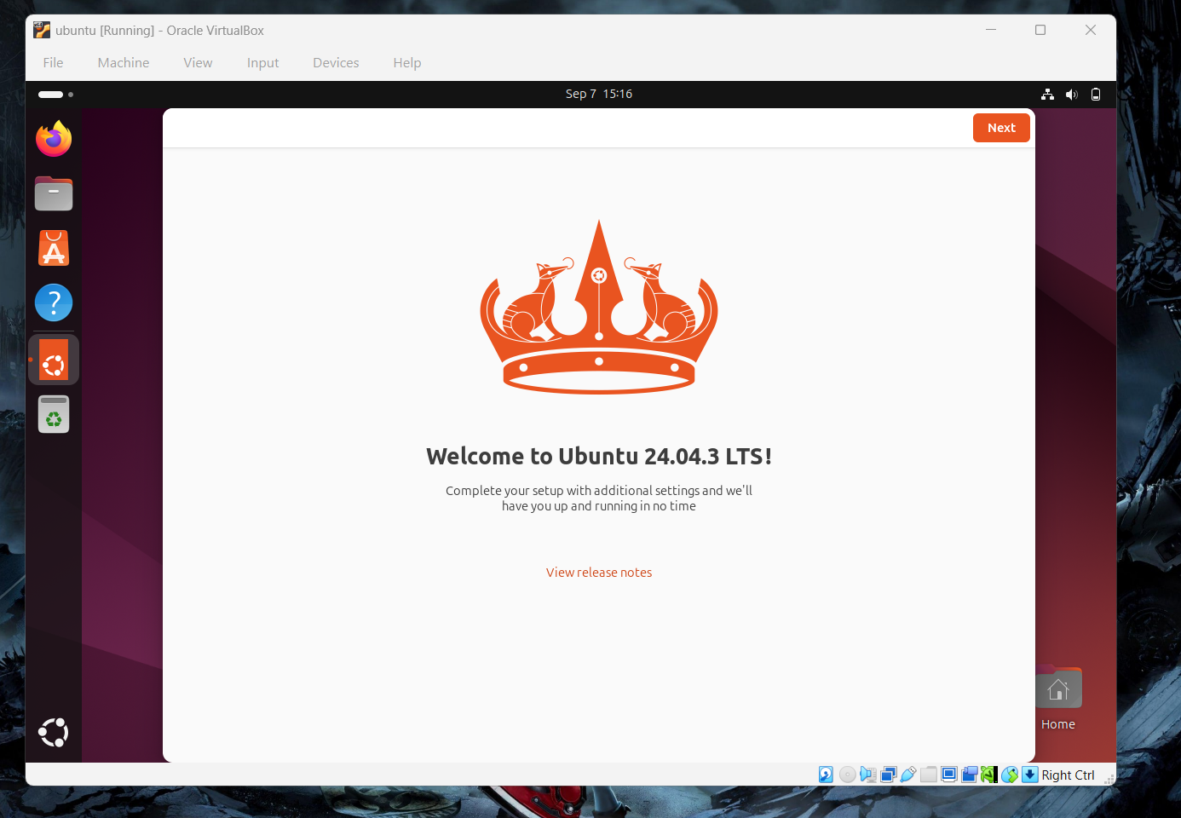

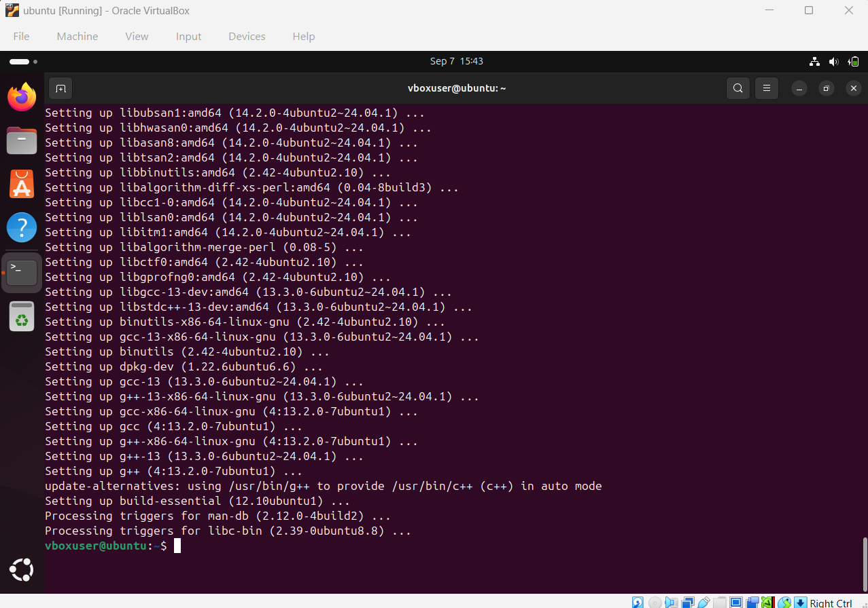
Install the required build tools and Linux kernel headers

