Experiment 3: Creation of a Simple Network Topology Using Open-Source Network Virtualization Tools

Objective: To create and configure a simple network topology using an open-source network virtualization tool (Mininet) and verify communication between virtual network nodes.
Environment & Requirements: Ubuntu Linux Virtual Machine running on Oracle VM VirtualBox, Mininet 2.3.0, Open vSwitch.

Step 1: Installing Mininet on Ubuntu Linux VM
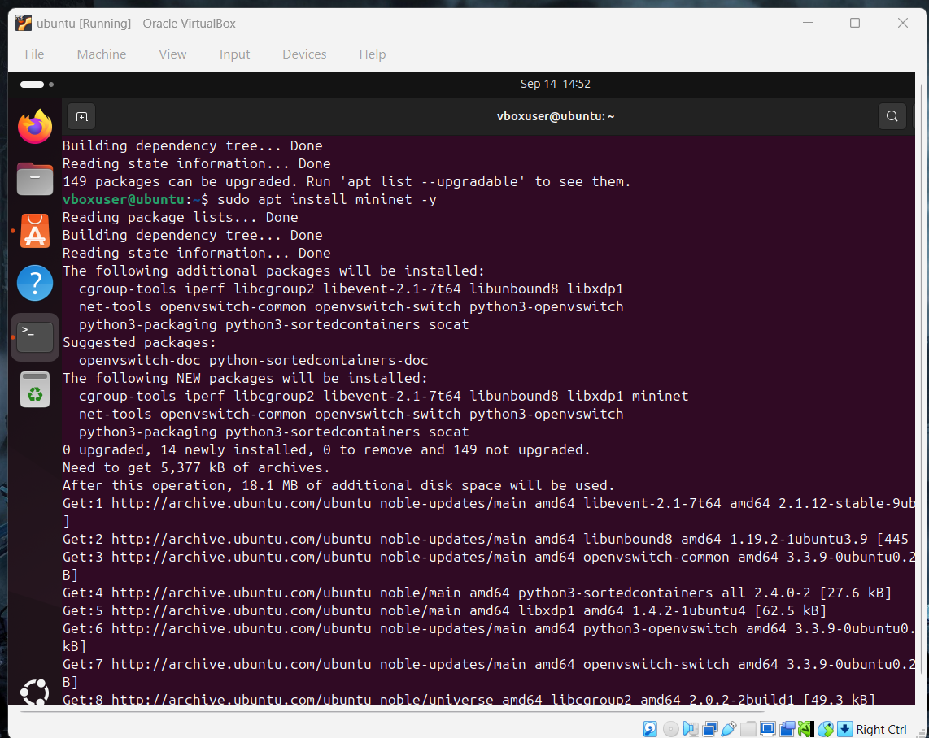
Explanation: Mininet and its required dependencies (including Open vSwitch, iproute2, and cgroup tools) are installed via the Ubuntu package manager using `sudo apt install mininet -y` inside Oracle VirtualBox.
Step 2: Verifying Version and Creating a Single Switch Topology (3 Nodes)
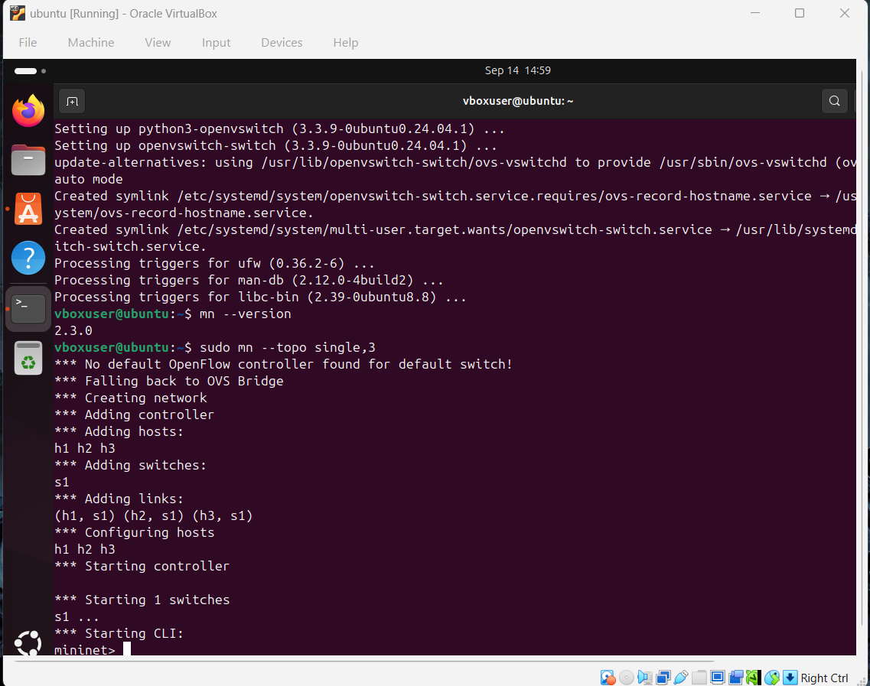
Explanation: Mininet version 2.3.0 is verified (`mn --version`), followed by launching a single-switch network topology with 3 hosts (`sudo mn --topo single,3`), establishing hosts h1, h2, and h3 connected to switch s1.
Step 3: Verifying Link Connectivity using Ping Commands
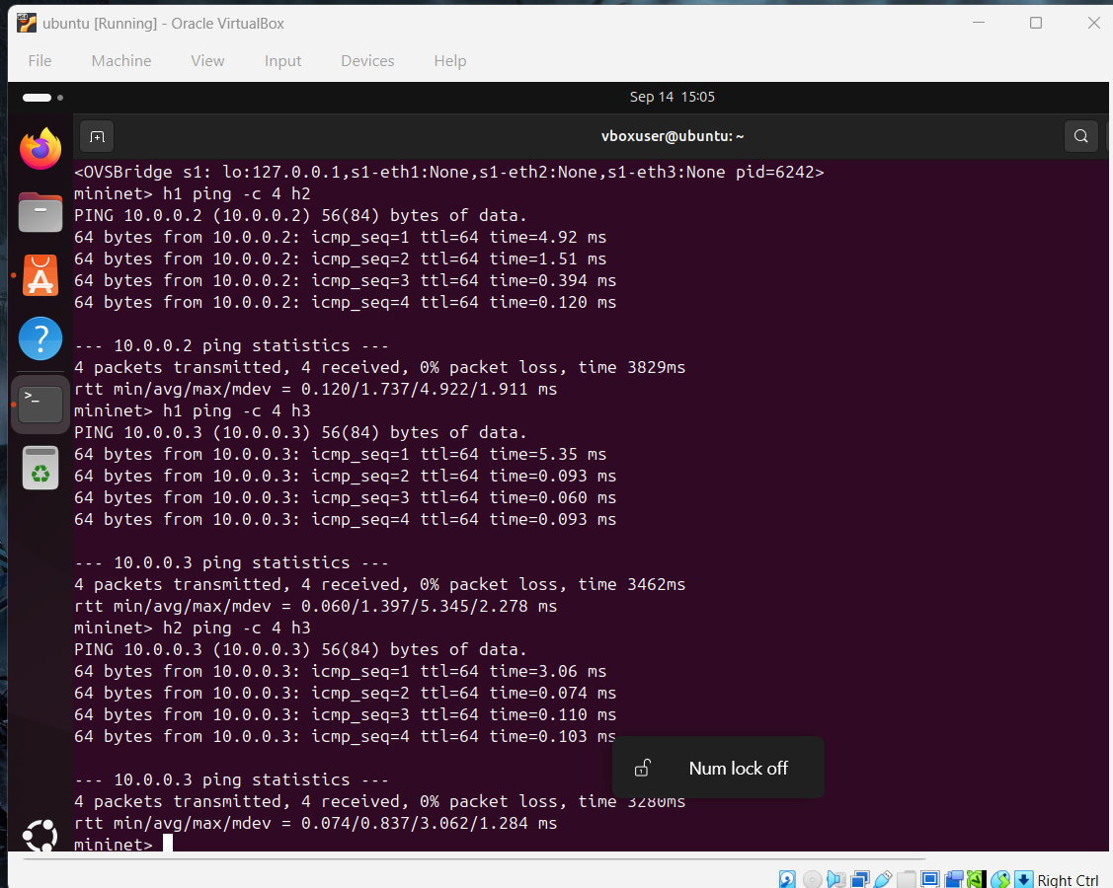
Explanation: Point-to-point network reachability between the virtual hosts is tested using `h1 ping -c 4 h2`, `h1 ping -c 4 h3`, and `h2 ping -c 4 h3`, all resulting in 0% packet loss and low latency.
Step 4: Exiting Previous Session and Deploying a Tree Topology (Depth 3, 8 Nodes)
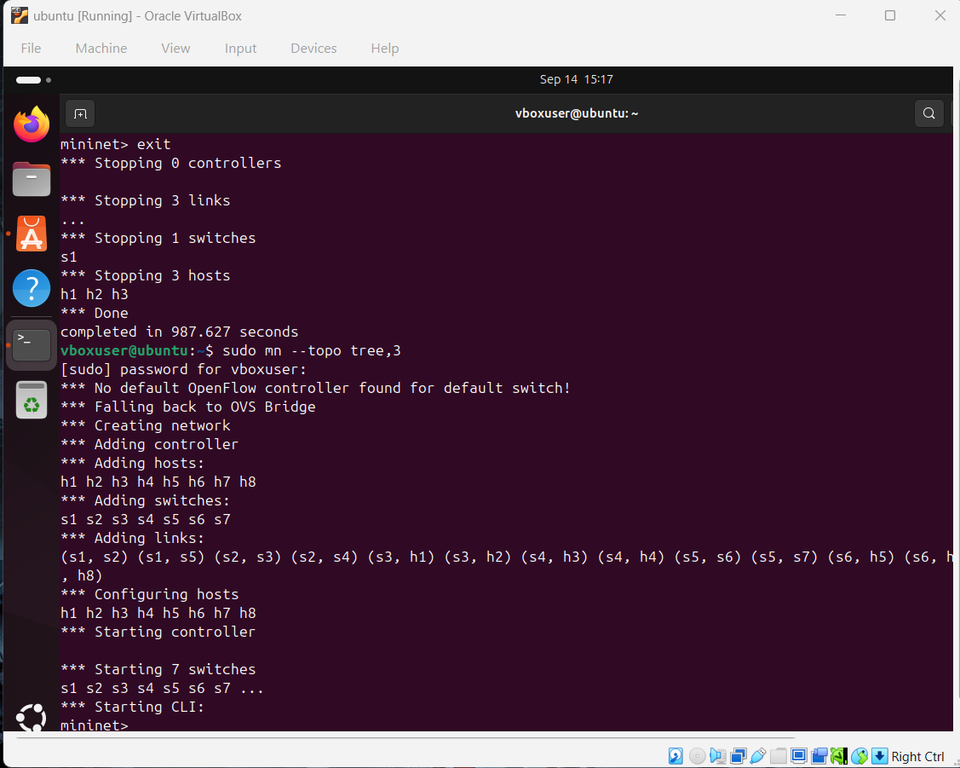
Explanation: The single topology is stopped using `exit`, and a hierarchical tree topology of depth 3 is deployed using `sudo mn --topo tree,3`, generating 8 virtual hosts (h1–h8) interconnected across 7 OpenFlow switches (s1–s7).
Step 5: Full Network Connectivity Verification via Pingall
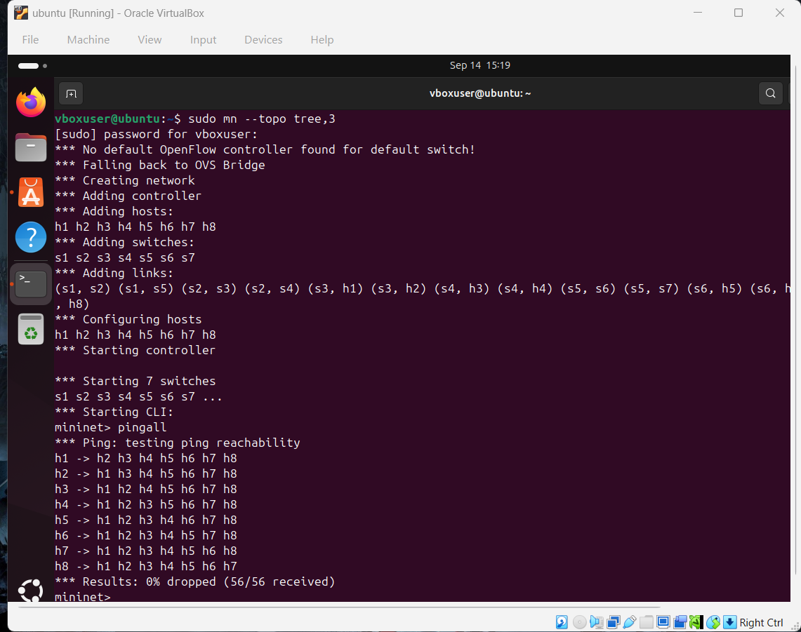
Explanation: The global `pingall` command is executed across the tree network to test reachability among all node pairs, achieving 100% successful transmission (56/56 ICMP packets received, 0% dropped).
Step 6: Automated Testing and Network Teardown
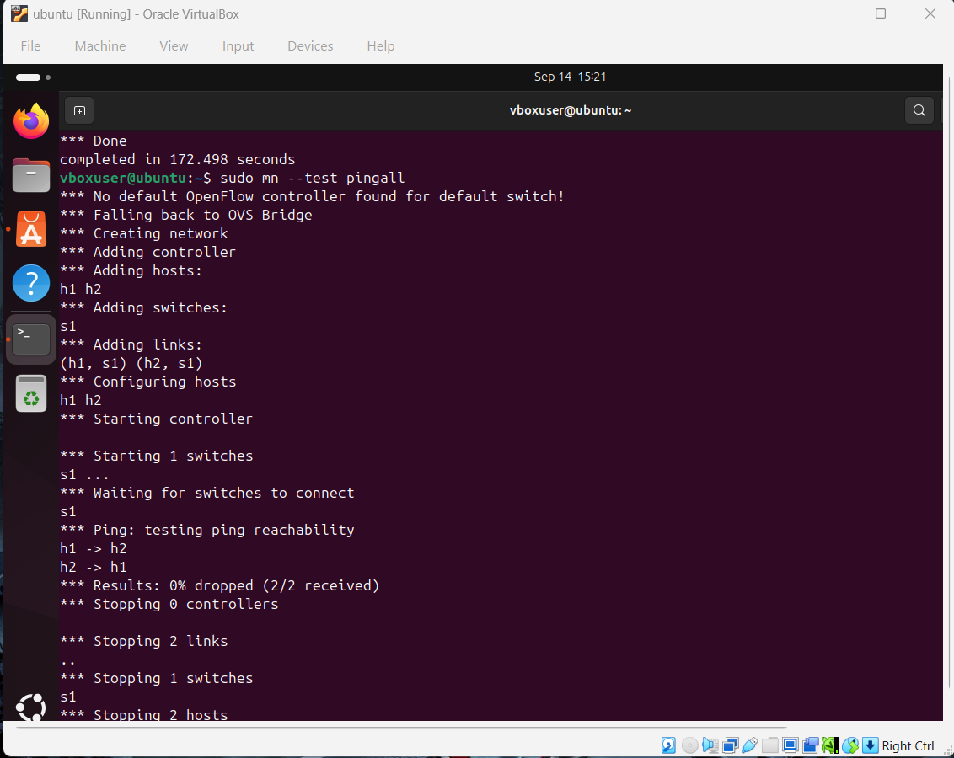
Explanation: An automated Mininet ping test is executed with a minimal 2-host topology using `sudo mn --test pingall`, successfully verifying node communication and cleanly stopping all switches, links, and hosts upon completion.

