Computer Networks Lab Assignment: NAT Network Configuration
Oracle VirtualBox Multi-VM Inter-Communication Verification
Step 1: Deploying Virtual Machines
Create and launch two Ubuntu virtual machines (Ubuntu1 and Ubuntu 2) in Oracle VirtualBox.
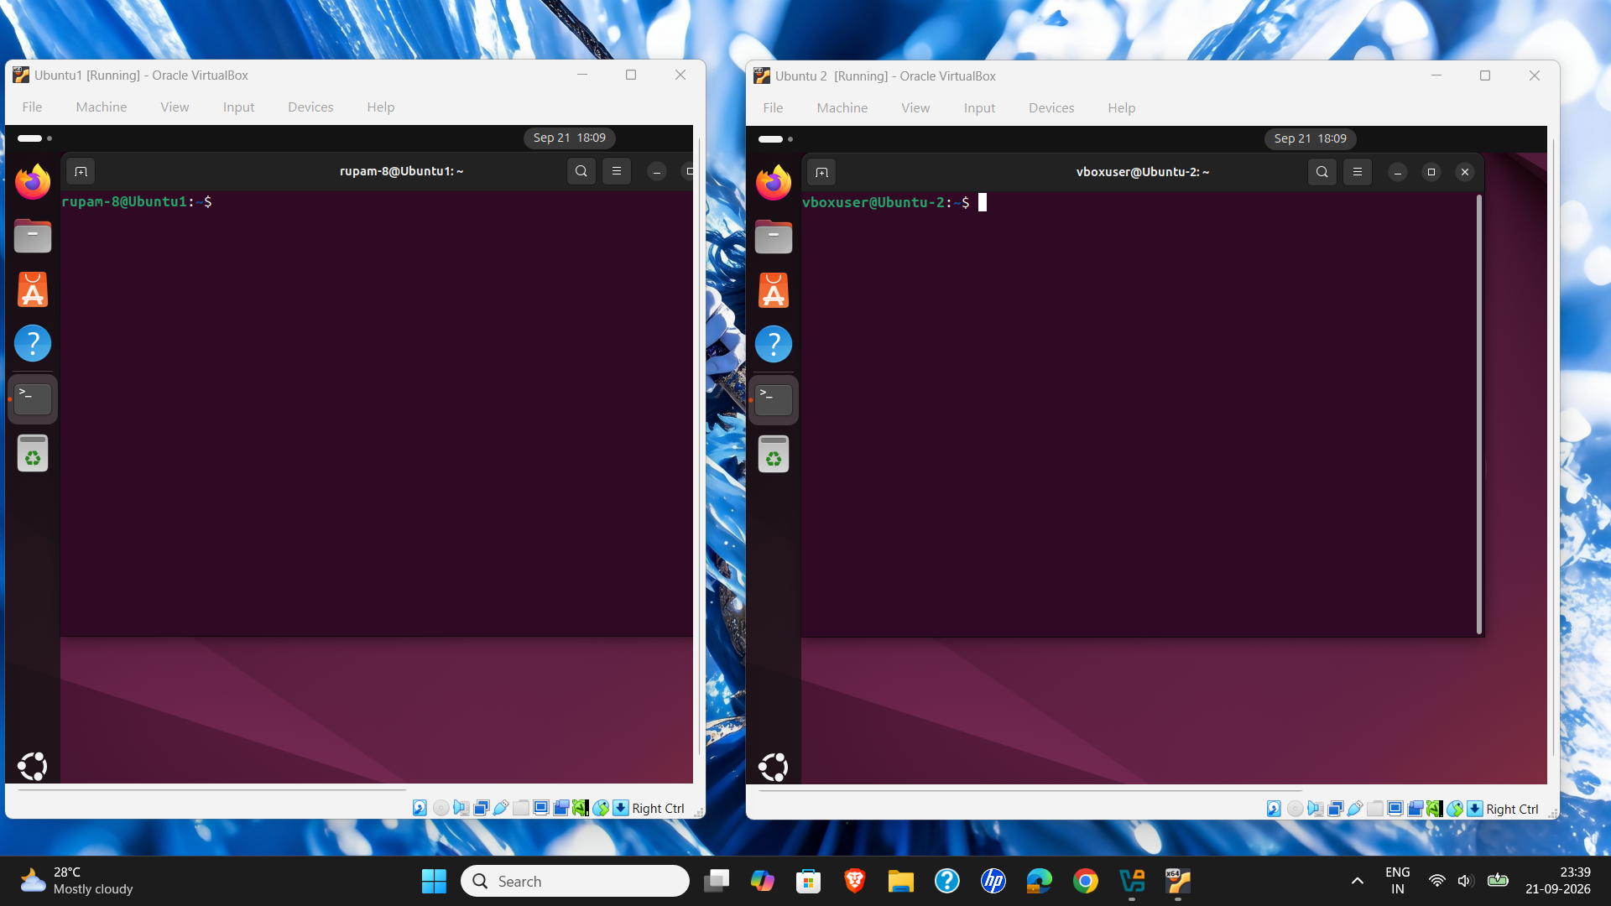
Step 2: Configuring Custom NAT Network
Create a customized NAT Network named 'Mynet' with IPv4 prefix 10.0.2.0/24 and DHCP service enabled in VirtualBox Network settings.
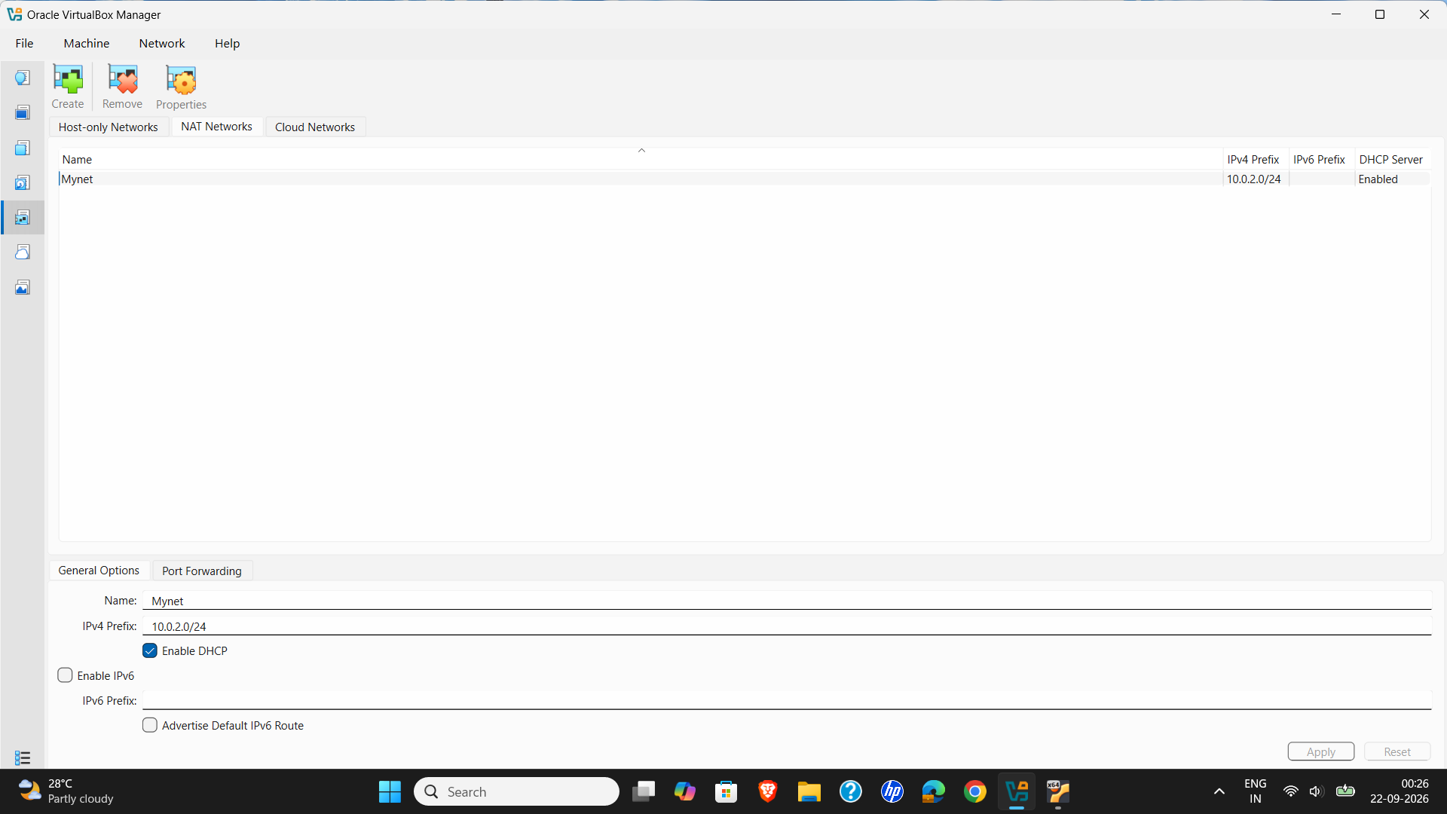
Step 3: Attaching VMs to the NAT Network
Attach the network adapters of both virtual machines to the newly created 'Mynet' NAT Network.
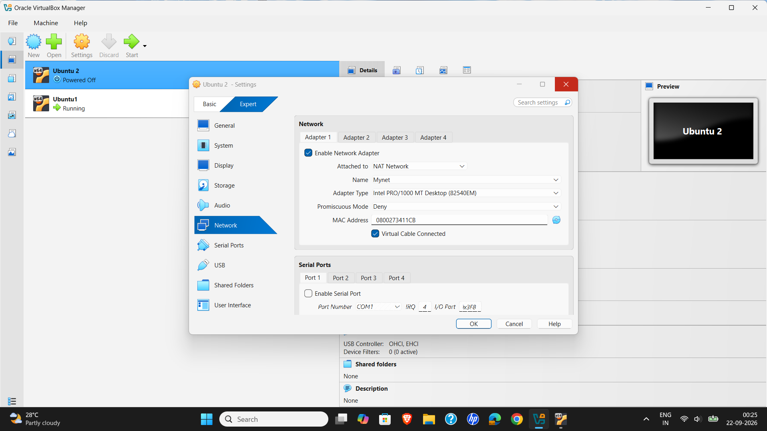
Step 4: Verifying Network Configuration and IP Assignment
Execute 'ip a' on both Ubuntu virtual machines to inspect network interface configurations and confirm assigned IP addresses (10.0.2.15 and 10.0.2.3).
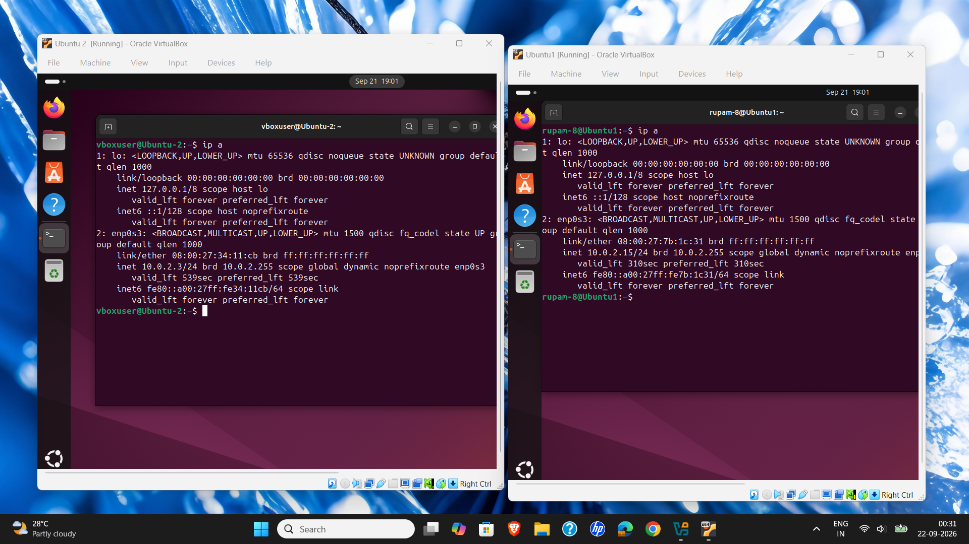
Step 5: Testing Inter-VM Connectivity (Ping Verification)
Perform bidirectional ping tests between Ubuntu 2 (10.0.2.3) and Ubuntu1 (10.0.2.15) to successfully confirm 0% packet loss and active network communication.
