Introduction

* 1. INTRODUCTION

Aim of this project is to create doctor patient handling management system that will help doctors in their work and will also help patients to book doctor appointments and view medical progress. The system allows doctors to manage their booking slots online. Patients are allowed to book empty slots online and those slots are reserved in their name. The system manages the appointment data for multiple doctors of various date and times. Each time a user visits a doctor his/her medical entry is stored in the database by doctor. Next time a user logs in he may view his/her entire medical history as and when needed. At the same time a doctor may view patient’s previews medical history while the patient visits him.

* + 1. OBJECTIVES
* This Website is very user friendly.
* It helps each and every patient to have their appointments booked or removed just with a single ONECLICK.
* One can easily view the doctor list just with ONECLICK
* Easily accessing doctors database and choosing doctor by ONECLICK
  + 1. JUSTIFICATION OF STUDY

We implement this system for better user experience. This system is very easy to access. Also for establish real time communication, using modern and updated technology. So, user can see the update without reload or refresh. This system will compatible with user device such as pc, laptop, tab & smart phone. So user can easily access the system anytime anywhere. This system is very simple & user friendly so, any user can use this system easily.

* + 1. SCOPE OF STUDY

Scope of the project is very broad in terms of other online doctor appointment portal. Few of them are:

* This Website would help every patient to easily access to the website.

* With this website it helps any patient to appoint their desired doctor just with ONECLICK
* One can see the availability of each and every doctor of their choice with a ONECLICK
* One can easily view the doctor list just with ONECLICK

Literature Survey

2.1 Waiting Time

Waiting time simply means a period of time which one must wait in order for a specific action to occur, after that action is requested or mandated (Fernandes et al., 1994). Patients’ waiting time has been defined as “the length of time from when the patient entered the outpatient clinic to the time the patient actually received his or her prescription” (Jamaiah, 2003). It is defined as the total time from registration until consultation with a doctor. There were two waiting times, the first is time taken to see a physician and the second is time to obtain medicine (Suriani, 2003). This paper deals with the waiting time to see physicians. Long waiting times are a serious problem for patients using urban health centres in developing countries (Bachmann, 1998). A block appointment system was introduced and evaluated in a large South African health centre. Waiting times of all patients were measured over one-week period before and after the implementation of appointments. Focus groups and individual interviews were conducted with staff and patients. After introducing appointments, patients with acute and chronic illnesses and having appointments had significantly shorter waits time than similar patients without appointments .Appointments had no benefits for patients not seeing doctors or collecting repeat medication. There was, however, an overall increase in patients' waiting times after introducing the system, mainly due to one typical day in the follow-up study. Focus groups and interviews revealed that staff were skeptical at baseline but at follow-up were positive about the system. Patients were enthusiastic about the appointment system at all stages. The study shows that block appointments can reduce patients’ waiting times for acute patients, but may not be suitable for all patients. Staff and patients had different views, which converged with experience of the new system.

2.2 Patients’ Appointment System

A patient appointment system or appointment schedule for health care center started long time ago . Management of patients’ appointments has earlier works and has developed simplified queuing models and fairly static scheduling conditions. Another attempt was made to calculate the waiting time between patient and doctor using the mathematical queuing models to minimize waiting time . However; traditionally the appointment system has considered that the doctor time is more important than patient time . So an appointment system was designed to minimize the doctor idle time but current designing of an appointment system is based on decisive factors with respect to both the patient and doctor . The patient appointment system has complex structures because it represents the patient appointment time in the healthcare center and controls the patient waiting time based on the type and the period of patient appointment .

2.2.1 Appointment Delay

Past research shows that the longer the appointment delay which is defined as the time between the day a patient requests an appointment and her actual appointment date, the higher the chances that he/she will cancel or not show up. This suggests an obvious way of minimizing no-shows and cancellations: this is done by asking the patients to come right away or make appointment requests on the day they want to be seen . This is called an open access (OA) or advanced access policy , and of late it has become a popular paradigm in practice and the subject of active research. Several authors report on their experiences in implementing OA, both positive and negative Some strongly advocate OA strongly against it .

2.2.2 Managing Patients’ Appointment system

According to Dexter (1999), managing patient appointment system is a computer application used to manage and reduce the patient waiting time in the health care center. Some health care centers do not use any appointment system. So it has a longer average patients’ waiting time than the health care center that adopts the patients’ appointment system. While patients can wait for more than one hour to be attended to by a physician in a health care center, they also can feel that they are being disregarded and treated unfairly. So when patients are given the time of appointment in a health care centre, they can evaluate the quality of service in the centre .Hence, developing patients’ appointment process for health care centres necessitates the use of a sophisticated queuing model that captures much of the real system’s features (saving time, reducing idle time, etc). Therefore the appointment schedule represents the real situation in the health care centre faced by patient appointment schedulers .On the other hand, the standard practice for scheduling and processing patient appointments are based on the nature of treatments of the patients and that better approaches more sensitive to patient needs are desirable .

2.3 Online Booking System

An online system is also known as a web based system. A web is made up of page that is commonly known as web page or web site, and a web site is a computer program that runs a web server that provides access to a group of related web pages (Alex, 2000). A system is a set of independent components working together to achieve a common objective. Therefore a web based system is a system that is accessible over the internet by a user in order to achieve a particular task for a given purpose. The Internet is a system that is use to connect computers and computer networks. It helps to link millions of computer networks all over the world and it allows the users to get information stored on other computers from a long distance (James, 1999). According to Chua (2010) the public demand for better healthcare system and the alarming number of missed appointments have forced the healthcare sector to recognize how they deliver care services. With the advance of IT technology today and seen healthcare system as a critical system, appointment booking system lies at the intersection of delivering efficient, dependable and timely access to health services. The conventional way of appointment booking is via fax, phone or email. But with the growing internet penetration, healthcare industry is moving towards the use of an online clinic system.

The Internet provides a wide range of technologies that enable hospitals to communicate with their patients. Recently, as the prevalence of Internet increasing, many hospitals initiated the website appointment system. Electronic patient-provider communication promises to improve efficiency and effectiveness of clinical care.

Software Requirement Specification

3.1 Specifications

Big hospitals usually have huge number of staff member and doctors. Managing the time, schedule and proper regularity of tasks becomes very difficult. In order to have efficient and effective system of doctor-patient interactions, a doctor patient handling and managing system is designed that not only assists the doctors in their work but also helps patients in numerous ways like booking doctor appointments and assessing medical reports and progress of treatment. The portal permits the doctors to maintain their empty slots for bookings by the patients using an online system. Patients are requires to look for the empty slots of doctors using the same online system, and reserve the slots using the required information. The system maintains records of all the doctors and manages the appointment data of all the doctors for different times and dates. When a patient visits a doctor his/ her date and time of visit is entered by the doctor in the database. Also the doctor stores his/ her medical progress or reports in the system. In this way the next time if a patient logs into his/ her account he can see his/ her complete medical records from the beginning till the end whenever he needs it. Similarly when a patient visits a doctor, the doctor can view his medical records of the patients to have better knowledge of his disease. The doctor can visit a patients history even before the patient visits him. This automated portal for doctor patient management system requires an online interface.

3.1.1 Modules

Different modules of the system are as follows:-

* User: The user can be a general user or any patient who wants to book appointment with the doctor.And also an anonymous user can post their queries without logging in.
* Admin: This module got the most privilege.And can have access

to anywhere in the system.Here admin can be the site administrator or any other member of the administration of the clinic.They generally manage bookings as well as manage different queries posted and also add doctors

* Doctor: This module is another core part of this web system.Generally doctors those who are added in the database are allowed to log in to the system and manage bookings and all.And also answer to different queries.

3.1.2 Key Features

Some key features of a system are as follows:-

* User login and registration: The patients have to get themselves register if not registered before and also can search for the doctor they need appointment with.
* Doctor login and registration: The doctor logins in to check the appointments allotted and if not registered can easily register their details in the system and also search for the queries asked.
* Admin Login: The system administrator can login and access all the accounts for updates.
* Appointment availability: patients can check for the availability of slots.
* Appointment booking: Patients can easily book appointment with the preffered doctor they choose.There are two types of patient one is the first time patient and another is the existing patient.The existing patient consist of a CNIC No which helps them to be differentiated from the new patients.
* Posting queries: Any user without logging in can just post their queries related to medical terms.They can ask their questions to any specialist they want maybe skin,heart or any
* Answering queries: Doctors or system administrator can easily view the queries posted and also can answer to the following queries posted by the users. A general question answer session can be held using this mechanism

Other features may include appointment booking via an email, booking cancellation and feedback corner.

3.1.3 Advantages and disadvantages of the system:

* The advantages of having such system are numerous. The patient will not have to wait in queue for hours to get the appointment. The appointments are simply made through the portal. Time management is very easy for both the doctors and patients. Medical history of the patient can be easily viewed. Patients can get the donations easily through donation centre.
* Besides these advantages there are few disadvantages. The database for such systems is very large and such systems require internet connection for working.

Requirement Analysis:

4.1 Methodology

* Waterfall Model

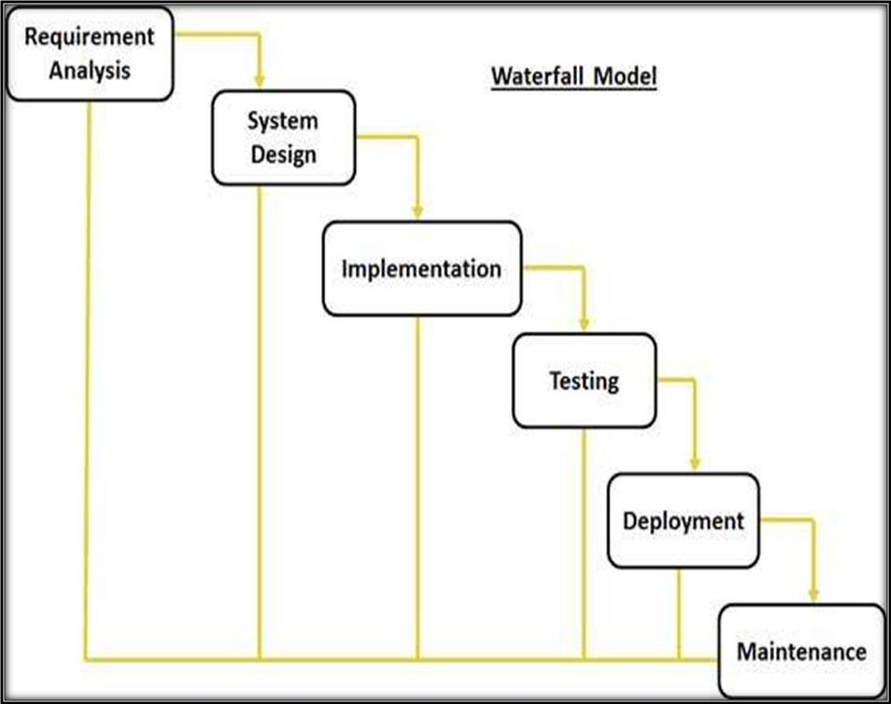

4.1.1 Justification of Methodology

Every software developed is different and requires a suitable SDLC approach to be followed based on the internal and external factors. Some situations where the use of Waterfall model is most appropriate are:

* Requirements are very well documented, clear and fixed.
* Product definition is stable.
* Technology is understood and is not dynamic.
* The project is short
* Simple and easy to understand and use
* Easy to manage due to the rigidity of the model . each phase has specific deliverables and a review process.
* Phases are processed and completed one at a time.
* Easy to arrange tasks.

4.2 System Analysis

4.2.1 Requirement Specifications

After analyzing the data collected, we formulated a number of requirements namely user requirement, system hardware software attribute. These were grouped as user, functional, non-functional and systems requirements.

4.2.2 User Requirement

During data collection, the we investigated and found out how the current system operates, not only that but also tried out which problems are faced and how best they can be settled. The users described some of the basic requirements of the system this includes Search for Patients, Register Patient, Update record, Doctor information record, view doctor availability record and view all types of reports.

4.2.3 Functional and Non Functional Requirements

The following is the desired functionality of the new system. Accept of submissions in form of raw patients; perform analysis of financial to authenticate the users of the system.

And non functional requirement include the following The system must verify the validate all user input ant user must be notified in case of errors detected in the database, the system should allow room for expansion.

4.2.4 System Requirement

This section describes the hardware components and software requirements needed for effective and efficient running of the system

Hardware Requirements:

|  |  |  |
| --- | --- | --- |
| **SL** | **Hardware** | **Minimum System Requirement** |
| 1 | Processor | 2.4 GHz Processor speed |
| 2 | Memory | 512 MB RAM |
| 3 | Disk Space | 100 GB |

Software Requirements:

|  |  |  |
| --- | --- | --- |
| **SL** | **Software** | **Minimum System Requirement** |
| 1 | Operating System | Windows XP,7,8,8.1,10 and Linux(Ubuntu) |
| 2 | Front End | HTML,CSS,JS |
| 3 | Back End | PHP |
| 4 | Database Used | MySql |
| 5 | Runtime Server | Xampp |