**PROBLEM STATEMENT-**

**Integral Spiral**: To create integer spiral based on the given input. Input will be 2 parameters – an integer (positive value) and direction (string value – LEFT/RIGHT for spiral direction)

**APPROACH USED-**

Below are few algorithm steps to solve **Integer Spiral** problem.

Algorithm:

1. START
2. Declare variables to receive input values (inputNumber, inputDirection)
3. Declare a type (JAVA Enum) to hold directions for SpiralDirection { NORTH, SOUTH, WEST, EAST } and initialize the spiral movement to NORTH
4. Create a matrix based on the size computed from input integer value (NxN matrix)
5. Initialize matrix elements as : central element as 0 and rest all as -1
6. Declare and Initialize localVariable to 0
7. WHILE (localVariable ++) < inputNumber
   1. READ SpiralDirection
   2. SWITCH (SpiralDirection)
   3. CASE SpiralDirection:
      1. READ inputDirection
      2. Calculate matrix position to be updated in sequence based on the direction
   4. END SWITCH
   5. UPDATE matrix position with localVariable for current iteration
8. Display spiral on console
9. END

**FLOW CHART-**

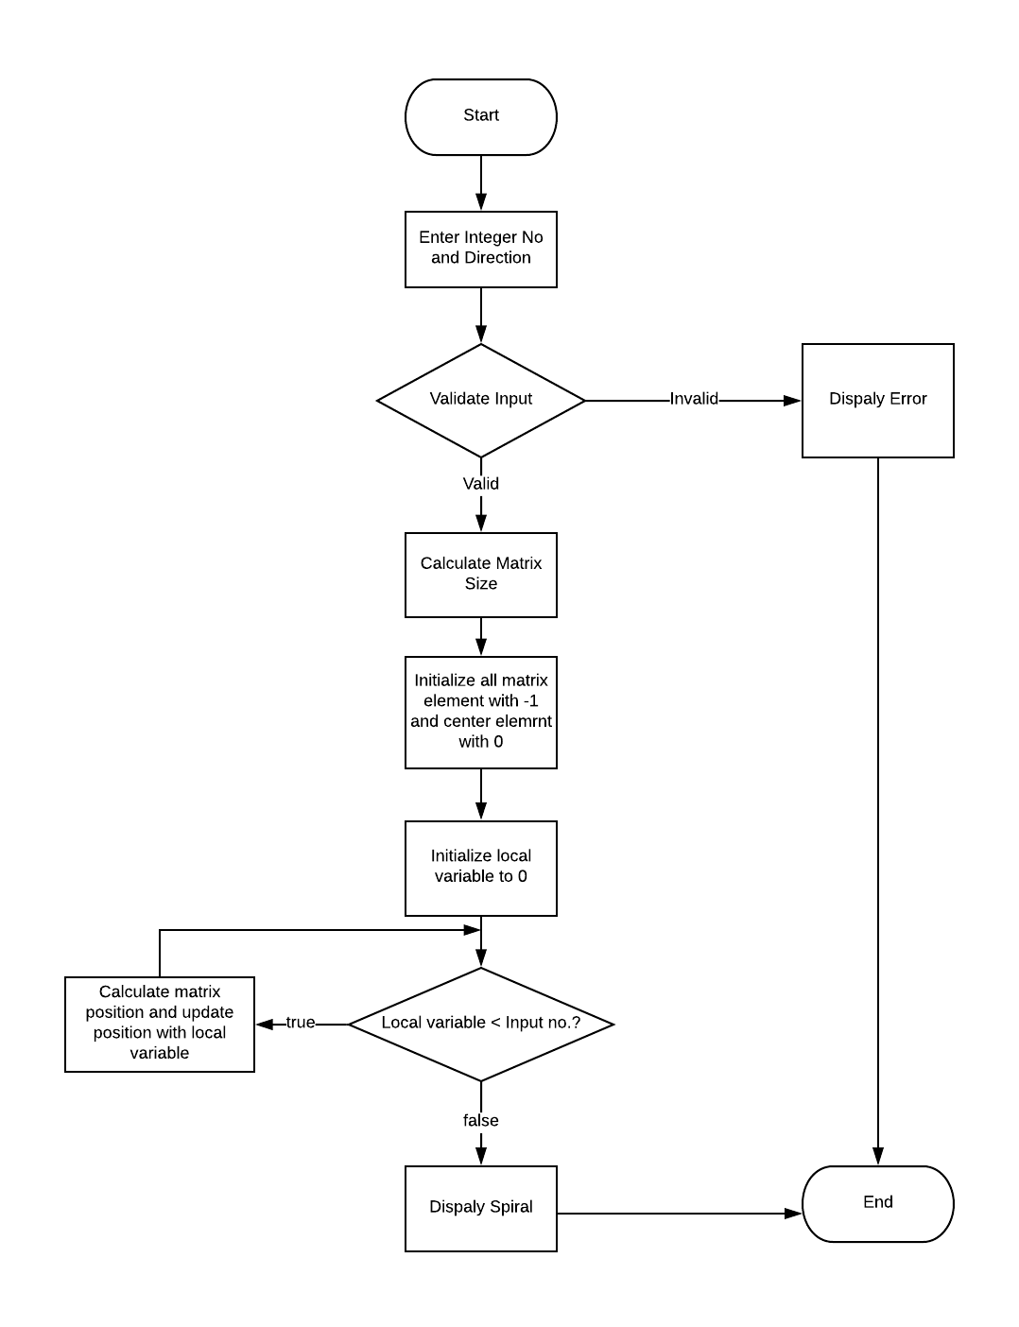

**TEST SCENARIOS-**

SUCCESS SCENARIO:

* If valid integer no. and valid direction is given as input values, then it will generate spiral successfully.

Input no.: This should be positive integer.

Input direction: This should be either “left” or “right”.

ERROR SCENARIO:

* Given input no. should not be negative integer else it will show error “You need to enter a positive value for integer.”
* Given input no. should not be string else it will show error “Integer Value is invalid. It should be number.”
* Given input direction should be either left or right else it will show error “Please enter direction of spiral either LEFT or RIGHT (case insensitive).”

JUNIT test case report:

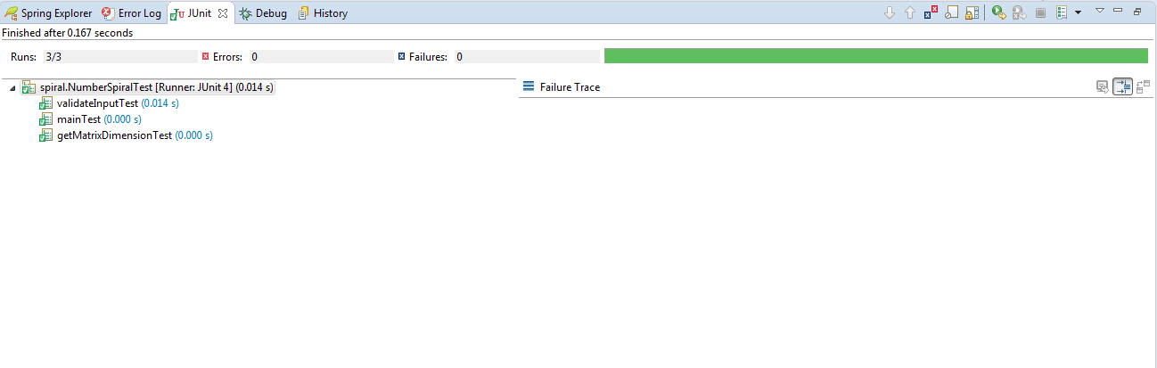

**OUTPUT-**

SUCCESS scenario#1

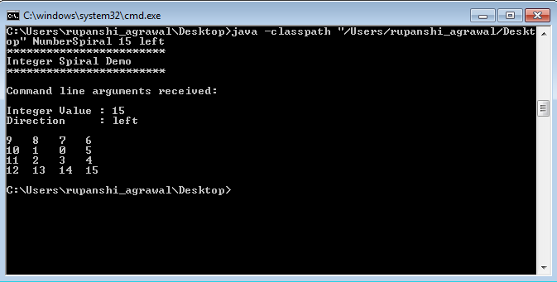

ERROR scenario#1

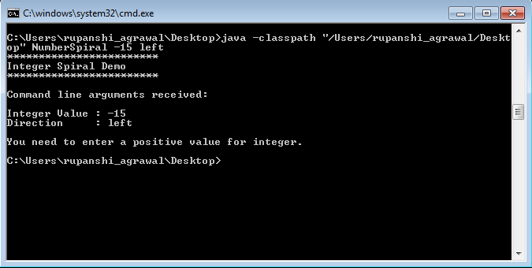

ERROR scenario#2

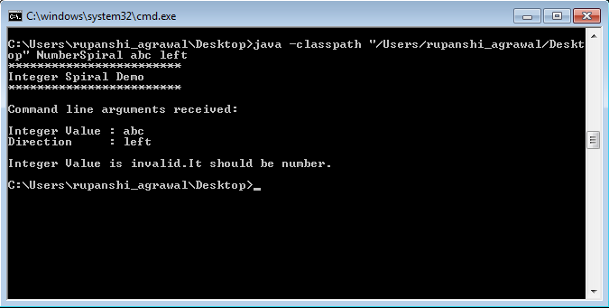

ERROR scenario#3

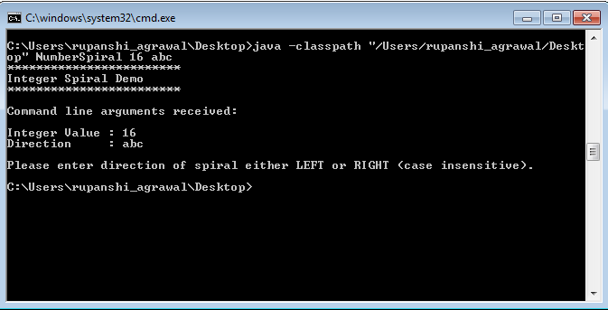

**STEPS to RUN the program from command line**

1. Download the folder from GIT URL:

<https://github.com/RupanshiAgrawal/SpiralAlgorithm.git>

1. Unzip the folder, Keep the downloaded folder in any drive (valid path) on your system
2. Open command prompt and navigate to the path of that folder:

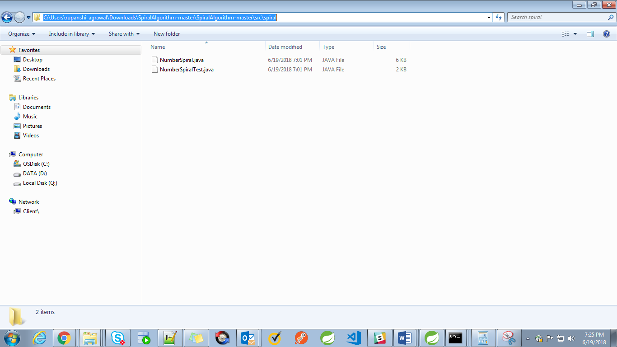

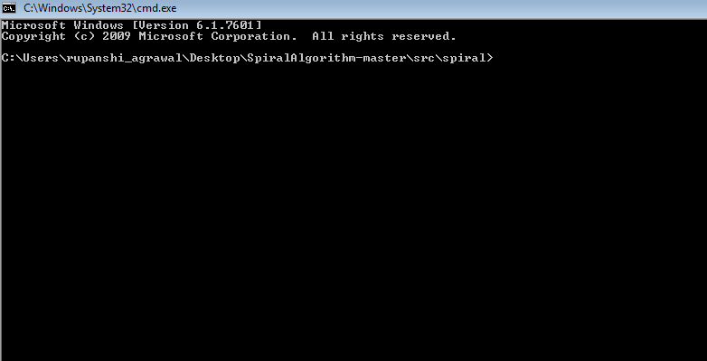

1. Run below java command to compile the program:

**javac NumberSpiral.java**

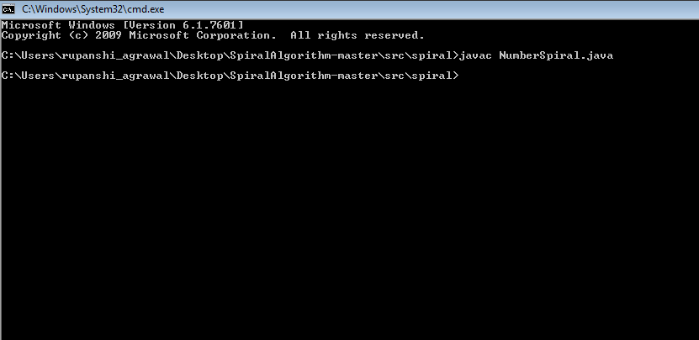

1. Run below java command to run actual program while passing input values:

**java -classpath "C:\Users\rupanshi_agrawal\Desktop\SpiralAlgorithm-master\src\spiral" NumberSpiral 8 left**

