**STUDENTS DECLARATION**

I hereby solemnly affirm, declare that organizational study of “**REBENOK INFOTECH**” was done by me with due to diligence and sincerity and this report based on that study is a bonified work by me and submitted to BHAUSAHEB VARTAK POLYTECHNICS**.**

Signature:

Guide Name

PLACE: VIRAR

DATE:

**ACKNOWLEDGEMENT**

Is my pleasure to express my sincere gratitude to all those who have given guidance and support in completion of this internship report. I wish to express my sincere thanks to Prof. Preeti Aware (dean of Bhausaheb Vartak Polytechnics) for their encouragement which helped in accomplishment of this study.

I am thankful to Mr. Kamlesh Prajapati HR Manager at, REBENOK INFOTECH who guided me throughout this organization study. Without his guidance the outcome of this project would not have been so successful.

Name: Rupali Savala Shinde

Enrollment No: 1800930071

Place: Virar

Date:

**Vidyavardhini’s Bhausaheb Vartak Polytechnics**

A

REPORT ON

**“REBENOK INFOTECH”**

**BY**

**MISS. RUPALI SAVALA SHINDE**

ROLL NO: 1209

UNDER THE GUIDENCE OF

**PROF. PREETI AWARE**

DEPARTMENT OF COMPUTER ENGINEERING

2020-2021

**CONTENT**

|  |  |  |
| --- | --- | --- |
| Sr.No | Title | Page No. |
| 1 | Introduction | 5,6 |
| 2 | About Grow Local Business | 7 |
| 3 | Head Office Teams & Management | 8 |
| 4 | Service, Our Division | 9,10 |
| 5 | Online Training And Classroom Training | 11 |
| 6 | Privacy Policy | 12 |
| 7 | About Web Designing | 13 |
| 8 | Company Profile | 14 |
| **9** | Services | 15 |
| 10 | About Our Company Product | 16,17,18 |
| 11 | Specifications & Services | 19 |
| 12 | Grow Local Business With Upward Direction | 20 |
| 13 | Our Clients | 21,22,23,24 |
| 14 | Our Training Course |  |
| 15 | Conclusion |  |
| 16 | References |  |

**INTRODUCTION**

I am Rupali Savala Shinde studying at Vidyavardhini’s Bhausaheb Vartak Polytechnics undertook an internship study at REBENOK INFOTECH to fulfill the requirement of Diploma Course. This was undertaken during and main purpose of this internship was to know how the theoretical aspects we study during our course, are puts into practice by the company.

The report traces the growth and development of the company and gives a skeletal outline about the technologies adopted by the organization; the report also explains the values and gives a brief about the financial aspects of REBENOK INFOTECH.

The objective of undergoing this internship was to get practical exposure to the structure and functioning of the organization. It was also meant to study the activities of various departments such as finance, marketing, production, human resource, purchase, store and service etc.

**OBJECTIVES OF THE STUDY**

* Outline and study the growth and working of the company from its inception.
* The objective of the study is to learn and understand the working of various functional departments like production, marketing, finance.
* SWOT ANALYSIS to identify the major strength weakness of the company for improvement.
* Study the performance of REBENOK INFOTECH

**WHY YOU SHOULD JOIN IN REBENOK INFOTECH(TRAINING INSTITUTE)?**

• Experience Trainer & Trained Faculties

• Individual Attention & Individual PC

• Convenient Batch Time Morning (8 am to 10 pm)

• Best Experience in IT and Training Field since year 2008

• 100 % Job Assistance / Placements

• Lifetime Online/ Offline Support Centers

Complaint/ Suggestion Box

**About Grow Local Business**

Grow Local Business Is a Division of Rebenok Infotech We Provides Services for Website Designing, Digital Marketing, and Accounting Software’s. We Will Grow Our Clients Business With Upward Direction By Digital Marketing.

Rebenok Infotech is the ISO 9001:2015 Certified Institute. REBENOK INFOTECH specializes in providing Training and IT Related Services. Our team of experts in Training & Resolve Problems Server and Client Environment and solutions will integrate Different platforms.

Within a short period of time, the organization has extended its activities to encompass all areas of the information sector. These activities include – computer system integration and marketing, peripherals, Repairer & Service, hardware & networking support and training.

**Company Mission**

1. To promote a center of Digital Services that will fully support the rapid development of the IT Sector.
2. To change the mindset of Business by focusing on the culture of Digital Services.
3. To collaborate with local/international Digital agencies for knowledge sharing.
4. To be a self-sufficient Institution through rendering services to other companies and institutions.

**Company Vision**

The Company guiding vision is to be known as the leading IT Services and training education in India. The Company collective aim is to be recognized as the best IT Service provider in India.

**HEAD OFFICE TEAMS & MANAGEMENT**

**Mr. Kamlesh Prajapati**:

(Owner & Networking Trainer) Best Experience in Training field Since Year 2008. Microsoft Certified Professional. Get Awarded For Best Faculty Award , 1st potation Award in Palghar District for IT Hardware & Networking.

**Mr. Ninad Champanerkar:**

(Event & Exam Controller) Experience in Training field Since Year 2017.

**Mr. Om Mourya:**

(Digital Marketing Trainer) Best Experience in Training field Since Year 2005.

**Miss. Jaspreet Sasotri:**

(Spoken English Trainer) Best Experience in Training field Since Year 2016.

**Mr. Lalit Annaldas:**

(Web & Software Programming Trainer) Best Experience in Training field Since Year 2015.

**Mrs. Madhavi Hegde:**

(Graphics & Web Designer)

**Mr. Swapnesh Pal:**

(Software Programming Trainer) Best Experience in Training field Since Year 2011.

**Mr. Dattatreya B. Joshi:**

(Spoken English Division) Best Experience in Training field Since Year 2007.

**Miss. Jyoti Vishwakarma:**

(Counsellor) Best Experience in Training Field Since Year 2017.

**Mrs. Divya** **Patil:**

(Faculty) Training Field Since Year 2016.

**SERVICES**

1. Web Designing

2. Google Business

3. Basic SEO

4. Advance SEO

5. Business Presentation

6. E-Mail Marketing

7. Business Profile

8. Graphics Designing

9. Accounting Software’s

10. Social Media Marketing

**OUR DIVISION**

1. Rebenok Infotech Training Institute

2. Grow English Academy Training Institute

3. Rebenok Computer Sales & Services

4. Search Local Business

**CLASSROOM TRAINING**

1. Diploma Courses

2. SEO & Digital Networking

3. Advanced Diploma

4. Hardware & Networking

5. Software Development

6. Short Term Courses

7. Spoken English

8. Ethical Hacking

9. Banking /Railway /SSC…Exams

10. Animation & Architecture

11. Job Placement

**ONIINE TRAINING**

* Online Computer Courses & Online Spoken English
* Online Hardware & Networking
* Web & Digital Marketing
* Online Ethical Hacking Courses
* Banking / Railway / SSC...Exams

**PRIVACY POLICY**

Your privacy is very important to us. Accordingly, we have developed this Policy in order for you to understand how we collect, use, communicate and disclose and make use of personal information. The following outlines our privacy policy.

* Before or at the time of collecting personal information, we will identify the purposes for which information is being collected.
* We will collect personal information by lawful and fair means and, where appropriate, with the knowledge or consent of the individual concerned.
* Personal data should be relevant to the purposes for which it is to be used, and, to the extent necessary for those purposes, should be accurate, complete, and up-todate.
* We will protect personal information by reasonable security safeguards against loss or theft, as well as unauthorized access, disclosure, copying, use or modification.
* We will collect and use of personal information solely with the objective of fulfilling those purposes specified by us and for other compatible purposes, unless we obtain the consent of the individual concerned or as required by law.
* We will only retain personal information as long as necessary for the fulfillment of those purposes.
* We will make readily available to customers information about our policies and practices relating to the management of personal information.

**ABOUT WEB DESIGNING**

Web design is the visual aesthetics and page layout of a website. It goes hand-in-hand with web development in the creation of a static website or dynamic web application.

Even if you don’t consider yourself a creative person, it’s still a good idea to learn web design. No matter whether you want to make static websites or dynamic web applications, design is an important part of the process. The design is the first thing people notice when they arrive on a website, and if it’s not good enough, they’ll leave. You don’t want to create a site that frustrates people, do you?

If you do identify yourself as a creative person, you might even consider a career as a web designer. Today, there is a huge need for competent web designers with up-to-date skills. It’s not an opportunity to be sneezed at. Learn coding and you’ll be a valuable asset to many. But learn coding and desing and you’ll be second to none!

**WEB DESIGN OVERVIEW:**

The web design process starts with a visual concept, which you could sketch by hand or with software like Photoshop. Then, you use HTML and CSS to build the website. HTML and CSS are the codes for writing web pages. HTML handles the basic structure and ‘bones’ of your page, while CSS handles the style and appearance.

Responsive design is a popular technique for making websites look good and function well on additional devices, like phones and tablets. It does this by setting different CSS rules for different browser widths.

**COMPANY PROFILE**

Rebenok Infotech is the ISO 9001:2015 certified institute

REBENOK INFOTECH specialize in providing training and IT Related Services. Organization has a team of experts in Training and Resolve Problems Server and Client Environment and solution will integrate different platforms.

With a short period of time, the organization has extended its activities to encompass all areas of the information sector. These activities include computer system integration and marketing, peripherals, Repair and Services, hardware and networking support and training. They provide training and spoken English, Cyber security, Tally with GST, Animation, Software Engineering, SEO and Digital Marketing, and there available many Career Course.

Grow Local Business is a Division of Rebenok Infotech. We provide Services for Web Designing. Digital Marketing & Accounting Softwares. Grow Local Business By Digital Marketing.

**DIVISION OF REBENOK INFOTECH**

1. Rebenok Infotech Institute
2. Grow Local Business
3. Grow English Academy

**SERVISES OF GROW ENGLISH ACADEMY**

1. English Basic Course
2. English General Course
3. English Advance Course
4. Personality Development

**ABOUT GROW ENGLISH ACADEMY**

* Having emerged as an educational hub, India is home to a large number of Spoken English institutes and Centre’s.
* Grow English academy is a division of rebenok infotech training institute. Grow English academy in virar.

**VISION STATEMENT**

The company guiding vision is to be known as the leading computer and education training in India. The company collective aims to be recognized as the best services and training provider in India.

**ABOUT OUR COMPANY PRODUCTS**

**Computer**

We provide all computer related products like Desktop computers keyboard, mouse and more.

* Computer
* Keyboard
* Mouse

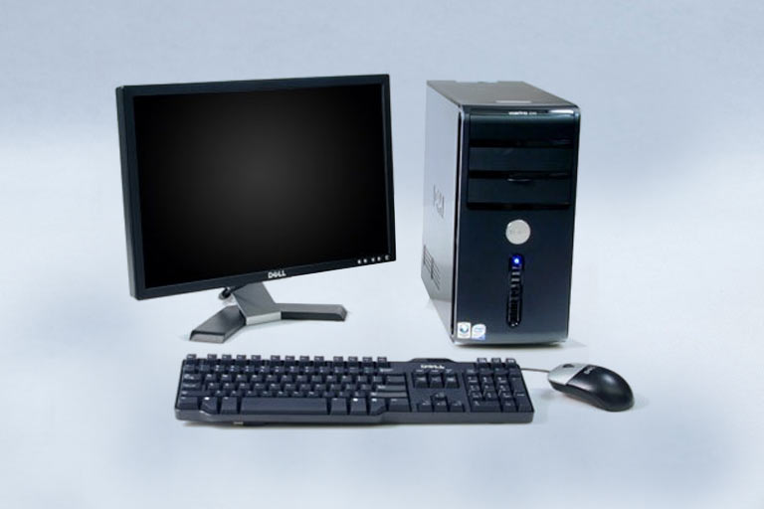

**Laptop**

We provide all laptop related accessories and more..

* Laptops
* All Accessories Of Laptops



**Hardware Parts**

We provide all hardware parts releted to computers...

* RAM, Hard Disk, Motherboard etc.

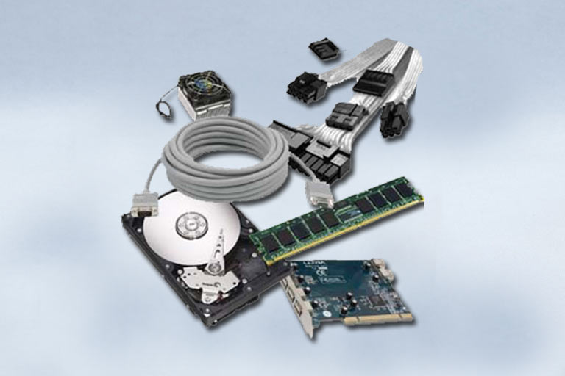

**Peripherals & Accessories**

We provide all Peripherals & Computer related Accessories.

* DVD Writer in CD/DVD Drive



**CCTV**

DVR & CCTV Cameras and More Devices.

* **DVR & CCTV Cameras**
* **More Devices**



**Security Devices…**

Biometric Devices and More Security Devices

* Biometric Devices
* More Security Devices

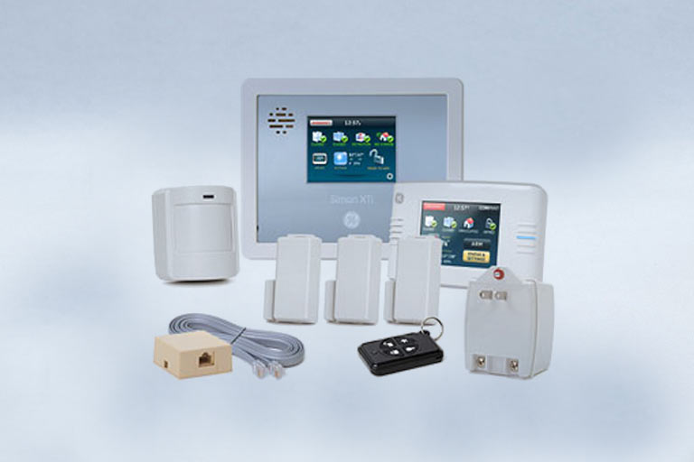

**SPECIFICATIONS AND SERVICES**

* Experience Trainer and Trained Faculties,
* Individual Attention and Individual PC,
* Convenient Batch Time and Morning (8am to 9pm)
* Best Experience in IT and Training Field Since Year 2008,
* 100% Job Assistance / Placements
* Lifetime Online / Offline Support Centers
* Complaint / Suggestion Box
* **Practice Tool:**

Notes provide For Each Course, Notes in mobile App,

Notes in Computer Software, Website Tutorial, Online

Supports Centers

* **Payment Mode:**

Cash/Cheque/Debit Cards/Credits Cards/Net Banking By

Easy Installment (Get Cash back on Online Payments)

* **Exams & Test**:

Practice Assignment on Each Topics, Module wise Test

Online Exam with Govt. Certificates

* **Affiliations & Authorization:**

AN ISO 9001:2015 Certified Institute, CBITVT, MSSDS,

CSE, MSME, CVC, EBITVTR etc.

**GROW LOCAL BUSINESS WITH UPWARD DIRECTION**

Grow Local Business is a Division of Rebenok Infotech. We Provide Service for Web Designing, Digital Marketing & Accounting Software’s. We Will Grow Our Client Business With Upward Direction By Digital Marketing.

The truth is that getting customers and clients for a **local business** is way harder than it seems. In order to **grow**, you've got to build relationships, get the word out, and create a referral engine. ... It even includes cost estimates which are exactly what **small businesses** need when they're laying out a marketing plan.

Grow local business provide services for web designing, Digital Marketing & Accounting Software’s. We Will Grow Our Clients & Many features available our clients.

**LATEST NEW APPLICATIONS**

* We have done ISO 9001:2015 Certified Company.
* Business Workshop
* Digital Marketing Seminar

**OUR CLIENTS**

**Certification Data:**



**S.T Mary High School:**



**Poonam Printers:**



**Cyprus Investments Consultants:**



**Sehat Clinic:**



**Travel Destination:**



**AG Finance Nest & Vakrangee Kendra:**



**Perfect Power Inverter:**



**Star Unique Printers:**



**Singh IT Solutions:**



**JKP Interior Decorators:**



**Shri Tech Cooling Tower:**



**Quality Policy:**

This Quality Policy covers information we collect from users and visitors of https://growlocalbusiness.in and our related research and review services (collectively, the “Services”). By using the Services or otherwise agreeing to this Quality Policy, you are consenting to the collection, use, disclosure and other handling of your information as described below.

If you have any concern about providing information to us or having such information displayed on the Services or otherwise used in any manner permitted in this Quality Policy, you should not use the Services.

**We value your Quality. This Policy outlines how we collect and use personal information on our website.**

● We only collect personal information from users who voluntarily share that information.

● We retain the collected personal information only as long as necessary.

● We do not share collected personal information with any third party.

● We protect personal information by reasonable security safeguards against loss or theft.

● We also use common internet technologies, such as Cookies, on our website so we can track user behavior and analyze the content and services of their interest.

We are committed to conducting our business in accordance with these principles in order to ensure that the confidentiality of personal information is protected and maintained.

[](https://growlocalbusiness.in/privacy_policy.html)R

**ALL ABOUT REBENOK INFOTECH**

**Who We Are:**

Rebenok Infotech is the ISO 9001:2015 Certified Institute REBENOK INFOTECH specialize in providing Training and IT Related Services. Our team of experts in Training & Resolve Problems Server and Client Environment and solutions will integrate Different platforms.

Rebenok Infotech is the Online and Classroom Computer Institute for Computer & Communication Courses Training in Virar - Vasai, Mumbai and Western India.  
We Provide Training for Spoken English, Cyber Security, MS-Office, Tally With GST, Hardware, Networking, Animation, Software Engineering, SEO & Digital Marketing , And Many Career Courses.

Within a short period of time, the organization has extended its activities to encompass all areas of the information sector. These activities include – computer system integration and marketing, peripherals, Repairer & Service, hardware & networking support and training.



**OUR TRAINING COURSE**

**Certified In IT Teachers Training Programming (CITTP):**

#### 1. MS-Office & Internet (Computing Techniques)

#### 2. Certificate Course of Computer Concepts (CCC)

#### 3. Effective Teaching Practices

#### 4. Soft Skills (Personality Development, English Speaking, CRM etc.)

#### 5. Electives (Any One)

6. Tally.ERP9 + Advance Excel + PPT

7. Web Programming Skills (HTML, CSS)

8. Graphic Skills (DTP)

9. Hardware & Networking (CCHN)

**Rebenok Certified IT Expert (RCITE):**

#### 1. MS-Office & Internet / CCC

#### 3. Business Accounting Basic & Advance Tally.ERP9

#### 3. Advance Excel

#### 4. Typing Skills

#### 5. Soft Skills (Personality Development, English Speaking, CRM etc.)

#### 6. Electives (Any One)

7. Web Design (CWD)

8. Programming Skills (C, C++)

9. Graphic Skills (DTP)

10. Hardware & Networking (CCHN)

**Diploma in Graphic Designing (DGD):**

#### 1. MS-Office & Internet / CCC

#### 2. Graphics (DTP)

#### 3. Basic Video Editing

#### 4. Typing Skills

#### 5. Soft Skills (Personality Development, English Speaking, CRM etc.)

#### 6. Project Work

**Diploma In Web Designing (DWD):**

#### 1. MS-Office & Internet / CCC

#### 2. Graphic Designing (DTP)

#### 3. Web Designing

#### 4. Typing Skills

#### 5. Soft Skills (Personality Development, English Speaking, CRM etc.)

#### 6. Electives (Any One)

7. PHP

8. ASP.Net

**Diploma In Software Programming (DSP):**

#### HTML, CSS, Java Script

#### C, C++

#### JAVA

#### Oracle

#### C#, VB.Net, My SQL Server

#### ASP.Net

**Diploma In Software Engineer (DSE):**

#### HTML, CSS, Java Script

#### C, C++

#### JAVA

#### Oracle

#### C#, VB.Net, My SQL Server

#### ASP.Net

#### Android Development

#### Web Designing

#### SEO & Digital Marketing

**Certified Computerized Accountant (CCA) :**

#### 1. Office Computing Skills

#### 2. Business Accounting Basic & Advance Tally.ERP9

#### 3. Advance Excel

#### 4. AC Skills (Personality Development, CRM etc.)

**Certified Financial Accounting (CFA):**

#### 1. MS-Office & Internet (Computing Techniques)

#### 2. Certificate Course of Computer Concepts (CCC)

#### 3. Business Accounting Basic & Advance Tally.ERP9

#### 4. Tax Management

#### 5. Advance Excel

#### 5. Typing Skills

#### 6. Soft Skills (Personality Development, English Speaking, CRM etc.)

**Certified Business Accountant (CBA):**

#### 1. MS-Office & Internet (Computing Techniques)

#### 2. Certificate Course of Computer Concepts (CCC)

#### 3. Business Accounting Basic & Advance Tally.ERP9

#### 4. Tax Management

#### 5. Advance Excel

#### 5. Typing Skills

#### 6. Soft Skills (Personality Development, English Speaking, CRM etc.)

**Banking & Insurance ● Finance Management ● Capital Markets**

**● Corporate Accountant**

**CONCLUSION**

Conclusion to Web Designing There are many reasons building a website requires that we obtain the right tools and resources. Standardization is one factor. When we use the right tools, we are assured that our pages would be standard and acceptable to every visitor.

**REFERENCES**

info@growlocalbusiness.in

http://www.rebenokinfotech.com

http://www.growenglishacademy.com

http://www.growlocalbusiness.com

http://www.kamleshprajapati.com