PHISHGUARD AI
Phishing Website Detection Using Machine Learning
HOME ASSIGNMENT – PROJECT DOCUMENTATION

TEAM MEMBER | ROLL NUMBER
K. Lakeshini Sree | 25EU02903
M. Rupasri | 24EU02026
M. Suvyaktha | 24EU02034
Department: CSE (AIML)
Institution: Siddhartha Academy of Higher Education
Subject: Machine Learning
Faculty: P. Bhagya Lakshmi

1. Project Summary
PhishGuard AI is a machine-learning-based application that helps users judge whether a website URL may be legitimate, suspicious or phishing-related. Phishing websites often imitate trusted services and try to trick people into sharing passwords, banking information or other personal details. The project examines URL patterns and security-related characteristics, then uses trained models to estimate the risk associated with a URL.
The application is designed to make the result easier to understand. Along with a classification, it can provide a risk level, URL analysis, a security recommendation, scan history, analytics and a downloadable PDF report. The aim is to support safer browsing; the output should be treated as a warning aid rather than a guarantee that a website is safe.

2. Problem Statement
Phishing links can be difficult to recognise because attackers use convincing domain names, misleading paths and familiar-looking website addresses. Manual checking takes time, and a blacklist may not contain a newly created phishing URL. Users therefore need a quick way to inspect URL characteristics and receive an understandable risk indication.
Objective: To develop a machine-learning system that analyses a website URL and classifies it as legitimate, suspicious or phishing, while presenting the result and a practical security recommendation.

3. Dataset and Data Source
The project presentation identifies the PhiUSIIL Phishing URL Dataset from the UCI Machine Learning Repository. It reports 235,795 records and 54 features in the dataset summary, with 134,850 legitimate records and 100,945 phishing records. A later dataset-structure slide reports a shape of (235795, 56), which may include additional identifier or target columns before the initial feature pipeline removes selected fields.
Dataset detail | Value reported in project presentation
Dataset | PhiUSIIL Phishing URL Dataset
Source | UCI Machine Learning Repository
Records | 235,795
Legitimate class | 134,850
Phishing class | 100,945
Missing values | 0
Duplicate rows | 0
Label mapping in presentation | 1 = Legitimate; 0 = Phishing
The label column provides the class that the model learns to predict. The presentation notes that categorical/text identifier fields were removed from the initial machine-learning pipeline while the target variable was retained. The repository README describes the model's input as a URL and engineered URL security features.

4. Exploratory Data Analysis (EDA) and Visualization
EDA was used to understand the class balance, examine URL-length patterns and inspect relationships among numerical features before training.

4.1 Class distribution
The dataset contains more legitimate records than phishing records. The difference is noticeable but neither class is missing or extremely small. The chart below uses the counts shown in the project presentation.
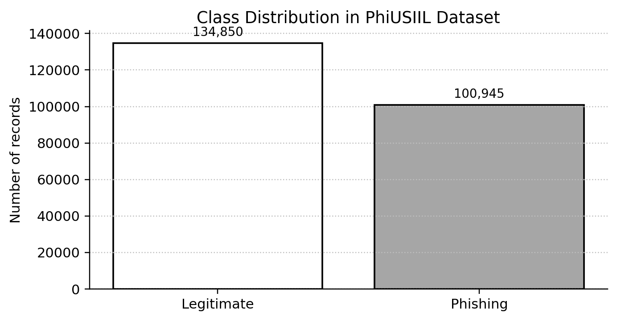

4.2 URL length analysis
The presentation reports that most URLs in both classes are relatively short, while a small number of very long URLs create a long right tail in the distribution. The two classes overlap substantially. This means URL length can contribute useful information, but it should not be used as the only signal for deciding whether a URL is phishing.

4.3 Feature correlation analysis
A correlation heatmap was used to examine how numerical features move in relation to one another. Strong positive correlations can indicate that two features carry overlapping information, while negative correlations indicate that higher values in one feature tend to occur with lower values in another. The presentation explains the interpretation of the heatmap but does not provide the underlying correlation values in the report material.

5. Data Preprocessing
Preprocessing prepared the dataset for model training and made the experiment repeatable. According to the presentation, no missing values or duplicate rows were found.
- Checked the dataset dimensions, columns and target label.
- Removed categorical/text identifier fields from the initial machine-learning pipeline while retaining the target variable.
- Used an 80:20 train-test split.
- Applied stratified splitting so the class proportions were maintained across the training and test sets.
- Used random_state = 42 for reproducibility.
- Applied StandardScaler in the presentation's preprocessing workflow.
Scaling is useful for models that are sensitive to feature magnitude, such as Logistic Regression. Tree-based models such as Random Forest generally do not require standardisation, but the final implementation should keep the training and prediction preprocessing steps consistent.

6. Feature Engineering and Feature Selection
Feature engineering represents a URL using measurable properties that may help distinguish suspicious links from ordinary ones. The repository README lists URL length, domain information, HTTPS usage, digit count, special-character count, suspicious symbols, dot count, path count, IP-address usage and suspicious keywords. It also describes a character-level TF-IDF representation of the URL using 2–5 character n-grams and a maximum vocabulary of 10,000 features.
The project presentation separately describes a Random Forest feature-importance ranking that retained 15 of 50 candidate features. The selected features listed in the presentation are:
- URLSimilarityIndex
- NoOfExternalRef
- LineOfCode
- NoOfSelfRef
- NoOfImage
- NoOfJS
- NoOfCSS
- HasSocialNet
- HasCopyrightInfo
- IsHTTPS
- LargestLineLength
- HasDescription
- NoOfDegitsInURL
- NoOfOtherSpecialCharsInURL
- DegitRatioInURL
Feature selection reduces the number of inputs and focuses the model on information considered useful for classification. The exact importance scores are not included in the supplied presentation, so the features are listed without assigning invented scores.

7. Machine Learning Models Used

7.1 Logistic Regression
Logistic Regression is a supervised classification algorithm used as a baseline. It learns a relationship between input features and the probability of a class. In the repository's URL-only branch, Logistic Regression is used with character-level TF-IDF features.

7.2 Random Forest
Random Forest combines the predictions of multiple decision trees. It can learn non-linear relationships in tabular data and can provide feature-importance rankings. The project presentation identifies Random Forest as the model selected for hyperparameter tuning in its tabular-feature workflow.

7.3 Decision Tree
A Decision Tree is a supervised machine-learning algorithm that makes predictions by splitting data into smaller groups based on feature values. For phishing detection, it can learn rules from URL and website-related characteristics to classify a website as legitimate or phishing. Decision Trees are easy to understand, although a single tree may overfit if it grows too complex.

7.4 Repository prediction pipeline
The current GitHub README describes two complementary prediction branches: (1) a URL-only Logistic Regression model using character-level TF-IDF, and (2) a feature-based model using engineered URL characteristics. The README states that the final phishing probability combines the URL model at 70% and the feature model at 30%. The combined probability is then mapped to a risk category.

8. Model Comparison
The presentation says that Random Forest, Logistic Regression and XGBoost achieved values close to 1.0 for accuracy, precision, recall and F1-score, and that Random Forest was chosen for tuning. However, the individual numerical values and the model-comparison plot are not present in the supplied text. The comparison below therefore records the qualitative conclusion only.
Model | Role in the presentation | Qualitative observation reported
Logistic Regression | Baseline classifier | Performance reported as close to 1.0 across listed metrics
Random Forest | Selected for tuning | Performance reported as close to 1.0; selected for GridSearchCV
Decision Tree | Decision-tree classifier | Not separately quantified in the supplied presentation
Accuracy measures overall correctness. Precision measures how many predicted phishing cases are truly phishing. Recall measures how many actual phishing cases are detected. F1-score balances precision and recall. For a security application, recall is important because missed phishing websites can expose users to harm; precision also matters because excessive false alarms can reduce trust in the tool.
Important: Do not submit the phrase “close to 1.0” as an exact result. If the evaluation output is available, insert the precise metrics and confusion matrix here.

9. Hyperparameter Tuning
The presentation reports using GridSearchCV with cross-validation to tune the Random Forest classifier. GridSearchCV tests combinations of specified hyperparameter values and selects the combination that performs best according to the chosen scoring method.
Parameter | Values tested | Best value reported
n_estimators | 100, 150 | 150
max_depth | 10, 20 | 20
min_samples_split | 2, 5 | 2
The selected settings use 150 trees, allow a maximum tree depth of 20 and use a minimum of two samples to split an internal node. These values are the best parameters reported in the supplied presentation.

10. Final Model and Results
In the presentation's tabular-feature workflow, the final tuned model is a Random Forest classifier trained using the 15 selected features. The model was evaluated using a train-test split, and the presentation reports that the candidate models performed close to 1.0 on the listed metrics. Exact test scores are not shown in the supplied material.
The current GitHub repository README describes the application-level final decision as a combination of URL-only TF-IDF Logistic Regression and a feature-based model, weighted 70% and 30% respectively. Its risk bands are:
Phishing probability | Risk level | Displayed classification
Below 30% | Low | Legitimate
30% to 69.99% | Medium | Suspicious
70% or above | High | Phishing
Because the presentation's Random Forest training description and the repository's hybrid prediction description are different, the team should confirm which version was used for the final demonstration and ensure the report, saved model files and code all describe the same version.

11. Model Persistence
Model persistence allows the trained model to be saved and reused without repeating the full training process each time the application starts. The presentation states that the trained model and selected features were saved using Joblib, then reloaded for predictions on new data.
The GitHub repository contains saved model artefacts, including phishing_detection_model.joblib, realtime_phishing_model.joblib, url_only_model.joblib, selected_features.joblib and related feature/vectorizer files. The exact artefact used by the running app should be confirmed from app.py before final submission.

12. Predictions and Demonstration
The user opens the PhishGuard AI application, enters a website URL and starts a scan. The system analyses the URL, calculates a phishing probability and displays the classification and risk level. The README describes the output as including detailed URL analysis and a security recommendation. The presentation also shows login/account creation, scan history, PDF reporting and security analytics.
- Open the application and sign in or create an account if prompted.
- Enter the URL to be checked in the URL scanner.
- Start the scan and wait for the prediction.
- Review the result, risk level, URL analysis and security recommendation.
- Open scan history or analytics to review earlier scans.
- Download the PDF report if a report is needed.
A model prediction is not a guarantee of safety. Users should avoid entering credentials on a suspicious website and should verify important links through a trusted source.

13. Real-World Application
- Browser security: warn users about potentially risky links before they proceed.
- Email security: screen links received in messages.
- Online banking protection: help identify misleading banking URLs.
- Cybersecurity tools: add URL risk scoring to a larger security workflow.
- URL screening systems: analyse many submitted URLs automatically.
The system can support decision-making, but it should not replace browser protections, trusted threat-intelligence services or careful user judgement. Its reliability depends on the training data, the features available at prediction time and how well the data represents current attacks.

14. Conclusion
PhishGuard AI demonstrates how machine learning can help identify potentially harmful website URLs. The project uses URL characteristics, feature engineering, model training and a user-facing application to turn technical signals into a risk classification. The workflow also covers exploratory analysis, preprocessing, feature selection, model comparison, hyperparameter tuning and saving trained artefacts for reuse.
The project provides a useful foundation for a practical cybersecurity tool. Future improvements could include testing on newer URLs, reporting exact evaluation metrics, checking false positives and false negatives, improving live feature extraction, adding browser integration and updating the model as phishing tactics change. The application should be presented as a supporting security tool, not as a perfect detector.

Dashboard Printout
The following image is the Security Analytics dashboard slide from the project presentation, attached as the dashboard printout requested in the assignment.
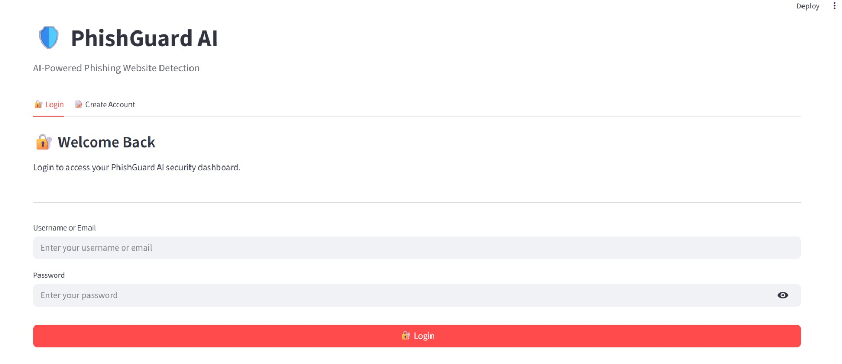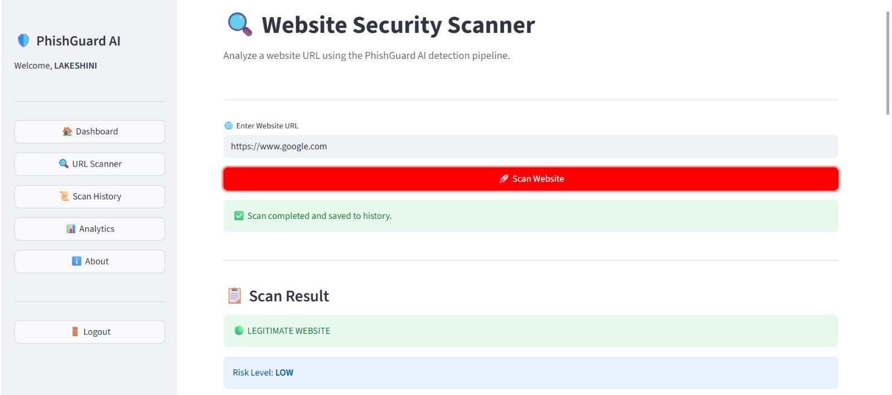

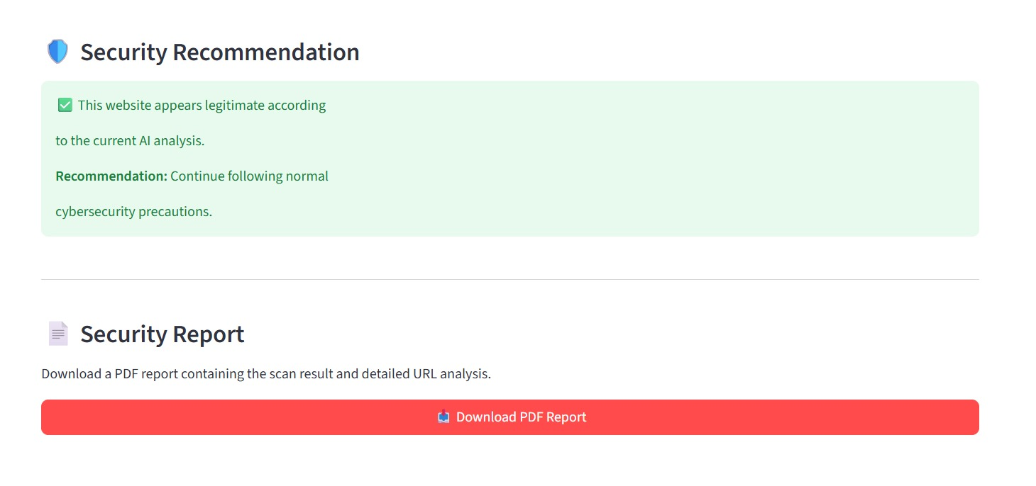
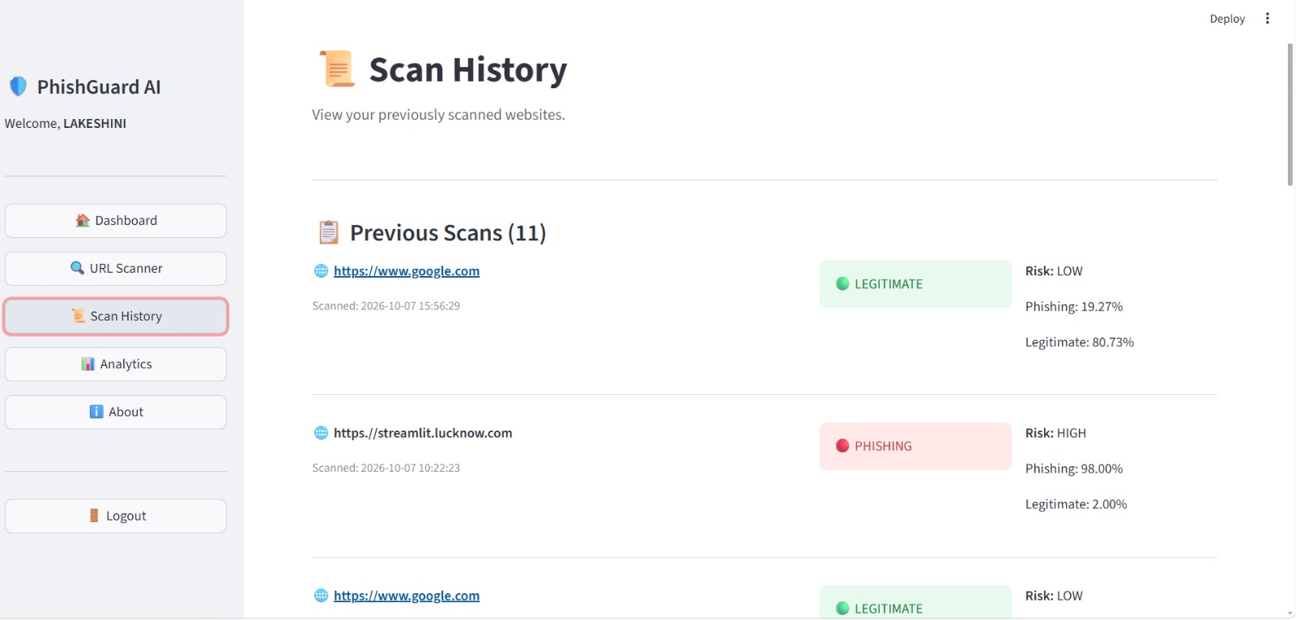

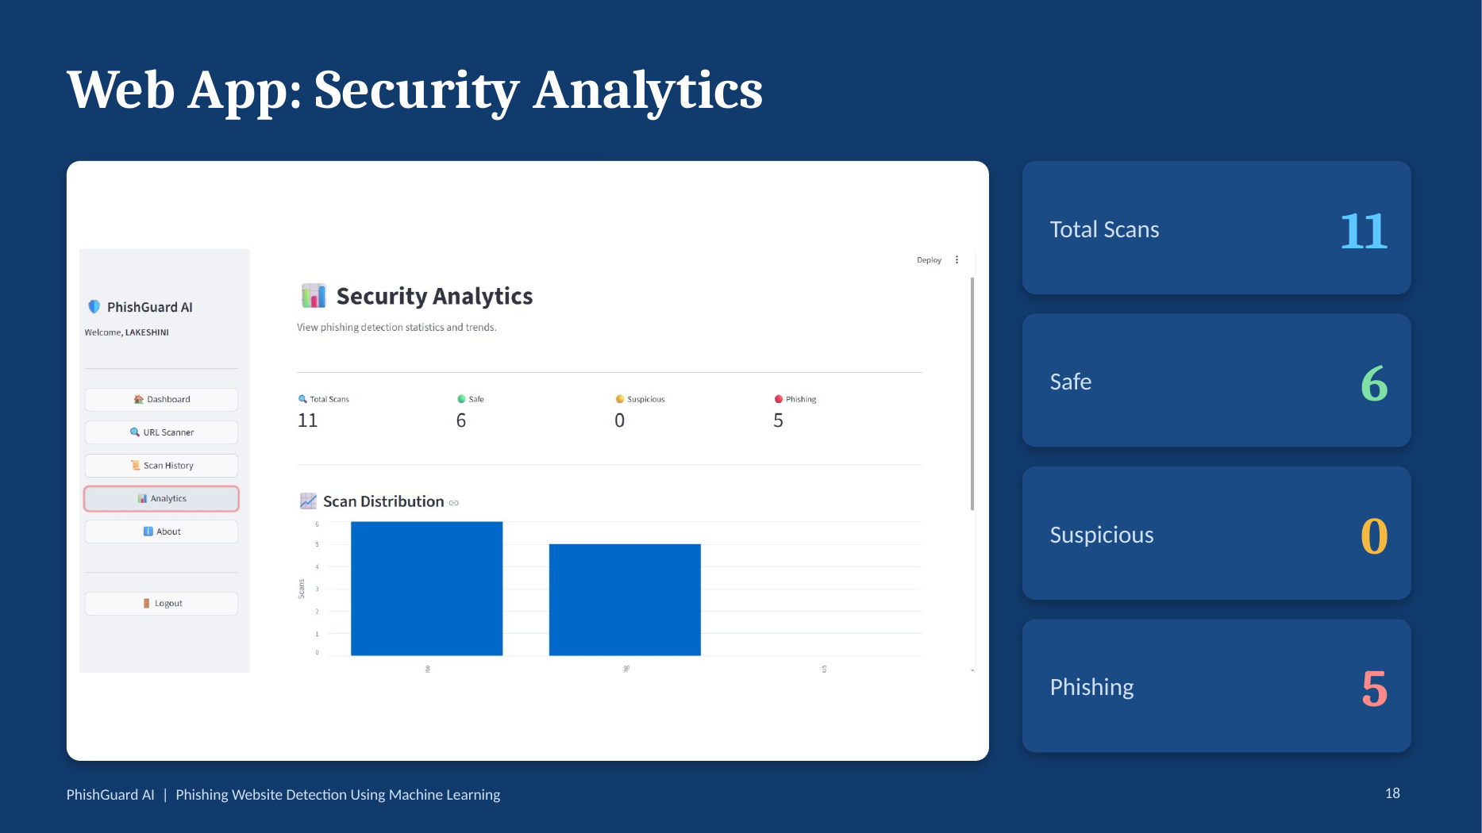

Dashboard values visible in the supplied presentation: Total scans = 11; Safe = 6; Suspicious = 0; Phishing = 5.

