DSA 0601 - Data handling and visualization
Set 22 - Time Series Analysis
1. Time series line chart of monthly sales
Code:
library(ggplot2)

sales <- data.frame(
Month = factor(c("January","February","March","April","May"),
levels = c("January","February","March","April","May")),
Sales = c(15000, 18000, 22000, 20000, 23000)
)

ggplot(sales, aes(x = Month, y = Sales, group = 1)) +
geom_line(color = "#2c7fb8", linewidth = 1) +
geom_point(size = 3, color = "#2c7fb8") +
geom_text(aes(label = Sales), vjust = -1, size = 3) +
labs(
title = "Monthly Sales Trend (January - May)",
x = "Month",
y = "Sales (in $)"
) +
theme_minimal()
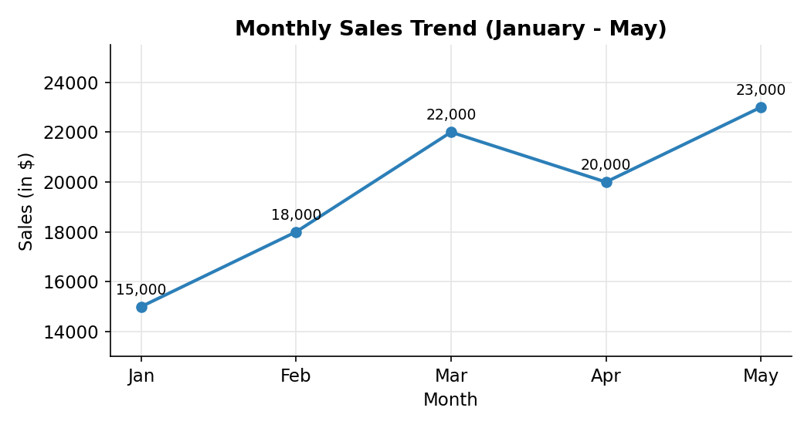
2. Scatter plot: advertising budget vs monthly sales
Code:
library(ggplot2)

ad_sales <- data.frame(
Month = c("Jan","Feb","Mar","Apr","May"),
Advertising_Budget = c(2000, 2500, 3200, 2800, 3500),
Sales = c(15000, 18000, 22000, 20000, 23000)
)

ggplot(ad_sales, aes(x = Advertising_Budget, y = Sales)) +
geom_point(size = 3, color = "#2c7fb8") +
geom_smooth(method = "lm", se = FALSE, color = "red") +
geom_text(aes(label = Month), vjust = 1.8, size = 3) +
labs(
title = "Advertising Budget vs Monthly Sales",
x = "Advertising Budget ($)",
y = "Monthly Sales ($)"
) +
theme_minimal()

cor(ad_sales$Advertising_Budget, ad_sales$Sales)
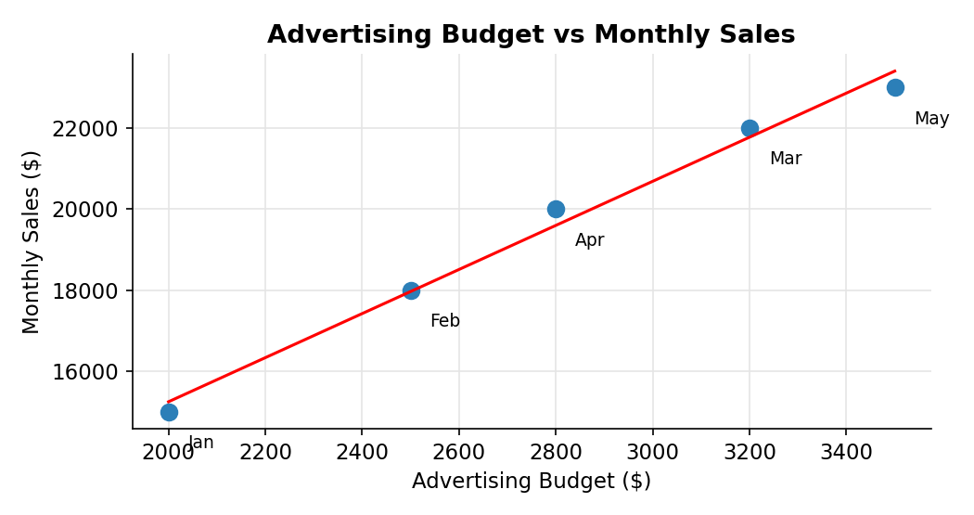
3. Tableau dashboard: sales trend and sales distribution by product
Code:
dashboard_data <- data.frame(
Month = rep(c("January","February","March","April","May"), each = 5),
Product = rep(c("Product A","Product B","Product C","Product D","Product E"), times = 5),
Sales = c(4000,3300,2700,2700,2300,
4900,4000,3300,3200,2600,
5900,4800,4000,3900,3400,
5400,4400,3600,3600,3000,
6200,5100,4100,4100,3500)
)
write.csv(dashboard_data, "Set22_Sales_Dashboard.csv", row.names = FALSE)
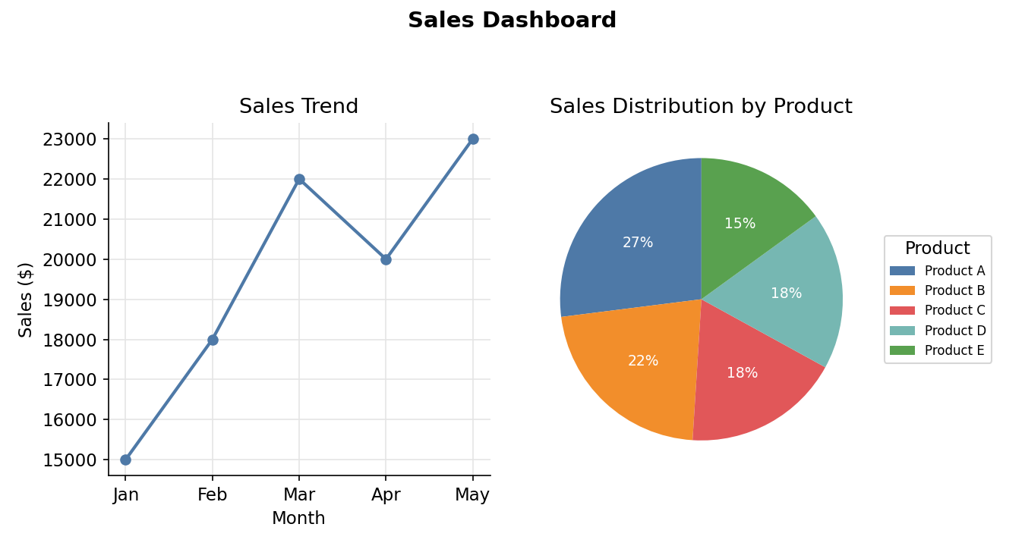
4. Autocorrelation plot to identify seasonality
Code:
sales_ts <- ts(c(15000, 18000, 22000, 20000, 23000),
start = c(2024, 1), frequency = 12)

acf(sales_ts,
lag.max = 3,
main = "Autocorrelation Function of Monthly Sales",
xlab = "Lag",
ylab = "ACF")
