DSA 0601 - Data handling and visualization
Set 24 - Product Inventory Management
1. Bar chart: quantity of each product in inventory
Code:
library(ggplot2)

inventory <- data.frame(
Product_ID = 1:5,
Product_Name = c("Product A","Product B","Product C","Product D","Product E"),
Quantity_Available = c(250, 175, 300, 200, 220)
)

ggplot(inventory, aes(x = Product_Name, y = Quantity_Available)) +
geom_col(fill = "skyblue", color = "black") +
geom_text(aes(label = Quantity_Available), vjust = -0.5) +
labs(
title = "Quantity Available by Product",
x = "Product",
y = "Quantity Available"
) +
theme_minimal()
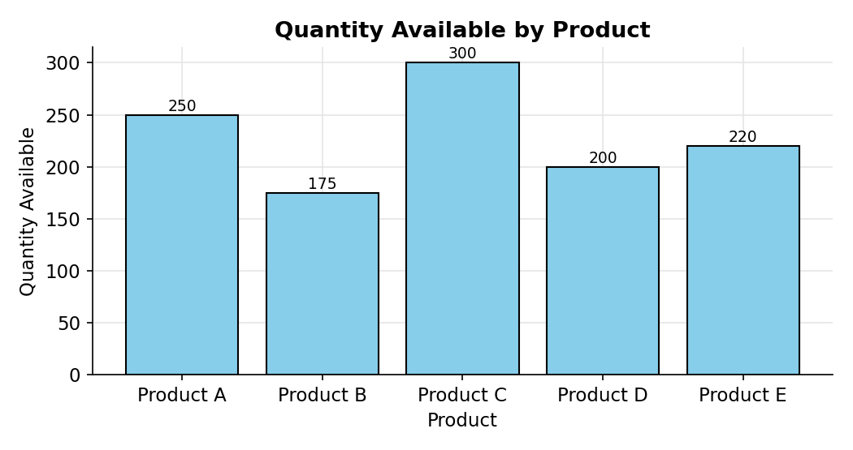
2. Stacked bar chart: quantity of products within each category
Code:
inventory$Category <- c("Electronics","Electronics","Home","Home","Accessories")
inventory$Price <- c(1200, 950, 400, 520, 150)

ggplot(inventory, aes(x = Category, y = Quantity_Available, fill = Product_Name)) +
geom_col(color = "white") +
labs(
title = "Quantity of Products within Each Category",
x = "Product Category",
y = "Quantity Available",
fill = "Product"
) +
theme_minimal()
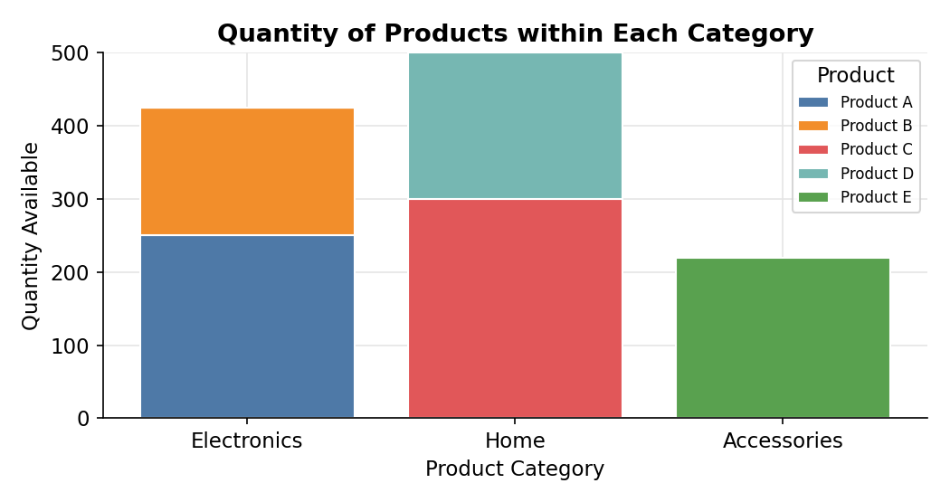
3. Tableau dashboard: bar chart and stacked bar chart
Code:
write.csv(inventory, "Set24_Product_Inventory.csv", row.names = FALSE)
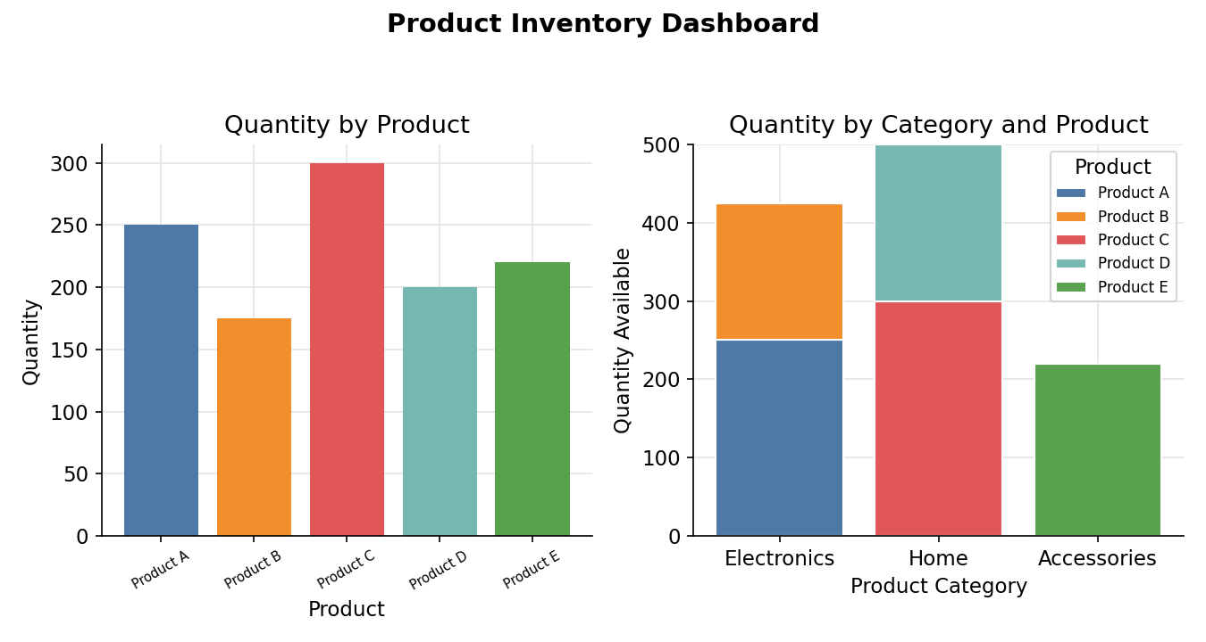
4. Scatter plot: product price vs quantity available
Code:
ggplot(inventory, aes(x = Price, y = Quantity_Available)) +
geom_point(size = 3, color = "#2c7fb8") +
geom_smooth(method = "lm", se = FALSE, color = "red") +
geom_text(aes(label = Product_Name), vjust = -1, size = 3) +
labs(
title = "Product Price vs Quantity Available",
x = "Price ($)",
y = "Quantity Available"
) +
theme_minimal()

cor(inventory$Price, inventory$Quantity_Available)
