DATA HANDLING AND VISUALIZATION
LABORATORY EXPERIMENT

Name | CHEVULA RUPAVATHI
Register Number | 192325077
R.No | 9
Slot | C
Subject | Data Handling and Visualization

SET 19: SURVEY RESPONSES ANALYSIS
1. Aim
To analyze survey responses using grouped bar charts, stacked bar charts, a response table, and an interactive Tableau dashboard.
2. Dataset
The following survey response dataset is used in this experiment.
Survey ID | Question 1 | Question 2 | Question 3
1 | A | B | C
2 | B | A | D
3 | C | A | B
Column description:
- Survey ID: Unique identifier for each survey response record.
- Question 1: Answer recorded for the first survey question.
- Question 2: Answer recorded for the second survey question.
- Question 3: Answer recorded for the third survey question.
The dataset contains 3 survey records and 9 answers in total.
3. Process / Procedure
- Enter the survey dataset into R as a data frame.
- Use tidyr to convert the data from wide format to long format, so each row represents one answer to one question.
- Count the answers for Question 1 and create a grouped (single-series) bar chart with ggplot2. The answer categories A, B, C, and D are retained so zero counts are visible.
- Create a stacked bar chart showing the response distribution for Question 1, Question 2, and Question 3. Use answer categories A, B, C, and D as the stack groups.
- Print the original survey data as a clearly labelled table.
- Import the dataset into Tableau and create the two charts and the response table as separate worksheets.
- Combine the worksheets into a Tableau dashboard and arrange the charts and table clearly.
- To run the R program, open RStudio, install any missing packages, paste the code into a new R script, save it, and click Source (or run the script). The plots appear in the Plots pane and the table prints in the Console.

4. R Program
Install the packages once if they are not already installed. Then run the complete script below.
# Set 19: Survey Responses Analysis
# Install once if needed:
# install.packages(c("ggplot2", "tidyr", "dplyr", "knitr"))
library(ggplot2)
library(tidyr)
library(dplyr)
library(knitr)
# 1. Create the dataset exactly as supplied
survey <- data.frame(
`Survey ID` = c(1, 2, 3),
`Question 1` = c("A", "B", "C"),
`Question 2` = c("B", "A", "A"),
`Question 3` = c("C", "D", "B"),
check.names = FALSE
)
# 2. Convert to long format for question-wise visualizations
survey_long <- survey %>%
pivot_longer(
cols = starts_with("Question"),
names_to = "Question",
values_to = "Answer"
)
answer_levels <- c("A", "B", "C", "D")
# 3. OUTPUT 1: Bar chart for Question 1.
# Include all answer levels so categories with zero responses remain visible.
q1_counts <- survey %>%
count(Answer = `Question 1`, name = "Count") %>%
right_join(data.frame(Answer = answer_levels), by = "Answer") %>%
mutate(Count = coalesce(Count, 0L),
Answer = factor(Answer, levels = answer_levels))
p1 <- ggplot(q1_counts, aes(x = Answer, y = Count, fill = Answer)) +
geom_col(width = 0.7, show.legend = FALSE) +
geom_text(aes(label = Count), vjust = -0.35, size = 4) +
scale_fill_manual(values = c(A = "#4472C4", B = "#ED7D31",
C = "#70AD47", D = "#A5A5A5")) +
scale_y_continuous(breaks = 0:3, limits = c(0, 1.5),
expand = expansion(mult = c(0, 0.02))) +
labs(title = "Question 1 Answer Distribution",
x = "Answer", y = "Number of responses") +
theme_minimal(base_size = 12) +
theme(plot.title = element_text(face = "bold", hjust = 0.5))
print(p1)
# 4. OUTPUT 2: Stacked bar chart across all three questions.
# Each question has three answers, one from each survey record.
all_counts <- survey_long %>%
count(Question, Answer, name = "Count") %>%
complete(Question, Answer = answer_levels, fill = list(Count = 0)) %>%
mutate(Answer = factor(Answer, levels = answer_levels),
Question = factor(Question,
levels = c("Question 1", "Question 2", "Question 3")))
p2 <- ggplot(all_counts,
aes(x = Question, y = Count, fill = Answer)) +
geom_col(width = 0.7) +
geom_text(aes(label = ifelse(Count > 0, Count, "")),
position = position_stack(vjust = 0.5), size = 3.5) +
scale_fill_manual(values = c(A = "#4472C4", B = "#ED7D31",
C = "#70AD47", D = "#A5A5A5"),
drop = FALSE) +
labs(title = "Response Distribution Across All Three Questions",
x = "Survey question", y = "Number of responses", fill = "Answer") +
theme_minimal(base_size = 12) +
theme(plot.title = element_text(face = "bold", hjust = 0.5),
legend.position = "bottom")
print(p2)
# 5. OUTPUT 3: Print the neatly labelled survey response table.
cat("\\nSurvey Response Table\\n")
print(knitr::kable(survey, format = "simple", align = "c"))
# Optional: view the long-format data used for charting
# print(survey_long)

5. Output

Output 1: Grouped Bar Chart for Question 1
Expected counts: A = 1, B = 1, C = 1, D = 0. Each bar represents the number of times that answer appears for Question 1.
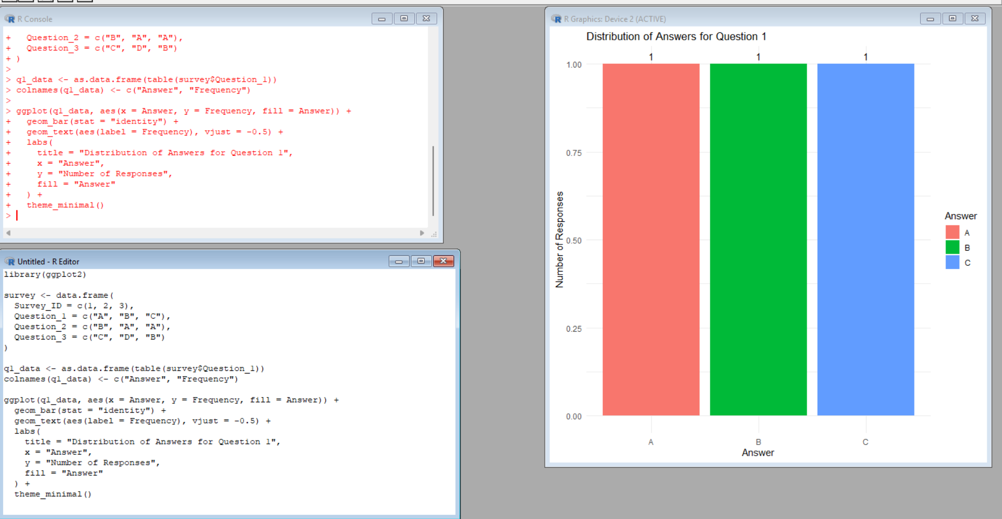

Output 2: Stacked Bar Chart for All Three Questions
Expected counts by question: Question 1 — A: 1, B: 1, C: 1, D: 0; Question 2 — A: 2, B: 1, C: 0, D: 0; Question 3 — A: 0, B: 1, C: 1, D: 1.
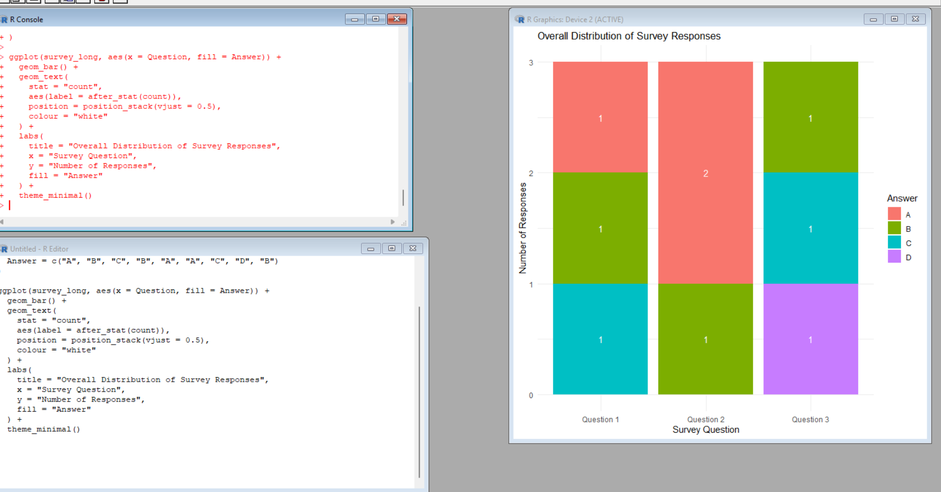

Output 3: Survey Response Table
The table below displays all three survey IDs and their answers.
Survey ID | Question 1 | Question 2 | Question 3
1 | A | B | C
2 | B | A | D
3 | C | A | B

Output 4: Tableau Dashboard Layout
The following is an illustrative dashboard layout preview showing how the two charts and response table can be arranged. It is a static mockup, not a live Tableau dashboard.

Expected dashboard arrangement: Question 1 chart at the upper left, stacked response chart at the upper right, and the response table across the bottom. In Tableau, selecting a chart mark can be configured to filter or highlight related data.

6. Tableau Dashboard Procedure
- Prepare and import the survey dataset. Save the data as an Excel or CSV file with columns Survey ID, Question 1, Question 2, and Question 3. In Tableau, choose Connect and open the file.
- Create a grouped bar chart for Question 1. Open a worksheet, place Question 1 on Columns and Number of Records (or COUNT of Survey ID) on Rows, and choose Bar. Show answer labels and give the worksheet a clear title. Keep A, B, C, and D visible if you want to show zero-count categories.
- Create a stacked bar chart for all three questions. For easiest setup, reshape the three question columns to rows in the Data Source page using Pivot (select Question 1–Question 3 and choose Pivot). Rename Pivot Field Names to Question and Pivot Field Values to Answer. Put Question on Columns, Number of Records on Rows, and Answer on Color. Turn on mark labels where practical.
- Create a worksheet containing the survey response table. Add Survey ID and the three question fields to Rows or Text in a text table, and format the headings.
- Create a new dashboard using the New Dashboard button. Choose an appropriate size such as Automatic or a fixed desktop size.
- Add all three worksheets to the dashboard. Arrange the two charts side by side and the response table below them.
- Add a dashboard title, suitable colours, legends, axis labels, and readable data labels. Check that all answer categories use consistent colours in the stacked chart.
- For interactive exploration, use a chart's drop-down menu and choose Use as Filter, or select Dashboard > Actions to add Filter or Highlight actions. Users can select a question or answer mark to filter or highlight related views. Test and clear selections to restore the full view.
Note: This document includes a static dashboard layout preview only. A live Tableau workbook/dashboard must be built and saved separately in Tableau.

7. Result
The survey response dataset was analyzed using a Question 1 bar chart, a stacked bar chart for all three questions, and a labelled response table. These visualizations can be combined in Tableau into an interactive dashboard for filtering, highlighting, and exploring the survey responses.

