DATA HANDLING AND VISUALIZATION
LABORATORY EXPERIMENT

Name | CHEVULA RUPAVATHI
Register Number | 192325077
R.No | 9
Slot | C
Subject | Data Handling and Visualization

SET 20: STOCK ANALYSIS

1. Aim
To analyze stock prices using a line chart, a daily percentage change bar chart, a stock price table, and an interactive Tableau dashboard.

2. Dataset
The following stock price dataset is used in this experiment.
Date | Stock A | Stock B | Stock C
2023-01-01 | 100 | 150 | 120
2023-01-02 | 105 | 152 | 118
2023-01-03 | 110 | 148 | 122
Column descriptions:
- Date: The calendar date on which each stock price was recorded.
- Stock A: Price recorded for Stock A on the given date.
- Stock B: Price recorded for Stock B on the given date.
- Stock C: Price recorded for Stock C on the given date.
The dataset contains three dates and three stock-price series.

3. Process / Procedure
- Enter the supplied stock price dataset into RStudio as a data frame.
- Convert the Date column from text to Date format using as.Date().
- Reshape the stock columns into long format with tidyr::pivot_longer() so all three stocks can be drawn on one line chart.
- Create a line chart comparing Stock A, Stock B, and Stock C over time using ggplot2, with a separate colour for each stock.
- Calculate Stock A's daily percentage change with ((current price - previous price) / previous price) × 100. The first date is NA because no previous price exists.
- Create a bar chart of the available daily percentage changes for Stock A, using a zero reference line to distinguish positive and negative changes.
- Print the original stock price data in a labelled table.
- Export the original data and the percentage-change data to CSV files for use in Tableau.
- Create the three Tableau worksheets and combine them into a dashboard. R exports data and generates charts, but does not automatically create a Tableau dashboard.

4. R Program
Install packages once if necessary. Then run the complete script in RStudio.
# Set 20: Stock Analysis
# Run this line once if any package is missing:
# install.packages(c("ggplot2", "tidyr", "dplyr", "knitr"))

library(ggplot2)
library(tidyr)
library(dplyr)
library(knitr)

# 1. Create the dataset exactly as supplied
stock <- data.frame(
Date = c("2023-01-01", "2023-01-02", "2023-01-03"),
`Stock A` = c(100, 105, 110),
`Stock B` = c(150, 152, 148),
`Stock C` = c(120, 118, 122),
check.names = FALSE
)

# 2. Convert Date text into R Date format
stock$Date <- as.Date(stock$Date, format = "%Y-%m-%d")

# 3. Reshape the three stock columns into long format for plotting
stock_long <- stock %>%
pivot_longer(
cols = c(`Stock A`, `Stock B`, `Stock C`),
names_to = "Stock",
values_to = "Stock Price"
)

# Q1 / OUTPUT 1: Line chart comparing all three stocks
p1 <- ggplot(stock_long,
aes(x = Date, y = `Stock Price`, colour = Stock, group = Stock)) +
geom_line(linewidth = 1) +
geom_point(size = 3) +
geom_text(aes(label = `Stock Price`), vjust = -0.8, size = 3,
show.legend = FALSE) +
scale_colour_manual(values = c("Stock A" = "#4472C4",
"Stock B" = "#ED7D31",
"Stock C" = "#70AD47")) +
labs(title = "Stock Prices Over Time",
x = "Date", y = "Stock Price", colour = "Stock") +
theme_minimal(base_size = 12) +
theme(plot.title = element_text(face = "bold", hjust = 0.5))
print(p1)

# Q2 / OUTPUT 2: Daily percentage change for Stock A
# The first day's percentage change is NA because no previous price exists.
stock <- stock %>%
arrange(Date) %>%
mutate(`Stock A % Change` =
((`Stock A` - lag(`Stock A`)) / lag(`Stock A`)) * 100)

pct_data <- stock %>% filter(!is.na(`Stock A % Change`))

p2 <- ggplot(pct_data,
aes(x = Date, y = `Stock A % Change`,
fill = `Stock A % Change` >= 0)) +
geom_col(width = 0.6) +
geom_hline(yintercept = 0, colour = "black", linewidth = 0.4) +
geom_text(aes(label = sprintf("%.2f%%", `Stock A % Change`)),
vjust = -0.5, size = 3.5, show.legend = FALSE) +
scale_fill_manual(values = c("TRUE" = "#70AD47", "FALSE" = "#C0504D"),
labels = c("FALSE" = "Decrease", "TRUE" = "Increase"),
name = "Daily movement") +
labs(title = "Daily Percentage Change for Stock A",
x = "Date", y = "Percentage change (%)") +
theme_minimal(base_size = 12) +
theme(plot.title = element_text(face = "bold", hjust = 0.5),
legend.position = "bottom")
print(p2)

# Q3 / OUTPUT 3: Print the original stock price table
stock_table <- stock %>%
select(Date, `Stock A`, `Stock B`, `Stock C`)
cat("\\nStock Price Data Table\\n")
print(knitr::kable(stock_table, format = "simple", align = "c"))

# Q4 / Tableau data exports
# Original wide-format table for the table worksheet and simple import
write.csv(stock_table, "Stock_Prices.csv", row.names = FALSE)

# Long format supports a Tableau line chart with Question/Stock and Price fields
write.csv(stock_long, "Stock_Prices_Long.csv", row.names = FALSE)

# Percentage-change data supports the Stock A daily change bar chart
write.csv(stock %>% select(Date, `Stock A`, `Stock A % Change`),
"Stock_A_Percentage_Change.csv", row.names = FALSE)

# Expected percentage changes:
# 2023-01-01 = NA
# 2023-01-02 = ((105 - 100) / 100) * 100 = 5.00%
# 2023-01-03 = ((110 - 105) / 105) * 100 = 4.7619% (approximately 4.76%)

5. Output

Output 1: Line Chart Comparing All Three Stocks
Expected line-chart values: Stock A = 100, 105, 110; Stock B = 150, 152, 148; Stock C = 120, 118, 122 across the three dates.
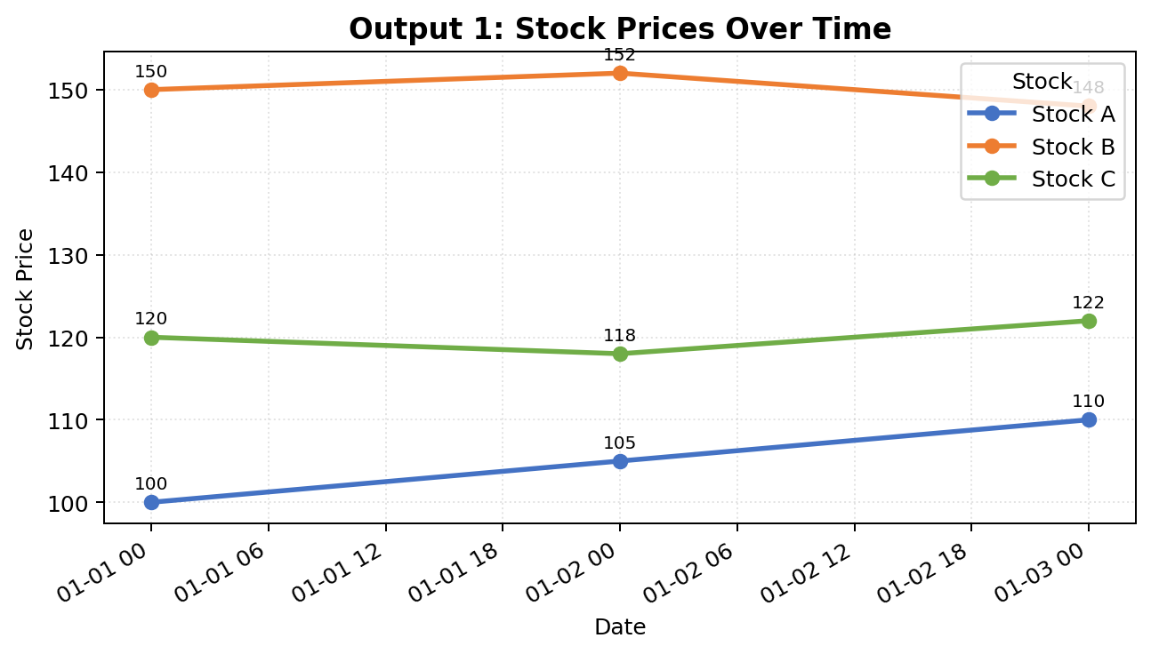

Output 2: Bar Chart of Stock A Daily Percentage Changes
The first date is omitted from the bar chart because its percentage change is NA. The change on 2023-01-02 is 5.00%, and the change on 2023-01-03 is approximately 4.76%. Both changes are positive and are shown above the zero line.
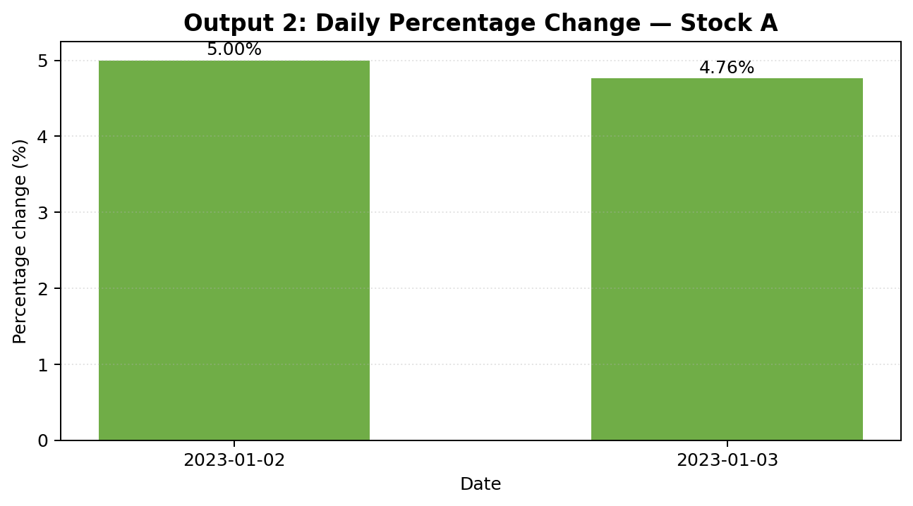

Output 3: Stock Price Table
The table lists the original dataset, with the Date displayed in YYYY-MM-DD format.
Date | Stock A | Stock B | Stock C
2023-01-01 | 100 | 150 | 120
2023-01-02 | 105 | 152 | 118
2023-01-03 | 110 | 148 | 122

Output 4: Suggested Tableau Dashboard Layout
The image below is a static layout preview illustrating a possible arrangement. It is not a live Tableau dashboard and does not mean a Tableau workbook has been created.
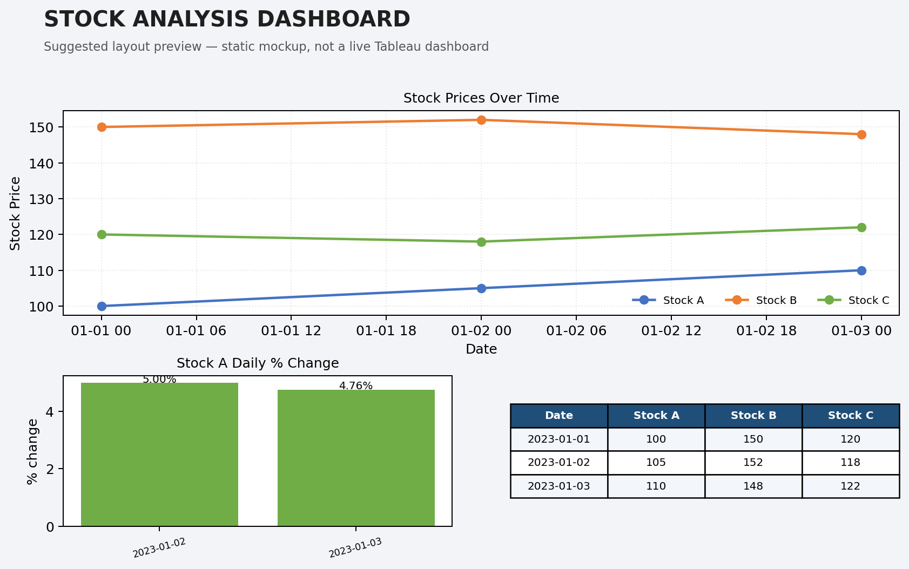

6. Tableau Dashboard Procedure
- Run the R script. It exports Stock_Prices.csv, Stock_Prices_Long.csv, and Stock_A_Percentage_Change.csv to R's current working directory. Use getwd() in R to find that folder.
- Open Tableau Desktop or Tableau Public and connect to the CSV file. Use Stock_Prices_Long.csv for the multi-stock line chart, Stock_A_Percentage_Change.csv for the percentage-change chart, and Stock_Prices.csv for the original data table. Alternatively, add the files as separate data sources.
- Create the line-chart worksheet: use Stock_Prices_Long.csv, drag Date to Columns and Stock Price to Rows, set the Marks type to Line, and drag Stock to Color. Add point markers and labels if desired.
- Create the percentage-change worksheet: use Stock_A_Percentage_Change.csv, drag Date to Columns and Stock A % Change to Rows, and select Bar. Add a zero line and labels. The first date is blank/NA and should not appear as a bar.
- Create the stock-price table worksheet: use Stock_Prices.csv and display Date, Stock A, Stock B, and Stock C as a text table.
- Click New Dashboard. Set a suitable dashboard size and add all three worksheets.
- Set the dashboard title to Stock Analysis Dashboard. Place the line chart across the top, with the percentage-change chart and stock table below, or use another clear layout.
- Format the legends, date labels, axes, and colours consistently. Add a Date filter if useful. To make selections interactive, open a chart's worksheet menu on the dashboard and select Use as Filter, or use Dashboard > Actions to configure filter/highlight actions.
- Save the Tableau workbook separately as a .twb or .twbx file. The R program exports the data and generates plots; it does not create or save the Tableau dashboard automatically.

7. Result
The stock price dataset was analyzed using a line chart comparing Stock A, Stock B, and Stock C, a bar chart showing Stock A's daily percentage changes, and a labelled stock price table. These visualizations can be combined into a Tableau dashboard for interactive exploration.

