DSA 0601 - Data handling and visualization
Set 28 - Vehicle Performance Analysis
1. Violin plot: Fuel_Efficiency across Safety_Rating categories
Code:
library(ggplot2)

vehicles <- data.frame(
Vehicle_ID = c("V1","V2","V3","V4","V5"),
Engine_Size = c(1.5, 2.0, 3.0, 2.5, 1.8),
Horsepower = c(110, 150, 250, 200, 130),
Fuel_Efficiency = c(18, 15, 12, 14, 17),
Top_Speed = c(180, 200, 250, 220, 190),
Safety_Rating = c(4, 5, 5, 4, 3)
)

ggplot(vehicles, aes(x = factor(Safety_Rating), y = Fuel_Efficiency,
fill = factor(Safety_Rating))) +
geom_violin(alpha = 0.6, trim = FALSE) +
geom_boxplot(width = 0.1, fill = "white") +
geom_jitter(width = 0.05, size = 2) +
labs(
title = "Fuel Efficiency by Safety Rating",
x = "Safety Rating",
y = "Fuel Efficiency (km/l)",
fill = "Safety Rating"
) +
theme_minimal()

aggregate(Fuel_Efficiency ~ Safety_Rating, vehicles,
function(x) c(mean = mean(x), sd = sd(x)))
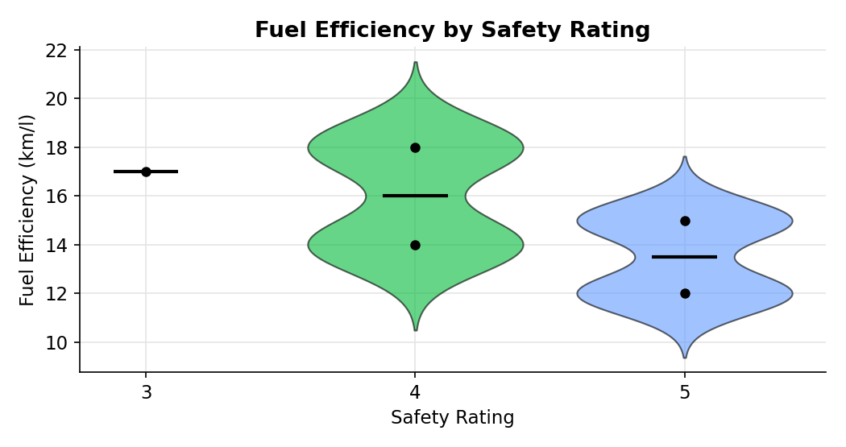
2. Scatter plot: Horsepower vs Top_Speed coloured by Engine_Size
Code:
ggplot(vehicles, aes(x = Horsepower, y = Top_Speed, color = Engine_Size)) +
geom_point(size = 4) +
geom_smooth(method = "lm", se = FALSE, color = "red") +
geom_text(aes(label = Vehicle_ID), vjust = -1, size = 3) +
scale_color_viridis_c() +
labs(
title = "Horsepower vs Top Speed",
x = "Horsepower",
y = "Top Speed (km/h)",
color = "Engine Size (L)"
) +
theme_minimal()

cor(vehicles$Horsepower, vehicles$Top_Speed)
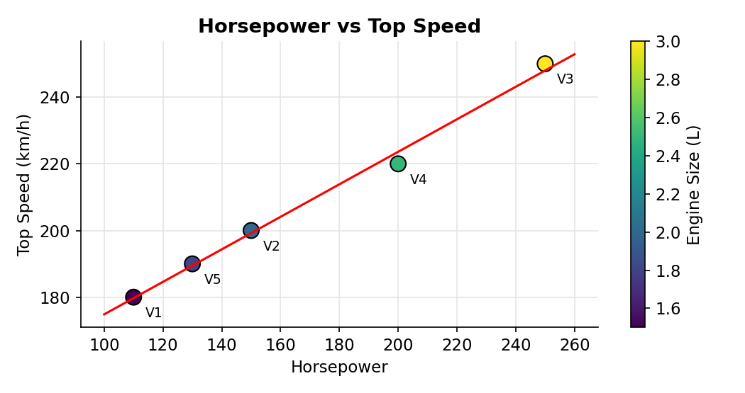
3. Correlation heatmap of all numerical variables
Code:
library(ggplot2)

num_vars <- vehicles[, c("Engine_Size","Horsepower","Fuel_Efficiency",
"Top_Speed","Safety_Rating")]
cor_matrix <- round(cor(num_vars), 2)
cor_long <- as.data.frame(as.table(cor_matrix))
colnames(cor_long) <- c("Var1", "Var2", "Correlation")

ggplot(cor_long, aes(x = Var1, y = Var2, fill = Correlation)) +
geom_tile(color = "white") +
geom_text(aes(label = Correlation), size = 3.5) +
scale_fill_gradient2(low = "blue", mid = "white", high = "red",
midpoint = 0, limits = c(-1, 1)) +
labs(
title = "Correlation Heatmap of Vehicle Variables",
x = "", y = ""
) +
theme_minimal() +
theme(axis.text.x = element_text(angle = 35, hjust = 1))
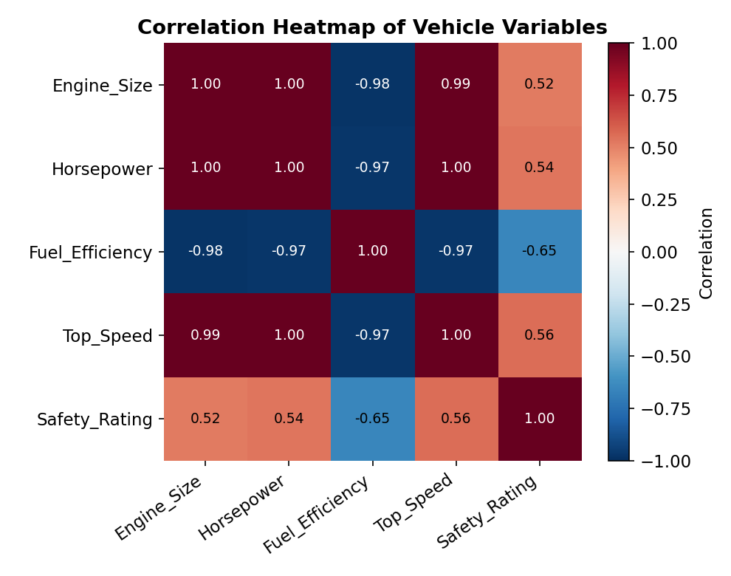
4. Tableau dashboard: balancing fuel efficiency and performance
Code:
vehicles$Balance_Score <- pmin(
(vehicles$Fuel_Efficiency - min(vehicles$Fuel_Efficiency)) /
(max(vehicles$Fuel_Efficiency) - min(vehicles$Fuel_Efficiency)),
(vehicles$Top_Speed - min(vehicles$Top_Speed)) /
(max(vehicles$Top_Speed) - min(vehicles$Top_Speed))
)
write.csv(vehicles, "Set28_Vehicle_Performance.csv", row.names = FALSE)
