DSA 0601 - Data handling and visualization
Set 29 - Student Academic Performance
1. Stacked area chart of Test_Score and Participation_Score
Code:
library(ggplot2)
library(tidyr)

students <- data.frame(
Student_ID = c("S1","S2","S3","S4","S5"),
Age = c(19, 21, 20, 22, 23),
Study_Hours = c(12, 8, 15, 10, 7),
Attendance = c(90, 70, 95, 85, 60),
Test_Score = c(85, 70, 92, 80, 65),
Participation_Score = c(8, 7, 9, 8, 6)
)

scores_long <- pivot_longer(students,
cols = c(Test_Score, Participation_Score),
names_to = "Measure", values_to = "Score")

ggplot(scores_long, aes(x = Student_ID, y = Score, fill = Measure, group = Measure)) +
geom_area(alpha = 0.9) +
labs(
title = "Test Score and Participation Score across Students",
x = "Student",
y = "Score (stacked)",
fill = "Measure"
) +
theme_minimal()
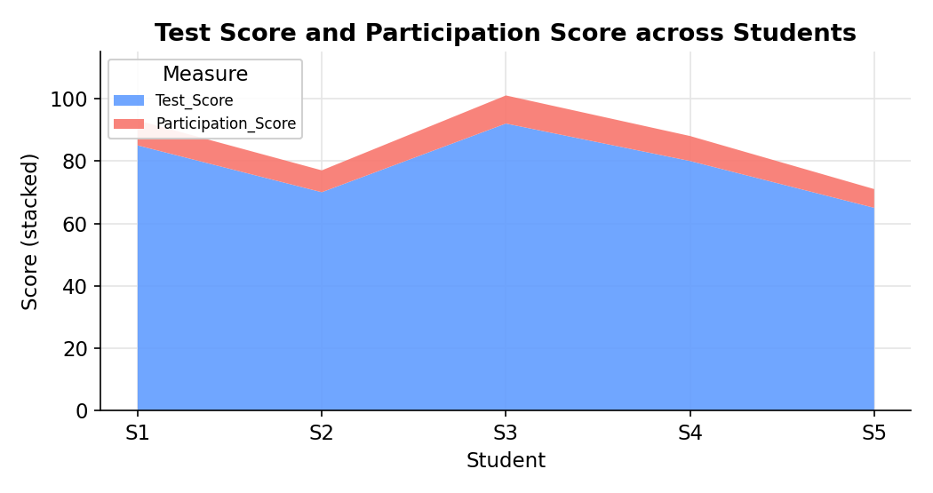
2. Boxplot of Study_Hours by Attendance quartile
Code:
library(ggplot2)

students$Attendance_Quartile <- cut(
students$Attendance,
breaks = quantile(students$Attendance, probs = seq(0, 1, 0.25)),
include.lowest = TRUE,
labels = c("Q1 (60-70)", "Q2 (70-85)", "Q3 (85-90)", "Q4 (90-95)")
)

ggplot(students, aes(x = Attendance_Quartile, y = Study_Hours,
fill = Attendance_Quartile)) +
geom_boxplot(alpha = 0.75) +
labs(
title = "Study Hours by Attendance Quartile",
x = "Attendance Quartile (%)",
y = "Study Hours",
fill = "Quartile"
) +
theme_minimal()

boxplot.stats(students$Study_Hours)$out
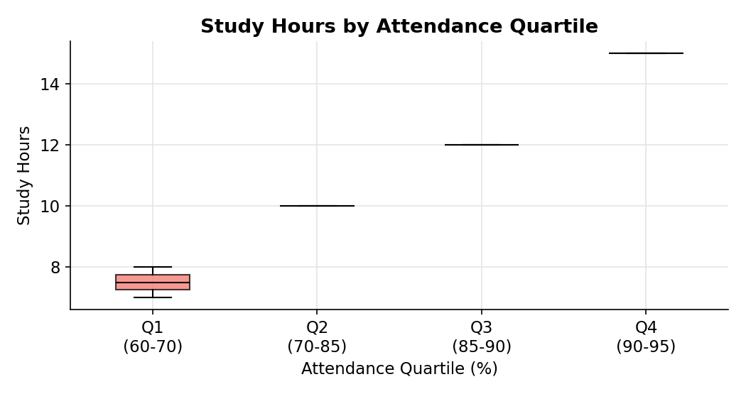
3. Density plot of Test_Score
Code:
ggplot(students, aes(x = Test_Score)) +
geom_density(fill = "skyblue", alpha = 0.7, color = "black") +
geom_rug() +
labs(
title = "Density Plot of Test Score",
x = "Test Score",
y = "Density"
) +
theme_minimal()

summary(students$Test_Score)
boxplot.stats(students$Test_Score)$out
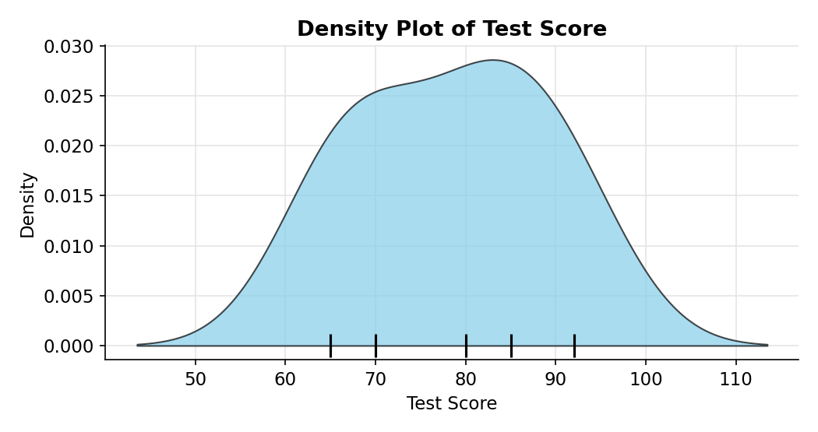
4. Tableau interactive scatter plot: Study_Hours vs Test_Score
Code:
write.csv(students[, 1:6], "Set29_Student_Performance.csv", row.names = FALSE)
