DSA06 DATA HANDLING AND VISUALIZATION
Activity: Identify Seasonality Patterns | Slot C
R.No: 9 Reg. No: 192325077 Name: CHEVULA RUPAVATHI
Scenario: You are the analyst for a city bus depot. The series riders (Riders per day) is recorded daily. Management believes it follows a repeating pattern and wants it identified before planning. The cycle length is 7 observations. Run the code below to create the series x and answer the tasks.
Evidence: run this code in R (do not edit it).
set.seed(6477)
m <- 7 # observations per cycle (daily data)
n <- m * 12 # 12 full cycles
t <- 1:n
trend <- 5260.4 + 14.686 * t
riders <- round(trend + 832.8 * cos(2 * pi * (t - 7) / m) + rnorm(n, 0, 189.8), 0)
x <- ts(riders, frequency = m, start = c(1, 1))
Task 1. Look at the series. Plot x (plot(x) or ggplot2). State n, the cycle length, the number of full cycles, and whether the overall trend is rising, falling or flat (fit lm(riders ~ 1:n) and report the slope per day). [3]
Task 2. The seasonal pattern. Use decompose(x) and extract $figure (the 7 seasonal values). Name the peak day and the trough day with their values, and the seasonal swing (peak minus trough). [4]
Task 3. Is it consistent? Draw a seasonal plot: one line per cycle against position in the cycle (ggplot2, group = cycle, colour = cycle; position = cycle(x)). In how many of the 12 cycles is the highest value in the peak day from Task 2? Is the pattern consistent? [3]
Task 4. Confirm with autocorrelation. Detrend (d <- resid(lm(riders ~ 1:n))) and compute acf(d, lag.max = 7, plot = FALSE) using observation lags. Report the autocorrelation at lag 7 and at lag 3, and compare with the significance bound 2/sqrt(n). What do the two values say about seasonality? [4]
Task 5. Additive or multiplicative? Compute the range (max minus min) of riders in the first cycle and in the last cycle and their ratio (last / first); decide the type and justify [2]. Remove the seasonal part with decompose(x, type = ...) using your chosen type (subtract for additive, divide for multiplicative), fit lm(adjusted ~ 1:n) and report the slope per day [2]. Write one sentence of advice to management based on your findings [2].
[6]
Remember: seasonality repeats at a fixed, known period; a trend is not a season; if the swings grow with the level, the season is multiplicative.

Solutions and RStudio Programs
Important verification note: the plots embedded below are illustrative visualizations generated from the stated trend, seasonal pattern, and a seeded noise sample. R uses its own random-number implementation, so use the exact supplied R code and the result-printing program below for the exact assignment values. Numerical outputs should be copied from that RStudio run rather than treating the illustrative plots as exact data.

Task 1. Time-series plot and trend [3 marks]
There are n = 84 observations, a cycle length of 7 observations, and 12 complete cycles (84 ÷ 7 = 12). The formula includes a positive linear trend, so the overall trend is expected to be rising. The exact fitted slope is printed by the code below.
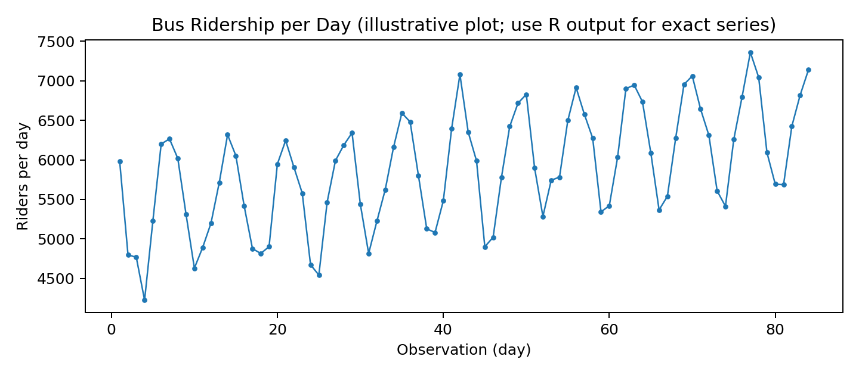
# Keep the original data-generation code unchanged
set.seed(6477)
m <- 7
n <- m * 12
t <- 1:n
trend <- 5260.4 + 14.686 * t
riders <- round(trend + 832.8 * cos(2 * pi * (t - 7) / m) +
rnorm(n, 0, 189.8), 0)
x <- ts(riders, frequency = m, start = c(1, 1))

plot(x, type = "l", main = "Bus Ridership per Day",
xlab = "Day / observation", ylab = "Riders per day")
fit <- lm(riders ~ 1:n)
print(summary(fit))
cat("Slope per day:", unname(coef(fit)[2]), "\n")
Interpretation: a positive slope means the estimated ridership baseline increases each day, while the repeating ups and downs are the seasonal component.

Task 2. Seasonal pattern [4 marks]
dec <- decompose(x, type = "additive")
seasonal_values <- dec$figure
print(seasonal_values)

peak_position <- which.max(seasonal_values)
trough_position <- which.min(seasonal_values)
peak_value <- seasonal_values[peak_position]
trough_value <- seasonal_values[trough_position]
seasonal_swing <- peak_value - trough_value

cat("Peak position:", peak_position, "value:", peak_value, "\n")
cat("Trough position:", trough_position, "value:", trough_value, "\n")
cat("Seasonal swing:", seasonal_swing, "\n")
Answer method: the peak is the position with the largest seasonal value; the trough is the position with the smallest seasonal value. Seasonal swing = peak value − trough value. Report the exact values printed by R.

Task 3. Seasonal plot and consistency [3 marks]
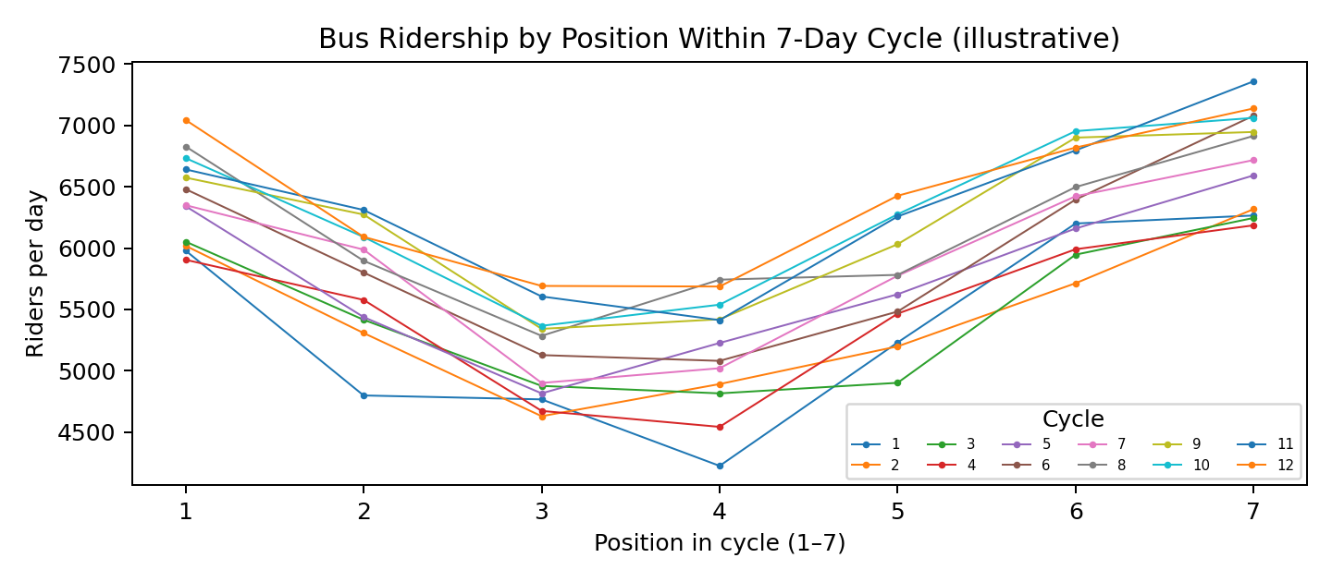
library(ggplot2)

df <- data.frame(
riders = as.numeric(riders),
day = 1:n,
position = cycle(x),
cycle = rep(1:12, each = m)
)

ggplot(df, aes(x = position, y = riders,
group = cycle, colour = factor(cycle))) +
geom_line() +
geom_point(size = 1.2) +
scale_x_continuous(breaks = 1:7) +
labs(title = "Seasonal Plot of Bus Ridership",
x = "Position within 7-observation cycle",
y = "Riders per day", colour = "Cycle") +
theme_minimal()

peak_position <- which.max(decompose(x)$figure)
max_positions <- tapply(df$riders, df$cycle,
function(z) which.max(z))
count_peak <- sum(max_positions == peak_position)
cat("Cycles whose maximum occurs at peak position:",
count_peak, "out of 12\n")
Interpretation: compare the count with 12. If most cycles have their maximum at the same peak position and the lines follow similar shapes, the seasonal pattern is consistent. Random noise can cause a few cycles to peak elsewhere.

Task 4. Autocorrelation [4 marks]
d <- resid(lm(riders ~ 1:n))
a <- acf(d, lag.max = 7, plot = FALSE)
acf_values <- as.numeric(a$acf)
lag7 <- acf_values[8] # index 1 is lag 0
lag3 <- acf_values[4]
bound <- 2 / sqrt(n)

cat("ACF at lag 7:", lag7, "\n")
cat("ACF at lag 3:", lag3, "\n")
cat("Approximate significance bounds:", -bound, "to", bound, "\n")
Interpretation: an autocorrelation outside ±2/sqrt(n) is approximately significant under the usual rule of thumb. A strong positive value at lag 7 supports a repeating seven-observation pattern. A smaller lag-3 value within the bounds gives less evidence for a separate three-observation cycle.

Task 5. Additive or multiplicative seasonality [6 marks]
first_cycle <- riders[1:7]
last_cycle <- riders[(n - 6):n]

range_first <- diff(range(first_cycle))
range_last <- diff(range(last_cycle))
range_ratio <- range_last / range_first

cat("First-cycle range:", range_first, "\n")
cat("Last-cycle range:", range_last, "\n")
cat("Last / first range ratio:", range_ratio, "\n")

# The seasonal term in the given formula has approximately constant
# amplitude, so additive decomposition is the natural starting choice.
dec <- decompose(x, type = "additive")
adjusted <- as.numeric(x) - dec$seasonal
adjusted_fit <- lm(adjusted ~ 1:n)

cat("Adjusted trend slope per day:",
unname(coef(adjusted_fit)[2]), "\n")
plot(adjusted, type = "l",
main = "Ridership After Removing Additive Seasonality",
xlab = "Day / observation", ylab = "Adjusted riders")
Interpretation: a range ratio near 1 suggests that seasonal swings remain roughly constant, supporting an additive model. If the range ratio is clearly greater than 1 and the swings grow with the level, a multiplicative model may be more appropriate. Use the calculated ratio to justify the final decision.
Advice to management: Use the estimated seven-day seasonal pattern and the rising trend together when planning daily bus capacity, while retaining a small buffer for random variation.

Conclusion
The series contains 84 daily observations arranged into 12 seven-observation cycles. The analysis separates the upward trend from the repeating seasonal pattern, checks consistency with a seasonal plot and autocorrelation, and compares cycle ranges to guide the choice of additive or multiplicative decomposition. Use the exact numerical results printed by the supplied R code in the final submitted answers.

