DSA 0601 - Data handling and visualization
Set 25 - Website Traffic Analysis
1. Tableau line chart: trend in page views over time
Code:
traffic <- data.frame(
Date = as.Date(c("2023-01-01","2023-01-02","2023-01-03","2023-01-04","2023-01-05")),
Page_Views = c(1500, 1600, 1400, 1650, 1800),
Click_Through_Rate = c(2.3, 2.7, 2.0, 2.4, 2.6)
)
write.csv(traffic, "Set25_Website_Traffic.csv", row.names = FALSE)
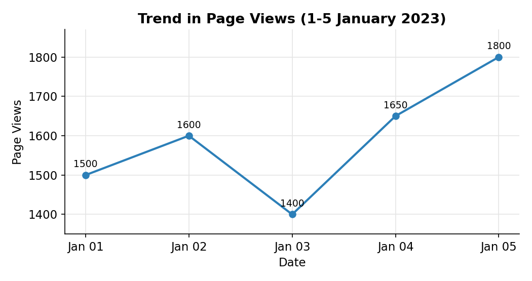
2. Bar chart: top N days with the highest click-through rate
Code:
library(ggplot2)
library(dplyr)

N <- 3
top_days <- traffic %>%
arrange(desc(Click_Through_Rate)) %>%
head(N)

ggplot(top_days, aes(x = reorder(format(Date, "%b %d"), -Click_Through_Rate),
y = Click_Through_Rate,
fill = format(Date, "%b %d"))) +
geom_col(color = "black", show.legend = FALSE) +
geom_text(aes(label = paste0(Click_Through_Rate, "%")), vjust = -0.5) +
labs(
title = "Top 3 Days by Click-through Rate",
x = "Date",
y = "Click-through Rate (%)"
) +
theme_minimal()
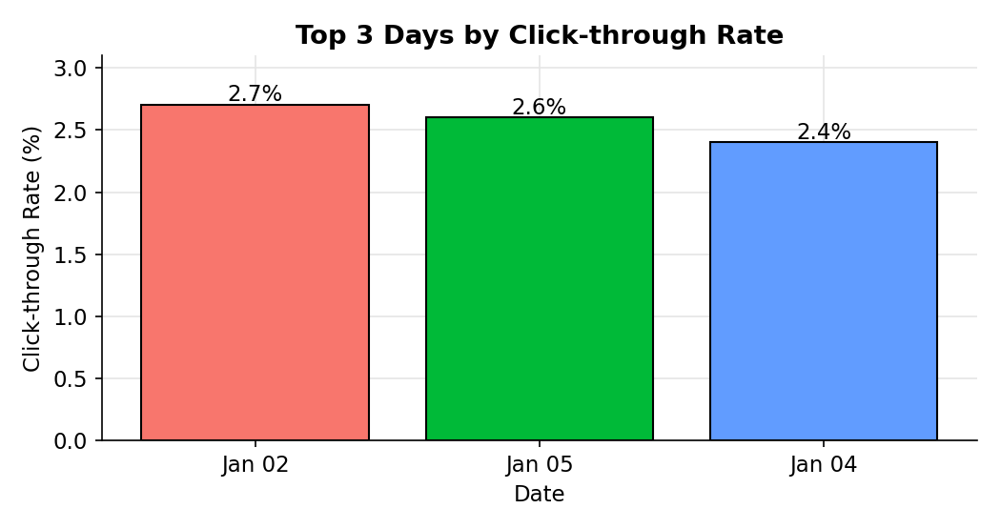
3. Stacked area chart: distribution of user interactions
Code:
library(ggplot2)
library(tidyr)

interactions <- data.frame(
Date = as.Date(c("2023-01-01","2023-01-02","2023-01-03","2023-01-04","2023-01-05")),
Likes = c(320, 350, 300, 380, 410),
Shares = c(90, 110, 80, 120, 140),
Comments = c(60, 75, 55, 85, 95)
)

inter_long <- pivot_longer(interactions, cols = c(Likes, Shares, Comments),
names_to = "Interaction", values_to = "Count")

ggplot(inter_long, aes(x = Date, y = Count, fill = Interaction)) +
geom_area(alpha = 0.9) +
labs(
title = "User Interactions on the Website",
x = "Date",
y = "Number of Interactions",
fill = "Interaction"
) +
theme_minimal()
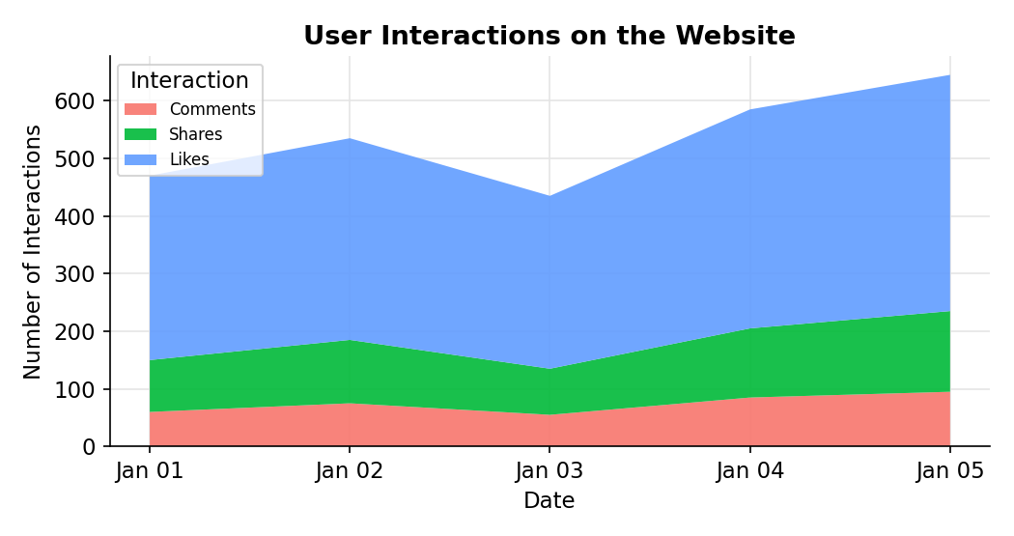
4. Tableau dashboard: interactive traffic source map and page views by source
Code:
sources <- data.frame(
Source = c("India","USA","UK","Germany","Australia"),
Page_Views = c(3100, 2400, 1200, 900, 550)
)
write.csv(sources, "Set25_Traffic_Sources.csv", row.names = FALSE)
