DSA 0601 - Data handling and visualization
Set 27 - Patient Health Risk Analysis
1. Scatterplot matrix for Age, BMI, BP and Cholesterol
Code:
patients <- data.frame(
Patient_ID = c("P1","P2","P3","P4","P5"),
Age = c(25, 40, 55, 35, 60),
BMI = c(22, 28, 30, 26, 32),
BP = c(120, 135, 145, 130, 150),
Cholesterol = c(180, 210, 240, 200, 260)
)
pairs(patients[, 2:5],
main = "Scatterplot Matrix of Patient Health Indicators",
pch = 19, col = "steelblue")
round(cor(patients[, 2:5]), 3)
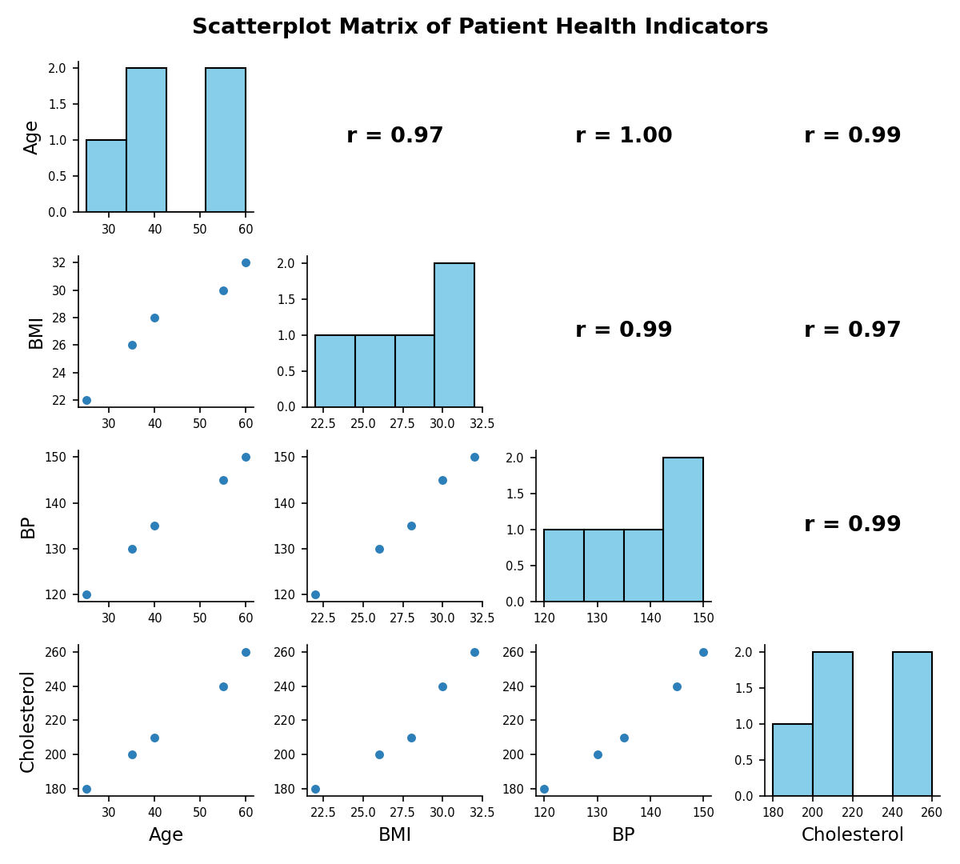
2. Q-Q plot and ECDF for Cholesterol
Code:
par(mfrow = c(1, 2))

qqnorm(patients$Cholesterol,
main = "Normal Q-Q Plot of Cholesterol",
xlab = "Theoretical Quantiles",
ylab = "Cholesterol (mg/dL)",
pch = 19, col = "steelblue")
qqline(patients$Cholesterol, col = "red")

plot(ecdf(patients$Cholesterol),
main = "ECDF of Cholesterol",
xlab = "Cholesterol (mg/dL)",
ylab = "Cumulative Probability",
col = "steelblue")

par(mfrow = c(1, 1))

shapiro.test(patients$Cholesterol)
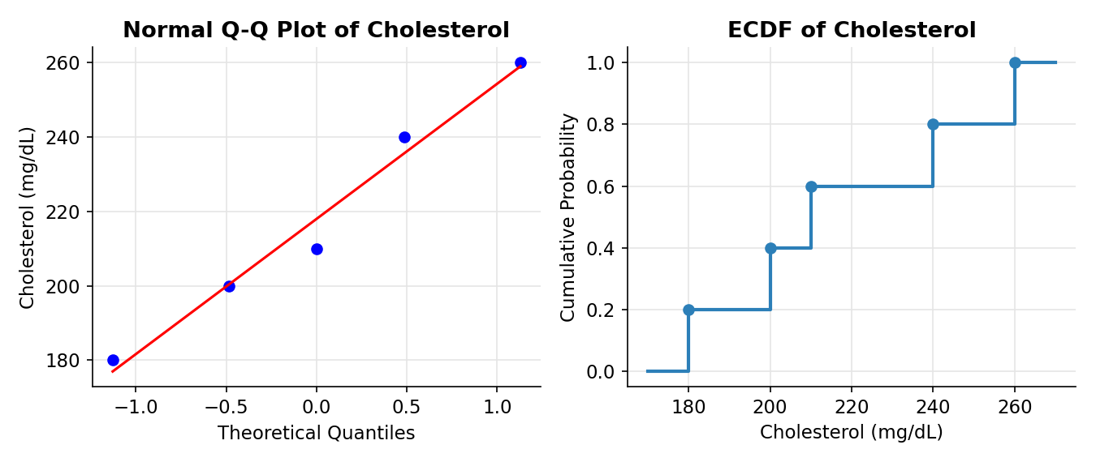
3. Bar chart of average value of each health indicator
Code:
averages <- colMeans(patients[, 2:5])

barplot(averages,
col = c("tomato", "seagreen", "steelblue", "orchid"),
main = "Average Value of Each Health Indicator",
xlab = "Health Indicator",
ylab = "Average Value",
ylim = c(0, 250))

text(x = seq(0.7, by = 1.2, length.out = 4), y = averages + 8,
labels = round(averages, 1))
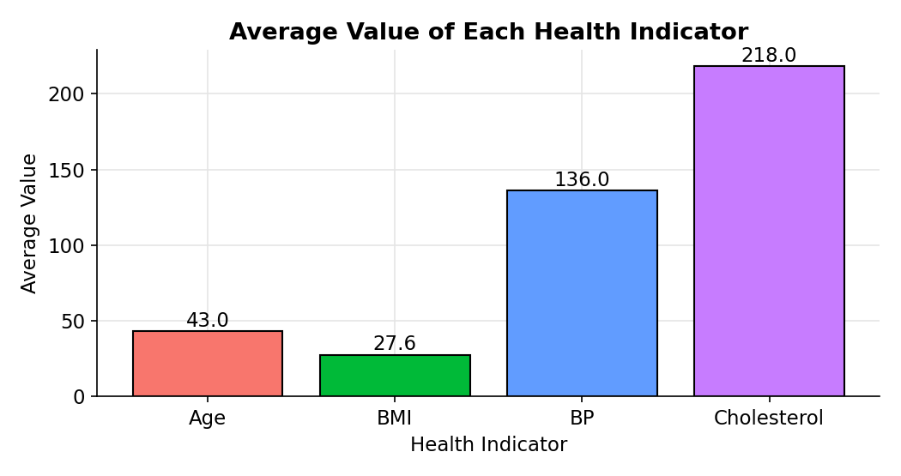
4. Tableau dashboard: risk heatmap with Age filter
Code:
library(tidyr)
library(dplyr)

norm01 <- function(x) (x - min(x)) / (max(x) - min(x))

patients$Risk_Score <- rowMeans(sapply(patients[, 2:5], norm01))
patients$Risk_Level <- cut(patients$Risk_Score,
breaks = c(-Inf, 0.33, 0.66, Inf),
labels = c("Low", "Medium", "High"))

patients_long <- patients %>%
mutate(across(Age:Cholesterol, norm01, .names = "{.col}_norm")) %>%
pivot_longer(cols = Age:Cholesterol, names_to = "Indicator", values_to = "Value") %>%
mutate(Normalised = case_when(
Indicator == "Age" ~ Age_norm, Indicator == "BMI" ~ BMI_norm,
Indicator == "BP" ~ BP_norm, TRUE ~ Cholesterol_norm)) %>%
select(Patient_ID, Indicator, Value, Normalised, Risk_Score, Risk_Level)

write.csv(patients, "Set27_Patients.csv", row.names = FALSE)
write.csv(patients_long, "Set27_Patients_Long.csv", row.names = FALSE)
