DSA06 – DATA HANDLING AND VISUALIZATION
Activity 5: Normality Detection using Q-Q Plots | Slot C
R.No: 9 | Reg. No: 192325077
Name: CHEVULA RUPAVATHI | Activity Marks: Part A – 16; Part B – 4

Part A: Normality Detection using Q-Q Plots (16 Marks)
A normal Q-Q plot compares sample quantiles with theoretical quantiles from a normal distribution. If the points follow the straight reference line closely, the data are approximately normal. Systematic curves or points far from the line suggest non-normality.

Chart 1: Typing speed (words per minute), n = 40
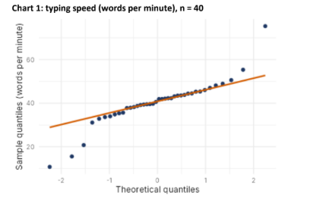
Normal? (Yes / No) | No
Shape (from the list) | Normal with outlier(s)
Evidence in the plot | Most central points follow the line, but several low-end points fall below it and the largest high-end point lies far above it. These tail departures, especially the extreme high value, indicate an outlier and non-normality.

Chart 2: Battery drain per hour (percent), n = 40
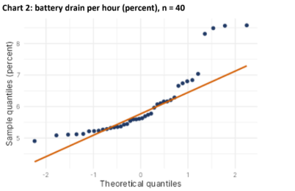
Normal? (Yes / No) | No
Shape (from the list) | Right-skewed
Evidence in the plot | The points curve away from the line: the upper quantiles rise well above the reference line, while the lower values are comparatively flat. The long upper tail indicates right skew.

Chart 3: Plant height (cm), n = 40
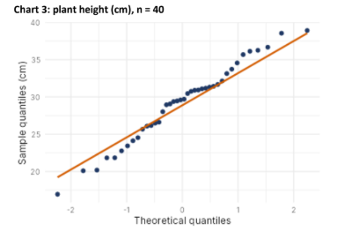
Normal? (Yes / No) | No
Shape (from the list) | Heavy-tailed
Evidence in the plot | The points at both ends move away from the reference line: the lower-tail points fall below it and the upper-tail points rise above it, while the middle is closer to the line. This outward tail pattern suggests heavier-than-normal tails.

Chart 4: Plant height (cm), n = 60
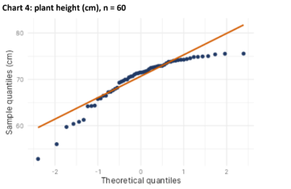
Normal? (Yes / No) | No
Shape (from the list) | Left-skewed
Evidence in the plot | The plot bends away from the line rather than following it throughout. The upper sample values flatten at the right end, while the lower values extend farther downward, suggesting a longer lower tail and left skew.

Part B (4 Marks)

B1. Chart 1 departure and remedy
Departure: Chart 1 is not normal because the tails depart from the reference line, with a particularly extreme high value and some low-end values away from the line. The best description from the given list is “Normal with outlier(s).” Before using mean-and-standard-deviation methods, check whether the extreme value is a data-entry or measurement error. If it is a valid observation, consider a robust method such as the median and interquartile range. A log transformation may also be tried if the values are positive and right-skewness is the main issue.

B2. Complete the ggplot2 Q-Q plot code
Completed expression: ggplot(df, aes(sample = value)) + stat_qq() + stat_qq_line()
Answer to the blanks: stat_qq() and stat_qq_line().
Explanation:
- stat_qq() plots the sample quantiles against the theoretical normal quantiles.
- stat_qq_line() adds the straight reference line used to assess whether the points follow a normal pattern.
Complete R code:
library(ggplot2)
ggplot(df, aes(sample = value)) +
stat_qq() +
stat_qq_line()

— End of Assignment —

