DSA06 – DATA HANDLING AND VISUALIZATION
Activity 6: Website Flow Sankey Design | Slot C
Student detail | Information
R.No. | 9
Reg. No. | 192325077
Name | CHEVULA RUPAVATHI

Original Assignment Diagram
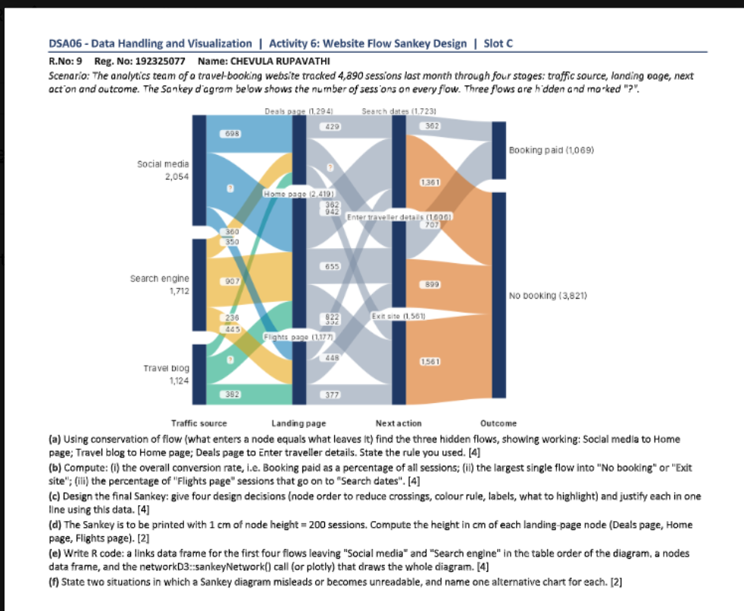
Scenario: The website recorded 4,890 sessions through traffic source, landing page, next action, and outcome. The three hidden flows are calculated below using conservation of flow.

Question (a): Find the Three Hidden Flows [4 Marks]
Rule used: For each node, total inflow equals total outflow. Therefore, a missing flow equals the node total minus the sum of its other known flows.
Hidden flow | Working | Answer
Social media → Home page | Social media total = 2,054. Known flows: 698 to Deals page and 350 to Flights page. 2,054 − 698 − 350 = 1,006. | 1,006 sessions
Travel blog → Home page | Travel blog total = 1,124. Known flows: 236 to Deals page and 382 to Flights page. 1,124 − 236 − 382 = 506. | 506 sessions
Deals page → Enter traveller details | Deals page total = 1,294. Known flows: 429 to Search dates and 362 to Exit site. 1,294 − 429 − 362 = 503. | 503 sessions

Question (b): Compute the Required Statistics [4 Marks]

(i) Overall conversion rate
Formula: Conversion rate = (Sessions with Booking paid ÷ Total sessions) × 100
Calculation: (1,069 ÷ 4,890) × 100 = 21.86% (approximately).
Answer: The overall conversion rate is approximately 21.9%.

(ii) Largest single flow into “No booking” or “Exit site”
The diagram shows 1,361 sessions from Search dates to No booking, 899 from Enter traveller details to No booking, and 1,561 from Exit site to No booking. The largest of these is 1,561 sessions from Exit site to No booking.

(iii) Percentage of Flights page sessions that go to Search dates
Formula: (Flights page → Search dates ÷ Total Flights page sessions) × 100
Calculation: (352 ÷ 1,177) × 100 = 29.91% (approximately).
Answer: Approximately 29.9% of Flights page sessions go on to Search dates.

Question (c): Four Design Decisions [4 Marks]
No. | Design decision | Justification
1 | Keep nodes in stage order: Traffic source → Landing page → Next action → Outcome. | This preserves the user's journey and makes the four stages easy to follow.
2 | Use one consistent colour per traffic source, or use a restrained colour rule for outcomes. | Consistent colours help readers trace flows without confusing categories.
3 | Label every node with its name and total sessions; label important links with counts. | Totals such as 2,054 Social media sessions and 1,069 bookings give context to the flow widths.
4 | Highlight the Booking paid outcome and the largest loss flow of 1,561 sessions. | This draws attention to conversion (1,069 bookings) and the biggest drop-off (Exit site).

Question (d): Landing-Page Node Heights [2 Marks]
Scale: 1 cm represents 200 sessions. Height (cm) = number of sessions ÷ 200.
Landing-page node | Sessions | Calculation | Height
Deals page | 1,294 | 1,294 ÷ 200 | 6.47 cm
Home page | 2,419 | 2,419 ÷ 200 | 12.095 cm (≈ 12.10 cm)
Flights page | 1,177 | 1,177 ÷ 200 | 5.885 cm (≈ 5.89 cm)

Question (e): R Code to Draw the Sankey Diagram [4 Marks]
The code below uses the networkD3 package. networkD3 expects source and target indices to start at 0, so the code subtracts 1 from the node indices. It includes all flows in the diagram; the first four links are the first four source-to-landing flows in diagram order.
# Install these packages once if they are not already installed
install.packages("networkD3")
install.packages("htmlwidgets")
library(networkD3)
library(htmlwidgets)
# Nodes are listed in stage order.
nodes <- data.frame(
name = c(
"Social media", "Search engine", "Travel blog",
"Deals page", "Home page", "Flights page",
"Search dates", "Enter traveller details", "Exit site",
"Booking paid", "No booking"
)
)
# Link order starts with flows from Social media and Search engine.
# Source/target values below are 1-based node positions for readability.
links <- data.frame(
source = c(
1, 1, 1, 2, 2, 2, 3, 3, 3,
4, 4, 4, 5, 5, 5, 6, 6, 6,
7, 7, 8
),
target = c(
4, 5, 6, 4, 5, 6, 4, 5, 6,
7, 8, 9, 7, 8, 9, 7, 8, 9,
10, 11, 10
),
value = c(
698, 1006, 350, 360, 907, 445, 236, 506, 382,
429, 503, 362, 942, 655, 822, 352, 448, 377,
362, 1361, 707
)
)
# networkD3 uses zero-based indices, so subtract 1.
links$source <- links$source - 1
links$target <- links$target - 1
sankeyNetwork(
Links = links,
Nodes = nodes,
Source = "source",
Target = "target",
Value = "value",
NodeID = "name",
fontSize = 12,
nodeWidth = 25,
sinksRight = TRUE
)
How to run in RStudio:
- Open RStudio and create a new R script (File → New File → R Script).
- Copy the complete code above into the script.
- Run the install.packages() lines once. If R asks you to select a CRAN mirror, choose one nearby.
- Run the remaining lines. The Sankey diagram should appear in the Viewer pane.
- Read the diagram from left to right: traffic source, landing page, next action, then outcome. Wider links represent more sessions.
Data check: source totals are 2,054, 1,712, and 1,124; landing-page totals are 1,294, 2,419, and 1,177; next-action totals are 1,723, 1,606, and 1,561; outcome totals are 1,069 and 3,821. Each stage sums to 4,890 sessions.

Question (f): Limitations of Sankey Diagrams [2 Marks]
No. | Limitation | Suitable alternative chart
1 | When there are many nodes and links, flows overlap and the diagram becomes cluttered. | A grouped bar chart or heat map.
2 | Small flows can be hard to see beside very large flows, and widths may be difficult to compare precisely. | A bar chart with values labelled.

Conclusion
A Sankey diagram shows how sessions move between stages and makes it easier to identify successful conversions and drop-off points. In this dataset, 1,069 of 4,890 sessions ended in a paid booking, giving a conversion rate of about 21.9%. The diagram also shows that 1,561 sessions exited the site, which is the largest single flow into the no-booking outcome.
— End of Assignment —

