SET 9
ONLINE LEARNING ACTIVITY ANALYSIS
Data Handling and Visualization using R
Course Code: DSA0601

Student_ID | Gender | Age | Course | Study_Time (hrs) | Videos_Watched | Quiz_Score | Login_Date
L01 | Male | 20 | R | 3.5 | 12 | 78 | 2025-01-05
L02 | Female | 22 | R | 4.2 | 15 | 85 | 2025-01-05
L03 | Male | 19 | SQL | 2.0 | 8 | 65 | 2025-02-08
L04 | Female | 21 | R | 5.0 | 18 | 92 | 2025-02-08
L05 | Male | 23 | R | 2.5 | 9 | 70 | 2025-03-12
L06 | Female | 20 | SQL | 4.0 | 14 | 88 | 2025-03-12

PROGRAM 1 – HISTOGRAM AND BOXPLOT
Aim: To create a histogram of Quiz_Score and a boxplot of Quiz_Score by Course, and to interpret the observed student performance.

Dataset
Student_ID | Gender | Age | Course | Study_Time (hrs) | Videos_Watched | Quiz_Score | Login_Date
L01 | Male | 20 | R | 3.5 | 12 | 78 | 2025-01-05
L02 | Female | 22 | R | 4.2 | 15 | 85 | 2025-01-05
L03 | Male | 19 | SQL | 2.0 | 8 | 65 | 2025-02-08
L04 | Female | 21 | R | 5.0 | 18 | 92 | 2025-02-08
L05 | Male | 23 | R | 2.5 | 9 | 70 | 2025-03-12
L06 | Female | 20 | SQL | 4.0 | 14 | 88 | 2025-03-12

Complete Executable R Code
# PROGRAM 1: Histogram and Boxplot

students <- data.frame(
Student_ID = c("L01","L02","L03","L04","L05","L06"),
Gender = c("Male","Female","Male","Female","Male","Female"),
Age = c(20,22,19,21,23,20),
Course = c("R","R","SQL","R","R","SQL"),
Study_Time = c(3.5,4.2,2.0,5.0,2.5,4.0),
Videos_Watched = c(12,15,8,18,9,14),
Quiz_Score = c(78,85,65,92,70,88),
Login_Date = c("2025-01-05","2025-01-05","2025-02-08",
"2025-02-08","2025-03-12","2025-03-12"),
stringsAsFactors = FALSE
)

# Histogram of Quiz_Score
hist(students$Quiz_Score,
main = "Distribution of Quiz Scores",
xlab = "Quiz Score",
ylab = "Number of Students",
col = "lightblue",
border = "black")

# Boxplot of Quiz_Score by Course
boxplot(Quiz_Score ~ Course,
data = students,
main = "Quiz Score by Course",
xlab = "Course",
ylab = "Quiz Score",
col = c("lightgreen", "lightpink"))
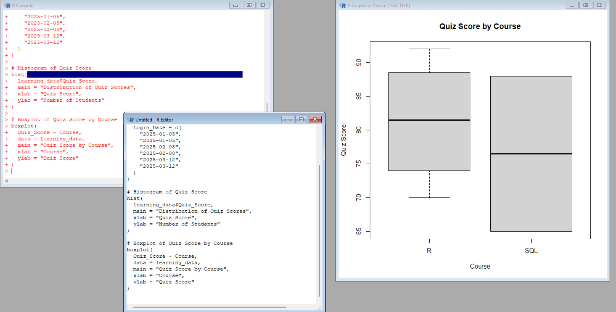

Explanation
- The data frame stores all six student records.
- hist() creates a histogram to show how Quiz_Score values are distributed.
- boxplot(Quiz_Score ~ Course) compares quiz-score distributions for R and SQL.
- main, xlab, and ylab add the required title and axis labels.
- The colours are only for clear visual presentation; they do not change the data.

Expected Output
- A histogram showing quiz scores ranging from 65 to 92.
- A boxplot with separate boxes for R and SQL.
- The R scores are 70, 78, 85, and 92; the SQL scores are 65 and 88.

Observation / Inference
- The observed quiz scores range from 65 to 92.
- In this small dataset, R has four observations and SQL has two observations.
- The R course average is 81.25, while the SQL course average is 76.5.
- The boxplot and averages show a difference in the observed scores between the two courses. This describes the sample and does not establish that the course itself caused the difference.

PROGRAM 2 – BUBBLE SCATTER PLOT
Aim: To create a scatter plot between Study_Time and Quiz_Score, use Videos_Watched to control bubble size, apply transparency, and describe the observed learning pattern.

Complete Executable R Code
# PROGRAM 2: Bubble Scatter Plot

students <- data.frame(
Student_ID = c("L01","L02","L03","L04","L05","L06"),
Gender = c("Male","Female","Male","Female","Male","Female"),
Age = c(20,22,19,21,23,20),
Course = c("R","R","SQL","R","R","SQL"),
Study_Time = c(3.5,4.2,2.0,5.0,2.5,4.0),
Videos_Watched = c(12,15,8,18,9,14),
Quiz_Score = c(78,85,65,92,70,88),
Login_Date = c("2025-01-05","2025-01-05","2025-02-08",
"2025-02-08","2025-03-12","2025-03-12"),
stringsAsFactors = FALSE
)

# Bubble scatter plot
plot(students$Study_Time, students$Quiz_Score,
main = "Study Time vs Quiz Score",
xlab = "Study Time (hours)",
ylab = "Quiz Score",
pch = 21,
bg = rgb(0.12, 0.45, 0.75, 0.45),
col = "black",
cex = students$Videos_Watched / 4)

# Add student labels
text(students$Study_Time, students$Quiz_Score,
labels = students$Student_ID,
pos = 3,
cex = 0.8)

# Add a legend explaining bubble size
legend("bottomright",
legend = c("Bubble size is proportional to Videos_Watched",
"Bubbles use 45% transparency"),
bty = "n",
cex = 0.8)
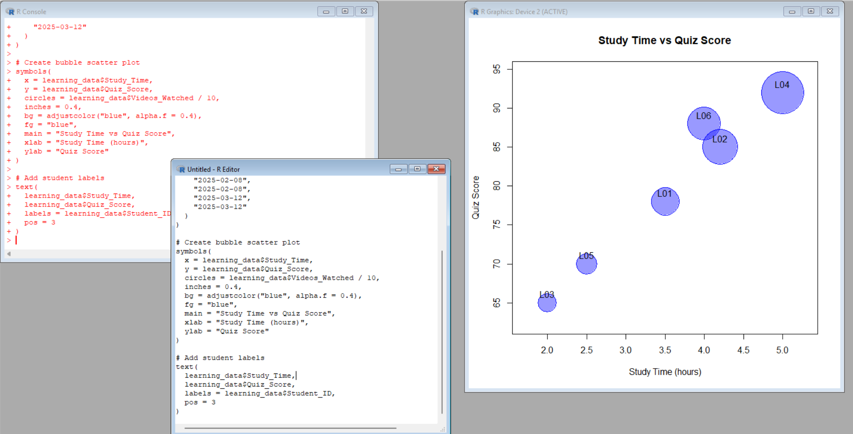

Explanation
- Study_Time is plotted on the x-axis and Quiz_Score on the y-axis.
- cex = students$Videos_Watched / 4 makes Videos_Watched directly control bubble size. Therefore, students who watched more videos have larger bubbles.
- rgb(..., 0.45) sets the bubble fill alpha value to 0.45, so the bubbles are visibly transparent.
- Student IDs are added as labels to make individual observations easier to identify.
- The plot describes an association visible in these six observations; it does not prove that study time causes a higher score.

Expected Output
- A scatter plot containing six bubbles.
- L04 has the largest bubble because 18 videos were watched.
- L03 has the smallest bubble because 8 videos were watched.
- The bubbles are semi-transparent, and their sizes vary according to Videos_Watched.

Observation / Inference
- In the sample, students with higher Study_Time generally have higher Quiz_Score values, although the pattern is not perfectly consistent.
- The largest bubble (L04) is at 5.0 hours and a score of 92, while the smallest bubble (L03) is at 2.0 hours and a score of 65.
- This is an observed pattern in a six-student dataset. It should not be interpreted as a causal relationship.
Result: A bubble scatter plot was created successfully with Videos_Watched controlling bubble size and clear transparency applied.Key R Functions Used

PROGRAM 3 – MONTHLY QUIZ SCORE TREND
Aim: To convert Login_Date into Date format, calculate monthly average Quiz_Score, plot the monthly trend, and apply a simple 2-month moving average.

Complete Executable R Code
# PROGRAM 3: Monthly Quiz Score Trend

students <- data.frame(
Student_ID = c("L01","L02","L03","L04","L05","L06"),
Gender = c("Male","Female","Male","Female","Male","Female"),
Age = c(20,22,19,21,23,20),
Course = c("R","R","SQL","R","R","SQL"),
Study_Time = c(3.5,4.2,2.0,5.0,2.5,4.0),
Videos_Watched = c(12,15,8,18,9,14),
Quiz_Score = c(78,85,65,92,70,88),
Login_Date = c("2025-01-05","2025-01-05","2025-02-08",
"2025-02-08","2025-03-12","2025-03-12"),
stringsAsFactors = FALSE
)

# Convert Login_Date to Date format
students$Login_Date <- as.Date(students$Login_Date)

# Create month column
students$Month <- format(students$Login_Date, "%Y-%m")

# Calculate monthly average quiz score
monthly_avg <- aggregate(Quiz_Score ~ Month,
data = students,
FUN = mean)

monthly_avg$Month <- as.Date(paste0(monthly_avg$Month, "-01"))
monthly_avg <- monthly_avg[order(monthly_avg$Month), ]

# Calculate a simple 2-month moving average
monthly_avg$Moving_Average_2M <- c(
NA,
mean(monthly_avg$Quiz_Score[1:2]),
mean(monthly_avg$Quiz_Score[2:3])
)

# Display tables
print(monthly_avg)

# Line chart for monthly average
plot(monthly_avg$Month, monthly_avg$Quiz_Score,
type = "o",
pch = 16,
main = "Monthly Average Quiz Score",
xlab = "Month",
ylab = "Average Quiz Score")

# Add the 2-month moving average
lines(monthly_avg$Month,
monthly_avg$Moving_Average_2M,
type = "o",
pch = 17,
lty = 2)

legend("topright",
legend = c("Monthly Average", "2-Month Moving Average"),
lty = c(1, 2),
pch = c(16, 17),
bty = "n")
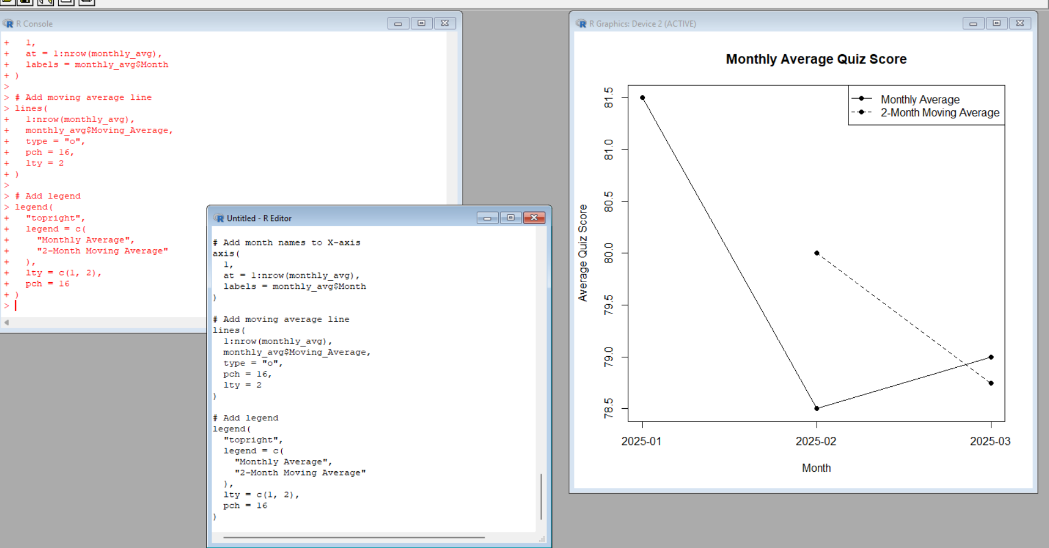

Explanation
- as.Date() converts Login_Date from text into R Date values.
- format(..., '%Y-%m') extracts the year and month used for grouping.
- aggregate() calculates the mean Quiz_Score for each month.
- The 2-month moving average is calculated using the current month and the previous month. January has no previous month, so its moving average is NA.
- The line chart shows both the monthly average and the smoothed 2-month moving average.

Expected Output
- A monthly average table with January = 81.5, February = 78.5, and March = 79.0.
- A 2-month moving average table with January = NA, February = 80.0, and March = 78.75.
- A line chart containing the monthly average line and the moving-average line.Monthly Average Table

Observation / Inference
- The monthly average decreases from 81.5 in January to 78.5 in February, then increases slightly to 79.0 in March.
- The 2-month moving average changes from 80.0 in February to 78.75 in March.
- Overall, the three-month averages show a small decline from January to March, with a slight recovery in March.
- The trend is based only on six records across three months, so it should be treated as a description of this dataset rather than a general long-term learning trend.
Result: The monthly quiz-score trend and simple 2-month moving average were calculated and visualized successfully.

PROGRAM 4 – TABLEAU MINI INTERACTIVE DASHBOARD
Aim: To create a simple interactive Tableau dashboard showing course-wise average quiz score and the relationship between Study_Time and Quiz_Score, with Videos_Watched represented by mark size and filters for Gender and Course.

Step-by-Step Tableau Procedure
1. Prepare the CSV file: Save the exact dataset as Online_Learning_Activity.csv. Keep the column names and values unchanged.
2. Import the data: Open Tableau Desktop or Tableau Public. Select Connect → To a File → Text File and choose Online_Learning_Activity.csv. Check that Quiz_Score, Study_Time and Videos_Watched are numeric fields and Login_Date is recognized as a date.
3. Create the bar chart: Open a new worksheet and name it Course Average Quiz Score. Drag Course to Columns. Drag Quiz_Score to Rows. Open the Quiz_Score aggregation menu and select Measure → Average. This gives Average Quiz_Score by Course.
4. Create the scatter plot: Create another worksheet and name it Study Time vs Quiz Score. Drag Study_Time to Columns and Quiz_Score to Rows. In the Marks card, choose Circle.
5. Use Videos_Watched as mark size: Drag Videos_Watched to Size on the Marks card. Each student's circle will now have a size based on the number of videos watched. Do not place Videos_Watched only on Tooltip if size encoding is required.
6. Add useful detail: Drag Student_ID to Detail so each student remains an individual mark. Optionally drag Course to Color to visually distinguish the two courses.
7. Add Gender filter: From the scatter-plot worksheet, drag Gender to the Filters shelf. Choose All values, then right-click Gender on the Filters shelf and select Show Filter.
8. Add Course filter: Drag Course to the Filters shelf and select All values. Right-click Course and choose Show Filter.
9. Build the dashboard: Click New Dashboard. Give the dashboard a suitable size such as Automatic. Drag the Course Average Quiz Score worksheet to the upper section and the Study Time vs Quiz Score worksheet below or beside it.
10. Add interactive filters: From the dashboard, use the filter cards for Gender and Course. If necessary, use the worksheet's filter menu to apply the selected filter to relevant worksheets. This lets the user view the dashboard for selected groups.
11. Add dashboard title: Use the dashboard title: Online Learning Activity Analysis Dashboard. Add a short subtitle such as Course Performance and Study Activity.
12. Arrange the dashboard: Keep the bar chart prominent for course comparison. Place the scatter plot beside or below it. Keep Gender and Course filters together on one side so they are easy to use. Avoid overcrowding.
13. Check interaction: Select different Gender and Course values and confirm that the displayed charts update. Verify that bubble/mark size continues to represent Videos_Watched.
14. Save: Save the Tableau workbook as a .twb or .twbx file, as required by the lab submission instructions.

Expected Tableau Output
- Bar chart: Average Quiz_Score by Course.
- R average Quiz_Score = 81.25.
- SQL average Quiz_Score = 76.5.
- Scatter plot: Study_Time on the x-axis and Quiz_Score on the y-axis.
- Mark/bubble size is controlled by Videos_Watched.
- Gender and Course filters are available for interactive exploration.
- Both worksheets appear together in one mini dashboard.

Observation / Inference
- The dashboard provides two views of the same six-student dataset: course-level averages and student-level study activity.
- The observed course averages are R = 81.25 and SQL = 76.5.
- The scatter plot allows users to visually inspect whether higher Study_Time values occur alongside higher Quiz_Score values in these records.
- The dashboard is interactive, so filtering by Gender or Course changes the visible subset. These views support exploration; they do not establish causation.
Result: A mini interactive Tableau dashboard can be created from Online_Learning_Activity.csv using the specified charts, filters, mark-size encoding, and dashboard arrangement.

