SET 7: CUSTOMER DEMOGRAPHICS ANALYSIS
Data Handling and Visualization using R
Course Code: DSA0601

PROGRAM 1 – BAR CHART

Aim
To create a bar chart to visualize the age of each customer.

Dataset
Customer ID and Age are used from the given dataset.

R Code
# Create Customer Demographics dataset
customer_data <- data.frame(
Customer_ID = c(1, 2, 3),
Age = c(28, 35, 42),
Gender = c("Female", "Male", "Female"),
Income = c(50000, 60000, 75000)
)
# Create bar chart
barplot(
customer_data$Age,
names.arg = customer_data$Customer_ID,
main = "Customer Age Distribution",
xlab = "Customer ID",
ylab = "Age",
col = "skyblue"
)

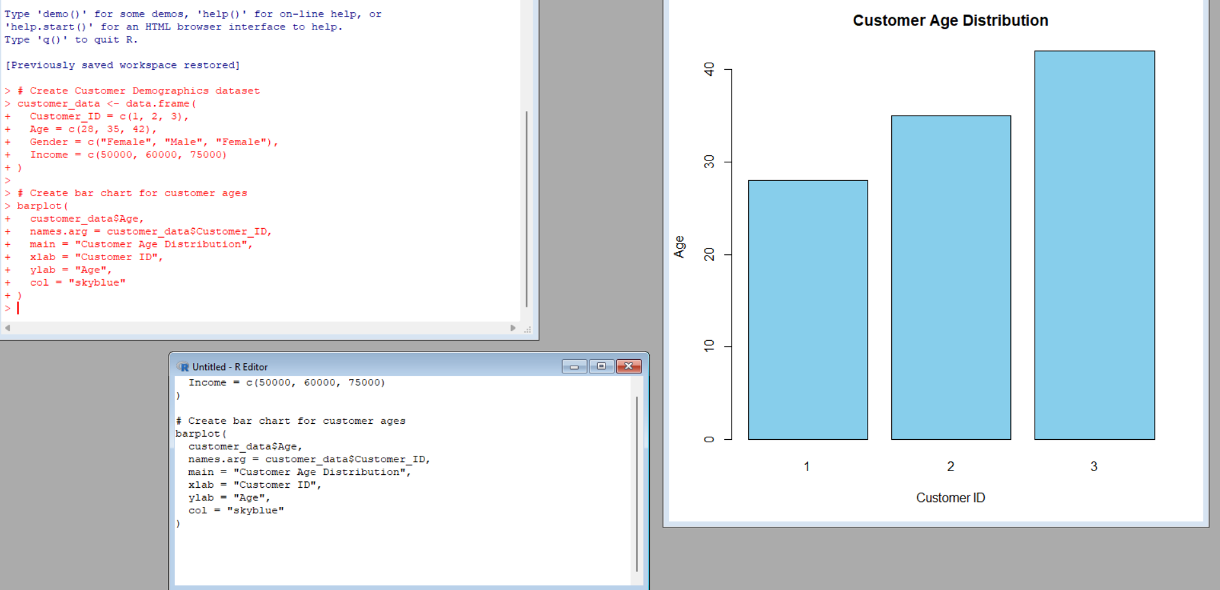Explanation of the Code
- `data.frame()` creates the customer dataset.
- `customer_data$Age` provides the age values.
- `barplot()` creates the bar chart.
- `names.arg` displays Customer IDs on the X-axis.
- `main`, `xlab`, and `ylab` provide the title and axis labels.

Expected Output
A bar chart showing Customer 1 = 28, Customer 2 = 35, and Customer 3 = 42.

Observation / Inference
The ages of the three customers are 28, 35, and 42. Customer 3 has the highest age.

Result
A bar chart representing the age distribution of customers was successfully created.

Key R Functions Used
data.frame(), barplot()

PROGRAM 2 – PIE CHART

Aim
To generate a pie chart representing the distribution of customers by gender.

Dataset
Gender information from the given customer dataset is used.

R Code
# Create Customer Demographics dataset
customer_data <- data.frame(
Customer_ID = c(1, 2, 3),
Age = c(28, 35, 42),
Gender = c("Female", "Male", "Female"),
Income = c(50000, 60000, 75000)
)
# Count customers by gender
gender_count <- table(customer_data$Gender)
# Create pie chart
pie(
gender_count,
labels = names(gender_count),
main = "Customer Gender Distribution",
col = c("pink", "lightblue")
)

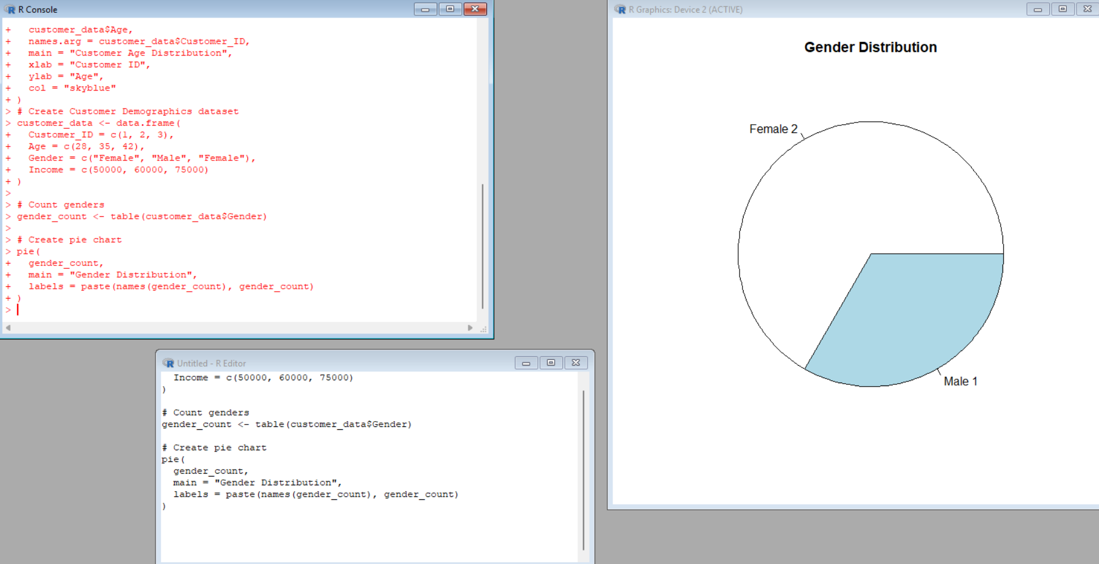

Explanation of the Code
- `table()` counts customers in each gender category.
- There are 2 Female customers and 1 Male customer.
- `pie()` creates the pie chart.
- `labels` displays the gender names and `main` gives the chart title.

Expected Output
A pie chart showing Female = 2 customers and Male = 1 customer.

Observation / Inference
The dataset contains more female customers than male customers. Female customers represent 2 out of 3 customers.

Result
A pie chart representing the gender distribution of customers was successfully created.

Key R Functions Used
data.frame(), table(), pie()

PROGRAM 3 – CUSTOMER DEMOGRAPHICS TABLE

Aim
To create and display a table containing the complete demographic information of each customer.

Dataset
The given Customer Demographics dataset is used.

R Code
# Create Customer Demographics dataset
customer_data <- data.frame(
Customer_ID = c(1, 2, 3),
Age = c(28, 35, 42),
Gender = c("Female", "Male", "Female"),
Income = c(50000, 60000, 75000)
)
# Display the customer demographic table
print(customer_data)
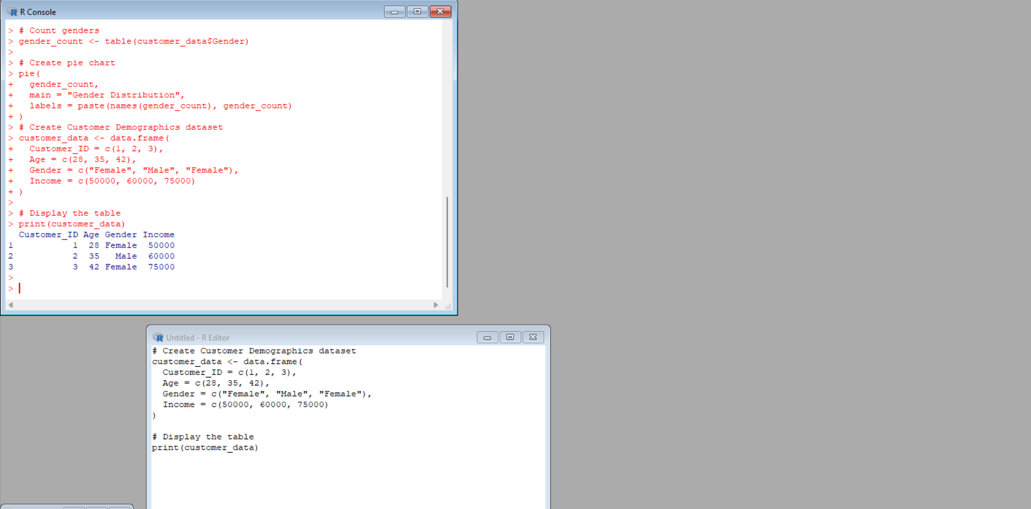

Explanation of the Code
- `data.frame()` creates the customer demographic dataset.
- Customer_ID, Age, Gender, and Income are the table columns.
- `print()` displays the complete table in the R console.

Expected Output
Customer_ID Age Gender Income
1 1 28 Female 50000
2 2 35 Male 60000
3 3 42 Female 75000

Observation / Inference
The table displays the demographic information of all three customers, including ID, age, gender, and income.

Result
The customer demographic information was successfully created and displayed as a table.

Key R Functions Used
data.frame(), print()

PROGRAM 4 – TABLEAU DASHBOARD
Tableau is separate from R. No R code is required to create the Tableau dashboard.

Step 1: Enter or Import the Dataset
- Open Tableau.
- Create a CSV file named Customer_Demographics.csv using the given dataset.
- Select Connect → Text File and select Customer_Demographics.csv.
- Check that Customer ID, Age, Gender, and Income are displayed correctly.
- Open Sheet 1.

Worksheet 1: Customer Age Bar Chart
Worksheet Name: Customer Age Bar Chart
- Columns: Customer ID
- Rows: Age
- Chart Type: Bar
- Title: Customer Age Distribution
- Drag Customer ID to Columns and Age to Rows.
- Select Bar from the Marks/Show Me options.

Worksheet 2: Gender Distribution Pie Chart
Worksheet Name: Gender Distribution Pie Chart
- Gender field: Gender
- Measure: Count of Customer ID
- Chart Type: Pie
- Drag Gender to Color.
- Drag Customer ID to Angle and Label.
- Change Customer ID to Count if required.
- Title: Customer Gender Distribution.

Worksheet 3: Customer Demographics Table
Worksheet Name: Customer Demographics Table
- Display Customer ID, Age, Gender, and Income.
- Drag Customer ID, Age, Gender, and Income to the table.
- Select Text Table from Show Me.
- Title: Customer Demographic Details.

Creating the Tableau Dashboard
- Click New Dashboard.
- Rename the dashboard Customer Demographics Analysis.
- Add Customer Age Bar Chart, Gender Distribution Pie Chart, and Customer Demographics Table.
- Arrange the bar chart and pie chart at the top and place the demographic table below.
- Adjust the size so all elements are clearly visible.
- Add the dashboard title.

Adding Interactivity
- Select the Gender field and choose Show Filter.
- Users can select Female or Male.
- The dashboard can then be explored interactively.

7. PROCEDURE
1. Open R/RStudio.
2. Enter the Customer Demographics dataset.
3. Execute R Program 1 to create the bar chart.
4. Execute R Program 2 to create the pie chart.
5. Execute R Program 3 to display the demographic table.
6. Observe the generated outputs.
7. Open Tableau.
8. Import or enter the same Customer Demographics dataset.
9. Create the Customer Age Bar Chart worksheet.
10. Create the Gender Distribution Pie Chart worksheet.
11. Create the Customer Demographics Table worksheet.
12. Combine all three worksheets into a Tableau dashboard.
13. Add suitable filters/interactivity.
14. Observe the final dashboard.

8. FINAL RESULT
The customer demographic data was successfully analyzed using a bar chart, pie chart, and demographic table in R. An interactive Tableau dashboard combining the required visualizations was also successfully developed.

