SET 8: EMPLOYEE PERFORMANCE ANALYSIS
Data Handling and Visualization using R
Course Code: DSA0601

PROGRAM 1 – LINE CHART

Aim
To create a line chart showing the performance trend of employees.

Dataset
Employee ID and Performance Score are used from the given dataset.

R Code
# Create Employee Performance dataset
employee_data <- data.frame(
Employee_ID = c(1, 2, 3),
Department = c("Sales", "HR", "Marketing"),
Years_of_Service = c(5, 3, 7),
Performance_Score = c(85, 92, 78)
)
# Create line chart
plot(employee_data$Employee_ID, employee_data$Performance_Score,
type = "o",
main = "Employee Performance Trend",
xlab = "Employee ID",
ylab = "Performance Score",
pch = 16)
# Add legend
legend("topright", legend = "Performance Score", lty = 1, pch = 16)
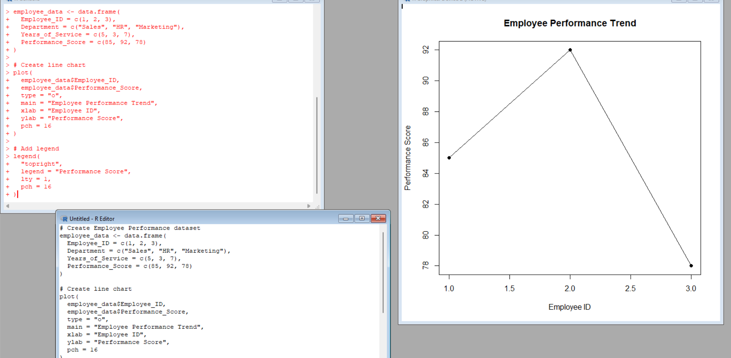

Explanation of the Code
- data.frame() creates the employee dataset.
- plot() creates the line chart.
- Employee ID is used on the X-axis and Performance Score on the Y-axis.
- type = "o" displays points and connecting lines.
- legend() adds the chart legend.

Expected Output
A line chart showing Employee 1 = 85, Employee 2 = 92, and Employee 3 = 78.

Observation / Inference
Employee 2 has the highest performance score of 92, while Employee 3 has the lowest score of 78.

Result
A line chart representing the employee performance trend was successfully created.

Key R Functions Used
data.frame(), plot(), legend()

PROGRAM 2 – BAR CHART

Aim
To create a bar chart showing the distribution of employees across different departments.

Dataset
The Department column from the given dataset is used.

R Code
# Create Employee Performance dataset
employee_data <- data.frame(
Employee_ID = c(1, 2, 3),
Department = c("Sales", "HR", "Marketing"),
Years_of_Service = c(5, 3, 7),
Performance_Score = c(85, 92, 78)
)
# Count employees in each department
department_count <- table(employee_data$Department)
# Create bar chart
barplot(department_count,
main = "Employee Distribution by Department",
xlab = "Department",
ylab = "Number of Employees")

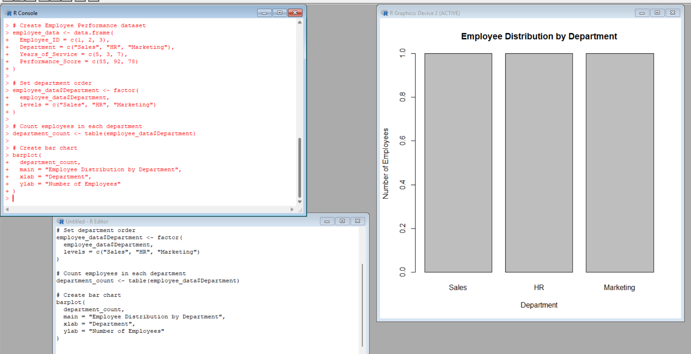Explanation of the Code
- table() counts the employees in each department.
- barplot() creates the bar chart.
- main, xlab, and ylab provide the title and axis labels.

Expected Output
Sales = 1 employee, HR = 1 employee, and Marketing = 1 employee.

Observation / Inference
Each department contains one employee, so all three bars have equal height.

Result
A bar chart showing the distribution of employees across departments was successfully created.

Key R Functions Used
data.frame(), table(), barplot()

PROGRAM 3 – EMPLOYEE PERFORMANCE TABLE

Aim
To create and display a table containing the complete performance information of each employee.

Dataset
The given Employee Performance dataset is used.

R Code
# Create Employee Performance dataset
employee_data <- data.frame(
Employee_ID = c(1, 2, 3),
Department = c("Sales", "HR", "Marketing"),
Years_of_Service = c(5, 3, 7),
Performance_Score = c(85, 92, 78)
)
# Display employee performance table
print(employee_data)
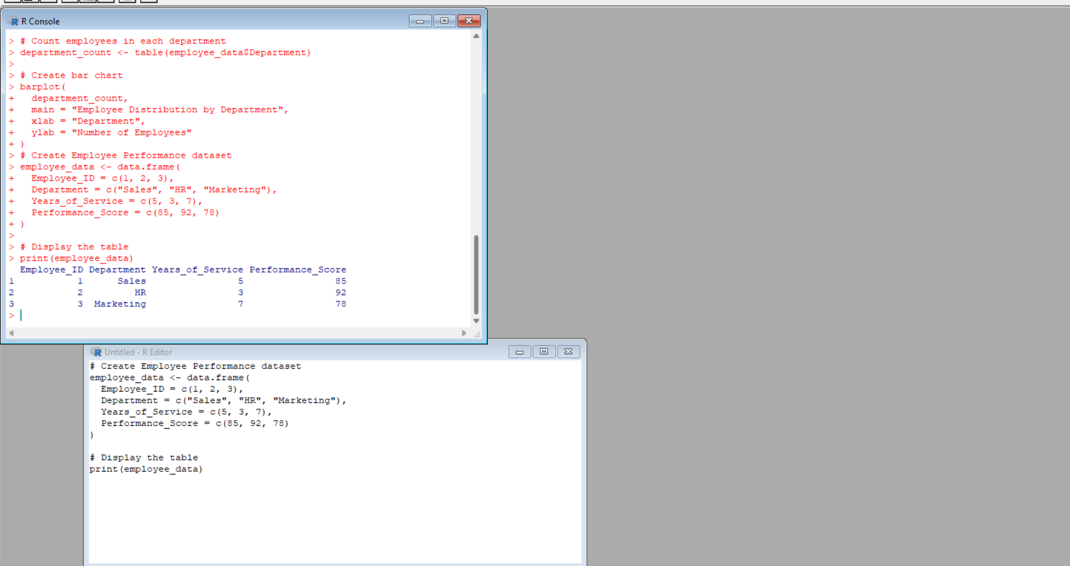

Explanation of the Code
- data.frame() creates the employee performance dataset.
- The table contains Employee ID, Department, Years of Service, and Performance Score.
- print() displays the complete table in the R console.

Expected Output
Employee_ID Department Years_of_Service Performance_Score
1 1 Sales 5 85
2 2 HR 3 92
3 3 Marketing 7 78

Observation / Inference
The table displays the complete performance information of all three employees.

Result
The employee performance data was successfully created and displayed as a table.

Key R Functions Used
data.frame(), print()

6. PROGRAM 4 – TABLEAU DASHBOARD
Tableau is separate from R. No R code is required for creating the Tableau dashboard.

Step 1: Import the Dataset into Tableau
- Create Employee_Performance.csv using the given dataset.
- Open Tableau.
- Select Connect → Text File and select Employee_Performance.csv.
- Check that all four columns are displayed correctly.
- Open Sheet 1.

Worksheet 1: Employee Performance Line Chart
- Worksheet Name: Employee Performance Line Chart
- Columns: Employee ID
- Rows: Performance Score
- Chart Type: Line
- Title: Employee Performance Trend
- Drag Employee ID to Columns and Performance Score to Rows.

Worksheet 2: Department Distribution Bar Chart
- Worksheet Name: Department Distribution Bar Chart
- Columns: Department
- Rows: Count of Employee ID
- Chart Type: Bar
- Title: Employee Distribution by Department
- Drag Department to Columns and Employee ID to Rows, then change Employee ID aggregation to Count.

Worksheet 3: Employee Performance Table
- Worksheet Name: Employee Performance Table
- Display Employee ID, Department, Years of Service, and Performance Score.
- Select Text Table from Show Me.
- Title: Employee Performance Details.

Creating the Tableau Dashboard
- Click New Dashboard.
- Rename it Employee Performance Analysis.
- Add the three worksheets.
- Place the line chart and bar chart at the top and the table below.
- Adjust worksheet sizes and add the dashboard title.

Adding Filters / Interactivity
- Select the Department field.
- Choose Show Filter.
- Users can select Sales, HR, or Marketing.
- The dashboard can then be explored interactively.

7. PROCEDURE
1. Open R/RStudio.
2. Enter the Employee Performance dataset.
3. Execute R Program 1 for the line chart.
4. Execute R Program 2 for the department bar chart.
5. Execute R Program 3 to display the employee performance table.
6. Observe the generated outputs.
7. Open Tableau.
8. Import or enter the same Employee Performance dataset.
9. Create the Employee Performance Line Chart worksheet.
10. Create the Department Distribution Bar Chart worksheet.
11. Create the Employee Performance Table worksheet.
12. Combine all three worksheets into one Tableau dashboard.
13. Add suitable filters/interactivity.
14. Observe the final dashboard.

8. FINAL RESULT
The employee performance data was successfully analyzed using a line chart, bar chart, and employee performance table in R. An interactive Tableau dashboard combining the required visualizations was also successfully developed.

