Beyond Compactness: A Spatial-Geometry Framework for Valuing Pressing
Structure and Testing Counterfactual Defender Positions
Soccer
Paper ID: [To be assigned]
Abstract.
Coaches describe pressing with words such as compactness, cover shadow, pressing angle, numerical support, and escape space, yet these ideas are rarely measured directly. That makes it difficult to compare pressing structures across moments, players, or teams, or to explain which specific spatial arrangement actually restricted an opponent's progression. We ask whether the geometry of a press can be formalized into measurable features, connected to short-horizon opponent progression, and then tested through counterfactual repositioning of individual defenders. The goal is to move beyond detecting whether a press occurred and instead describe what structure was used, what it restricted, and how individual defenders could be repositioned to help coaches and technical staff make better pressing decisions.
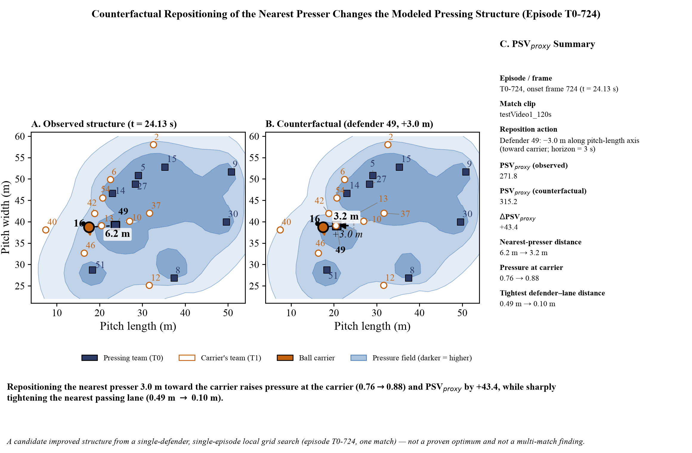
Figure 1. Episode T0-724: observed pressing structure versus a bounded counterfactual repositioning of the nearest presser. The candidate move raises pressure at the carrier and PSV_proxy by +43.4; it is not a proven optimum.
From single-camera broadcast video tracked at 30 fps over one 120-second match segment, we construct a continuous spatial pressure field. Each defender receives a time-to-reach/influence value derived from distance and velocity toward the target, and team influence is combined through an independent-OR aggregate. A finite-state machine detects 19 press episodes, 11 for Team A and 8 for Team B. For each episode we extract 59 features across five families: geometry, including nearest and second-presser distance, local numerical superiority, compactness, and convex-hull area; motion, including closing speed and participant count; escape, including passing-lane pressure and low-pressure-lane count; field, including pressure at the carrier, pressure gradient, and contour coverage; and context, including pitch third, channel, and distance to goal. Pressing Structure Value is represented by PSV_proxy, defined as unimpeded forward progress minus progress predicted under the observed pressure field. A bounded local-grid search then moves one defender by +/-1 m, 2 m, or 3 m on each axis, pitch-clamped, and recomputes PSV_proxy under the alternative structure.

The detected press episodes yield complete feature rows with zero skipped cases. Heuristic outcome attribution resolves only 3 episodes concretely - two BALL_REGAIN and one FORCED_BACKWARD - while 16 remain UNCERTAIN, reflecting sparse matched evidence rather than missing features. A higher-coverage continuous pressure-intensity signal reaches 68.2% frame coverage and separates PRESS_FORMING from NO_PRESS frames with Cohen's d = +0.661, while correlating with the existing discrete press score at mean r = +0.315. A signed dominance variant rises by +0.109 for the pressing team's own episodes and +0.027 for the opponent. In episode T0-724, moving the nearest presser 3 m toward the carrier along the pitch-length axis increases PSV_proxy by +43.4, a candidate improved structure rather than a proven optimum.
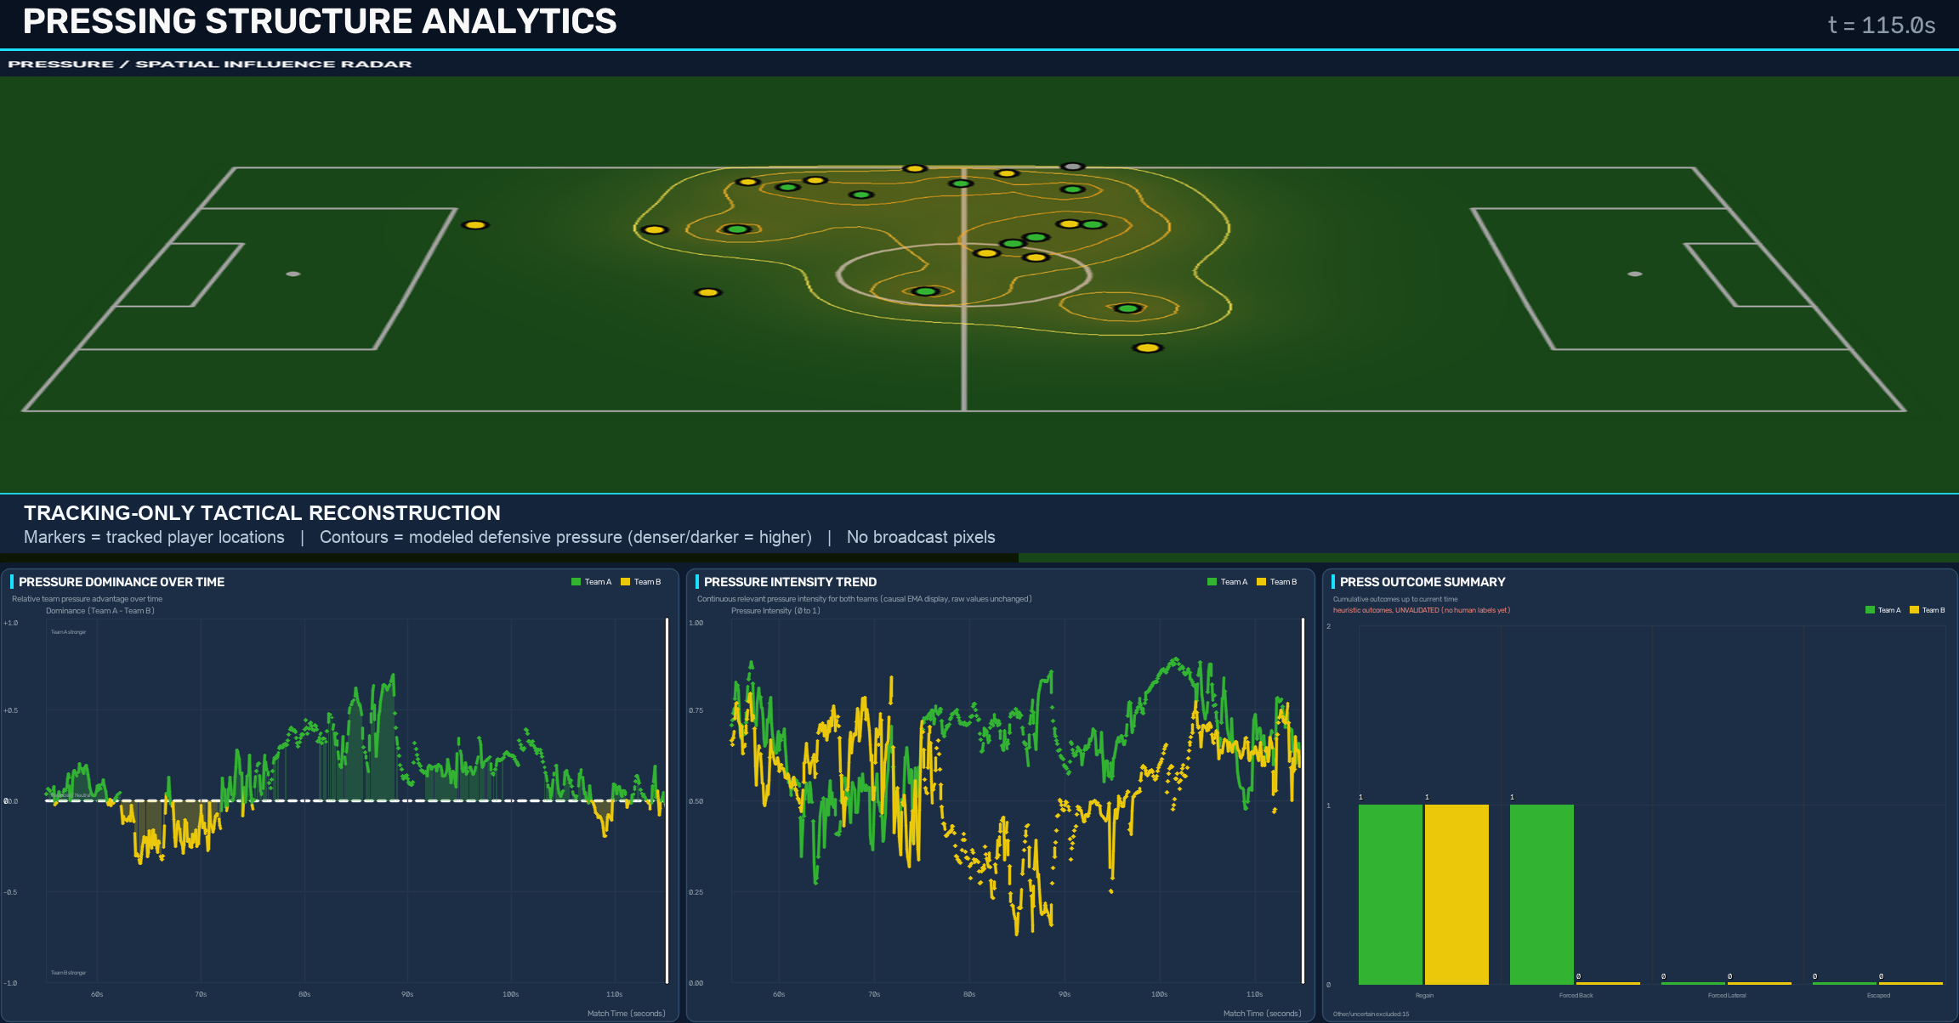
Figure 2. Tracking-only practitioner view combining reconstructed player positions and pressure contours with signed pressure dominance, team pressure intensity, and press-outcome counts. Zero is the signed-dominance balance reference; the separate 0.633 intensity threshold gates low-pressure periods.
The continuous pressure signal is intended as an inspection aid alongside the finite-state press episodes, not as evidence that pressing caused goals or other match outcomes. With only 3 concretely attributed episode outcomes and 16 uncertain cases, the present sample does not support a reliable correlation with goals or a PSV_proxy-outcome relationship. No classifier or archetype clustering is claimed. The pipeline instead provides an inspectable route from raw tracking to per-episode pressing shape and candidate defender repositioning for coaching review or opposition scouting, while requiring multi-match data and human-adjudicated outcomes before any structure-value claim can be validated statistically.
This research was developed in collaboration with SoccerSolver. SoccerSolver currently works with more than 10 football clubs.
Open-source repository: https://github.com/RupayanHalder39/Problem4_Best_Spatial_Structure_for_Pressing_Football

