Closing the Gap: Attack-Gated Space Control and Bounded Counterfactual Repositioning in Soccer
Soccer
Paper ID: [To be assigned]
Abstract.
Coaches routinely ask which player should step into open space before an opponent exploits it, but this call is usually made on intuition, not measurement. Existing pitch-control and Voronoi models flag “dangerous” space geometrically, without checking whether the current attack can reach it, and rarely recommend a fix while checking whether that fix opens a new gap. We ask whether attack-relevant dangerous space can be identified from player tracking, and whether a bounded counterfactual search can recommend which defender or midfielder should reposition to close it without creating a new structural gap elsewhere.
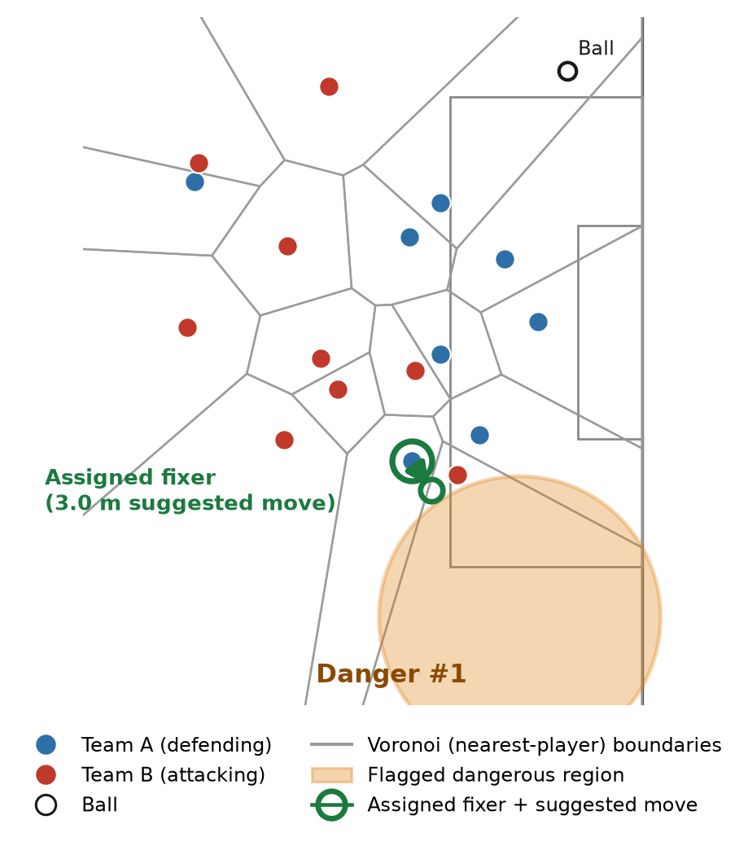
At this instant, the bounded (≤ 3 m) local search recommends a 3.0 m repositioning for the assigned fixer that reduces the flagged region’s severity by 0.00775 with zero new-gap penalty (net benefit = +0.01326) — one of only 3 genuinely improving cases found in an exhaustive scan of the full 3,600-frame match.
Figure 1. Real tracking data at one match instant (t = 74.4 s): a top-down academic rendering of the flagged dangerous region (orange) for the defending team, the Voronoi tessellation (nearest-player territory, gray) used to compute it, both teams’ real player positions, the ball, and the assigned fixer’s recommended repositioning (green).
This is one of only three frames, across an exhaustive scan of all 3,600 frames × 2 teams, where the bounded search finds a genuinely improving reposition; the large majority of frames honestly report no improving candidate, consistent with the Results below — shown here to illustrate the mechanism, not a typical outcome.
From broadcast video tracked at 30 fps over one 120-second match segment (3,600 frames), we compute a Voronoi tessellation per frame and score each opponent-owned cell as an area-gated weighted sum of five components: goal proximity (0.20), centrality (0.10), ball proximity (0.15), receiver support (0.20), and coverage gap (0.35). A causal, tiered majority-vote estimator (current frame, then 4s/12s/30s trailing windows) determines the attacking team. A hard eligibility gate then restricts candidates to cells within 5 m of the ball’s longitudinal progress, or reachable within 30 m or a 0.15 receiver-support threshold, excluding cells behind the live attack or arising when the defending team itself holds the ball. Up to three mutually distinct eligible regions per team are kept via centroid/radius de-duplication, and each region’s fixer candidate is scored on proximity, feasibility, abandonment cost, and local support. A bounded (≤ 3 m) local search then evaluates candidate repositions against a benefit function trading danger removed against new-gap risk, structural damage, and movement cost.
Across a 475-frame sample, the eligibility gate eliminates strongly-behind-the-attack selections entirely, while ahead-of-ball/level selections rise from 53.3% to 64.4% (Figure 2); 21.9% of frames resolve an eligible primary danger, 64.8% are honestly reported possession-uncertain, and 13.3% have known context but no eligible candidate.
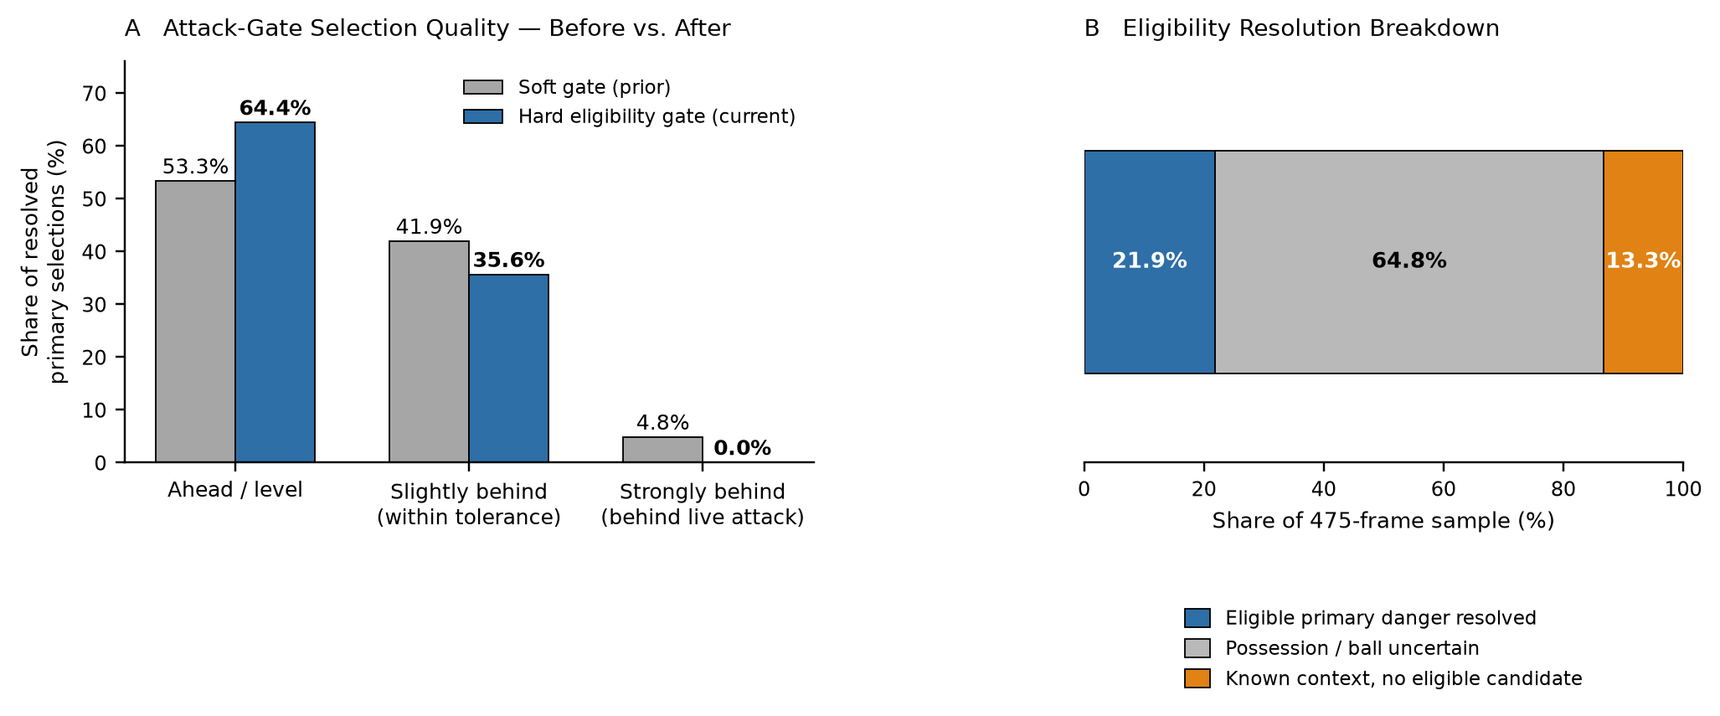
Figure 2. Effect and coverage of the Current-Attack Eligibility gate. (A) The hard gate increases ahead/level primary selections from 53.3% to 64.4% and eliminates strongly-behind selections from 4.8% to 0.0%, compared with the earlier soft-gate version. (B) Across the same 475-frame sample, 21.9% of frames resolve an eligible primary danger, while 64.8% remain possession/ball uncertain and 13.3% have known context but no eligible candidate.
In a 601-frame demo segment, 48 frames resolve a primary region: 21 (44%) contain three distinct dangerous regions, 23 (48%) contain two, and 4 (8%) contain one, with de-duplication merging overlapping candidates in 47 of 48 cases; same-player fixer conflicts arise in 4 of 48 frames, always resolved by reassigning the next-best real candidate. The positive-benefit case in Figure 1 (a 3.0 m move) reduces flagged-region severity by 0.00775 with zero new-gap penalty (net benefit +0.01326); most frames, however, report no improving bounded candidate, since the nearest real defender is often 20-40 m away. The system turns “where is the danger, and who should close it” into a reproducible, frame-level answer, supporting opposition scouting, training-ground rehearsal of defensive shape, and post-match review. It does not claim globally optimal repositioning, validated scoring probability, or a proven outcome effect: the bounded single-player search, one-match sample, and unvalidated severity/access proxies mean this is coach-facing decision support, not automated tactical truth, pending multi-match validation.
Open-source repository: [Public GitHub URL to be added before submission]

