Design Patterns

Singleton Pattern
Singleton pattern is one of the simplest design patterns in Java. This type of design pattern comes under creational pattern as this pattern provides one of the best ways to create an object.
This pattern involves a single class which is responsible to create an object while making sure that only single object gets created. This class provides a way to access its only object which can be accessed directly without need to instantiate the object of the class.
We're going to create a SingleObject class. SingleObject class have its constructor as private and have a static instance of itself.
SingleObject class provides a static method to get its static instance to outside world.SingletonPatternDemo, our demo class will use SingleObject class to get a SingleObjectobject.
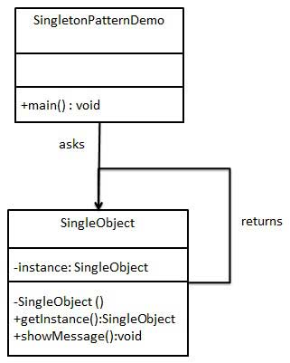

Step 1

Create Value Object.

Student.java

public class Student {
private String name;
private int rollNo;

Student(String name, int rollNo){
this.name = name;
this.rollNo = rollNo;
}

public String getName() {
return name;
}

public void setName(String name) {
this.name = name;
}

public int getRollNo() {
return rollNo;
}

public void setRollNo(int rollNo) {
this.rollNo = rollNo;
}
}

Step 2

Create Data Access Object Interface.

StudentDao.java

import java.util.List;

public interface StudentDao {
public List<Student> getAllStudents();
public Student getStudent(int rollNo);
public void updateStudent(Student student);
public void deleteStudent(Student student);
}

Step 3

Create concrete class implementing above interface.

StudentDaoImpl.java

import java.util.ArrayList;
import java.util.List;

public class StudentDaoImpl implements StudentDao {

//list is working as a database
List<Student> students;

public StudentDaoImpl(){
students = new ArrayList<Student>();
Student student1 = new Student("Robert",0);
Student student2 = new Student("John",1);
students.add(student1);
students.add(student2);
}
@Override
public void deleteStudent(Student student) {
students.remove(student.getRollNo());
System.out.println("Student: Roll No " + student.getRollNo() + ", deleted from database");
}

//retrive list of students from the database
@Override
public List<Student> getAllStudents() {
return students;
}

@Override
public Student getStudent(int rollNo) {
return students.get(rollNo);
}

@Override
public void updateStudent(Student student) {
students.get(student.getRollNo()).setName(student.getName());
System.out.println("Student: Roll No " + student.getRollNo() + ", updated in the database");
}
}

Step 4

Use the StudentDao to demonstrate Data Access Object pattern usage.

DaoPatternDemo.java

public class DaoPatternDemo {
public static void main(String[] args) {
StudentDao studentDao = new StudentDaoImpl();

//print all students
for (Student student : studentDao.getAllStudents()) {
System.out.println("Student: [RollNo : " + student.getRollNo() + ", Name : " + student.getName() + " ]");
}

//update student
Student student =studentDao.getAllStudents().get(0);
student.setName("Michael");
studentDao.updateStudent(student);

//get the student
studentDao.getStudent(0);
System.out.println("Student: [RollNo : " + student.getRollNo() + ", Name : " + student.getName() + " ]");
}
}

Factory Pattern
Factory pattern is one of most used design pattern in Java. This type of design pattern comes under creational pattern as this pattern provides one of the best ways to create an object.
In Factory pattern, we create object without exposing the creation logic to the client and refer to newly created object using a common interface.

Implementation
We're going to create a Shape interface and concrete classes implementing the Shapeinterface. A factory class ShapeFactory is defined as a next step.
FactoryPatternDemo, our demo class will use ShapeFactory to get a Shape object. It will pass information (CIRCLE / RECTANGLE / SQUARE) to ShapeFactory to get the type of object it needs.
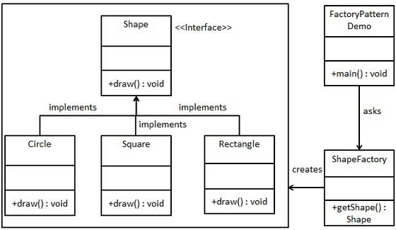
Step 1
Create an interface.

Shape.java

public interface Shape {
void draw();
}
Step 2
Create concrete classes implementing the same interface.

Rectangle.java

public class Rectangle implements Shape {

@Override
public void draw() {
System.out.println("Inside Rectangle::draw() method.");
}
}
Square.java

public class Square implements Shape {

@Override
public void draw() {
System.out.println("Inside Square::draw() method.");
}
}
Circle.java

public class Circle implements Shape {

@Override
public void draw() {
System.out.println("Inside Circle::draw() method.");
}
}
Step 3
Create a Factory to generate object of concrete class based on given information.

ShapeFactory.java

public class ShapeFactory {

//use getShape method to get object of type shape
public Shape getShape(String shapeType){
if(shapeType == null){
return null;
}
if(shapeType.equalsIgnoreCase("CIRCLE")){
return new Circle();

} else if(shapeType.equalsIgnoreCase("RECTANGLE")){
return new Rectangle();

} else if(shapeType.equalsIgnoreCase("SQUARE")){
return new Square();
}

return null;
}
}
Step 4
Use the Factory to get object of concrete class by passing an information such as type.

FactoryPatternDemo.java

public class FactoryPatternDemo {

public static void main(String[] args) {
ShapeFactory shapeFactory = new ShapeFactory();

//get an object of Circle and call its draw method.
Shape shape1 = shapeFactory.getShape("CIRCLE");

//call draw method of Circle
shape1.draw();

//get an object of Rectangle and call its draw method.
Shape shape2 = shapeFactory.getShape("RECTANGLE");

//call draw method of Rectangle
shape2.draw();

//get an object of Square and call its draw method.
Shape shape3 = shapeFactory.getShape("SQUARE");

//call draw method of circle
shape3.draw();
}
}

