**2**

**Understanding the AWS Well-Architected Framework and Getting Certified**

In the previous chapter, you got a glimpse of AWS’s innovation pace and broad service offerings. As a solutions architect, you might wonder how these services come together to address various parameters of your IT workload needs. You may also wonder how you can ensure your architecture is following best practices while achieving your business needs. For that purpose, AWS provides architecture guidance in a cloud-native way using its Well-Architected Framework.

In this chapter, you will learn details about the Well-Architected Framework and how to apply best practices for every component of your cloud application. You will go through the six pillars of the Well-Architected Framework and the AWS Well-Architected Lenses for specific workloads such as serverless, analytics, IoT, etc. You will learn about using the AWS Well-Architected tool to validate your architecture against AWS-recommended best practices by conducting a **Well-Architected Review** (**WAR**).

Further, you will then learn how we can take a slice of the cloud pie and build your credibility by becoming certified. Finally, toward the end of the chapter, we will look at some tips and tricks you can use to simplify your journey to obtain AWS certifications. We will also look at some frequently asked questions about the AWS certifications.

In this chapter, we will cover the following topics:

* The AWS Well-Architected Framework
* The six pillars of the Well-Architected Framework
* AWS Well-Architected Lenses
* Building credibility and getting certified
* Learning tips and tricks for obtaining AWS certifications
* Some frequently asked questions about AWS certifications

Let’s get started by looking at a holistic architecture approach in AWS.

**The AWS Well-Architected Framework**

As a solutions architect, you may have questions about architecture optimization for reliability, scaling, high availability, performance, and security even before getting started with various AWS services. You may ask how the AWS cloud will accommodate those needs and compare it with your existing on-premise architecture practice.

AWS built the Well-Architected Framework to address those needs. The Well-Architected Framework provides customers with access to AWS’s Well-Architected content. This content is based on extensive architectural reviews with clients, helping to identify and mitigate potential architectural risks while promoting best practices.

AWS also created the **WAR** to help customers have better outcomes when building architectures on AWS. You can understand the areas of your architecture that could be improved, which in turn helps you address areas you have been firefighting and that distract from adding value. As you go through the review process, you can learn about new capabilities to add value to your application and drive better outcomes to build and operate workloads on the cloud. With this, you can get the following benefits:

* Learn strategies and best practices for architecting in the cloud
* Measure your architecture against best practices
* Improve your architecture by addressing any issues

AWS has six Well-Architected pillars covering the breadth and depth of architecture along with the WAR to validate them. Let’s learn more about it.

**The six pillars of the Well-Architected Framework**

The cloud in general, and AWS in particular, is so popular because it simplifies the development of Well-Architected Frameworks. If there is one *must-read* AWS document, it is *AWS Well-Architected Framework*, which spells out the six pillars of the Well-Architected Framework.

The full document can be found here: <https://docs.aws.amazon.com/wellarchitected/latest/framework/welcome.html>.

AWS provides the Well-Architected tool, which provides prescriptive guidance about each pillar to validate your workload against architecture best practices and generate a comprehensive report. Please find a glimpse of the tool below:

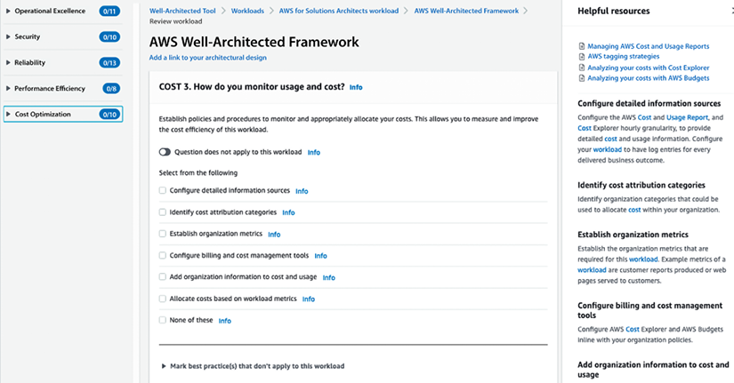

*Figure 2.1: AWS Well-Architected tool*

To kick off a WAR for your workload, you first need to create an AWS account and open the Well-Architected tool. To start an architecture review per the gold standard defined by AWS, you need to provide workload information such as the name, environment type (production or pre-production), AWS workload hosting regions, industry, reviewer name, etc. After submitting the information, you will see (as in the above screenshot) a set of questions about each Well-Architected pillar, with the option to select what is most relevant to your workload. AWS provides prescriptive guidance and various resources for applying architecture best practices to questions within the right-hand navigation.

As AWS has provided detailed guidance for each Well-Architected pillar in their document, let’s look at the main points about the six pillars of the Well-Architected Framework.

**The first pillar – security**

Security should always be a top priority in both on-premises and cloud architectures. All security aspects should be considered, including data encryption and protection, access management, infrastructure security, network security, monitoring, and breach detection and inspection.

To enable system security and to guard against nefarious actors and vulnerabilities, AWS recommends these architectural principles:

* Implement a strong identity foundation
* Enable traceability
* Apply security at all levels
* Automate security best practices
* Protect data in transit and at rest
* Keep people away from data
* Prepare for security events

You can find the security pillar checklist from the Well-Architected tool below, which has ten questions with one or more options relevant to your workload:

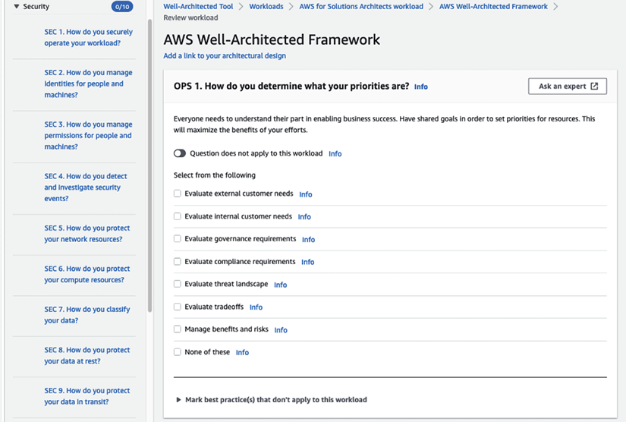

*Figure 2.2: AWS Well-Architected Security pillar*

In the preceding screenshot, in the left-hand navigation, you can see questions related to security best practices, and for each question, there will be multiple options to choose from per your workload. Answering these questions will help you to determine the current state of your workload security and highlight if there are any gaps in the WAR report such as **High-Risk Issues** (**HRIs**). You can find more details on the security pillar by referring to the AWS Well-Architected Framework user document: <https://docs.aws.amazon.com/wellarchitected/latest/security-pillar/welcome.html>.

To gain practical experience in implementing optimal security practices, it is advisable to complete the well-architected security labs. You can find details on the labs here: <https://www.wellarchitectedlabs.com/security/>.

The next pillar, reliability, is almost as important as security, as you want your workload to perform its business functions consistently and reliably.

**The second pillar – reliability**

Before discussing reliability in the context of the Well-Architected Framework, let’s first get a better understanding of reliability as a concept. Intuitively, a resource is said to have *“reliability”* if it often works when we try to use it. You will be hard-pressed to find an example of anything that is perfectly reliable. Even the most well-manufactured computer components have a degree of *“unreliability.”* To use a car analogy, if you go to your garage and you can usually start your car and drive it away, then it is said to have high *“reliability.”* Conversely, if you can’t trust your car to start (maybe because it has an old battery), it is said to have low *“reliability.”*

Reliability is the probability of a resource or application meeting a certain performance standard and continuing to perform for a certain period of time. Reliability is leveraged to gain an understanding of how long the service will be up and running in the context of various real-life conditions.

**Note**

Reliability and availability are sometimes erroneously used interchangeably. To continue with the car analogy, for your car to be available, it must be functional, ready for use, turned on, and ready to go. These conditions make it have high *availability*. For your car to have high *reliability*, it must start most of the time – you can depend on it being able to function.

Reliability is the measurement of how long a resource performs its intended function, whereas availability is the measurement of how long a resource is in operation as a percentage of the total time it was in operation and not in operation (see the *Availability*section of the previous chapter for more information). For example, a machine may be available 90% of the time but have a reliability of 75%. The two terms are related but different and have different meanings. They have different objectives and can have different costs to maintain certain service levels.

The reliability of an application can be difficult to measure. There are a couple of methods to measure reliability. One of them is to measure the probability of failure of the application components that may affect the availability of the whole application.

More formally, we can calculate the **Mean Time Between Failures** (**MTBF**):

https://learning.oreilly.com/api/v2/epubs/urn:orm:book:9781803238951/files/Images/B18475_02_001.png

MTBF represents the time elapsed between component failures in a system. The metric used to measure time in MTBF is typically hours, but it can also be measured in other units of time such as days, weeks, or years depending on the specific system, component, or product being evaluated.

Similarly, **Mean Time To Repair** (**MTTR**) may be measured as a metric representing the time it takes to repair a failed system component. Ensuring the application is repaired on time is essential to meet service-level agreements. Other metrics can be used to track reliability, such as the fault tolerance levels of the application. The greater the fault tolerance of a given component, the lower the susceptibility of the whole application to being disrupted in a real-world scenario.

As you can see, reliability is a vital metric for assessing your architecture. The reliability of your architecture should be as high as possible, and the Well-Architected Framework recognizes the importance of this with its second pillar, Reliability. A key characteristic of the Reliability pillar is minimizing or eliminating single points of failure. Ideally, every component should have a backup. The backup should be able to come online as quickly as possible and in an automated manner, without human intervention.

Self-healing is another important concept to attain reliability. An example of this is how Amazon S3 handles data replication. Before returning a SUCCESS message, S3 saves your objects redundantly on multiple devices across a minimum of three **Availability Zones** (**AZs**) in an AWS Region. This design ensures that the system can withstand multiple device failures by rapidly identifying and rectifying any lost redundancy. Additionally, the service conducts regular checksum-based data integrity checks.

The Well-Architected Framework paper recommends these design principles to enhance reliability:

* Automatically recover from failure
* Test recovery procedures
* Scale horizontally to increase aggregate workload availability
* Stop guessing capacity
* Manage changes in automation

You can find the reliability pillar checklist from the Well-Architected tool below:

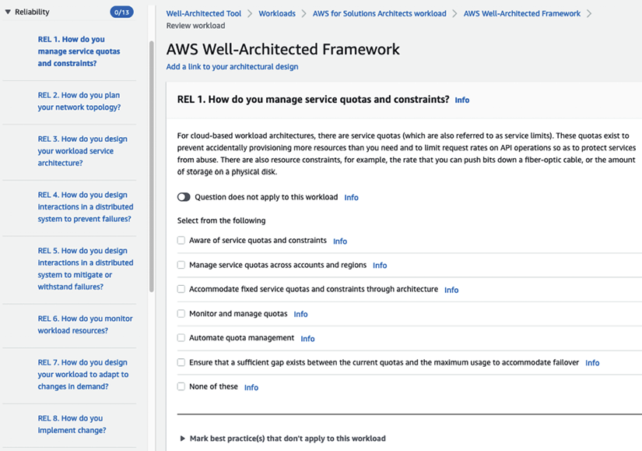

*Figure 2.3: AWS Well-Architected reliability pillar*

In the preceding screenshot, you can see questions related to achieving reliability best practices in the left-hand navigation. Answering these questions will help you determine the current state of your workload reliability and highlight HRIs, which you must fix. You can find more details on the reliability pillar by referring to the AWS Well-Architected Framework user doc: <https://docs.aws.amazon.com/wellarchitected/latest/reliability-pillar/welcome.html>.

Reliability is a complex topic that requires significant effort to ensure that all data and applications are backed up appropriately. To implement the best reliability practices, the well-architected labs can be utilized, providing hands-on experience in applying optimal reliability strategies. You can find details on the labs here: <https://www.wellarchitectedlabs.com/reliability/>.

To retain users, you need your application to be highly performant and to respond within seconds or milliseconds as per the nature of your workload. This makes performance a key pillar when building your application. Let’s look at more details on performance efficiency.

**The third pillar – performance efficiency**

In some respects, over-provisioning resources is just as bad as not having enough capacity to handle your workloads. Launching a constantly idle or almost idle instance is a sign of bad design. Resources should not be at full capacity and should be utilized efficiently. AWS provides various features and services to assist in creating architectures with high efficiency. However, we are still responsible for ensuring that the architectures we design are suitable and correctly sized for our applications.

When it comes to performance efficiency, the recommended design best practices are as follows:

* Democratize advanced technologies
* Go global in minutes
* Use serverless architectures
* Experiment more often
* Consider mechanical sympathy

You can find the Performance efficiency pillar checklist from the Well-Architected tool below with eight questions covering multiple aspects to make sure your architecture is optimized for performance:

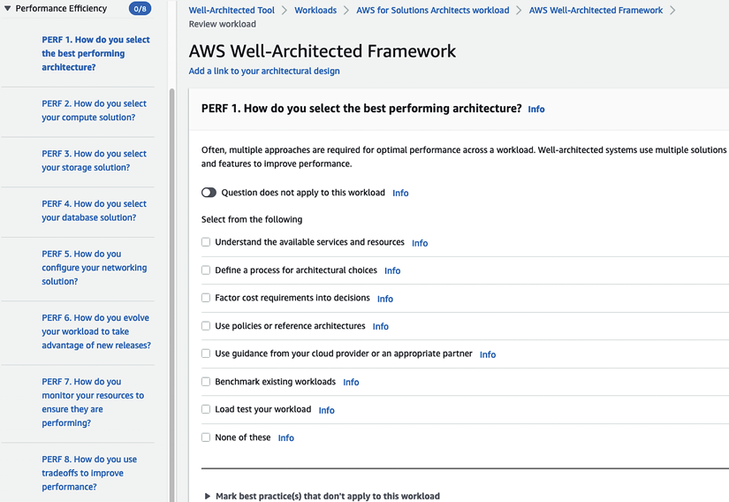

*Figure 2.4: AWS Well-Architected performance pillar*

In the preceding screenshot, you can see questions related to building performant applications, and answering these questions will help you identify and improve your workload performance. You can find more details on the performance efficiency pillar by referring to the AWS Well-Architected Framework user doc: <https://docs.aws.amazon.com/wellarchitected/latest/performance-efficiency-pillar/welcome.html>.

Monitoring is critical to performance, as it helps identify potential issues within a system and optimize it for optimal operation. To effectively monitor your workload for performance, hands-on labs are available that provide practical experience and help to implement appropriate monitoring techniques. You can find details on the labs here: <https://www.wellarchitectedlabs.com/performance-efficiency/>.

Cost optimization is one of the primary motivators for businesses to move to the cloud as per Gartner’s *6 Steps for Planning a Cloud Strategy*. However, the cloud can become expensive if you don’t apply best practices and run the cloud workload the same way you run an on-premises workload. The cloud can save you tons of money with proper cost optimization techniques. Let’s look into the next pillar, cost optimization.

**The fourth pillar – cost optimization**

This pillar is related to the third pillar. Suppose your architecture is efficient and can accurately handle varying application loads and adjust as traffic changes.

Additionally, your architecture should identify when resources are not being used and allow you to stop them or, even better, stop those unused compute resources for you. In this department, AWS provides autoscaling, which allows you to turn on monitoring tools that will automatically shut down resources if they are not being utilized. We strongly encourage you to adopt a mechanism to stop resources once they are identified as idle. This is especially useful in development and test environments.

To enhance cost optimization, these principles are suggested:

* Implement cloud financial management
* Adopt a consumption model
* Measure overall efficiency
* Stop spending money on undifferentiated heavy lifting
* Analyze and attribute expenditure

Whenever possible, use AWS-managed services instead of services you need to manage yourself. Managed cloud-native services should lower your administration expenses. You can find the cost optimization pillar checklist from the Well-Architected tool below with ten questions covering multiple aspects to make sure your architecture is optimized for cost:

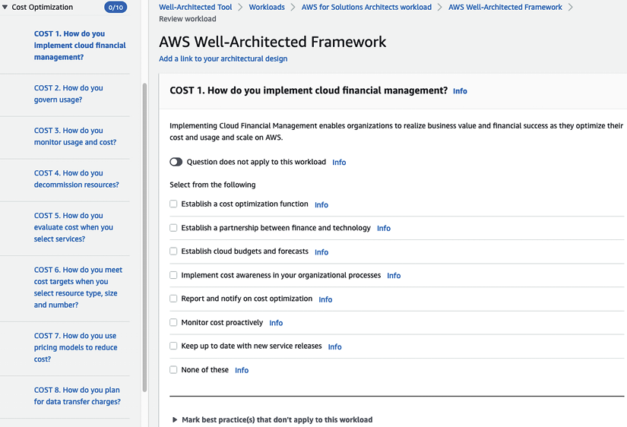

*Figure 2.5: AWS Well-Architected cost optimization pillar*

In the preceding screenshot, you can see questions about cost optimization best practices, and answering these questions will help you save costs by optimizing your workload for the cloud. You can find more details on the cost optimization pillar by referring to the AWS Well-Architected Framework user doc: <https://docs.aws.amazon.com/wellarchitected/latest/cost-optimization-pillar/welcome.html>.

One of the primary motivations for businesses to move to the cloud is cost savings. It is essential to optimize costs to realize a return on investment after migrating to the cloud. To learn about the best practices for cost monitoring and optimization, hands-on labs are available that provide practical experience and help to implement effective cost management strategies. You can find details on the labs here: <https://www.wellarchitectedlabs.com/cost/>.

Significant work starts after deploying your production workload, making operational excellence a critical factor. You need to make sure your application maintains the expected performance in production and improves efficacy by applying as much automation as possible. Let’s look at more details of the operational excellence pillar.

**The fifth pillar – operational excellence**

The operational excellence of a workload should be measured across these dimensions:

* Agility
* Reliability
* Performance

The ideal way to optimize these key performance indicators is to standardize and automate the management of these workloads. To achieve operational excellence, AWS recommends these principles:

* Perform operations as code
* Make frequent, small, reversible changes
* Refine operation procedures frequently
* Anticipate failure
* Learn from all operational failures

You can find the operational excellence pillar checklist from the Well-Architected tool below with eleven questions covering multiple aspects to make sure your architecture is optimized for running in production:

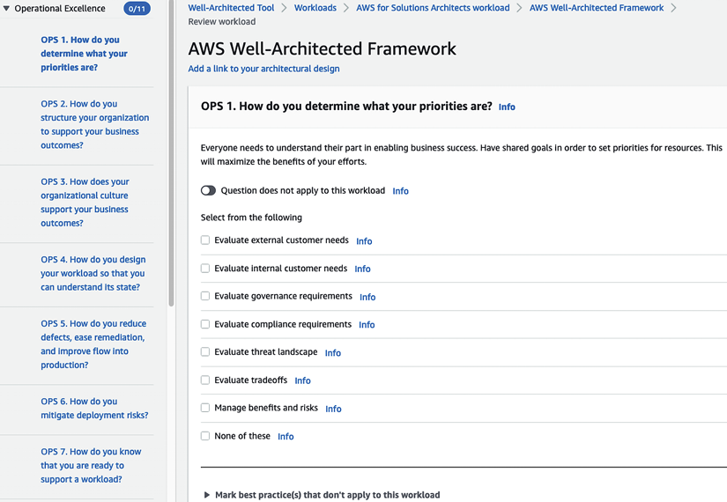

*Figure 2.6: AWS Well-Architected operational excellence pillar*

In the preceding screenshot, you can see questions about driving operational excellence best practices. Answering these questions will help you achieve efficiency and agility by automating your workload infrastructure, application deployment, monitoring, and alerts. You can find more details on the operational excellence pillar by referring to the AWS Well-Architected Framework user doc: <https://docs.aws.amazon.com/wellarchitected/latest/operational-excellence-pillar/welcome.html>.

Operational excellence is the true value of the cloud, as it enables the automation of production workloads and facilitates self-scaling. Hands-on guidance for implementing best practices in operational excellence is available through the well-architected labs, providing practical experience to optimize the operational efficiency of a system. You can find details on the labs here: <https://www.wellarchitectedlabs.com/operational-excellence/>.

Sustainability is now the talk of the town, with organizations worldwide recognizing their social responsibilities and taking the pledge to make business more sustainable. As a leader, AWS was the first cloud provider to launch suitability as an architecture practice at re:Invent 2021. Let’s look into more details of the sustainability pillar of the Well-Architected Framework.

**The sixth pillar – sustainability**

As more and more organizations adopt the cloud, cloud providers can lead the charge to make the world more sustainable in improving the environment, economics, society, and human life. *The United Nations World Commission on Environment and Development* defines sustainable development as “*development that meets the needs of the present without compromising the ability of future generations to meet their own needs”*. Your organization can have direct or indirect negative impacts on the Earth’s environment through carbon emissions or by damaging natural resources like clean water or farming land. To reduce environmental impact, it’s important to talk about sustainability and adopt it in practice wherever possible. AWS is achieving that by adding the sixth pillar to its Well-Architected Framework, with the following design principles:

* Understand your impact
* Establish sustainability goals
* Maximize utilization
* Anticipate and adopt new, more efficient hardware and software offerings
* Use managed services
* Reduce the downstream impact of your cloud workloads

You can find the sustainability pillar checklist from the Well-Architected tool below with six well-thought-out questions covering multiple aspects to make sure your architecture is sustainable:

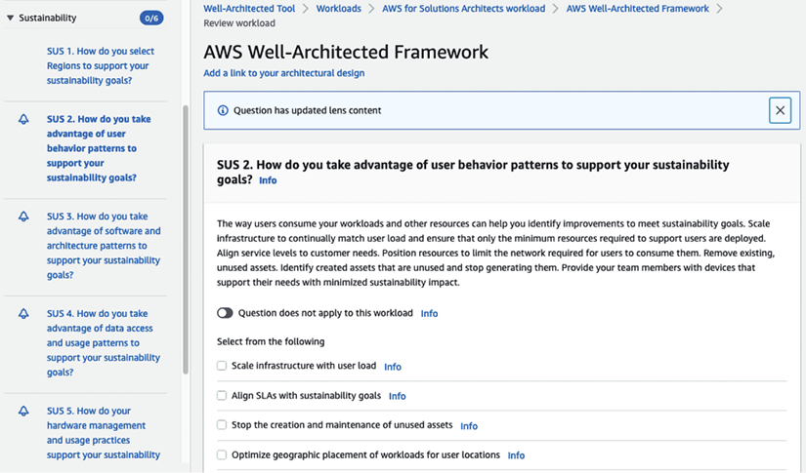

*Figure 2.7: AWS Well-Architected sustainability pillar*

In the preceding screenshot, you can see questions related to understanding if your workload is helping you to achieve your sustainability goals and how AWS can help you meet these goals. You can find more details on the sustainability pillar by referring to the AWS Well-Architected Framework user doc: <https://docs.aws.amazon.com/wellarchitected/latest/sustainability-pillar/sustainability-pillar.html>.

Making conscious choices and having an awareness of your carbon footprint is essential to drive sustainability. AWS provides ways to save energy through their services, and with the help of the well-architected labs, workloads can be made sustainable and environmentally aware. You can find details on the labs here: <https://www.wellarchitectedlabs.com/sustainability/>.

While the Well-Architected Framework provides more generic guidance for optimizing your architecture, which is applicable across workloads, there is a need for more specific architectural practice for specialized workloads. That’s why AWS published Well-Architected Lenses to address workload and domain-specific needs. Let’s take an overarching view of AWS’s Well-Architected Lenses.

**AWS Well-Architected Lenses**

As of April 2022, AWS has launched 13 Well-Architected Lenses addressing architecting needs specific to technology workloads and industry domains. The following are the important available lenses for AWS’s Well-Architected Framework:

* **Serverless Applications Lens** – Building a serverless workload saves costs and offloads infrastructure maintenance to the cloud. The Serverless Applications Lens provides details on best practices to architect serverless application workloads in the AWS cloud. More information on the design principles is available on the AWS website: <https://docs.aws.amazon.com/wellarchitected/latest/serverless-applications-lens>.
* **Internet of Things (IoT) Lens** – To design an IoT workload, you must know how to manage and secure it on millions of devices that need to connect over the internet. The IoT Lens provides details on designing an IoT workload. More details on design principles are available on the AWS website: <https://docs.aws.amazon.com/wellarchitected/latest/iot-lens>.
* **Data Analytics Lens** – Data is the new gold. Every organization is trying to put its data to the best use to get insights for its customers and improve its business. The Data Analytics Lens provides best practices for building a data pipeline. More details on the design principles are available on the AWS website: <https://docs.aws.amazon.com/wellarchitected/latest/analytics-lens>.
* **Machine Learning (ML) Lens** – ML applies to almost any workload, especially getting future insights from historical data. With the ever-increasing adoption of ML workloads, it is essential to have the ability to put an ML model into production and use it at scale. The ML Lens provides best practices for training, tuning, and deploying your ML model. More details on the design principles are available on the AWS website: <https://docs.aws.amazon.com/wellarchitected/latest/machine-learning-lens>.
* **Hybrid Networking Lens** – Networking is the backbone of any application workload, whether on-premises or in the cloud. As enterprises are adopting the cloud, the need for a hybrid cloud setup is increasing every day, to establish communication between on-premises and cloud workloads. The AWS Hybrid Networking Lens introduces best practices for designing networks for the hybrid cloud. More details on the design principles are available on the AWS website: <https://docs.aws.amazon.com/wellarchitected/latest/hybrid-networking-lens>.

Above, we have covered some of the important lenses, but I encourage you to explore other industry-focused Well-Architected Lenses such as gaming, streaming media, finance, and workload-specific lenses, including SAP, SaaS, **HPC** (**High-Performance Computing**), and **FTR** (**Functional Technical Review**) to validate your cloud platforms. You can apply various lenses when defining your workload in AWS’s Well-Architected tool, as shown below:

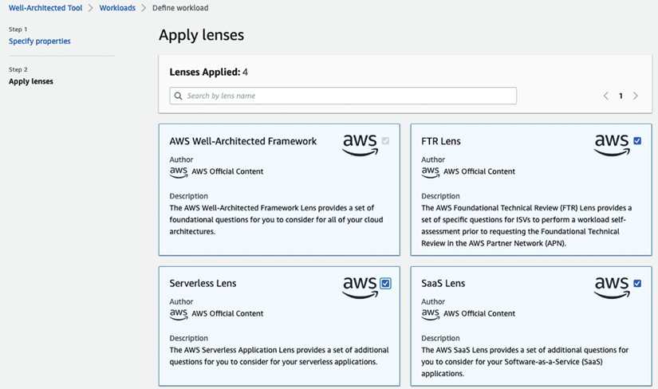

*Figure 2.8: AWS Well-Architected Lenses*

After applying a lens to your workload, you will get a best practice checklist specific to the domain; for example, the screenshot below shows a Well-Architected checklist for the Serverless Lens:

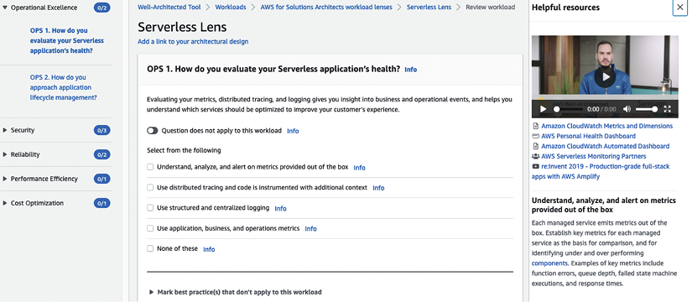

*Figure 2.9: AWS Well-Architected Serverless Lens*

As shown in the preceding screenshot, much like AWS’s WAR tool where you saw six pillars in the previous section, each lens has questions related to 5 key pillars to validate workloads and identify HRIs.

AWS users must constantly evaluate their systems to ensure that they follow the recommended principles of the AWS Well-Architected Framework and AWS Well-Architected Lenses and that they comply with and follow architecture best practices. As you must be getting more curious about AWS by now, let’s learn how to build your knowledge of the AWS cloud and establish yourself as a subject matter expert.

**Building credibility and getting certified**

It is hard to argue that the cloud is not an important technology shift. We have established that AWS is the clear market and thought leader in the cloud space.

Now, enterprises are eager to adopt cloud technologies because they do not want to fall behind their competition and become obsolete. Hopefully, by now, you are excited to learn more about AWS and other cloud providers, or at the very least, you’re getting a little nervous and have a little FOMO yourself.

We will devote the rest of this chapter to showing you the path of least resistance for becoming an AWS guru and someone who can bill themselves as an AWS expert. As with other technologies, it is hard to become an expert without hands-on experience, and it’s hard to get hands-on experience if you can’t demonstrate that you’re an expert. The best method, in my opinion, to crack this chicken-and-egg problem is to get certified.

Fortunately, AWS offers a wide array of certifications to demonstrate deep AWS knowledge and expertise to potential clients and employers. As AWS creates more and more services, they continue to offer new certificates aligned with these new services. The following are the available AWS certification listed on the AWS website as of April 2022.

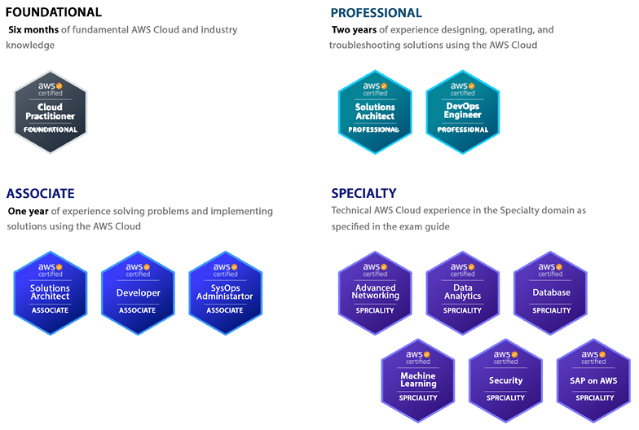

*Figure 2.10: AWS certifications*

In the screenshot above, you can see that AWS has certifications for everyone. If you are starting out or working in a non-tech domain, it’s better to go for foundational certifications. To gain further knowledge, you can choose associated certifications and become an expert by gaining specialist and professional certifications.

AWS continuously updates existing certification exams to accommodate all new services and feature launches. Let’s review the available certifications and how they fit into your career aspirations to enhance your current skills in the cloud.

**Building a non-tech AWS cloud career**

You may see working with the cloud as a very tech-savvy job. However, that is not always the case. Several cloud roles don’t require deep technical knowledge; just a basic understanding will get your foot in the door to start a cloud career. For example, anyone from a sales and marketing background can thrive in cloud marketing, cloud business development, or a cloud sales role without deep technical knowledge. Similarly, program managers are required in any industry where basic cloud knowledge will help you get started in the role. However, it’s recommended to build cloud foundation knowledge to prepare yourself better, which you can gain from an AWS Certified Cloud Practitioner certification. Let’s look into more details.

**AWS Certified Cloud Practitioner – Foundational**

This is the most basic certification offered by AWS. It is meant to demonstrate a broad-stroke understanding of the core services and foundational knowledge of AWS. It is also a good certification for non-technical people that need to be able to communicate using the AWS lingo but are not necessarily going to be configuring or developing in AWS. This certification is ideal for demonstrating a basic understanding of AWS technologies for people such as salespeople, business analysts, marketing associates, executives, and project managers.

**The AWS Solutions Architect path**

Solutions architect is one of the most sought-after roles in the cloud industry. Often, solutions architects carry the responsibilities of designing a workload in the cloud and applying architecture best practices using the AWS Well-Architected Framework. The following AWS certifications can help you kick-start your career as an AWS cloud solutions architect.

**AWS Certified Solutions Architect – Associate**

**IMPORTANT NOTE**: On August 31**st**, 2022, a new version of the AWS Certified Solutions Architect - Associate exam became available.

This is the most popular certification offered by AWS. Many technically minded developers, architects, and administrators skip taking the Cloud Practitioner certification and start by taking this certification instead. If you are looking to demonstrate technical expertise in AWS, obtaining this certification is a good start and the bare minimum to demonstrate AWS proficiency. However, to demonstrate proficiency in architecting IT workloads in the AWS cloud, you should pursue the Solutions Architect – Professional certification as mentioned below.

**AWS Certified Solutions Architect – Professional**

This certification is one of the toughest to get and at least five to six times harder than the Associate-level certification. Earning this certification will demonstrate to employers that you have a deep and thorough understanding of AWS services, best practices, and optimal architectures based on the particular business requirements for a given project. Obtaining this certification shows potential employers that you are an expert in designing and creating distributed systems and applications on the AWS platform. It used to be that having at least one of the Associate-level certifications was a prerequisite to sitting for the Professional-level certifications, but AWS has eliminated that requirement.

You can refer to *Solution Architect’s Handbook 2****nd****Edition* available on Amazon (<https://www.amazon.com/gp/product/1801816611>), for more details on the AWS solutions architect role and to gain in-depth knowledge of building use-case-focused architecture on the AWS platform.

DevOps is one of the key components for operationalizing any workload. Let’s learn more about the DevOps path in AWS.

**The AWS Cloud DevOps Engineer path**

DevOps is a critical engineering function that makes a development team more agile by automating the deployment pipeline. Automation is key to adopting the cloud and using its full potential, where a DevOps engineer plays an essential role. Gaining the AWS certification can help you navigate the DevOps path with AWS.

**AWS Certified SysOps Administrator – Associate**

This certification will demonstrate to potential employers and clients that you have experience deploying, configuring, scaling up, managing, and migrating applications using AWS services. You should expect the difficulty level of this certification to be a little bit higher than the other Associate-level certifications, but also expect quite a bit of overlap in the type of questions that will be asked with this certification and the other Associate-level certifications.

**AWS Certified DevOps Engineer – Professional**

This advanced AWS certification validates knowledge on how to provision, manage, scale, and secure AWS resources and services. This certification will demonstrate to potential employers that you can run their DevOps operations and proficiently develop solutions and applications in AWS. This certification is more challenging than any Associate certification but easier than the AWS Solutions Architect Professional certification.

**The AWS Cloud Developer path**

Developers are central to any IT application. They are builders who bring life to ideas, making developers vital in the cloud. However, software developers are more focused on programming languages and algorithms but build software in the cloud; they need to be aware of various development tools that cloud providers facilitate. The following is the certification to gain the required cloud knowledge for building software in AWS.

**AWS Certified Developer – Associate**

Obtaining this certification will demonstrate your ability to design, develop, and deploy applications in AWS. Even though this is a developer certification, do not expect coding in any questions during the exam. However, knowing at least one programming language supported by AWS will help you achieve this certification. Expect to see many of the same concepts and similar questions to what you would see in the Solutions Architect certification. AWS doesn’t have any professional certification for developers, but it is recommended to pursue AWS DevOps Engineer certifications to scale and operationalize your software application in the cloud.

While we have talked about the generalist career path in the cloud, several specialty paths are available where AWS has certifications to validate your knowledge. Let’s look into the AWS certifications overview if you have expertise in a specific area.

**The AWS Specialty Solutions Architect path**

While generalist solutions architects design overall workloads, they need to dive deep into certain areas where more in-depth knowledge is required. In that case, specialist solutions architects come to the rescue; they provide their expertise to apply best practices for a specific domain such as security, networking, analytics, ML, etc. You have seen in the Well-Architected tool sections that AWS has domain-specific lenses to optimize specialty workloads and engage specialist solutions architects. The following are AWS certifications to validate your specialty knowledge in the AWS cloud.

**AWS Certified Advanced Networking – Specialty**

This AWS specialty certification demonstrates that you possess the skills to design and deploy AWS services as part of a comprehensive network architecture and the know-how to scale using best practices. This is one of the hardest certifications to obtain, like AWS Certified Solutions Architect – Professional. To pass the networking specialty exam, you have to put in additional effort.

For most exams, you go through online courses on famous learning platforms such as A Cloud Guru/Udemy and take practice exams before attending the actual exam. But for the networking specialty certification, that will not be enough. You need to go through other resources such as AWS whitepapers, blogs, and AWS re:Invent videos and take notes. You must review multiple resources until you are clear about concepts and keep revising your notes. We will discuss learning resources in more detail later in this chapter, under the *Learning tips and tricks for obtaining AWS certifications* section.

**AWS Certified Security – Specialty**

Possessing the AWS Certified Security – Specialty certification demonstrates to potential employers that you are well versed in AWS and the ins and outs of AWS security. It shows that you know security best practices for encryption at rest, encryption in transit, user authentication and authorization, and penetration testing, and are generally able to deploy AWS services and applications in a secure manner that aligns with your business requirements.

**AWS Certified Machine Learning – Specialty**

This is an excellent certification to have in your pocket if you are a data scientist or a data analyst. It shows potential employers that you are familiar with many of the core ML concepts and the AWS services that can be used to deliver ML and artificial intelligence projects.

**AWS Certified Database – Specialty**

Having this certification under your belt demonstrates to potential employers your mastery of the persistence services in AWS and your deep knowledge of the best practices needed to manage them. Some of the services tested are these:

* Amazon RDS
* Amazon Aurora
* Amazon Neptune
* Amazon DynamoDB
* Amazon QLDB
* Amazon DocumentDB

**AWS Certified Data Analytics – Specialty**

Completing this certification demonstrates to employers that you have a good understanding of the concepts needed to perform data analysis on petabyte-scale datasets. This certification shows your ability to design, implement, and deploy analytics solutions that deliver insights by enabling data visualization and implementing the appropriate security measures.

**AWS Certified SAP – Specialty**

SAP specialty is a new certification exam that became available starting in April 2022. The AWS SAP specialty certification is for SAP professionals to demonstrate their knowledge of the AWS cloud. It shows your ability to implement, migrate, and support SAP workloads in AWS using AWS’s Well-Architected Framework.

While AWS continues to add new certifications to validate your cloud skills, they also retire old certifications that are not relevant over time; for example, AWS had a Big Data Specialty certification, which checked your knowledge of databases, ML, and analytics. Over time, as the use of databases and AI/ML increased, AWS launched separate certifications called AWS Database – Specialty and AWS Machine Learning – Specialty. In April 2020, AWS deprecated the Big Data – Specialty certification and renamed it the AWS Analytics – Specialty certification to focus just on data analytics services. Similarly, AWS retired the AWS Certified Alexa Skill Builder – Specialty exam on March 23, 2021.

Let’s learn some tips and tricks for obtaining AWS certifications.

**Learning tips and tricks for obtaining AWS certifications**

Now that we have learned about the various certifications offered by AWS, let’s learn about some of the strategies we can use to get these certifications with the least amount of work possible, and what we can expect as we prepare for these certifications.

**Focus on one cloud provider**

Some enterprises are trying to adopt a cloud-agnostic or multi-cloud strategy. The idea behind this strategy is not to depend on only one cloud provider. In theory, this seems like a good idea, and some companies such as Databricks, Snowflake, and Cloudera offer their wares to be run using the most popular cloud providers.

However, this agnosticism comes with some difficult choices. One way to implement this strategy is to choose the least common denominator, for example, only using compute instances so that workloads can be deployed on various cloud platforms. Implementing this approach means that you cannot use the more advanced services offered by cloud providers. For example, using AWS Lambda in a cloud-agnostic fashion is quite tricky.

Another way that a multi-cloud strategy can be implemented is by using more advanced services, but this means that your staff will have to know how to use these services for all the cloud providers you decide to use. You will be a *jack of all trades and a master of none*, to use the common refrain.

Similarly, it isn’t easy to be a cloud expert across vendors individually. It is recommended to pick one cloud provider and try to become an expert on that one stack. AWS, Azure, and GCP, to name the most popular options, offer an immense amount of services that continuously change and get enhanced, and they keep adding more services. Keeping up with one of these providers is not an easy task. Keeping up with all three, in my opinion, is close to impossible. Pick one and dominate it.

**Focus on the Associate-level certifications**

As we mentioned before, there’s quite a bit of overlap between the Associate-level certifications. In addition, the jump in difficulty between the Associate-level certificates and the Professional-level ones is quite steep.

It’s highly recommended to sit for at least two, if not all three, of the Associate-level certifications before attempting the Professional-level certifications. Not only will this method prepare you for the Professional certifications but having multiple Associate certifications will also make you stand out against others that only have one Associate-level certificate.

**Get experience wherever you can**

AWS recommends having one year of experience before taking the Associate-level certifications and two years of experience before sitting for the Professional-level certifications. This may seem like a *catch-22* situation. How can you get experience if you are not certified? However, it’s a recommendation and not a mandatory requirement. This means that you can gain experience in training and study for the exam. You can do your project using an AWS Free Tier account with a pretty decent number of services available in the first year, and you can gain good hands-on experience.

**The best way to get certified**

Before we get to the best way to get certified, let’s look at the worst way. Amazon offers extremely comprehensive documentation. You can find this documentation here: <https://docs.aws.amazon.com/>.

AWS docs are a great place to help you troubleshoot issues you may encounter when you are directly working with AWS services or perhaps to size the services you will be using correctly. However, they are not a good place to study for exams. It will get overwhelming quickly, and much of the material you will learn about will not be covered in the exams.

The better way to get certified is to use the training materials that AWS specifically provides for certification, starting with the roadmaps of what will be covered in each certification. These roadmaps are a good first step toward understanding the scope of each exam.

You can begin to learn about all these roadmaps, or learning paths, as AWS likes to call them, here: <https://aws.amazon.com/training/learning-paths/>.

You will find free online courses and paid intensive training sessions for these learning paths. While the paid classes may be helpful, they are not mandatory for you to pass the exam.

Before you look at the learning paths, the first place to find out the scope of each certification is the study guides available for each certification. In these study guides, you will learn at a high level what will and what won’t be covered for each exam. For example, the study guide for the AWS Cloud Practitioner Certification can be found here: <https://d1.awsstatic.com/training-and-certification/docs-cloud-practitioner/AWS-Certified-Cloud-Practitioner_Exam-Guide.pdf>.

Now, while the training provided by AWS may be sufficient to pass the exams, and I know plenty of folks that have passed the certifications using only those resources, there are plenty of third-party companies that specialize in training people with a special focus on the certifications. The choices are almost endless. Let’s look at a few more resources here.

**Getting started in AWS**

AWS launched the Skill Builder portal (<https://explore.skillbuilder.aws/>), which enhances AWS’s training portal.

AWS Skill Builder has thousands of self-paced digital training sessions and learning paths, as shown below.

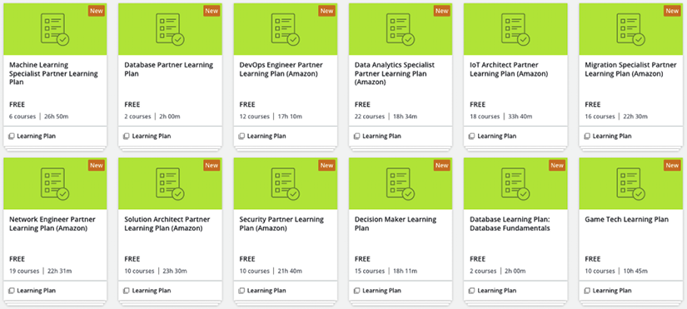

*Figure 2.11: AWS Skill Builder learning paths*

You can pick any learning path you need and explore related digital courses. If you want classroom training, that is available in the AWS training portal; however, it may come with a price. AWS provides free cloud practitioner training in its Skills Center, where you can register and get instructor-led training for free. AWS has also opened its first free training center located in Seattle and is planning to expand in the coming months. If you have Skills Centers where you are, you can benefit by registering on the AWS website directly: <https://aws.amazon.com/training/skills-centers/>.

**Online courses**

In addition to the courses provided by AWS, other training organizations and independent content creators provide excellent courses for obtaining AWS certifications.

**A Cloud Guru**

A Cloud Guru has been around since 2015, which is a long time in cloud years. A Cloud Guru has courses for most of the AWS certifications. They have a few other courses unrelated to certifications that are also quite good. Linux Academy used to be another good resource to use to prepare for a certification exam, but that got acquired by A Cloud Guru, which means now you can access the best of these in one place.

They used to charge by the course, but a few years back, they changed their model to a monthly subscription, and signing up for it gives you access to the whole site. The training can be accessed here: <https://acloud.guru/>.

**Udemy courses**

Several independent content creators on Udemy, such as Stephane Maarek and Jon Bonso, have excellent content and are passionate about AWS, with a growing following. For example, as of April 2022, Stephane Maarek’s Solution Architect Associate course has over half a million students with over 120,000 ratings and a satisfaction rating of 4.7 stars out of 5.

The pricing model used is also similar to Whizlabs. The practice exams are sold separately from the online courses. You can choose the pricing, from a monthly subscription to a course fee, depending on your strategy, such as if you want to get an individual certification or target multiple/all AWS certifications.

You can also explore other training providers such as Cloud Academy and Coursera. However, you don’t need to sign up for multiple course providers.

**YouTube videos**

As always, YouTube is an excellent source of free learning. AWS has its own YouTube channel with nearly 600,000 subscribers and 14,000 videos. These videos cover AWS services by AWS product managers and solutions architects. AWS uploads all re:Invent and summit videos on the YouTube channel, the best resources to dive deep into any services. You can find several playlists people have created to prepare for certifications.

**Books**

If you are a book reader, there are multiple AWS certification-related books available on Amazon, which you can refer to prepare for the exam. If you are preparing for the AWS Solutions Architect – Professional exam and are solidifying concepts, refer to *Solution Architect’s Handbook* (<https://www.amazon.com/gp/product/1801816611>). It explains multiple architectural patterns using the AWS platform and goes deep into using each of the Well-Architected pillars to apply architectural best practices.

**Practice exam websites**

It doesn’t matter how much you are reading or how many courses you watch, there are always knowledge gaps, and practice exams are the best sources to identify and focus on weak areas. Let’s look at some practice exam resources.

**AWS practice question sets**

AWS recently launched practice question sets for all the certifications in their Skill Builder portal. These are the AWS certification official practice question sets featuring 20 questions developed by AWS to demonstrate the style of AWS certification exams. These exam-style questions include detailed feedback and recommended resources to help you prepare for your exam. It is an excellent source to understand exam patterns and difficulty levels.

The following is a sample list, which you can access using the link <https://explore.skillbuilder.aws/learn> and select the filter **Exam Preparation** under **Training Category**.

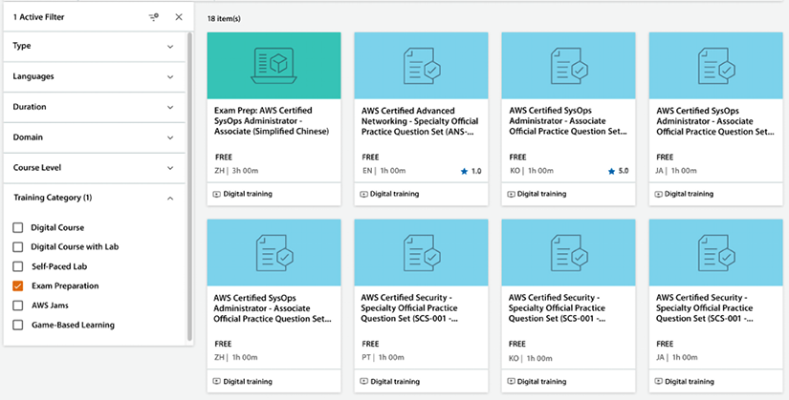

*Figure 2.12: AWS certification practice question sets*

There are free practice exams available for almost all available certifications. Let’s look at more third-party resources for more practice exam choices.

**Whizlabs**

Whizlabs (<https://www.whizlabs.com/>) is suitable for Associate-level certification and testing your knowledge in multiple areas to find weak points. Whizlabs also provides answers with detailed explanations and associated resources that can help you fill any knowledge gaps by exploring related content against questions you got wrong.

Whizlabs divides the charges for their training between their online courses and their practice tests. One disadvantage of Whizlabs is that, unlike the exam simulator with A Cloud Guru, where they have a bank of questions and randomly combine them, the Whizlabs exam questions are fixed and cannot be shuffled to create a different exam.

They also have a free version of their practice exams for most certifications, with 20 free questions.

**BrainCert**

Like Whizlabs, you can use BrainCert for AWS Professional and Specialty level certification ([https://www.braincert.com](https://www.braincert.com/)). They have a perfect set of questions that are similar to the exam’s difficulty level with detailed explanations for each answer. While Whizlabs practice exams have lifetime validity, BrainCert provides only one-year validity.

**Tutorials Dojo**

Tutorials Dojo is another good practice exam website you can access by visiting <https://tutorialsdojo.com/>. It has recently received great reviews from the cert community and has good-quality questions for AWS Specialty certification exams.

The same strategy as mentioned before can be used with Whizlabs or BrainCert. You don’t need to sign up for multiple vendors for the more straightforward exams, but you can combine a couple for the harder exams.

**Certification preparation approach**

Video courses such as Udemy and A Cloud Guru are used the most to prepare for certifications. The following is the recommendation for tackling the training:

* Unless you have previous experience with the covered topics, watch all the training videos at least once. If it’s a topic you feel comfortable with, you can play the videos at a higher speed, and then you will be able to watch the full video faster.
* For video lessons that you find difficult, watch them again. You don’t have to watch all the videos again – only the ones that you found difficult.
* Make notes of topics that seem to be pretty new to you. Writing notes always clears your thoughts.
* Make sure to take any end-of-section quizzes, wherever available.
* Once you finish watching the videos, the next step is to attempt some practice exams.

The above recommendation remains true if you are choosing books for your exam preparation, where you want to take notes and re-visit chapters where the topic is new to you.

Finally, keep taking practice exams until you feel confident and consistently correctly answer a high percentage of the questions (anywhere between 80% and 85%, depending on the certification).

The questions provided in the exam simulator will not be the same as the ones from the exam, but they will be of a similar difficulty level, and they will all be in the same domains and often about similar concepts and topics.

By using the exam simulator, you will achieve a couple of things. First, you will be able to gauge your progress and determine whether you are ready for the exam. I suggest you keep taking the exam simulator tests until you consistently score at least 85% or above. Most real certifications require you to answer 75% of the questions correctly, so consistently scoring a little higher should ensure that you pass the exam.

Some of the exams, such as the Security – Specialty exam, require a higher percentage of correct answers, so you should adjust accordingly. Using the exam simulator will also enable you to figure out which domains you are weak in. After taking a whole exam in the simulator, you will get a list detailing exactly which questions you got right and which were wrong, and they will all be classified by domain.

So, if you get a low score in a certain domain, you know that’s the domain that you need to focus on when you go back and review the videos again. Lastly, you will be able to learn new concepts by simply taking the tests in the exam simulator.

Now, let’s address some of the questions that frequently arise while preparing to take these certifications.

**Some frequently asked questions about the AWS certifications**

While preparing for certifications, you may have several questions, like where to start and how to finish. The following sections will list frequently asked questions that often come to mind.

**How long will it take to get certified?**

A question frequently asked is how many months you should study for before sitting down for the exam. Look at that in terms of hours instead of months.

As you can imagine, you will be able to take the exam a lot sooner if you study for 2 hours every day instead of only studying for 1 hour a week. If you decide to take some AWS-sponsored intensive full-day or multi-day training, that may go a long way toward shortening the cycle.

One way to optimize your time is instead of watching videos, you can listen to them in the car or while on the train going into the city. Even though watching them is much more beneficial, you can still embed key concepts while listening to them, and that time would have been dead time anyway.

You don’t want to space out the time between study sessions too much. If you do that, you may find yourself in a situation where you start forgetting what you have learned. The number of hours it will take you will also depend on your previous experience. If you are working with AWS for your day job, that will shorten the number of hours needed to complete your studies.

The following subsections will give you an idea of the amount of time you should spend preparing for each exam.

**The Cloud Practitioner certification**

Preparing for this certification typically takes between 15 and 25 hours. Achieving this credential will help you develop skills and acquire critical knowledge related to implementing cloud initiatives. By earning the AWS Certified Cloud Practitioner certification, you can demonstrate your fluency with the cloud and validate your foundational knowledge of AWS.

**Associate-level certifications**

If you don’t have previous AWS experience, plan to spend between 70 and 100 hours preparing. Also, keep in mind that there is considerable overlap between the other certifications once you pass one of the Associate certifications. It will not take another 70 to 100 hours to obtain the second and third certifications. As mentioned in this chapter, it is highly recommended to take the two other Associate-level certifications soon after passing the first one.

Expect to spend another 20 to 40 hours studying for the two remaining certifications if you don’t wait too long to take them after passing the first one.

**Professional-level certifications**

There is quite a leap between the Associate-level certifications and the Professional-level certifications. The domain coverage will be similar, but you will need to know how to use the AWS services covered in much more depth, and the questions will certainly be harder. Assuming you took at least one of the Associate-level certifications, expect to spend another 70 to 100 hours watching videos, reading, and taking practice tests to pass this exam.

AWS removed the requirement of having to take the Associate-level certifications before being able to sit for the Professional-level certifications. However, it is still probably a good idea to take at least some Associate exams before taking the Professional-level exams.

As is the case with the Associate-level exams, once you pass one of the Professional-level exams, it should take much less study time to prepare for another Professional exam as long as you don’t wait too long to take the second exam and forget everything.

**Specialty certifications**

I am lumping all the Specialty certifications under one subheading, but there is significant variability in the difficulty level between all the Specialty certifications. If you have a background in networking, you will be more comfortable with the Advanced Networking certification than with the Data Science certification.

When it comes to these certifications, you may be better off focusing on your area of expertise unless you are collecting all certifications. For example, if you are a data scientist, the Machine Learning – Specialty certification and Analytics certification may be your best bet.

Depending on your experience, expect to spend about these amounts of time:

* Security – Specialty – 40 to 60 hours
* SAP – Specialty – 40 to 60 hours
* Machine Learning – Specialty – 50 to 70 hours
* Data Analytics – Specialty– 40 to 60 hours
* Database – Specialty – 30 to 50 hours
* Advanced Networking – Specialty – 50 to 70 hours

**How to request additional exam time**

An additional 30 minutes can make a lot of difference between passing and failing exams, especially when sitting for more challenging exams such as AWS Professional and Specialty certifications. An essential tip for **non-native English speakers** is that you can request an extra 30 minutes to complete the exam. Take the following steps to get an additional 30 minutes:

1. Click on the home page of your CertMetrics account: <https://www.certmetrics.com/amazon/>
2. On the right, click the **Request Exam Accommodations** button

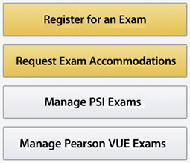

*Figure 2.13: Request Exam Accommodations button*

1. Click the **Request Accommodation** button
2. Select **ESL +30 Minutes** from the accommodation dropdown
3. Click **Create** and you will see the following approval request available under the **Exam Registration** tab

https://learning.oreilly.com/api/v2/epubs/urn:orm:book:9781803238951/files/Images/B18475_02_14.png

*Figure 2.14: Exam Registration tab*

Make sure to apply for the accommodation before scheduling your exam as it won’t be applicable to already scheduled exams. It’s a one-time activity and applies to all future exam registrations after getting approval.

**What are some last-minute tips for the day of the exam?**

AWS offers two exam modes: remote and on-site at an AWS authorized exam center. When taking an AWS certification exam at a testing center, the on-site staff will help with check-in, exam access on test center computers, and will answer any questions. On the other hand, with online exam proctoring, you can take the same exam with the same allotted time as you would in a testing center, but on your own computer. During the exam, a proctor will remotely monitor your progress.

A decent half marathon time is about 90 minutes, which is how long you get to take the Associate-level exams, and a good marathon time is about 3 hours, which is how long you get to take the Professional-level exams.

Keeping focus for that amount of time is not easy. For that reason, you should be well rested when you take the exam. It is highly recommended to take the exam on a day when you don’t have too many other responsibilities; I would not take it after working a full day. You will be too burned out.

Make sure you have a light meal before the exam – enough so that you are not hungry during the test and feel energetic, but not so much that you feel sleepy from digesting all that food.

Just as you wouldn’t want to get out of the gate too fast or too slow in a race, keep pace yourself during the exam. You also don’t want to be beholden to the clock, checking it constantly. The clock will always appear in the top-right part of the exam, but you want to avoid looking at it most of the time. I recommend writing down on the three sheets you will receive where you should be after every 20 questions and checking the clock against these numbers only when you have answered 20 questions. This way, you will be able to adjust if you are going too fast or too slow, but you will not spend excessive time watching the clock.

The above is just a recommendation, however; everyone has their own strategy which you can build when practicing the exam. Apply whatever strategy best fits your style. Let’s now summarize what we have learned in this chapter.

**Summary**

This chapter pieced together many of the technologies, best practices, and AWS services covered in the book. We weaved it all together into AWS’s Well-Architected Framework, which you should be able to leverage and use for your projects.

You learned about AWS’s Well-Architected Framework and how to use the AWS Well-Architected tool to validate your architecture against AWS-provided best practices. All workloads are not the same, and you learned about AWS’s Well-Architected Lenses focusing on specific workloads.

After reviewing the architecture best practices, you have hopefully convinced yourself to hop aboard the cloud train. One of the easiest ways to build credibility is to get certified. We learned that AWS offers 12 certifications. We learned that the most basic one is AWS Cloud Practitioner and that the most advanced certifications are the Professional-level certifications. In addition, as of 2022, we learned that there are six Specialty certifications for various domains. We also covered some of the best and worst ways to obtain these certifications.

Finally, we hope you are now curious enough to potentially get at least some of AWS’s certifications. I hope you are excited about the possibilities that AWS can bring.

The next chapter will cover how the AWS infrastructure is organized and how you can leverage the cloud to drive digital transformation initiatives.