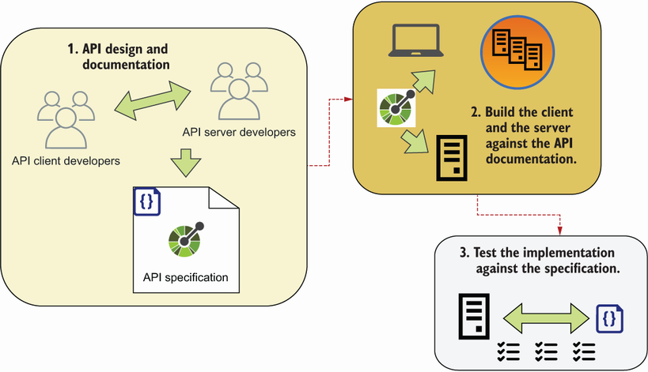

Documentation-driven development is an API-first development method in which you design and document the API first; then, you build the API server and the API client against the documentation; and finally, you use the API documentation to validate the server and client implementations. Documentation-driven development helps you reduce the chances of API integration failure, and it gives you more control and visibility of integration errors.

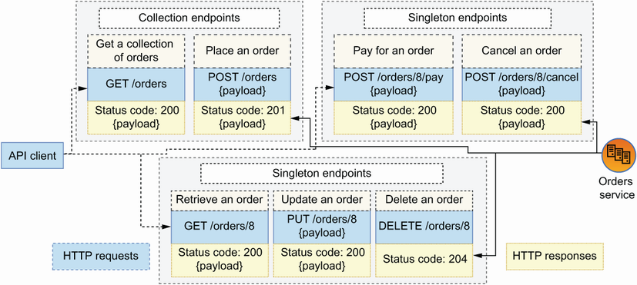

REST APIs are structured around endpoints. We distinguish between singleton endpoints, such as GET /orders/8, and collection endpoints, such as GET /orders. REST APIs leverage the semantics of HTTP methods to indicate actions (such as POST to create resources), and they use HTTP status codes that signal the result of processing the request (such as 200 for successful responses).