1. *Write a program to print Twin prime number less than 1000. If two consecutive odd numbers are both prime then they are known as twin primes*.

**CODE :-**

def is_prime(num):

    for i in range(3, int(num ** 0.5) + 1, 2):

        if num % i == 0:

            return False

    return True

for i in range(3, 1000, 2):

    if is_prime(i) and is_prime(i + 2):

        print(i,",", i + 2," is twin prime number")

**OUTPUT**

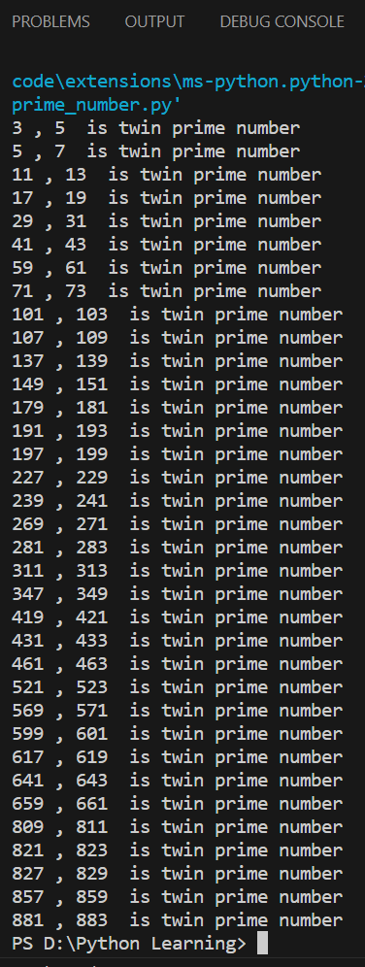

1. Write a program to implement formule of Permutation and Combination.

**Permutation Code:**

n = 5

r = 3

def permutation(n, r):

    if n < r:

        return 0

    result = 1

    for i in range(n, n - r, -1):

        result *= i

    return result

permutations = permutation(n, r)

print(f"{n}P{r}={permutations}")

**Combinations Code:**

n = 5

r = 3

def combination(n, r):

    if n < r:

        return 0  #

    result = 1

    for i in range(1, r + 1):

        result *= (n - i + 1)

        result //= i

    return result

combinations = combination(n, r)

print(f"{n}C{r}={combinations}")

**OUTPUT Permutation:**

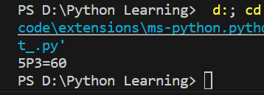

**OUTPUT Combination:**

