- Do not edit/delete any heading or section with
red text.
- Type /paste you answers in relevant sections (below Final Answer (in all questions , Approach (wherever required ) and Charts & tables (wherever required)) of the solution
- Link to submission guidelines
- Please note that submission not following the guidelines will not be accepted

OBJECTIVE QUESTIONS

Question 1: What is the total no. of attributes present in the data?
Solution:

Final Answer (if any):
The raw Tickets sheet has 10 attributes (ID Ticket, Fecha, Employee ID, Agent ID, Request Category, Issue Type, Severity, Priority, Resolution Time (Days), Satisfaction Rate). The IT Agents reference sheet has 6 attributes (Agent ID, Full Name, Email, Year/Month/Day of Birth).
So, there are total of 16 attributes.

Approach (if any):
Counted the header row of the Tickets and IT Agents sheets directly

Charts & Tables (if any):
- Table / Chart Name:
Cleaned Data sheet (header row)
- Description:
The Cleaned Data sheet header row lists all 19 columns used across the objective and subjective analysis.

Question 2: Which columns have inconsistent or missing values, and what is the count of such values?
Solution:

Final Answer (if any):
No blank/null cells exist in either sheet, but four columns contained inconsistent category labels or malformed names, totaling 34,606 affected ticket rows and 15 affected agent records

Approach (if any):

Used COUNTIF/COUNTIFS on each column to check for blanks, then reviewed the distinct values in Severity, Priority, and Full Name using pivot tables, cross-checking Full Name against the Email column's firstname. lastname convention to detect naming inconsistencies. Corrected all issues directly in the Cleaned Data and IT Agents sheets.

Charts & Tables (if any):
- Table / Chart Name:
Cleaned Data sheet + IT Agents sheet (before/after cleaning)
- Description:
Summary table below shows each inconsistency found, the fix applied, and the affected row/record count.
Column | Issue Found | Fix Applied | Affected Rows/Records
Severity | "0 - Unclasified" (misspelled) | -> "0 - Unclassified" | 356
Severity | "3 - Mayor" (should be "Major") | -> "3 - Major" | 4,836
Priority | "0 - Unassiged" (misspelled) | -> "0 - Unassigned" | 29,410
IT Agents.Full Name | Reversed order (6), abbreviated initial (3), missing space  (2), missing last  name (2) | Corrected via cross-check against Email address | 15 of 50 agents

Question 3: What is the average daily ticket volume over time?
Solution:

Final Answer (if any):
53.37 tickets per day on average across the full 2016-2020 period (97,498 tickets over 1,827 days).

Approach (if any):
Used this formula to get the result.
=ROUND(GETPIVOTDATA("ID Ticket",$A$11)/COUNTA(A12:$A$1838),2)

Charts & Tables (if any):
- Table / Chart Name:
  - I Objective sheet – “Ticket Volume Trend" line chart

Ticket Volume Trend
8600
8400
8200
8000
7800
7600
7400
7200
7000
6800
6600
Total
Jan Feb Mar Apr May Jun Jul Aug Sep Oct Nov Dec

Question 4: What is the distribution of ticket categories (e.g., Login Access, System, Software)?
Solution:

Final Answer (if any):
System 39,002 (40.0%), Login Access 29,193 (29.9%), Software 19,570 (20.1%),
Hardware 9,733 (10.0%).

Approach (if any):
Pivot table with Request Category as rows and Count of ID Ticket as the value field, visualized with a pie chart.

Charts & Tables (if any):
- Table / Chart Name:
  - I Objective sheet - "Ticket Category Distribution" pie chart
- Description:
Share of total ticket volume by request category; System and Login Access together account for ~70% of all tickets.

Ticket Category Distribution

Hardware Login Access Software System

Question 5: How many tickets has each agent handled? Solution:

Final Answer (if any):
Each of the 50 agents handled between 1,856 and 2,027 tickets, averaging 1,950 tickets per agent - a very even distribution.

Approach (if any):
Pivot table with Agent Name (via the Cleaned Data lookup column) as rows and Count of ID Ticket as the value field, sorted descending and charted as a bar chart.

Charts & Tables (if any):
- Table / Chart Name:
  - I Objective sheet - "Tickets Handled per Agent" bar chart
- Description:
Ticket count per agent, sorted highest to lowest; the narrow spread (1,856-2,027) shows workload is already balanced fairly evenly across the team.

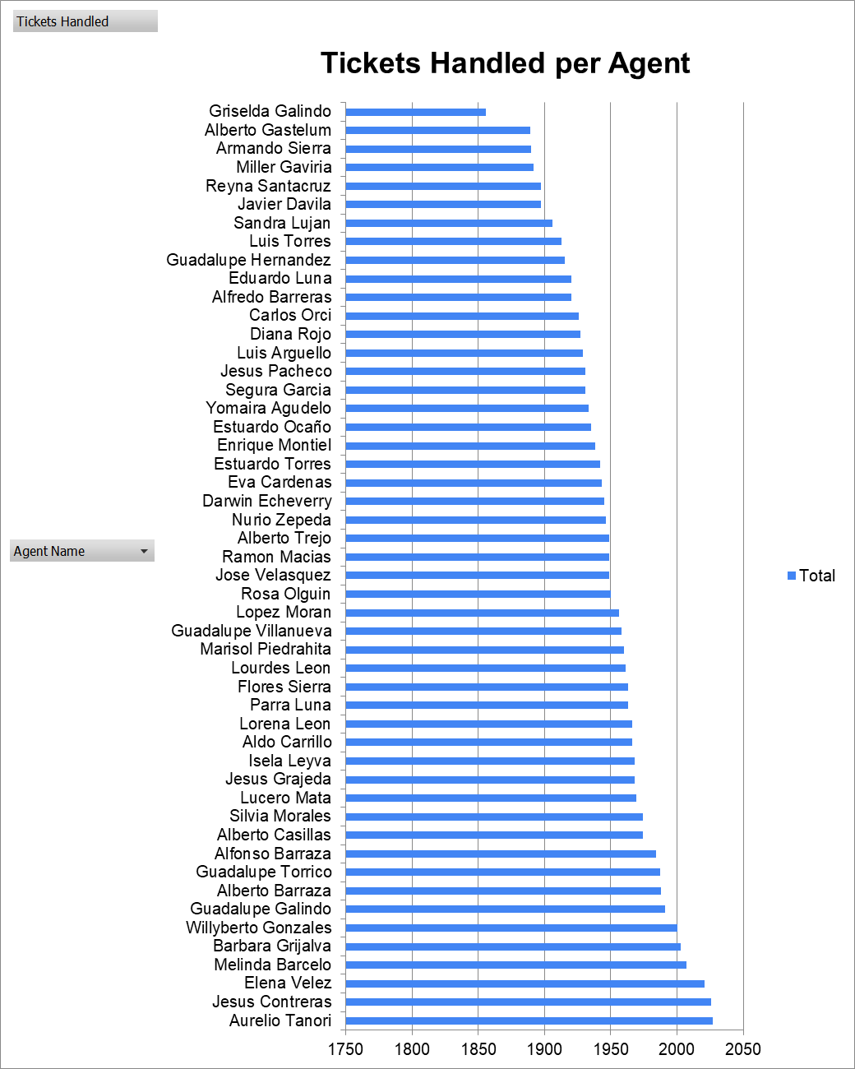

Question 6: How can you extract the domain from the email addresses in the IT Agents sheet?
Solution:

Final Answer (if any):
All 50 agents share a single email domain: fp20analytics.

Approach (if any):
Formula Used (=LEFT(
RIGHT(C2,LEN(C2)-FIND("@",C2)),
FIND(".",RIGHT(C2,LEN(C2)-FIND("@",C2)))-1
))

Charts & Tables (if any):
- Table / Chart Name:
IT Agents sheet, column G (Email Domain)
- Description:
Domain extraction formula applied to all 50 agent email addresses; every agent resolves to the same corporate domain.

Question 7: How can you find the full name of an agent given their Agent ID?
Solution:

Final Answer (if any):
=INDEX('IT Agents'!$B:$B,MATCH(D2,'IT Agents'!$A:$A,0)) - implemented as the "Agent Name" column (K) in Cleaned Data, e.g. Agent ID 4 -> "Barraza Alberto".

Approach (if any):
INDEX/MATCH lookup: MATCH locates the row where the Agent ID in the Tickets data equals the Agent ID in the IT Agents sheet, and INDEX returns the corresponding Full Name from that row. Applied to all 97,498 ticket rows so every ticket carries its agent's name.

Charts & Tables (if any):
- Table / Chart Name:
Cleaned Data sheet, column K (Agent Name)
- Description:
Sample lookups: Agent ID 1 -> Lucero Mata, Agent ID 4 -> Alberto Barraza, Agent ID 22 -> Lorena Leon.

Question 8: What is the count of each issue type (e.g., IT Error, IT Request)?
Solution:

Final Answer (if any):
IT Request: 73,220 (75.1%); IT Error: 24,278 (24.9%).

Approach (if any):
Pivot table with Issue Type as rows and Count of ID Ticket as the value field, visualized with a pie chart.

Charts & Tables (if any):
- Table / Chart Name:
  - I Objective sheet - "Issue Type Distribution" pie chart
- Description:
Three out of four tickets are routine requests rather than error reports, suggesting most support volume is provisioning/self-service work rather than break-fix work.
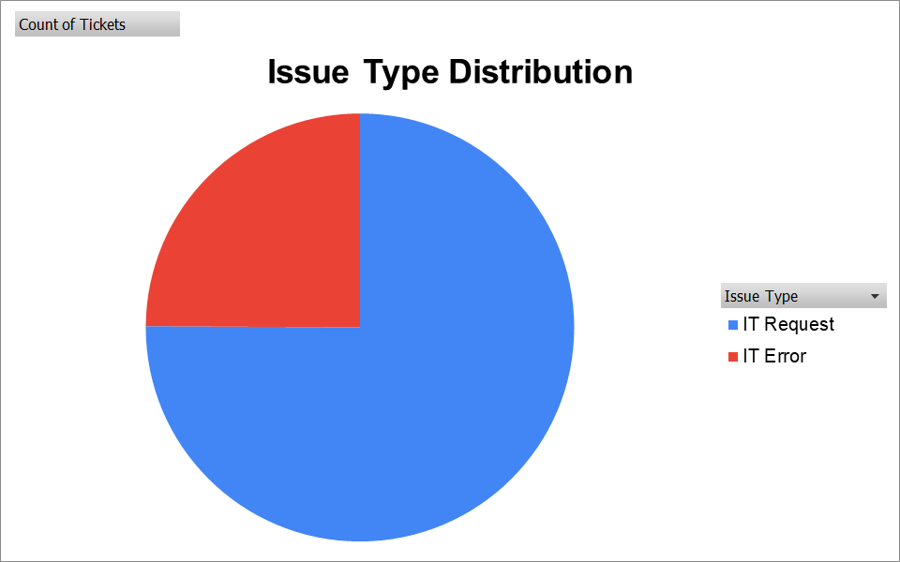

Question 9: What is the average resolution time for tickets?
Solution:

Final Answer (if any):
4.55 days overall, but this hides large variation by category: Hardware 7.63 days, System 6.62 days, Software 5.24 days, Login Access just 0.31 days.

Approach (if any):
=AVERAGE('Cleaned Data'!I2:I97499) for the overall figure; a pivot table with Request Category as rows and Average of Resolution Time (Days) as the value field for the category breakdown, charted as a column chart.

Charts & Tables (if any):
- Table / Chart Name:
  - I Objective sheet - "Average Resolution Time by Category" column chart
- Description:
Average resolution time varies more than 24x between the fastest (Login Access) and slowest (Hardware) category.
Average Resolution Time by Category
9

8

7

6

5

4
Total
3

2

1

0
Hardware
System
Software
Login Access

Question 10: How has the volume of tickets changed over time?
Solution:

Final Answer (if any):
Ticket volume grew from 13,051 in 2016 to 29,088 in 2020 - a 122.9% increase over five years, with growth accelerating in 2019-2020.

Approach (if any):
Pivot table with Year as rows and Quarter as columns, Count of ID Ticket as the value field, charted as a line chart to show both the year-over-year trend and the quarterly pattern within each year.

Charts & Tables (if any):
- Table / Chart Name:
  - I Objective sheet - "Ticket Volume Trend by Year & Quarter" line chart
- Description:
Every year shows higher volume than the last, with 2020 Q4 (7,684 tickets) the single busiest quarter on record.


Ticket Volume Trend by Year & Quarter
9000
8000
7000
6000
5000
4000
3000
2000
1000
0
Qtr1 Qtr2 Qtr3
Qtr4
2016 2017 2018 2019 2020

Question 11: What is the average age of the IT agents? Solution:

Final Answer (if any):
35.4 years, with the team split fairly evenly across three age bands: 29-33 (12 agents), 34-38 (07 agents), 39-43 (10 agents), 44-48 (13 agents), 49-53 (6 agents), 54-58 (2 agents)

Approach (if any):
=AVERAGE('Cleaned Data'!$L:$L)

Charts & Tables (if any):
- Table / Chart Name:
  - I Objective sheet - "Agent Age Distribution" column chart
- Description:
Age distribution skews toward early-to-mid career agents, with the 30-39 band the largest single group.

Question 12: Is there a correlation between the severity of issues and the resolution time?
Solution:

Final Answer (if any):
Correlation coefficient = -0.0405 - essentially no linear relationship between severity and resolution time.

Approach (if any):
Severity mapped to a numeric "Severity Rank" (Unclassified=0, Minor=1, Normal=2, Major=3, Urgent=4) via a SWITCH formula, then =CORREL('Cleaned Data'!M2:M97499,'Cleaned Data'!I2:I97499). A supporting pivot table breaks down average resolution time by severity level.

Charts & Tables (if any):
- Table / Chart Name:
  - I Objective sheet - "Average Resolution Time by Severity" column chart
- Description:
Resolution time does not scale with severity - "Urgent" tickets actually resolve fastest (2.00 days) while "Normal" tickets take longest (4.66 days), implying severity tagging is not currently driving triage priority.
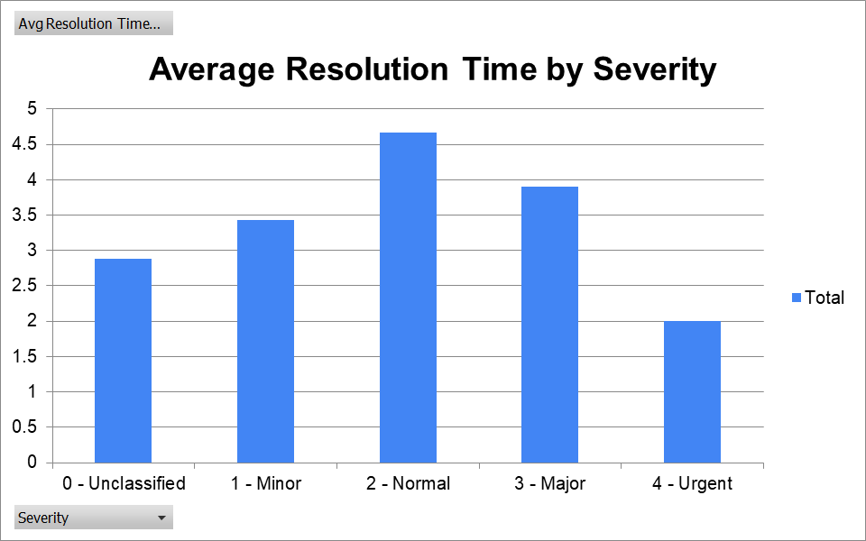

Question 13: How many categorical columns are there in the data? [Search about categorical and continuous data, and try to answer this question]
Solution:

Final Answer (if any):
13 categorical columns, 3 continuous/numeric columns (out of 6 total columns in IT Agents & 10 total columns in Tickets).

Approach (if any):
Categorical data describes a group/identity rather than a measurable quantity; continuous data is measurable and arithmetic operations (sum/average) are meaningful on it. ID-type numeric fields (Employee ID, Agent ID, Year) are treated as categorical since they are labels, not quantities.

Charts & Tables (if any):
- Table / Chart Name:
Cleaned Data sheet (column classification)
- Description:
Classification of all 16 columns into categorical vs. continuous types.
Categorical Columns | Continuous Columns
ID Ticket | Fecha
Employee ID | Resolution Time (Days)
Request Category | Satisfaction Rate
Issue Type
Agent ID
Severity
Priority
Full Name
Email
Year of Birth
Month of Birth
Day of Birth

SUBJECTIVE QUESTIONS

Question 1: If there is an investment, should it be used to hire more IT agents, improve training programs, or upgrade ticket management software?
Analysis: Perform a cost-benefit analysis using ticket resolution and satisfaction metrics.

Solution:

Approach:
Built a pivot table of Ticket Volume, Avg Resolution Time, and Avg Satisfaction by Agent Name (Q-1 I Subjective sheet) to compare the cost (time/volume) against the benefit (satisfaction) of each category, then compared category-level effort against the fixed 50-agent team.
Also Added an agent-level pivot showing ticket count, average resolution time, and average satisfaction per agent to test the link between speed and satisfaction.

Charts & Tables:
- Table / Chart Name:
  - I Subjective sheet - "Average Satisfaction by Category" chart + table
- Description:
Satisfaction is nearly identical across categories (4.09-4.11) despite resolution time ranging from 0.31 to 7.63 days.
AVG. SATISFACTION & RESOLUTION TIME TREND
Average of Resolution Time (Days)
Average of Satisfaction Rate
9
8
7
6
5
4
3
2
1
0
H A R D W A R E
L O G I N A C C E S S
S O F T W A R E
S Y S T E M

Insights:
Satisfaction shows almost no sensitivity to resolution speed - even Hardware, the slowest category at 7.63 days, scores the same ~4.10 satisfaction as instant-resolving Login Access. The same 50 agents absorbed a 123% ticket-volume increase (2016-2020) without resolution time degrading.

Recommendations:
Prioritize a ticket management software/diagnostic-tooling upgrade targeted at Hardware and System (the two slowest, highest-effort categories) - since satisfaction isn't resolution-time-driven, training should focus on communication/service quality rather than raw speed. Hold agent headcount steady and reassess after the tooling upgrade.

Question 2: Which agents need additional training based on their performance metrics?
Analysis: Identify agents with the lowest satisfaction ratings and longest resolution times.

Solution:

Approach:
Ranked all 50 agents by average satisfaction using AVERAGEIFS against Cleaned Data, then pulled the bottom 10 with SMALL/INDEX/MATCH alongside their average resolution time and ticket volume for context (Q-2 I Subjective sheet).

Charts & Tables:
- Table / Chart Name:
  - I Subjective sheet - "Bottom 10 Agents by Satisfaction" chart + table
- Description:
The 10 lowest-satisfaction agents (3.04-3.67) compared against their resolution time and ticket volume.

Insights:
Bottom 10 agents by Avg Satisfaction Rate
6
5
4
3
2
1
0
Alberto Alfonso Carlos Elena Guadalupe Jesus Lopez Lorena Nurio Sandra Trejo Barraza Orci Velez Villanueva Pacheco Moran Leon Zepeda Lujan
Average of Resolution Time (Days)
Average of Satisfaction Rate
Most of the bottom 10 (Alberto Trejo, Nurio Zepeda, Elena Velez, Lorena Leon) also show above-average resolution times (5.2-5.5 days vs. the 4.55-day team average), consistent with a speed-related training gap. Alfonso Barraza is the exception - his resolution time (5.00 days) is close to average, yet his satisfaction (3.04) is the lowest on the team, pointing to a non-speed issue rather than a workload problem.

Recommendations:
An agent should be recommended for additional training if they consistently show:
  - Higher-than-average resolution time.
  - Lower-than-average customer satisfaction.

Question 3: Do certain categories of requests have longer resolution times?
Analysis: Analyze the resolution times by request category.

Solution:

Approach:
Built a two-dimensional pivot table (Q-3 I Subjective sheet) with Request Category as rows and Priority as columns, Average Resolution Time as the value field, to see whether the priority tag actually predicts faster handling within each category.

Charts & Tables:

- Table / Chart Name:
  - I Subjective sheet - "Avg Resolution Time by Category & Priority" chart + table
- Description:
Average resolution time broken out by category and priority level.
Avg Resolution Time by Category
12

10

8

6

4
- - Unassigned
- - Low
- - Mid
- - High
2

0
Hardware
System
Software Login Access

Insights:
Yes - Hardware (7.63 days) and System (6.62 days) take far longer than Software (5.24 days) and especially Login Access (0.31 days). More notably, within every category, "Unassigned"/"Low" priority tickets consistently take LONGER than "High" priority ones (e.g. Hardware: 9.84 days Unassigned vs. 5.48 days High) - confirming that priority tagging, when applied, does drive faster handling.

Recommendations:
If categories like System and Hardware consistently have the highest average resolution times, this could indicate:
  - They require more complex troubleshooting.
  - Specialized technical expertise is needed.
  - There may be bottlenecks in the resolution process.

Question 4: How effective are the current software tools in managing IT tickets?
Analysis: Evaluate performance metrics before and after the implementation of new tools.

Solution:

Approach:
- Low average resolution time -> Software likely supports efficient workflows.
- High average resolution time -> Potential bottlenecks in the software or process.
- If ticket volume increases while resolution time remains stable, the software is scaling well.

Charts & Tables:
- Table / Chart Name:
  - I Subjective sheet - "Yearly Resolution Time & Satisfaction Trend" chart + table
- Description:
Year-over-year resolution time, satisfaction, and ticket volume, 2016-2020.
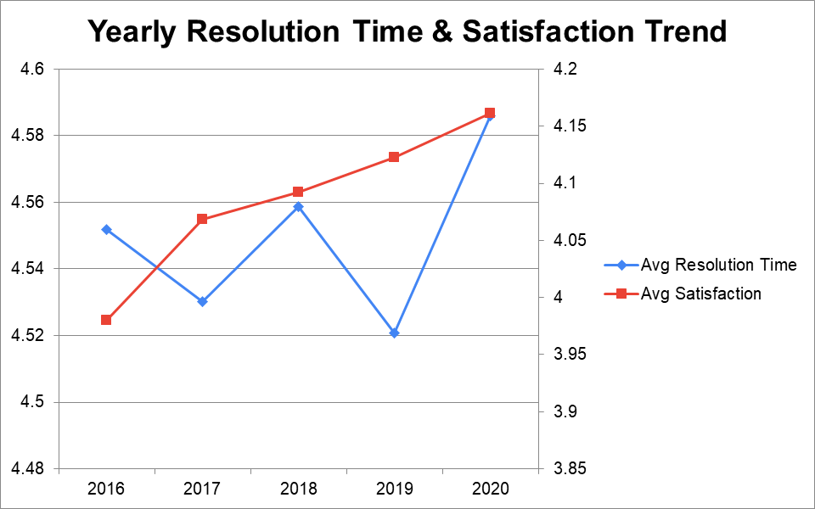

Insights:
Resolution time stayed essentially flat (4.52-4.59 days) across all five years while ticket volume grew 123% (13,051 -> 29,088) with the same 50-agent headcount, and satisfaction actually improved (3.98 -> 4.16) over the same period.

Recommendations:
Current tools/process are effectively absorbing the growing ticket load - no urgent tooling replacement is justified on effectiveness grounds. However, the flat resolution-time-under-rising-volume pattern suggests the team is nearing capacity; monitor closely and revisit if 2021+ volume keeps climbing at the same rate.

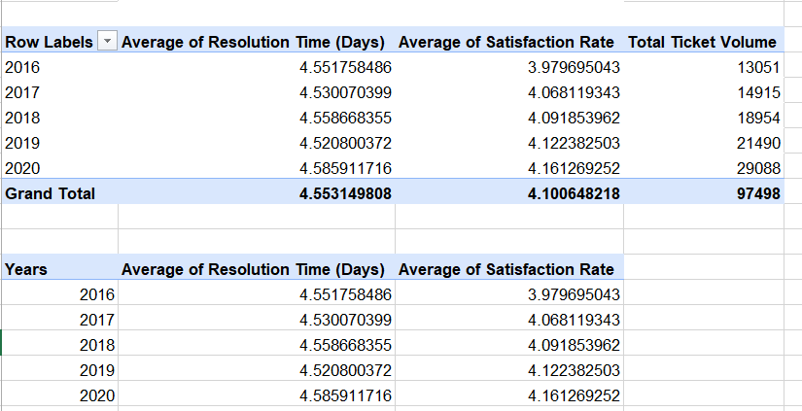

Count of ID Ticket | Column Labels
Row Labels | 0 - Unassigned | 1 - Low | 2 - Mid | 3 - High | Grand Total
0 - Unclassified | 115 | 80 | 55 | 106 | 356
1 - Minor | 626 | 549 | 407 | 676 | 2258
2 - Normal | 26826 | 15282 | 14468 | 32080 | 88656
3 - Major | 1434 | 614 | 713 | 2075 | 4836
4 - Urgent | 409 | 169 | 202 | 612 | 1392
Grand Total | 29410 | 16694 | 15845 | 35549 | 97498

(Added a pivot table that compares severity to priority to show misclassified tickets)

Question 5: How has the performance of the IT support team changed over time (e.g., monthly or quarterly)?
Analysis: Trend analysis using time series charts.

Solution:

Approach:
Built a pivot table (Q-5 I Subjective sheet) with quarter as rows and Average Resolution Time / Average Satisfaction as value fields, plotted as a dual-axis line chart to see quarter-to-quarter movement within the yearly trend from Question 4.

Charts & Tables:
- Table / Chart Name:
  - I Subjective sheet - "Quarterly Resolution Time & Satisfaction Trend" chart + table
- Description:
Quarter-by-Quarter resolution time and satisfaction rates

.
4.57
4.56
4.55
4.54
4.53
4.52
4.51
4.5
Quarterly Resolution Time & Satisfaction Trend
4.15
4.1

4.05

4
Avg Resolution Time
Avg Satisfaction
3.95
3.9
Qtr1 Qtr2 Qtr3 Qtr4

Insights:
Resolution time oscillates in a fairly narrow band (4.4-4.8 days) with normal quarter-to-quarter noise but no sustained upward or downward run; satisfaction shows a gentle upward drift across the full period. No individual month or quarter stands out as an operational crisis point.

Recommendations:
No corrective action needed for quarter-to-quarter volatility - it reflects normal variation, not a systemic problem. Continue monitoring quarterly or monthly to catch any future sustained trend early.

Question 6: If we invest more on tech (Hardware, software, etc), do you think it will improve the ticket resolution times and employee satisfaction?
Analysis: Use historical data to project potential improvements.

Solution:

Approach:

Used FORECAST.LINEAR on the five years of actual data (2016-2020) to project 2021 and 2022 resolution time and satisfaction if current trends simply continue with no new investment (Q-6 I Subjective sheet).

Charts & Tables:
- Table / Chart Name:
  - I Subjective sheet - "Resolution Time & Satisfaction Trend + 2021-22 Projection" chart + table
- Description:
- Actual 2016-2020 values plus linear-trend projections for 2021 and 2022.

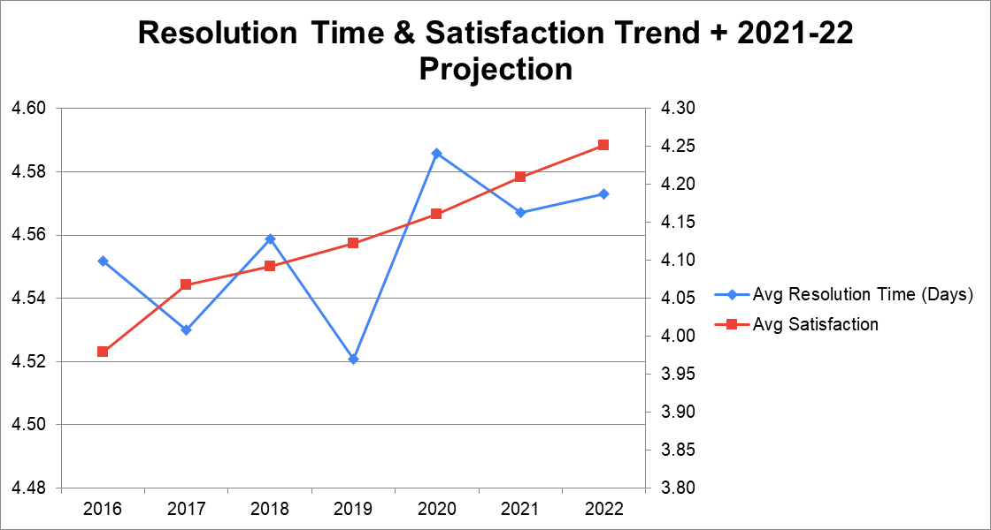

.

Insights:
On the current trajectory, resolution time is projected to stay essentially flat (~4.57 days in both 2021 and 2022) while satisfaction keeps drifting upward on its own (~4.21 in 2021, ~4.25 in 2022) - meaning satisfaction improvement does not require new tech spend, but resolution-time improvement will not happen organically either.

Recommendations:
If management's goal is specifically to cut resolution time (not just satisfaction), tech investment is justified since the trend alone won't deliver it. If the goal is satisfaction, the current trajectory is already improving without further spend - prioritize investment toward resolution-time reduction (e.g. automation for Hardware/System diagnostics) rather than general-purpose upgrades.

Row Labels | Total Ticket Volume | Average of Resolution Time (Days) | Average of Satisfaction Rate
Hardware | 9733 | 7.62539813 | 4.100996609
Login Access | 29193 | 0.313808105 | 4.094508958
Software | 19570 | 5.238732754 | 4.106336229
System | 39002 | 6.615609456 | 4.102302446
Grand Total | 97498 | 4.553149808 | 4.100648218

Question 7: What are the key performance metrics for IT agents, and how can they be improved, do we need to fire any agents?
Analysis: Define and analyze metrics such as average handling time, satisfaction scores, and number of tickets resolved.

Solution:

Approach:
Built a full 50-agent KPI table (Tickets Handled, Avg Resolution Time, Avg Satisfaction) and a separate bottom-5-by-satisfaction table (Q-7 I Subjective sheet) to check whether any agent is underperforming badly enough to warrant termination rather than coaching.

Charts & Tables:
- Table / Chart Name:
  - I Subjective sheet - full KPI table + bottom-5 flagged table
- Description:
All 50 agents' ticket volume, resolution time, and satisfaction, with the 5 lowest-satisfaction agents singled out.
Agent Name | Avg Satisfaction | Avg Resolution Time | Tickets Handled
Alfonso Barraza | 3.04 | 5.00 | 1,984
Alberto Trejo | 3.59 | 5.32 | 1,949
Sandra Lujan | 3.60 | 5.20 | 1,906
Nurio Zepeda | 3.61 | 5.41 | 1,946
Elena Velez | 3.62 | 5.38 | 2,021

Insights:
Key KPIs are Tickets Handled, Avg Resolution Time, and Avg Satisfaction. The 5 flagged agents (Alfonso Barraza 3.04, Alberto Trejo 3.59, Sandra Lujan 3.60, Nurio Zepeda 3.61, Elena Velez 3.62) all still handle 1,906-2,021 tickets, close to the 1,950 team average - they are underperforming on quality/speed, not on volume.

Recommendations:

No firings are warranted based on this data - all flagged agents are pulling a normal ticket load, which makes them coachable rather than replaceable. Put the 5 flagged agents through a structured training cycle and re-evaluate the same metrics in 90 days before considering any staffing action.

Question 8: How do employee demographics (e.g., department, seniority) impact satisfaction and ticket outcomes?
Analysis: Segment analysis using filters and pivot tables.

Solution:

Approach:
The dataset has no demographic fields for the ticket-raising employees, only agent birth date - used IT Agent age band (29-33, 34-38, 39-43, 44-48, 49-53, 54-58) as a proxy for experience/seniority and built a pivot table of Ticket Volume, Avg Resolution Time, and Avg Satisfaction by band (Q-8 I Subjective sheet).

Charts & Tables:
- Table / Chart Name:
  - I Subjective sheet - "Average Resolution and Satisfaction rate by Age Group " chart + table
- Description:
Ticket volume, resolution time, and satisfaction by IT agent age band.

Insights:
The 34-38 age band stands out negatively: it has the longest average resolution time (4.68 days, the worse than other bands), and the lowest satisfaction (3.96, well below).This band appears to be carrying a disproportionate workload.

Recommendations:
Rebalance ticket routing to reduce load concentration on the 34-38 age band, and investigate whether this group needs additional support tooling or staffing rather than assuming it's a skills gap - their volume, not their competence, looks like the primary driver.

Question 9: Identify the trends for IT support operations based on ticket volumes and satisfaction, and mention the peak and stable times?
Analysis: Use pivot tables and charts to identify peak and off-peak hours.

Solution:

Approach:
Built a pivot table (Q-9 I Subjective sheet) with Day of Week as rows (explicitly reordered Mon-Sun) and Ticket Volume / Avg Satisfaction as value fields, to look for weekday-vs-weekend or day-specific peaks.

Charts & Tables:
- Table / Chart Name:
  - I Subjective sheet - "Ticket Volume by Day of Week" chart + table
- Description:
Ticket volume and satisfaction by day of week.

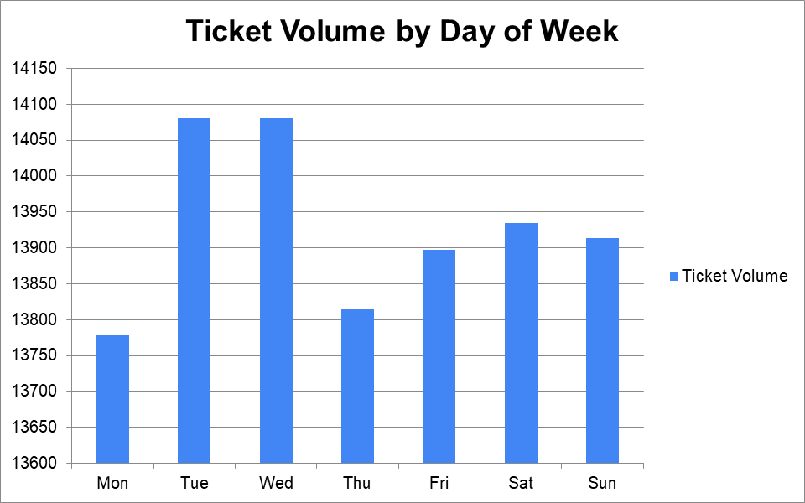

Insights:
Ticket volume is essentially flat across all seven days (13,778-14,080, a spread of under 2.2%) - Tuesday and Wednesday are marginally the busiest, Monday marginally the quietest, but there is no meaningful weekday-vs-weekend pattern. This points to a 24/7, always-on support operation rather than a traditional 9-to-5 office pattern. Satisfaction is similarly stable (4.08-4.12) every day.

Recommendations:
Since demand is stable rather than peaked, staffing/shift scheduling can be flat across the week rather than weighted toward particular days - the operational priority should be managing the steady long-term volume growth (Questions 4/6), not day-of-week peaks, since none exist.

Question 10: What metrics should be included in the final dashboard to provide a comprehensive view of call center performance and guide investment decisions?

Solution:

Approach:
Synthesized the objective and subjective findings into a single-screen dashboard (Dashboard sheet in the Excel workbook) designed for the kind of multi-week management review described in the task guidelines.

Charts & Tables:
- Table / Chart Name:
Dashboard sheet
- Description:
Full interactive dashboard with KPI tiles, 6 charts, 4 slicers, 2 Performance matrix, 1 Key Insights.

Insights:
The dashboard leads with 4 headline KPIs (Total Tickets, Avg Resolution Time, Avg Satisfaction, Avg Tickets per Agent), followed by the six visuals most requested across the objective/subjective questions.

Recommendations:
All required slicers are built and connected to every chart and KPI tile, so management can isolate a specific year or urgency level across a multi-week review without a rebuilt report each time; every visual and KPI updates live when either slicer is changed.

